Name ………………………………………………………………………. Admission No. ________________Signature ……… Date _________________________
121/1
MATHEMATICS PAPER 1
DECEMBER 2021
2 ½ HOURS

MOMALICHE 4 CYCLE 8
FORM FOUR JOINT EXAMINATION 2021

Kenya Certificate of Secondary Education

MATHEMATICS
PAPER 1
DECEMBER 2021
2 ½ HOURS

INSTRUCTIONS TO DANDIDATES
1. Write your name, index number and class.
2. The paper contains two sections: Section I and II
3. Answer ALL questions in section I and ONLY FIVE questions from section II.
4. All working and answers must be written on the question paper in the spaces provided below each question.
5. Marks may be awarded for correct working even if the answer is wrong.
6. Negligence and slovenly work will be penalized.
7. Non-programmable silent electronic calculators and mathematical tables are allowed for use.
8. This paper consists of 15 printed pages. Candidates should check to ensure that all pages are printed as indicated and no questions are missing

FOR EXAMINER’S USE ONLY

SECTION 1

1 | 2 | 3 | 4 | 5 | 6 | 7 | 8 | 9 | 10 | 11 | 12 | 13 | 14 | 15 | 16 | TOTAL
GRAND TOTAL

SECTION II

17 | 18 | 19 | 20 | 21 | 22 | 23 | 24 | TOTAL

SECTION 1 (50 Marks)
Answer ALL questions from this section

1. Evaluate: $\frac{\frac{1}{2} of 18 -3+2\frac{1}{2}×\frac{3}{-5}}{\frac{1}{2}+ 3\frac{3}{4} ÷ \frac{3}{4}}$ (3 marks)

2. The straight line joining the points P (a, 7) and Q (13, a) is parallel to the line whose equation is
3y + 2x = 9. Find the value of a. (3 marks )

3. Solve the following inequalities and represent the solution on a number line and hence state the integral values of x
7x – 4 ≤ 9x + 2 < 3x + 14 (4 marks)

4. The gradient of curve at any point is given by 2x – 1. Given that the curve passes through point
(1, 5), find the equation of the curve. (3 Marks)

5. Solve for x in the equation. (3 marks)
$\frac{{81}^{2x} x {27}^{x}}{9^{x}}$ = 729

6. The GCD of 6480, 7200 and a third number is 144. The L.C.M of the three numbers
is 2⁵ x 3⁵ x 5² x 7³. Find the smallest third number. (3 marks )

7. Mr. Waweru needs to import a car from Japan where cost is USD 5000 outside Kenya. He intends to buy the car through an agent who deals in Japanese yen. The agent will charge him 20% commission on the price of the car and further 80,325 Japanese yen for shipment of the car. How much Kenya shillings will he need to send to the agent to obtain the car given that?
1USD = 105.00 yen and 1USD = KSh. 63.00 (3 marks)

8. Use tables of reciprocals only to find the value of
$\frac{5}{0.0829}$ - $\frac{14}{0.581}$ (3 marks)

9. The figure below AB//CD, AD and BC intersect at T. Given that AT:TD = 1:3 and CB = 12cm. Calculate the length of TB. (3 marks)
T
D
B
C
A
a
x
((
))

10. Draw the net of the solid shown below. (3 marks )
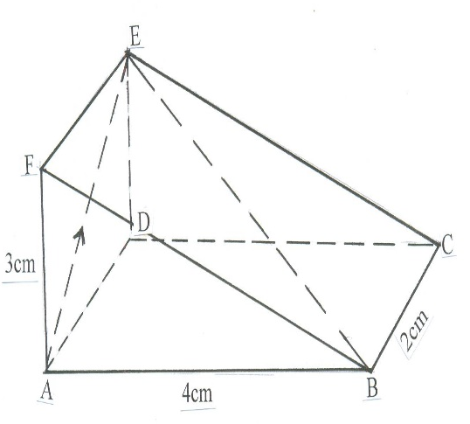

11. The figure below shows a histogram. (3mks)
Frequency
Density
2.0
1.6
1.2
0.8
0.4
0

0

7.5 9.5 11.5 15.5 21.5
Length in x cm
Fill in the table below the missing frequencies.
Length in x cm | Frequency
7.5≤ x ≤ 9.5 | 12
9.5≤ x ≤ 11.5
11.5≤ x ≤ 15.5
15.5≤ x ≤ 21.5

12. Solve for x: ${\left(\log_{2}{x}\right)}^{2}$-${Log}_{2}$ $x^{3}$ = 4 (4 marks)

$$\left({\log_{2}{x})}^{2}\right)$$

13. Mutua bought 8 pairs of trousers and six shirts at Sh. 4160. Had he bought twice as many shirts and half as many trousers, he would have saved Sh. 160. Find the cost of each item. (3 marks)

14. Two containers have base area of 750cm² and 120cm² respectively. Calculate the volume of the larger container in litres given that the volume of the smaller container is 400cm³. (3 marks)

15. In the figure below O is the centre of circle PQRS. ∠PTS = 56⁰ and ∠PQS = 28⁰ and TPQ is a straight line.
P
Q
R
S
T
O

56⁰

Find: (a) ∠TSP (2mark)

(b) ∠PRQ (1 mark)

16. Simplify the following expression. (3 marks)
$\frac{x-3}{x+3}$ - $\frac{3x-9}{x^{2}-9}$

SECTION II (50 marks)
17. Three partners Mutua, Muthoka and Mwikali contributed Sh. 600,000, Sh. 400,000 and Sh. 800,000 respectively to start a business of a matatu plying Mbumbuni – Machakos route. The matatu carries 14 passengers with each paying Sh. 250. The matatu makes two round trips each day and ever full. Each day Sh. 6000 is used to cover running costs and wages.
- Calculate their net profit per day. (2 marks)

- The matatu works for 25 days per month and is serviced every month at a cost of KSh.10, 000. Calculate their monthly profit in June. (1 mark)

- The three partners agreed to save 40% of the profit, 24% to be shared in the ratio of their contribution. Calculate Muthoka’s share in the month of July (4 marks)

- The matatu developed mechanical problems and they decided to sell it through an agent who charged a commission of 5% on selling price. Each partner received KSh. 475,000 from the agent after he had taken his commission. Determine the price at which the agent sold the matatu. ( 3 marks)

18. The income tax rates in a certain year are as shown below.

Income (k₤ – p.a | Rate (KSh. per ₤)
1 – 4200 | 2
4201 – 8000 | 3
8001 – 12600 | 5
12601 – 16800 | 6
16801 and above | 7

Omar pays Sh. 4000 as P.A.Y.E per month. He has a monthly house allowance of KSh.10800 and is entitled to a personal relief of KSh. 1,100 per month. Determine:

(i) his gross tax per annum in Kshs (2 Marks)

(ii) his taxable income in K₤ per annum (2 marks)

(iii) his basic salary in Ksh. per month. (2marks)

(iv) his net salary per month (2 marks)

19. (a) (i) Fill the table below for the function.
y = 2x² + 5x – 12 for -8≤ x ≤ 4 (2 marks)

x | -7 | -6 | -5 | -4 | -3 | -2 | -1 | 0 | 1 | 2 | 3 | 4
2x² | 98 |  |  |  | 18 |  |  |  | 2 |  |  | 32
5x | -35 |  |  |  | -15 |  |  |  | 5 |  |  | 20
-12 | -12 |  |  |  | -12 |  |  |  | -12 |  |  | -12
y | 51 |  |  |  | -9 |  |  |  | -5 |  |  | 40

(ii) Using the table, draw the graph of the function y = 2x² + 5x – 12. Use the scale 1cm to 1 unit on the x-axis and 1cm for 10 units for the y – axis (4 marks)
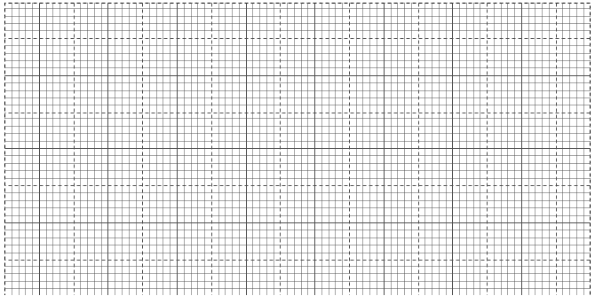

(b) Use the graph drawn above to solve the following equations.
(i) 2x² + 5x – 12 = 0 (2 marks)

(ii) 3 – 7x – 3x² = 0 (2 marks)

20.The diagram below shows the speed-time graph for a bus travelling between two stations. The bus
begins from rest and accelerates uniformly for 30 seconds. It then travels at a constant speed for 60
seconds and finally decelerates uniformly for 40 seconds.
Speed
(m/s)
Time in seconds

Given that the distance between the two stations in 2090m. Calculate
(a) The maximum speed, in km/h the bus attained (3 Marks)

(b) The acceleration (2 Marks)

(c) The distance travelled during the last 20 seconds (2 Marks)

(d) The time the bus takes to travel the first half of the journey (3 Marks)

21. In the figure below, K,L,M and N are points on the circumference of the circle centre O. The points K,
O, M and P are on a straight line. PN is tangent to the circle at N. ∠KOL = 130⁰ and ∠MKN = 40⁰.
130⁰
40⁰
P
L
N
Q
O
M
K

Stating the reason in each case, find the values of the following angles,
- MLN (2 marks)

- OLN (2 marks)

- LNP ( 2 marks)

- MPN ( 2 marks)

- KNQ (2 marks)

22. The figure below shows a model of a solid in the shape of a frustum of a cone with a hemispherical top.

60cm
28cm
70cm

The diameter of the hemispherical top is 70cm and is equal to the diameter of the top of the frustum. The frustum has a base diameter of 28cm and a slant height of 60cm.
- Calculate the area of the hemispherical surface. ( 1mark)

- Calculate the slant height of the cone from which the frustum was cut. (4marks)

- Calculate the total surface area of the mode. (5 marks)

23. The figure below shows triangle OPQ in which OS = $\frac{1}{ 3}$ OP and OR = $\frac{1}{3}$ OQ. T is a point on QS such that QT = $\frac{3}{4}$ QS
P
S
O
Q
R
T

- Given that OP = p and OQ = q, express the following vectors in terms of p and q.
̃
̃
(i) SR (1 Mark)
̃

(ii) QS (2 Marks)
̃

(iii) PT (2 Marks)
̃

(iv) TR (2 Marks)
̃

- Hence or otherwise show that the points P, T and R are collinear. (3 Marks)

24. The displacement S metres of a body moving along a straight line after t seconds is given by
S = -2t³ + $\frac{3}{2}t$² + 3t
(a) Find its initial acceleration. (3 marks)

(b) Calculate:-
(i) The time when the body was momentarily at rest. (3 marks)

(ii) Its displacement by the time it comes to rest momentarily (2 marks)

(c) Calculate the maximum velocity attained (2 marks)

