`Name:……………………………………………..…......................Index No……....………… Signature……………….................. Date: ……………......
231/1 (THEORY)
BIOLOGY PAPER 1
TIME: 2 HOUR

PAVEMENT FORM 4 TRIAL 2 EXAMINATION 2021/2022
Kenya certificate of secondary education (K.C.S.E)

- Write your Name and Index Number in the spaces provided above.
- Sign and write the date of examination in the spaces provided above.
- This paper consists of TWO sections: A and B.
- Answer ALL the questions in section A in the spaces provided after each question
- In Section B, answer question 6 (compulsory) in the spaces provided and either question 7 or 8 in the spaces provided after question 8.
- Answers must be written in English only.

For Examiner’s Use Only:

QUESTIONS | MAXIMUM SCORE | CANDIDATE’S SCORE
1- 31 | 80

Candidates should check the question paper to ascertain that all the pages are printed as indicated and that no questions are missing
- State the branch of Biology that would be used in solving the problem of disputed parentage.
(1mark)
……………………………………………………………………………………………………………………………………………………………………………………………………………………
- A young scientist observed a bird laying her eggs in a nest and later the eggs hatched into chicks. Name two characteristics shown by the chicks that show a chick is a living thing but an egg is not. (2marks) ……………………………………………………………………………………….………………….
…………………………………………………………………………………………………………...
- Study the diagram below and answer questions that follow
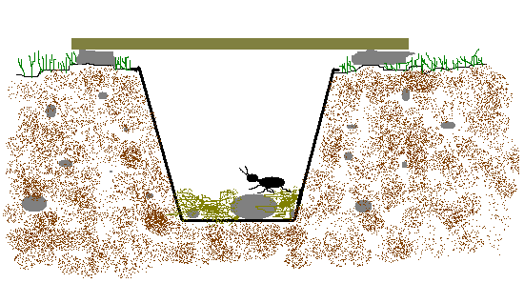

(i) What is the name given to the apparatus shown above (1 mark)
………………………………………………………………………………………………………….
(ii) What is its use in Biological studies? (2 marks)
…………………………………………………………………………………………………………..…………………………………………………………………………………………………………...
- a) A form two student observed the leaf shown below.
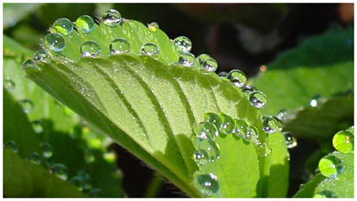
- Name the process shown by the leaf. (1mark)
……………………………………………………………………………………………………………………………………………………………………………………………………………………
- Differentiate between the process shown above and transpiration (2marks)
…………………………………………………………………………………………………………..
…………………………………………………………………………………………………………...
…………………………………………………………………………………………………………..
- A certain species of flowering plant relies entirely on sexual reproduction for propagation. The Chromosome number of the cell in the ovarian wall is 16.
a) The pollen tube nucleus. (1mark)
…………………………………………………………………………………………………………………………………………………………………………………………………………………..
b) A cell of the endosperm. (1mark)
………………………………………………………………………………………………………………………………………………………………………………………………………………….
- a) What are fossils? (1mark)
………………………………………………………………………………………………………….

…………………………………………………………………………………………………………

- State two limitations of the use of fossils as an evidence of evolution. (2marks)
…………………………………………………………………………………..……………………… . …………………………………………………………………………………………………………
…………………………………………………………………………………………………………...
- Name the disease of the blood characterized by,
- Abnormally large number of white blood cells (1mark)
……………………………………………………………………………………………………………………………………………………………………………………………………………………
- Crescent –shaped hemoglobin (1mark)
…………………………………………………………………………………………………………………………………………………………………………………………………………………..
- a) State two roles of hydrochloric acid secreted by the stomach wall. (2marks)
…….……………………………………………………………………………………………………

…….……………………………………………………………………………………………………

(b) Name the cells that secrete the above component. (1mark) …………………………………………………………………………………………………………………………………………………………………………………………………………………..

- Name the organisms that cause each of the following diseases.
i) Amoebic dysentery. (1mark) …………………………………………………………………………………………………………...…………………………………………………………………………………………………………..
ii) Bilharzia (1mark)
…………………………………………………………………………………………………………………………………………………………………………………………………………………..
- Explain how marine fish regulate their osmotic pressure. (3marks)
…………………………………………………………………………………………………………………………………………………………………………………………………………………………….………………………………………………………………………………………………………………..……………………………………………………………………………………………………………….
- A rhinoceros in a national park was found to be infected with ticks. State the trophic level occupied by the :
(i) Rhinoceros. (1mark) …………………………………………………………………………………………………………………………………………………………………………………………………………………..
(ii) Ticks (1mark) ……………………………………………………………………………………………………………………………………………………………………………………………………………………
- Study the flow chart below of a process that takes place in both plants and animals.
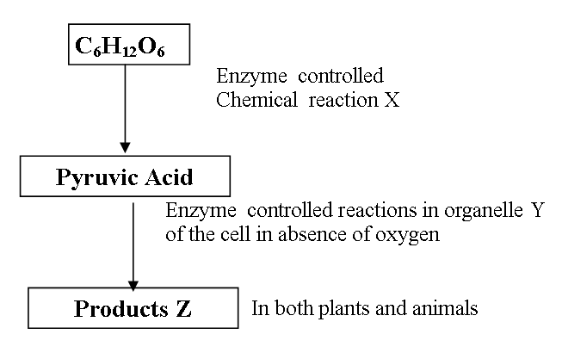

a) Name the above process. (1mark)
……………………………………………………………………………………………………………………………………………………………………………………………………………………
b) In the above process name the chemical reaction represented by X. (1mark)
…………………………………………………………………………………………
- The diagram below shows a gaseous exchange structure in the stems of angiosperms.
C
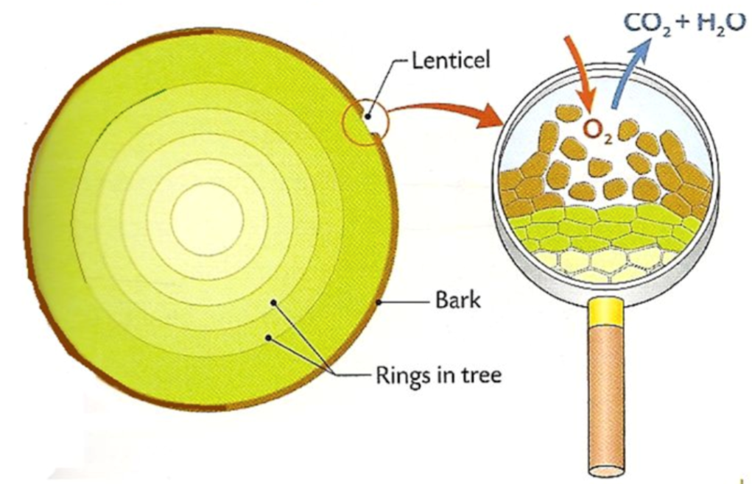
A
B
X
Name;
- Part labelled A. (1 mark)
…………………………………………………………………………………………………
- Apparatus X. (1 mark)
…………………………………………………………………………………………………
- Substances represented by arrows B and C. (2 marks)
B……………………………..…………………………………………………….………………... C…………………………………….…………………………………….……… ………………….
- When blood is flowing through a vena cava, which main blood vessel will it flow through next?
(1mark)
……………………………………………………………………………………………………
- Below is an image of a biological vector. Use it to answer questions that follow.
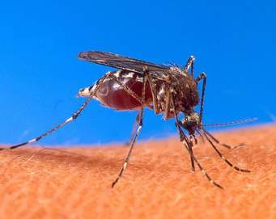
(a) Identify the parasite transmitted into human blood by the organism. (1 mark)
…………………………………………………………………………………………………………...
(b) Name the blood cells that are destroyed by the parasite in (a) above. (1 mark)
………………………………………………………………………………………………………….
(c) State one biological method used to eradicate the larvae of these organisms. (1 mark)
…………………………………………………………………………………………………………
- Give the structural adaptations of the following in an insect pollinated plant.
(a) Pollen grain. (1 mark)
…………………………………………………………………………………………………………………………………………………………………………………………………………………..
(b) Stigma. (2 mark)
…………………………………………………………………………………………………………………………………………………………………………………………………………………..
- Use the illustration below to answer questions that follow.
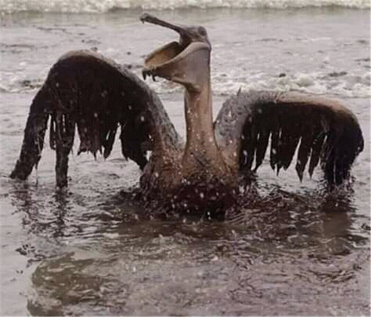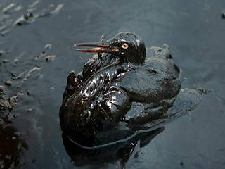
(a) Identify the type of pollution that has such an effect. (1 mark)
…………………………………………………………………………………………………………...

(b) State two effects of the type of pollution identified in (a) above to the organism. (2 marks)
………………………………………………………………………………………………………………………………………………………………………………………………………………………………………………………………………………………………………………………………
- Identify the following types of responses:
(a) Pollen tube growing towards the ovary (1 mark)
…………………………………………………………………………………………………
(b) Maggots moving away from light. (1 mark)
…………………………………………………………………………………………………
- State two activities of the cell that are controlled by the nucleus. (2 marks)
………………………………………………………………………………………………………………………………………………………………………………………………………………………………………………………………………………………………………………………………
- The field of view of a light microscope appeared as shown below in diagram A and the diameter in A was occupied by cells as shown in B.
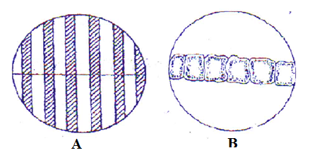
Calculate the length of one cell. (3 marks)
………………………………………………………………………………………………………………………………………………………………………………………………………………………………………………………………………………………………………………………………

- State two importance of water in germination of seeds. (2 marks)
………………………………………………………………………………………………………………………………………………………………………………………………………………………………………………………………………………………………………………………………
- Why is sexual reproduction advantageous in flowering in plants? (2 marks)
……………………………………………………………………………………………………………………………………………………………………………………………………………………
- Below is an illustration of an organism captured by students during a practical lesson.
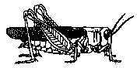
(a) Identify three features that enable the organism to be placed in the phylum Arthropoda. (3marks) ………………………………………………………………………………………………………………………………………………………………………………………………………………………………………………………………………………………………………………………………
(b) Explain why the organism will die when Vaseline is applied on its thorax. (1 mark)
……………………………………………………………………………………………………………………………………………………………………………………………………………………………………………………………………………………………………………………………..
- State the significance of natural selection. (2 marks)
………………………………………………………………………………………………………………………………………………………………………………………………………………………………………………………………………………………………………………………………

- Explain why a plant shoot develops lateral branches when its tip is removed. (2 marks)
…………………………………………………………………………………………………………………………………………………………………………………………………………………………………………………………………………………………………………………………………………………………………………………………………………………………………………
- The diagram below shows the structure of a neurone.
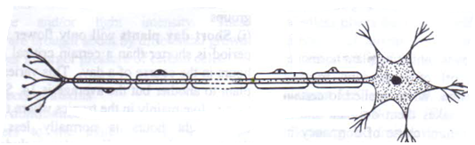
(a) Identify the neurone and state its function (2 marks)
…………………………………………………………………………………………………………
…………………………………………………………………………………………………………
(b) Name the part of the brain that is involved in learning and memory. (1 mark)
………………………………………………………………………………………………………
- Explain what happens to the structures of the human eye when a student reading a white printed paper on a bright sunny day enters a dark room for examinations. (3 marks)
…………………………………………………………………………………………………………
…………………………………………………………………………………………………………
………………………………………………………………………………………………………..
…………………………………………………………………………………………………………
…………………………………………………………………………………………………………

.
- The experiment below was carried out by form four students. The result was recorded below:
Sheet of mica placed halfway horizontally
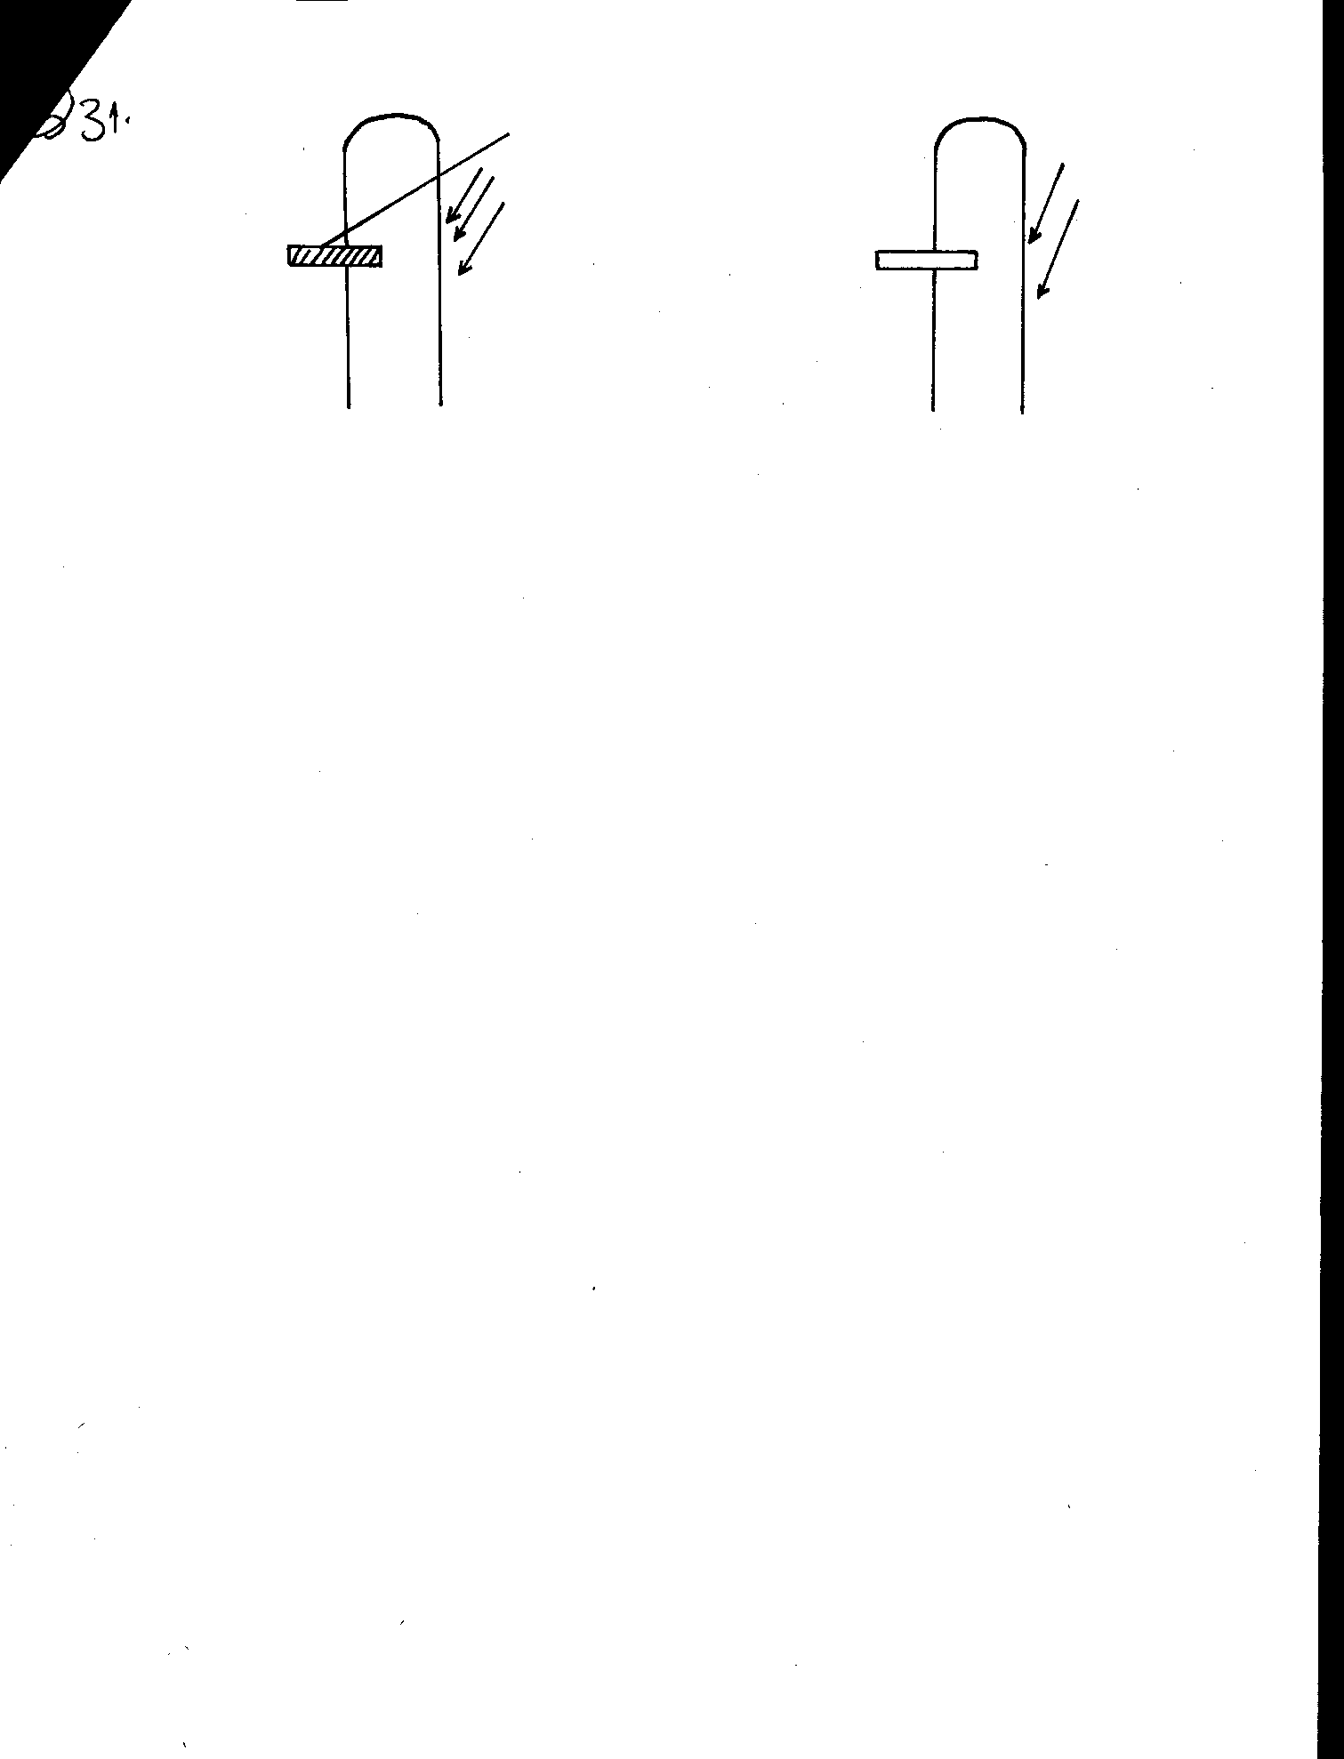
5 days later
Source of light
Explain why the shoot doesn’t bend towards the light. (3marks)
………………………………………………………………………………………………………………………………………………………………………………………………………………………………………………………………………………………………………………………………
- In an investigation, a group of students came across animals living in the following habitats. What was the likely main nitrogenous waste product of each in its habitat? (3marks)
Habitat | Nitrogenous waste
Terrestrial
Fresh water
Marine

- State the functions of each of the following parts of male reproductive system. (3marks)
  - Sertoli cells ……………………………………………………………………………...................
  - Epidydimis……………………………………………………………………………………………
  - Seminiferous tubules ………………………………………………………………………………..
- The diagram below shows various types of gene mutations..
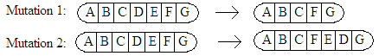
  - Identify the type of gene mutation shown above. (2marks)
Mutation 1 …………………………………………………………………………………………….
Mutation 2 …………………………………………………………………………………………….
  - Distinguish between gene and chromosomal mutations (2mark)
…..……………………………………………………………………………………………………………………………………………………..…………………………………………………………..

