Name ………………………..………………………… Index No. ..………………..…….….
Candidates Sign: …………....…..…
Date: ……………………………….
232/3
PHYSICS
Paper 3
(Practical)
Time: 2 ¼ Hours

OPENER EXAMINATIONS 2021/2022
PAVEMENT NATIONAL EXAMINATION

Kenya Certificate of Secondary Education (K.C.S.E)

232/3
PHYSICS
Paper 3
(Practical)
Time: 2 ¼ Hours

Instructions To The Candidates
- Answer all the questions in the spaces provided in the question paper.
- You are supposed to spend the first 15 minutes reading the whole paper carefully before commencing your work.
- Marks are given for clear record of the observations accurately made, their suitability and accuracy and the use made of them.
- Mathematical tables and electronic calculators may be used

FOR EXAMINERS USE ONLY

Question 1 | c | F | g(i) | g(ii) | g(iii) | h
Max Score | 2 | 7 | 5 | 2 | 2 | 2
Candidate’s Score |  |  |  |  |  | TOTAL
TOTAL
 | Part 1 |  |  |  | Part 2
Question 2 | b | D | e | f | b | c
Max Score | 1 | 8 | 5 | 2 | 3 | 1  TOTAL
Candidate’s Score

GRAND TOTAL
TOTAL

This paper consists of 6 printed pages.
Candidates should check the question paper to ensure that all the
Pages are printed as indicated and no questions are missing.

Question 1
You are provided with the following;
- A piece of candle
- Plane mirror
- Metre rule
- A thin lens mounted on a lens holder
- A cardboard with cross-wire at its centre
- A piece of plasticine
- A white screen
Proceed as follows;
- Set up the apparatus as shown in figure 1.
Cardboard with cross-wires at centre
Lens
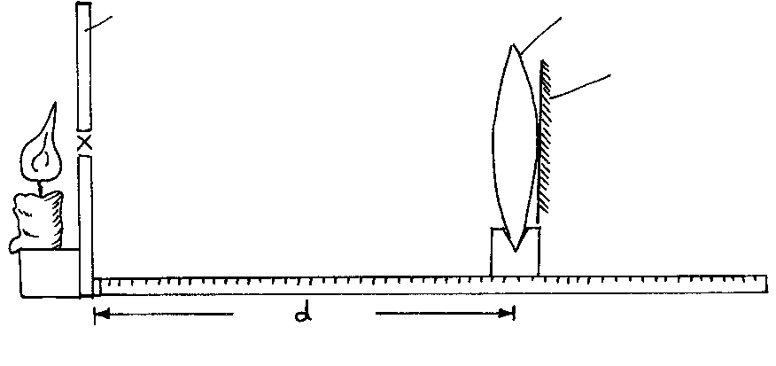
Figure 1
Candle
Plane mirror
Ensure that the candle frame is at the same height as the cross-wires. The plane mirror should also be attached to the lens as shown using a piece of cello tape. Plasticine can be used to fix the metre rule to the table.
- Place the cardboard with cross-wire at the centre at the O mark of the metre rule.
- Move the object along the metre rule until a sharp image of the cross-wire is formed alongside the object cross-wire.
Measure the length d using the metre rule.
d: ………………………………………………………………m (2 marks)
- Now arrange the candle flame, the lens the object and the screen as shown below.
Lens
Candle
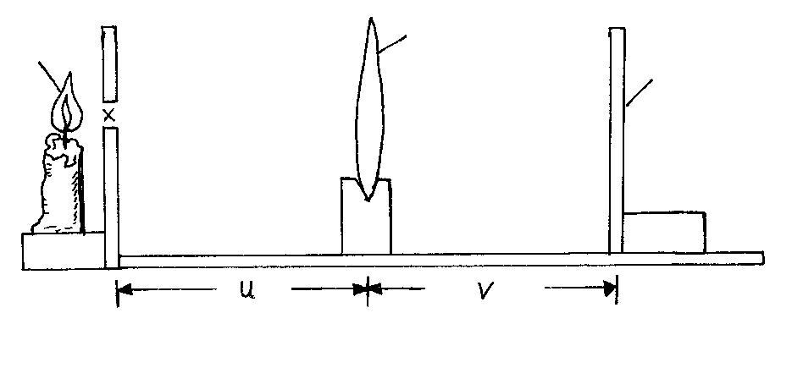
Figure 2
Screen
- Adjust the distance between the lens and the object O to each of the distances given in the table. For every value of u, adjust the position of the screen until a sharp image of the cross-wires appears on the screen. Measure the value of v and record in the table.
- Repeat the procedure (e) above for each of the other values of u and complete the table below.

u (cm) | 35 | 40 | 45 | 50 | 55 | 60 | 70
v (cm)
uv (cm³)
u + v (cm)

(7 marks)
- (i) Plot the graph of uv against u + v. (5 marks)

(ii) From your graph, calculate the slope, S (2 marks)
………………………………………………………………………………………………………………………………………………………………………………………………………………………………………………………………………………………………………………………………………
(iii) Use the graph to determine the focal length. (2 marks)
………………………………………………………………………………………………………………………………………………………………………………………………………………………………………………………………………………………………………………………………………………………………………………………………………………………………………………………………………………………………………………………………………………………….………

- How is the focal length obtained in (i) above related to d obtained in c).
Explain your answer. (2 marks)
…………………………………………………………………………………………………………………………………………………………………………………………………………………………………………………………………………………………………………………………………………………………………………………………………………………………………………………………………………

Question 2
PART I
You are provided with the following:
- A spiral spring
- One stand, one boss and one clamp
- A metre rule
- A stop watch
- A set of masses
Proceed as follows:
- Arrange the set-up as shown below
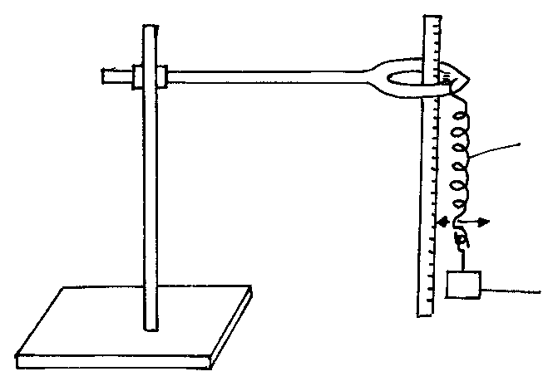
Figure 3
Mass
Pointer
Metre rule
Spiral spring
- Note the reading of the pointer of the spring when no mass is suspended from its hook.
L_{o} = _____________________ cm (1 mark)
- Attach a 50g mass on the spiral spring and measure the length L of the spring with the mass 50g on the spring, slightly displace the spring downwards and note the time for 20 oscillations. Record your results in table 2 below
- Repeat procedure in c) above for 100g, 120g, 150g, 200g and 250g. Complete the table.
Table 2
Mass M(g) | 50 | 100 | 120 | 150 | 200 | 250
L (cm)
e = L – L_{o} (cm)
time, t for 20 oscillations (s)
Log t
Log e
(8 marks)
- Plot the graph of log t against log e. (5 marks)

- Given that
Log t intercept = ½ log Determine the value of A (2 marks)
………………………………………………………………………………………………………………………………………………………………………………………………………………………………………………………………………………………………………………………………………………………………………………………………………………………………………………………………………………………………………………………………………………………………….……………….………

PART II
You are provided with the following apparatus
- One new dry cell
- One cell holder
- Switch, K
- An ammeter
- A voltmeter
- A variable resistor, rheostat or potentiometer
- Seven connecting wires, at least 4 of which with crocodile clips
- A bulb holder
- A torch bulb 2.5V (for 2 dry cells)

- Set up the apparatus as shown below
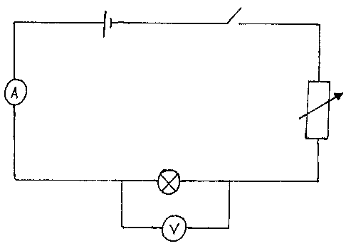
- Set the ammeter reading to 0.04A, 0.06A and 0.08A using the rheostat. Get the corresponding readings and fill the table below. (3 marks)
Current (A) | Voltage (V) | Resistance (Ω)
0.04
0.06
0.08
- From the table, calculate the average resistance of the bulb filament. (1 mark)
………………………………………………………………………………………………………………………………………………………………………………………………………………………………………………………………………………………………………………………………………………………

