Name:……………………………………………………………………………Index No:………………………
Candidate’s Signature:……………...
Date:………………………………….
511/3
MUSIC
Paper 3
December 2021
2½ Hours

SAMIA SUB COUNTY JOINT EXAMINATION
Kenya Certificate of Secondary Education
MUSIC
Paper 3
2½ Hours
Instructions to candidates
- Write your name and index number in the spaces proved above
- Sign and write the date of the examination in the spaces
- Answer all the questions in this paper
- In question 1 choose either (a) or (b)
- In question 4 choose any two of the questions numbered (a), (b), (c) and (d)
- All answers must be written in the spaces provided
- This paper consists of 9 printed pages
- Candidates should check the question paper to ensure that all the pages are printed as indicated and that no questions area missing
- Candidates should answer the questions in English

For official use only
Section | Question | Maximum  Score | Candidate’s  Score
A | 1a | 9
A | 1b | 6
A | 2 | 15
B | 3 | 14
B | 4 | 14
B | 5 | 10
B | 6 | 10
B | 7 | 6
C | 8 | 16
Grand total  Grand Total |  | 100  100

SECTION A. BASIC SKILLS ( 30 MKS)
- Melody
- Starting with the given opening, compose a melody of sixteen bars for voice, modulating to the relativemajor and returning to the tonic. Introduce dynamics. (9 marks)
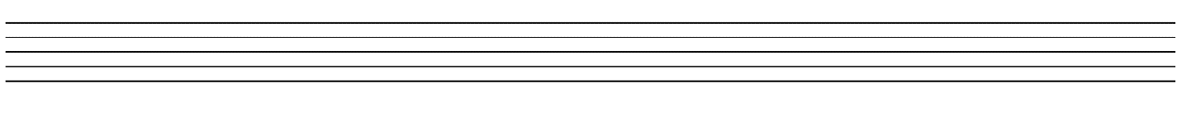

- Using staff notation, compose a tune to the following words. Add phrase marks. (6 marks)
Singing, playing and dancing together
Keeps the children united and happy

- Harmonize the following melody for soprano, alto tenor and bass (SATB). Choose appropriate chords from, I, ii, IV, V and vi. Incorporate a passing sixfour in the firstbar. (15 marks)

SECTION B. HISTORY AND ANALYSIS.
- AFRICAN MUSIC (14 MKS)
- Name three communities that traditionally perform the following dances (3marks)
- Ohangla
………………………………………………………………………………………….
- Gitiiro
………………………………………………………………………………………….
- Entabanan
…………………………………………………………………………………………
- Give any four advantages of using call and response style of singing ( 4marks)
……………………………………………………………………………………………………………………………………………………………………………………………………………………………………………………………………………………………………………………………………………………………………………………………………………………………………………………………………………………………………………………………………………………………………………………………………………….
- What are self sounding instruments?(2marks)
…………………………………………………………………………………………………………………………………………………………………………………………………….
- The style of performing African folksongs has changed over the years, give any two factors that have contributed to this change.(2 marks)
………………………………………………………………………………………………………………………………………………………………………………………………………………………………………………………………………………………………………
- State three roles of music in harvesting (3marks)
………………………………………………………………………………………………………………………………………………………………………………………………………………………………………………………………………………………………………………………………

- WESTERN MUSIC
- WILLIAM BYRD
- State two factors that influence Byrd as acomposer( 2marks)
…………………………………………………………………………………………………………………………………………………………………………………………………………………………………………………………………………………………………………………………………………………………………………
- State any three of his contributions to instrumental music (3marks)
………………………………………………………………………………………………………………………………………………………………………………………………………………………………………………………………………………………………………………………………………………………………………
- Name any two of his contemporaries (2 marks)
………………………………………………………………………………………………………………………………………………………………………………………………………………………………………………
- JOSEPH HAYDN
- Why is Hayden refers to as father of symphony. Give three reasons (3 marks)
………………………………………………………………………………………………………………………………………………………………………………………………………………………………………………………………………………………………………………………………………………………
- Name the title of haydens most popular oratorios (2 marks)
………………………………………………………………………………………………………………………………………………………………………………………………………………………………………………………………………………………………………………………………………………………………………
- Name two limitations of patronage to hydns music career (2marks)
………………………………………………………………………………………………………………………………………………………………………………………………………………………………………………………………………………………………………………………………………………………

- FRANZ LISZT
- State the nationality of List (1mark)
…………………………………………………………………………………………………………….
- Describe les preludes (2 marks)
………………………………………………………………………………………………………………………………………………………………………………………………………………………………………………
- Name any two examples of lists piano works (2 marks)
………………………………………………………………………………………………………………………………………………………………………………………………………………………………………………
- Name any two contemporaries of liszt (2marks)
…………………………………………………………………………………………………………………………………………………………………………......................................................................................................

- BELLA BARTOK
- In which period of western music history did he compose (1mark)
……………………………………………………………………………………………………………….
- State any three factors that influenced Bartoks music compositions (3 marks)
………………………………………………………………………………………………………………………………………………………………………………………………………………………………………………………………………………………………………………………………………………………………………
- What is night music? (2 marks)
………………………………………………………………………………………………………………………………………………………………………………………………………………………………………………
- Which instrument is Bartok associated with? (1 mark)
………………………………………………………………………………………………………………………
- PRESCRIBED AFRICAN MUSIC. (10 mks)
(Chivoti by Diwani Nzaro from you tube)
- What type of african performance is this recording? (1mark)
………………………………………………………………………………………………………………..
- Explain three roles of the main medium (3marks)
………………………………………………………………………………………………………………………………………………………………………………………………………………………………………………………………………………………………………………………………………………………………………

- Identify the two styles of perfoemnce evident in the recording (2 marks)
………………………………………………………………………………………………………………………………………………………………………………………………………………………………………………………………………………………………………………………………………………………………………………………………………………………………………………………………………………………………
- Explain how climax has been achieved in the performance (2 marks)
………………………………………………………………………………………………………………………………………………………………………………………………………………………………………………
- Describe the ending of the performance (2marks)
………………………………………………………………………………………………………………………………………………………………………………………………………………………………………………
- PRESCRIBED WESTERN WORK (10 mks)
(TOO MUCH I ONCE LAMENTED)
- Give two features which identify ‘too much I once lamented’ as a ballet . (2marks)
………………………………………………………………………………………………………………………………………………………………………………………………………………………………………………
- Identify the following melodic devices used in the following sections in the music (2marks)
- Bar 53-56 in the tenor voice
………………………………………………………………………………………………………………………
- Bar 75in the bass and alto voices
………………………………………………………………………………………………………………………

- State three contrasting features between the first and second refrains of the works (3marks)
………………………………………………………………………………………………………………………………………………………………………………………………………………………………………………………………………………………………………………………………………………………………………………………………………………………………………………………………………………………………
- By use of bar numbers , describe the form of this music ( 2marks)
………………………………………………………………………………………………………………………………………………………………………………………………………………………………………………………………………………………………………………………………………………………………………………………………………………………………………………………………………………………………

- Describe the metre used in this music ( 1mark)
………………………………………………………………………………………………………………………

- UNPREPARED ANALYSIS (6 marks)
Study the piece below and answer the questions that follow.
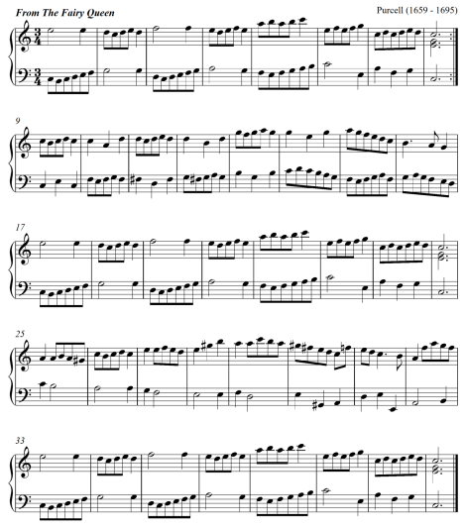
- For what medium is this music written? (1 mark)
……………………………………………………………………………………………………

- Describe the form of this music citing bar numbers. (2 marks)
…………………………………………………………………………………………………………………………………………………………………………………………………………
- Give the key scheme of the music. (1 ½ marks)
…………………………………………………………………………………………………………………………………………………………………………………………………………
- State the bar numbers in which the following developmental devices have been used. (1 mark)
- Sequence ………………………………………………………………………………
- Scalic motion …………………………………………………………………………
- Describe the range of the music. ( ½ mark)
………………………………………………………………………………………………….
SECTION C: GENERAL MUSIC KNOWLEDGE (16 MARKS)
- a) (i) Differentiate between a whole consort and a broken consort. (2marks)
____________________________________________________________________________________________________________________________________________________________________________________________________________________________________________________________________________________________________________________________
- Outline three ways through which hip-hop music has influenced the performance of traditional dances in Kenya. (3 marks)
____________________________________________________________________________________________________________________________________________________________________________________________________________________________________________________________________________________________________________
- State four factors that influence the quality of sound produced on a traditional African fiddle. (4 marks)
________________________________________________________________________________________________________________________________________________________________________________________________________________________________________________________________________________________________________________________________________________________________________________________________________________________________________________________________________________________________________________________________________________________________________________________________________________________________________________________
- The following melody was written for trumpet in B flat. Rewrite it in concert pitch. (4 mks)
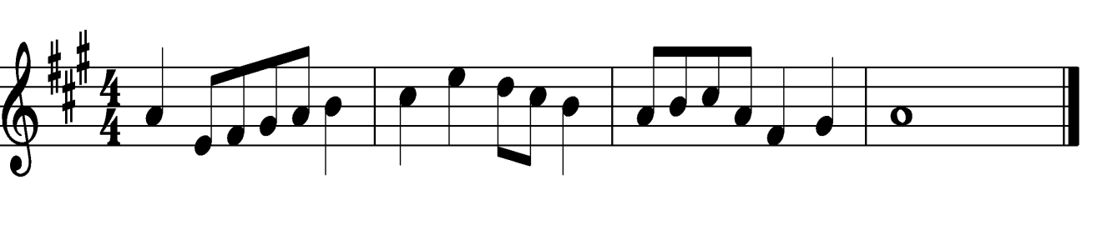
- Name any three composers of the Kenya national anthem. (3 marks)
______________________________________________________________________________________________________________________________________________________________________________________________________________________________________________________

THIS IS THE LAST PRINTED PAGE

