NAME………………………………………………INDEX NO………………………………
SCHOOL…………………………………………………………DATE………………..
232/1
PHYSICS
PAPER ONE
DECEMBER 2021
TIME: 2HRS

SAMIA JOINT EVALUATION TEST
(Kenya Certificate of Secondary Education)

INSTRUCTIONS
- Write your name and index number in the spaces provided above
- The paper consists of two sections, sections A and B
- Answer all questions in section A and B in the spaces provided below each question
- All answers and working must be clearly shown, marks may be awarded for correct steps even if the answers are wrong
- Mathematical tables and silent electronic calculators may be used
- Take g=10m/s²
FOR EXAMINER’S USE ONLY
SECTION | QUESTION | MAXIMUM SCORE |  |  | CANDIDATE’S SCORE
A | 1-9 | 25
B | 10  11  12  13  14 | 12  12  10  12  12  19
 | TOTAL |  | 80

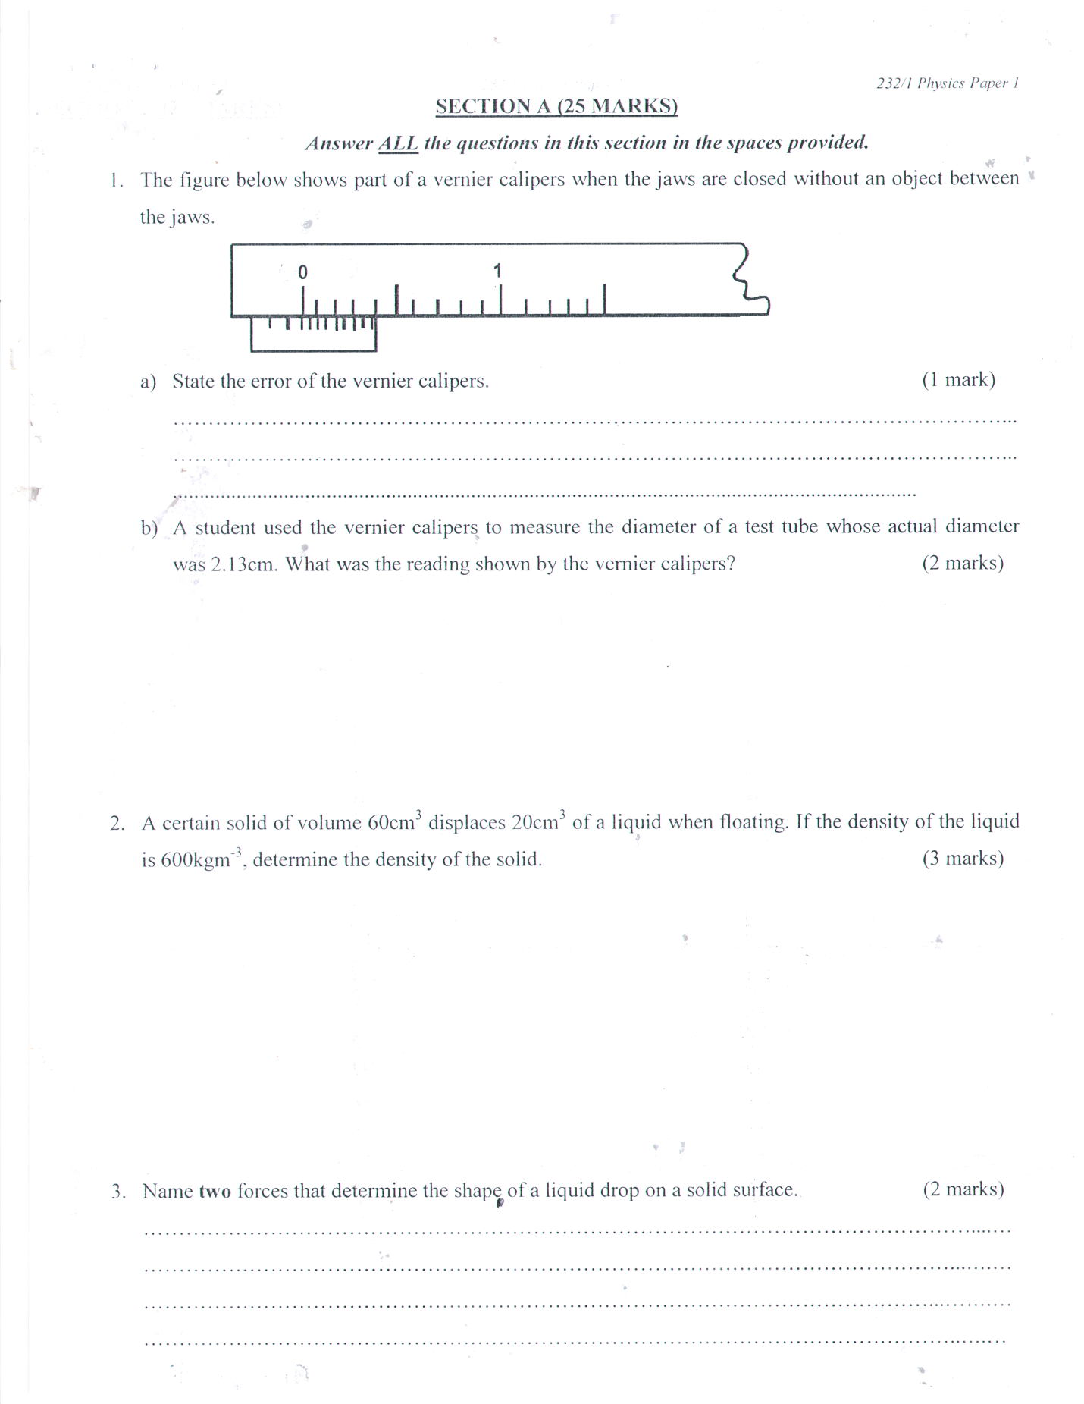
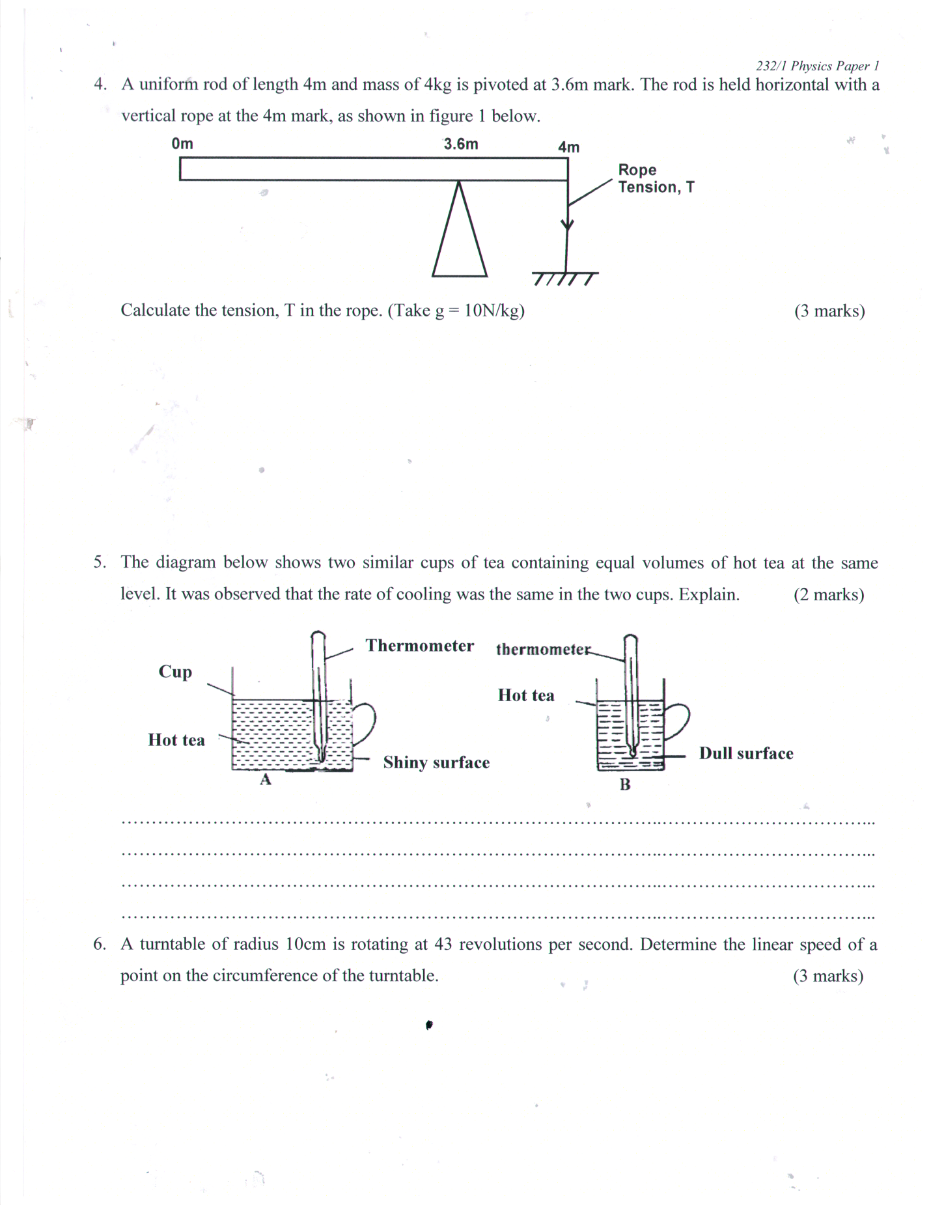

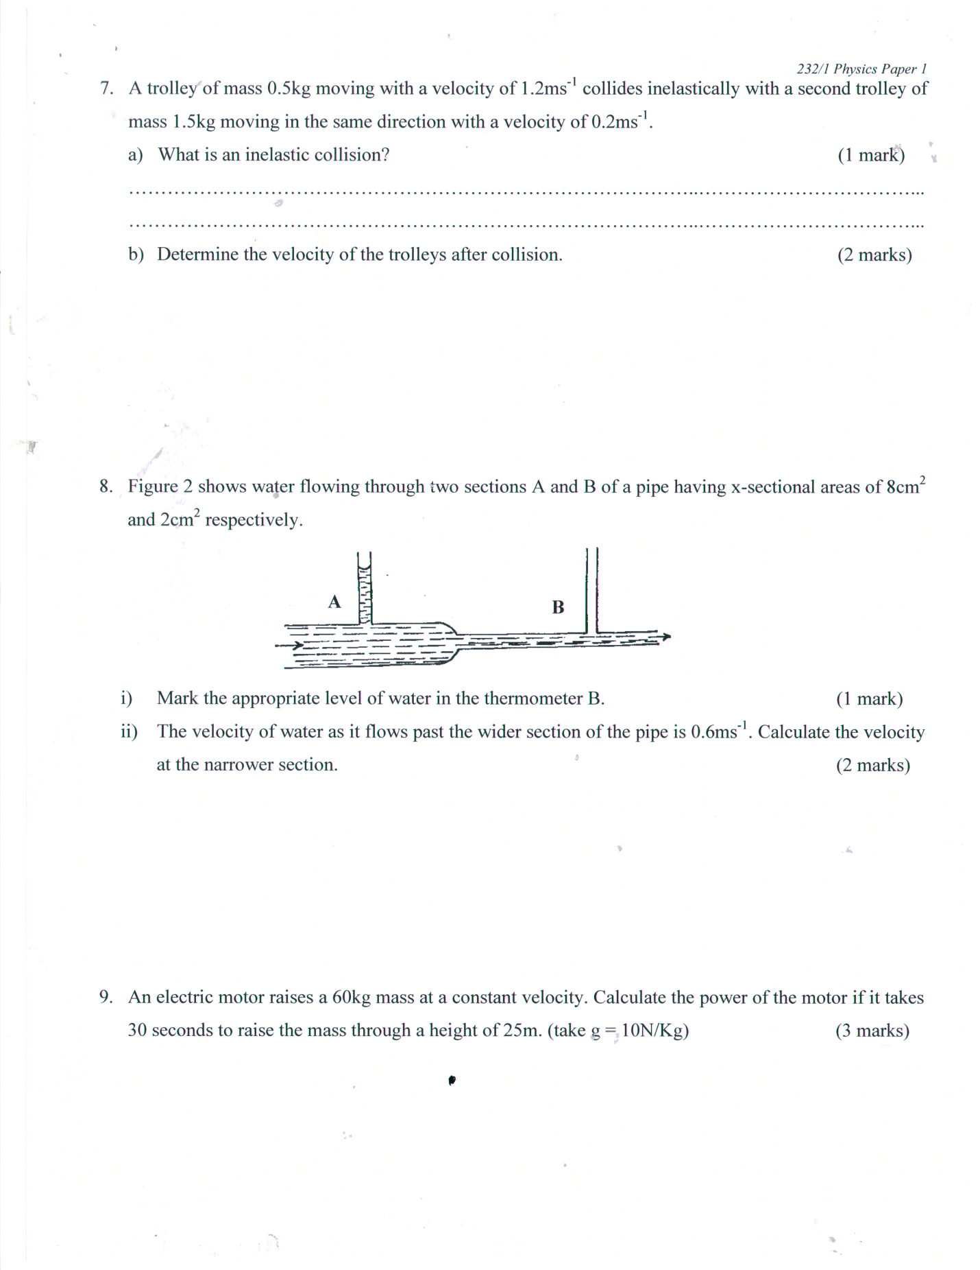

SECTION B 55 MARKS
10. A mechanic uses a pulley system with a velocity ratio of 6 to raise engine of weight 2800N through a vertical distance of 1.5. The mechanic pulls with an effort of 500N. Calculate:
- The effort distance 2mks

- The work done by effort 2mks

- The useful work done by the pulley machine 2mks

- The mechanical advantage of the machine 2mks

- The efficiency of the machine 2mks

- State two reasons why the efficiency of a machine is always less than 100% 2mks
………………………………………………………………………………………………………………………………………………………………………………………………………………………………………………………………………………………………………………………

11. A ball of mass 50kg is thrown horizontally from the top of a cliff 20m high with a horizontal velocity of 20m as shown below on reaching the ground it completely covered piston x of a hydraulic lift such that no water splashes out. The other piston y has a weight of 25000N. assuming the top was opened when the ball struck the surface of water.
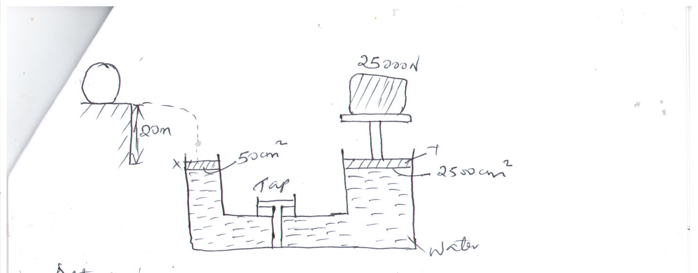

Determine:
- The time taken by the ball to strike the surface of water at piston x 3mks

- The distance from the foot of the cliff to where the ball strikes the surface of water. 2mks

- The vertical velocity with which it struck the surface of water at piston x 2mks

- The force with which the ball struck the surface of water 2mks

- The distance moved by the 25000N load piston y if the level of water in piston x and piston y was initially the same. 3mks

12. Define latent heat of fusion 1mk
b. Water of mass 200g at a temperature of 60^{O}C is put in a well legged copper calorimeter of mass 80g. A piece of ice at O^{O}C and mass 20g is placed in the calorimeter and the mixture stirred gently until all the ice melts. The final temperature of the mixture is then measured (latent heat of fusion of ice = 33400Jkg, S.H.C of water = 42000Jkg⁻¹k⁻.
Determine:
- The heat absorbed by the mercury ice at O^{O}C 2mks

- The heat absorbed by the melted ice to rise to temperature T 2mks

- The heat lost by the warm water and the calorimeter (S.H.C of the calorimeter =
900 Jkg⁻¹k⁻. 2mks

- The final temperature T. of the mixture 3mks

13. Omukaga a form three physics student in a certain secondary school conducted an experiment purposed to establish relationship between normal reaction and frictional force between two surfaces. He measured the masses of the blocks of wood, then he hooked the blocks of wood on the spring balance and pulled each of them gradually in turn until the block just began to slide. He recorded the maximum reading registered by the spring balance for each of the block.

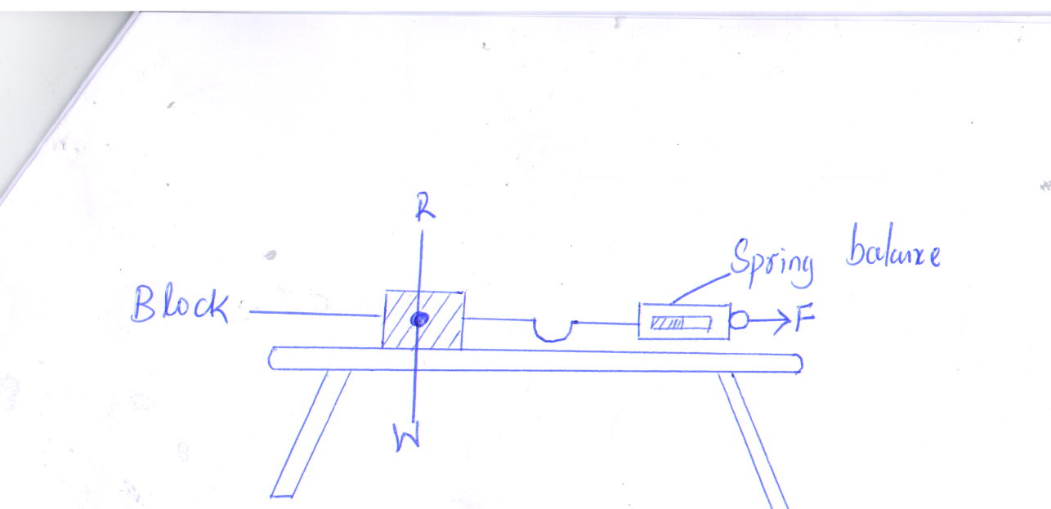

Mass of block(g) | Normal reaction, R | Spring balance reading
160 |  | 0.9
250 |  | 1.8
390 |  | 2.7
490 |  | 3.7
600 |  | 4.6
640 |  | 5.0

- If g= 9.807 N/kg complete the table 2mks

- Plot a graph of normal reactions R against spring balance reading 4mks

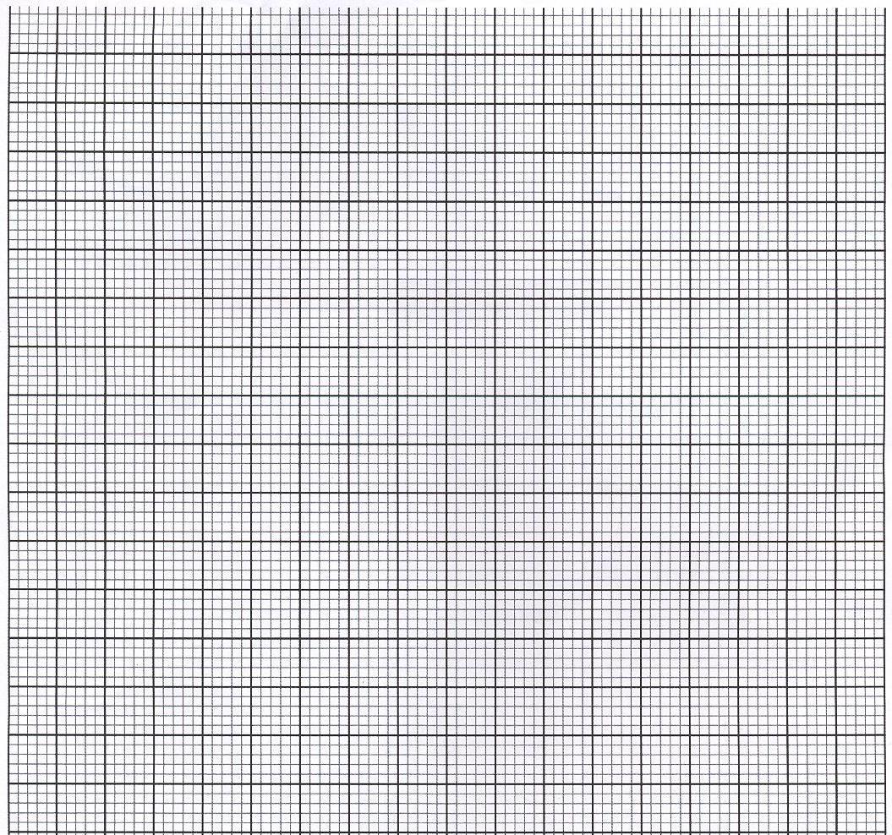

- From the graph determine the gradient of the graph 3mks

- What physical quantity does the gradient of the graph represent 1mk

- What is the type of friction measured by the spring balance? 1mk

14. a. State the law of floatation 1mk
…………………………………………………………………………………………………………………………………
b. A body weighs 40N in air, 30N when in water and 35N when in liquid. Find the relative density of liquid. 3mks

c. A simple hydrometer is set up with a test-tube of mass 10g and length 12cm with a flat base and partly fixed with load shorts. The test-tube has a uniform cross-sectional area 2.0cm² and 10cm of its length is under water as shown in the figure below.
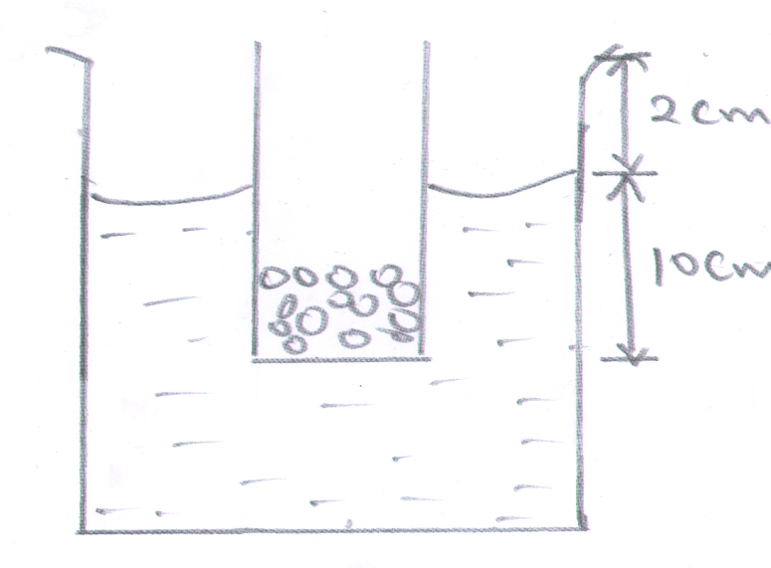
- Taking the density of water as 1000kg/m³. Calculate the mass of the lead shorts in the tube 3mks

- The mass of the lead shorts to be added if it has to displace an equal volume of a liquid of density 1.25g/cm³ 2mks

