**TERM 2 - 2023**

**BIOLOGY THEORY (231)**

**FORM TWO (2)**

**Time - 2 Hours**

**Name …………………………………………….……… Admission Number …………….**

**Candidate’s Signature ………………….…...………... Class ……………………………**

**INSTRUCTIONS**

1. *This paper has two sections* ***A*** *and* ***B.***
2. *All questions are* ***compulsory.***
3. *Write your answers in the spaces provided.*
4. *Wrong spelling of technical terms shall be* ***penalized.***

|  |  |  |
| --- | --- | --- |
| **SECTION** | **Maximum**  **Score** | **Student’s Score** |
| **A** | **40** |  |
| **B** | **40** |  |
| **TOTAL** | **80** |  |

**SECTION A (40 Marks)**

1. Name the branch of Biology that deals with the study of the following: (3 marks)
2. Cells ………………………………………………………………………………….
3. Development of techniques for the application of biological processes

………………………………………………………………………………………..

1. Structure of tissues ……………………………………………………………………………………….
2. Explain how the following factors increase the rate of water loss from a plant leaf.
3. Broad leaf surface (1 mark)

……………………………………………………………………………………………………………………………………………………………………………………………………

1. Wind (2 marks)

……………………………………………………………………………………………………………………………………………………………………………………………………

1. Arrange the following in the ascending order: (2 marks)
2. Division, Species, Kingdom, Order, Class

……………………………………………………………………………………………………………………………………………………………………………………………………

1. Cell, Organ, Organism, Organelle, Tissue.

……………………………………………………………………………………………………………………………………………………………………………………………………

1. a) Name the cell responsible for Carbon (IV) oxide transport in human beings. (1 mark)

……………………………………………………………………………………………………………………………………………………………………………………...………………….

b) Give **two** advantages of Carbon (IV) oxide transport by the cells named in (a). (2marks)

……………………………………………………………………………………………………………………………………………………………………………………………………………………………………………………………………………..……………………………….

1. The following are photomicrographs of two common organelles

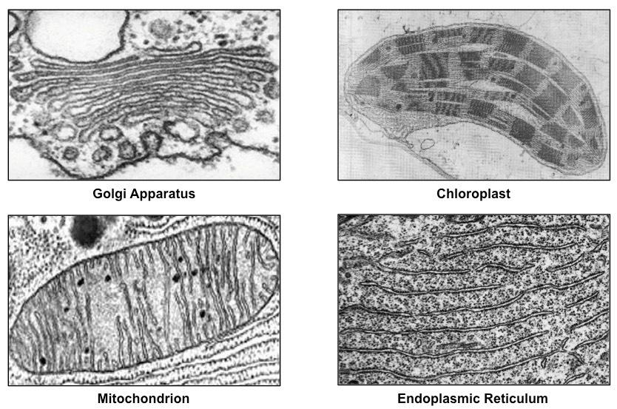 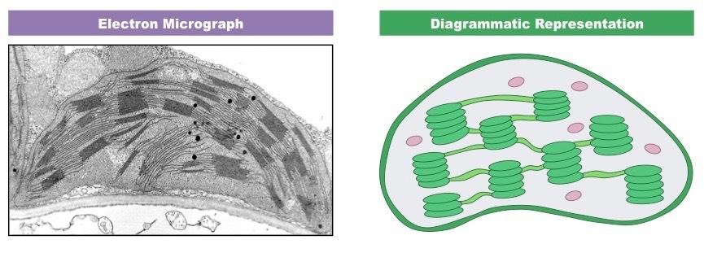

**J**

**K**

1. State **two** ways in which reaction in organelle **J** is beneficial to reactions in **K**. (2 marks)

……………………………………………………………………………………………………………………………………………………………………………………………………

1. Name the structure that increases surface area for reactions in organelle **J.** (1 mark)

…………………………………………………………………………………………………

1. How are the following structures important in the human body? (2 marks)
2. Pericardium

……………………………………………………………………………………………………………………………………………………………………………………………………

1. Pleural membrane

……………………………………………………………………………………………………………………………………………………………………………………………………

1. a) Name the part of the brain that influences gaseous exchange in human beings. (1 mark)

……………………………………………………………………………………………………

b) Describe how intercostal muscles influence inhalation in mammals. (4 marks)

……………………………………………………………………………………………………………………………………………………………………………………………………………………………………………………………………………………………………………………………………………………………………………………………………………………

1. Explain how the following affects energy requirements in mammals
2. Increase in Body Size (2 marks)

……………………………………………………………………………………………………………………………………………………………………………………………………

1. Being male (2 marks)

……………………………………………………………………………………………………………………………………………………………………………………………………

1. A normal plant cell was placed in Solution **X** and went through stages **P**, **Q**, **R** then **S**.

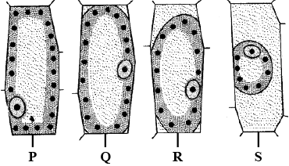

1. State the identity of Solution **X.** (1 mark)

…………………………………………………………………………………………

1. Account for the appearance of the cell at stage **S.** (2 marks)

………………………………………………………………………………………………………………………………………………………………………………………………………………………………………………………………………………………………………

1. At stage **S** the space between the cell wall and the plasma membrane of the cell was found filled with Solution **X**. Name the physiological process that enabled this. (1 mark)

…………………………………………………………………………………………

1. State the functions of the following apparatus. (2 marks)
2. Bait trap ………………………………………………………………………………………..
3. Pooter ………………………………………………………………………….……………….
4. Samson wrote the scientific name of Lion as PANTHERA LEO.
5. Give the name of this system of naming organisms (1 mark)

……………………………………………………………………………………….…………

1. Write the scientific name of Lion in the correct way (1 mark)

………………………………………………………………………….………………………

1. Name the carbohydrates that make up the following structures in living organisms. (2 marks)
2. Xylem ………………………………………………………………………………….
3. Exoskeleton of insects …………………………………………………………………
4. Amina was given orange juice, reagent **K**, boiling tube, measuring cylinder, test tube holder and source of heat. She was instructed to test for reducing sugar in the juice.
5. Name reagent **K** …………………………...…………………………… (1 mark)
6. State the steps she was to follow in this experiment. (3 marks)

…………………………………………………………………………………………………………………………………………………………………………………………………………………………………………………………………………………………………………………………………………………………………………………………………………

1. State the observation she made for a positive result. (1 mark)

……………………………………………………………………………………………………………………………………………………………………………………………………

**SECTION B (40 Marks)**

1. The set up shown below was used to investigate a physiological process by Form 2 learners. **P** and **Q** represent solutions of different concentrations.

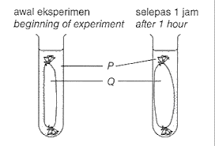

**R**

1. Name **two** materials in the school laboratory that can be used as **R.** (2 marks)

……………………………………………………………………………………………………………………………………………………………………………………….……………

1. Which term is used to describe solution **P** in relation to solution **Q**? (1 marks)

……………………………………………………………………………………………….…

1. Account for the observation made in **Q** after 1 hour. (3 marks)

………………………………………………………………………………………………………………………………………………………………………………………………………………………………………………………………………………………………………………………………

1. How is the process investigated in the experiment shown above important to the function of chloroplast? (2 marks)

……………………………………………………………………………………………………………………………………………………………………………………………………

1. The diagram shown below is a schematic representation of enzyme-substrate interaction

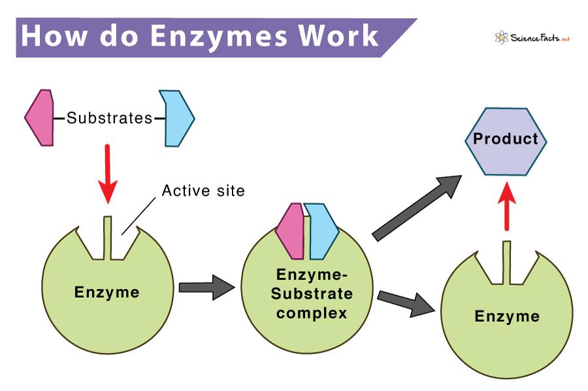

1. i) Describe how temperature beyond optimum will affect product formation in the reaction shown above. (2 marks)

……………………………………………………………………………………………………………………………………………………………………………………………………

ii) List **three** factors that will increase the rate of reaction in the set up above apart from temperature. (3 marks)

………………………………………………………………………………………………………………………………………………………………………………………………………………………………………………………………………………………………………

1. Name the main product from the set-up above in a reaction where the following enzymes are involved (3 marks)

i) Lactase

…………………………………………………………………………………………………

ii) Carbonic Anhydrase

…………………………………………………………………………………………………

iii) Catalase

…………………………………………………………………………………………………

1. The diagram shown below represents a mammalian heart.

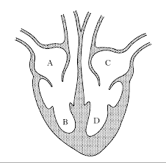

**G**

**F**

**E**

1. State the difference in composition of blood found in blood vessels **E** and **G** in terms of the following: (2 marks)

|  |  |  |
| --- | --- | --- |
| **Feature** | **Blood Vessel E** | **Blood Vessel G** |
| Amount of Nitrogenous Wastes |  |  |
| Oxygen Concentration |  |  |

1. Name the valve that prevents backflow of blood: (2 marks)

i) From **G** to **D**

………………………………………………………………..………………...………………

ii) From **D** to **C**

………………………………………………………………………….………………………

1. What is the significance of the following? (2 marks)

i) **D** having a thicker wall than **B**

……………………………………………………………………………………………………………………………………………………………………………………………………

ii) Presence of part **F**

……………………………………………………………………………………………………………………………………………………………………………………………………

1. Explain the advantage organisms with the heart structure above have over the rest.

(2 marks)

………………………………………………………………………………………………………………………………………………………………………………………………………………………………………………………………………………………………………

1. The following is a schematic representation of the blood clotting process.

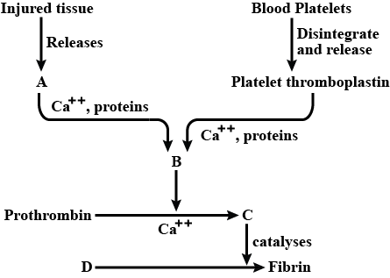

1. Identify the following components of the blood clotting process. (2 marks)

i) **C** ……………………………………………………………………………………...

ii) **D** ……………………………………………………………………………………..

1. i) Name the component of blood that stops the process illustrated above. (1 mark)

…………………………………………………………………………………………

ii) Give **two** ways by which the compound mentioned in b(i) hinders the blood clotting process. (2 marks)

………………………………………………………………………………………………………………………………………………………………………………………………………………………………………………………………………………………………………

1. Name the vitamin that is useful in the process above. (1 mark)

…………………………………………………………………………………………………

1. Give **two** ways in which the process illustrated above is important to the mammalian body. (2 marks)

……………………………………………………………………………………………………………………………………………………………………………………………………

1. Penina counted 10 onion epidermal cells along the diameter of field of view of a light microscope. The field of view had a radius of 2.5mm.
2. Determine the diameter of one cell in micrometers. (2 marks)
3. If she used Eye piece lens magnification of X15 and Objective lens magnification of X40, determine the following:

i) Total Magnification used. (2 marks)

ii) Actual diameter of one cell. (2 marks)

1. Give **two** reasons why this method of cell size estimation is not accurate. (2 marks)

……………………………………………………………………………………………………………………………………………………………………………………………………

**THIS IS THE LAST PRINTED PAGE.**