TERM 2 - 2023
CHEMISTRY (233)
FORM ONE (1)
Time - 2 Hours

Name …………………………………………….……… Admission Number …………….
Candidate’s Signature ………………….…...………... Class ……………………………

INSTRUCTIONS TO CANDIDATES:
- Write your Name, Admission number, Stream and Date of the examination in the spaces provided above.
- Answer ALL the questions in the spaces provided.
- Mathematical tables and silent electronic calculators may be used.
- All working must be clearly shown where necessary.
- Students should check the question paper to ascertain that all the pages are printed as indicated and that no questions are missing

For Examiner’s Use Only
Questions | Maximum Score | Candidate’s Score
1 –23 | 80

- (a) Meshack, a form one student wanted to measure exactly 25cm³ of dilute hydrochloric acid for an experiment. Name the most suitable apparatus that he should use to take the measurement. (1mark)
……………………………………………………………………………………………..
……………………………………………………………………………………………..
(b) Give one reason why a glass apparatus will be preferred when taking the measurement in (a) above. (1mark)
……………………………………………………………………………………………..
……………………………………………………………………………………………..
- The table below shows the solubility of three solids P, Q, and R.
Solid | Cold Water | Hot water
P | Soluble | Soluble
Q | Insoluble | Insoluble
R | Insoluble | Soluble

Describe how you would obtain pure samples of R, P and Q (3marks)
……………………………………………………………………………………………..
……………………………………………………………………………………………..
……………………………………………………………………………………………..
……………………………………………………………………………………………..
……………………………………………………………………………………………..
……………………………………………………………………………………………..

- The P^{H} values of some solutions are given below

P^{H} | 14.0 | 1.0 | 8.0 | 6.5 | 7.0
Solution | M | L | N | P | Z
- Identify the solution with the lowest concentration of hydrogen ion. Give reason for your answer (1mark)
……………………………………………………………………………………………..
……………………………………………………………………………………………..

- Which solution would be used as an anti-acid for treating stomach upset? Give a reason for your answer (1mark)
……………………………………………………………………………………………..
……………………………………………………………………………………………..
- What are the natures of solutions M and L? (1mark)
……………………………………………………………………………………………..
……………………………………………………………………………………………..
- Which solution is likely to be that of calcium hydroxide? (1mark)
……………………………………………………………………………………………..
……………………………………………………………………………………………..
- Select the solution in which a sample of magnesium oxide is likely to dissolve. Give a reason for your answer (2marks)
……………………………………………………………………………………………..
……………………………………………………………………………………………..
- Distinguish between a Mixture and a Compound (2marks)
……………………………………………………………………………………………..
……………………………………………………………………………………………..
……………………………………………………………………………………………..
……………………………………………………………………………………………..
……………………………………………………………………………………………..
……………………………………………………………………………………………..

- In an experiment to separate a mixture Q of two miscible liquids, Liquids N (B.P 56$°C$) and liquid M (B.P 118$°C$) a student set up the apparatus as shown.
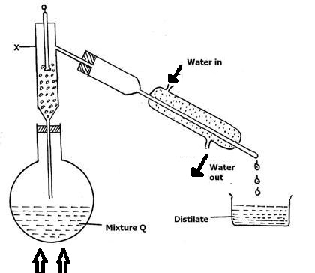
HEAT
- What makes it possible to separate substances using this method? (1mark)
……………………………………………………………………………………………..
……………………………………………………………………………………………..
- Name X (1mark)
……………………………………………………………………………………………..
……………………………………………………………………………………………..
- What is the purpose of the apparatus labelled X? (1mark)
……………………………………………………………………………………………..
……………………………………………………………………………………………..
- Identify one mistake in the set up (1mark)
……………………………………………………………………………………………..
……………………………………………………………………………………………..
- Which liquid was collected in the beaker as the first distillate? (1mark)
……………………………………………………………………………………………..
……………………………………………………………………………………………..
- What method would the student use to test the purity of the distillates obtained (1mark)
……………………………………………………………………………………………..
……………………………………………………………………………………………..
- Give any one way of increasing the efficiency of this method so as to produce purer components. (1mark)
……………………………………………………………………………………………..
……………………………………………………………………………………………..
- Give any one industrial application of this method of separation of mixtures. (1mark)
……………………………………………………………………………………………..
……………………………………………………………………………………………..
- A form one student mixes sodium chloride and water. Give the names of the following

- The solute (1mark)
……………………………………………………………………………………………..
……………………………………………………………………………………………..
- The solvent (1mark)
……………………………………………………………………………………………..
……………………………………………………………………………………………..
- The solution (1mark)
……………………………………………………………………………………………..
……………………………………………………………………………………………..
- A Bunsen burner produces two types of flames.
- Name the two types of flames. (1mark)
……………………………………………………………………………………………..
……………………………………………………………………………………………..

- Give any two differences between the two types of flames named in (a) above (2marks)
……………………………………………………………………………………………..
……………………………………………………………………………………………..
……………………………………………………………………………………………..
……………………………………………………………………………………………..

- Describe how to obtain Elianto oil from maize seeds. (2marks)
……………………………………………………………………………………………..
……………………………………………………………………………………………..
……………………………………………………………………………………………..
……………………………………………………………………………………………..
……………………………………………………………………………………………..
……………………………………………………………………………………………..
- Dilute sulphuric (VI) acid was added to a compound P of zinc. The solid reacted with the acid to form a colorless solution Q, and gas R which formed a white precipitate when passed through lime water.
- Name:
- Compound P (1mark)
……………………………………………………………………………………………..
……………………………………………………………………………………………..
- Solution Q (1mark)
……………………………………………………………………………………………..
……………………………………………………………………………………………..
- Gas R (1mark)
……………………………………………………………………………………………..
……………………………………………………………………………………………..
- Write a word equation for the reaction which took place when dilute sulphuric(VI)acid was added to compound P. (1mark)
……………………………………………………………………………………………..
……………………………………………………………………………………………..
- State the observation that would be made if a similar compound of calcium was used in place of that of zinc. Explain. (2marks)
……………………………………………………………………………………………..
……………………………………………………………………………………………..
……………………………………………………………………………………………..
……………………………………………………………………………………………..
- (a) Distinguish between an acid and a base. (2marks)
……………………………………………………………………………………………..
……………………………………………………………………………………………..
……………………………………………………………………………………………..
……………………………………………………………………………………………..

(b). Consider the following reagents:
Soda, Quencher, Sodium Chloride solution, distilled water and wood ash solution.
Complete the table below using the above reagents: (1¹/₂ marks)
Nature | Reagent(s)
Acidic
Basic
Neutral

( c) Name the three common acid-base indicators and state their colours in acidic and basic media. (4¹/₂ marks)
Indicator | Colour in acid | Colour in a base

- (a) Define the term ‘element’ (¹ /₂ mark)
……………………………………………………………………………………………..
……………………………………………………………………………………………..
(b).Name the elements present in each of the following compounds.
- Magnesium sulphate (1¹/₂ marks)
……………………………………………………………………………………………..
…………………………………………………………………………………………….
- Iron (II)sulphide (1 mark)
……………………………………………………………………………………………..
…………………………………………………………………………………………….
- The graph shown below is heating curve of solid substance. Use it to answer questions below

Using kinetic theory of matter explain what happens in the following regions
AB (2marks)
……………………………………………………………………………………………..
……………………………………………………………………………………………..
……………………………………………………………………………………………..
BC (2marks)
……………………………………………………………………………………………..
……………………………………………………………………………………………..
……………………………………………………………………………………………..
CD (2marks)
……………………………………………………………………………………………..
……………………………………………………………………………………………..
- Explain the following
- Boiling tube is usually more suitable for boiling liquids than a test tube (1mark)
……………………………………………………………………………………………..
……………………………………………………………………………………………..
- Round bottomed flask is preferred for fractional distillation and not a flat bottomed flask (1mark)
……………………………………………………………………………………………..
……………………………………………………………………………………………...
- The curve below represents the variation of temperature with time when pure and impure samples of solid were heated separately

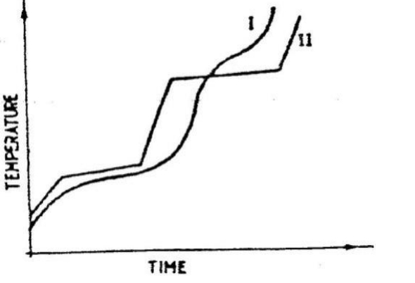
Which curve shows the variation of temperature for the pure solids? Explain (2marks)
……………………………………………………………………………………………..
……………………………………………………………………………………………..

- Complete the table below. (3marks)
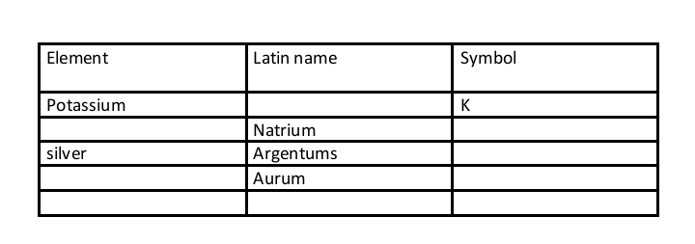
- State the function of the following apparatus in the laboratory. (2marks)

- Deflagrating spoon
……………………………………………………………………………………………..
……………………………………………………………………………………………..
- Desiccators
……………………………………………………………………………………………..
……………………………………………………………………………………………..
- The diagram below is a set up for the laboratory preparation of dry oxygen gas.
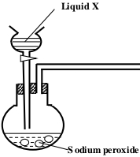
- Complete the diagram to show how a dry sample of oxygen gas can be collected. (3marks)

- Name liquid X (1mark)
……………………………………………………………………………………………..
- Write a word equation for the reaction that took place in the flask. (1mark)
……………………………………………………………………………………………..
……………………………………………………………………………………………..
- State the best method to separate the following mixtures
- Components of crude oil (1mark)
……………………………………………………………………………………………..
……………………………………………………………………………………………..

- Oil from sunflower seeds (1mark)
……………………………………………………………………………………………..
……………………………………………………………………………………………..
- Coloured pigment from grass (1mark)
……………………………………………………………………………………………..
……………………………………………………………………………………………..
- Hydrated copper (II) sulphate exists as blue crystals while anhydrous copper (II) sulphate is a white powder. Describe a laboratory experiment that can be used to show that the action of heat on hydrated copper (II) sulphate is a reversible reaction (3marks)
……………………………………………………………………………………………..
……………………………………………………………………………………………..
……………………………………………………………………………………………..
……………………………………………………………………………………………..
- A patient was given tablets with prescription 2 x 3 on the envelope. Clearly outline how the patient should take the tablets. (2marks)

……………………………………………………………………………………………..
……………………………………………………………………………………………..

- The apparatus below was used to separate a mixture of liquid A and B.
- Name the method of separation shown. (1mark)

……………………………………………………………………………………………..

- Give the possible identities of liquids A and B (1mark)

A……………………………………………………………………………..
B………………………………………………………………………………..
- State one property of the liquids that make it possible to separate them using such apparatus. (1mark)
…………………………………………………………………………………

…………………………………………………………………………………
- Pure naphthalene has a melting point of 80.2ºC. What is the effect of adding camphor to the pure naphthalene on its melting point? (1mark)
……………………………………………………………………………………………..
……………………………………………………………………………………………..
- What role do the following play in the commercial preparation of oxygen?
- Concentrated sodium hydroxide (1mark)
……………………………………………………………………………………………..
……………………………………………………………………………………………..
- Concentrated sulphuric(IV)acid (1mark)
…………………………………………………………………………………………

