TERM 2 - 2023
PHYSICS
FORM ONE (1)
Time - 2 Hours
Name …………………………………………….……… Admission Number …………….
Candidate’s Signature ………………….…...……….. Class ……………………………
Instructions to Candidates
- Write your name, admission number, class and signature in the spaces provided at the top of the page.
- Answer ALL the questions in the spaces provided.
- All working MUST be clearly shown.
- This paper consists of 8 printed pages.
- Candidates should answer the questions in English and check to ensure that no question(s) is missing.
FOR EXAMINER’S USE ONLY

QUESTIONS | MAXIMUM SCORE | CANDIDATE’S SCORE
1-26 | 50

This paper consists of 8 printed pages. Candidates should check and ascertain that all questions are printed as indicated and that no questions are missing. TURN OVER

Answer all the questions in this section in the spaces provided.
1. The diagram in figure 1 below shows part of a meter rule scale. Write down the reading shown at different points indicated. (3 marks)

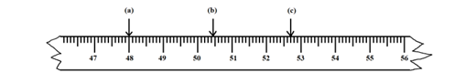
Figure 1
A………………………….
B…………………………...
C…………………………….
2. Explain the relationship between physics and Geography. (1 mark) ……………………………………………………………………………………………………… ……………………………………………………………………………………………………… 3. Explain how you would estimate the circumference of a curved object using a thread and a ruler. (3 marks) ……………………………………………………………………………………………………… ……………………………………………………………………………………………………… ……………………………………………………………………………………………………… ……………………………………………………………………………………………………… 4.The mass of a density bottle of $50{cm}^{3}$is 10.0g when empty. Aluminium turnings are poured into the bottle and the total mass is 60.0g. Water is then added into the turnings till the bottle is full. If the total mass of the bottle and its contents is 90g, calculate the density of Aluminium. (4mks)
……………………………………………………………………………………………………… ……………………………………………………………………………………………………… ……………………………………………………………………………………………………… ………………………………………………………………………………………………………

5. State three characteristics of a solid whose volume is to be determined by displacement method. (3 marks) ……………………………………………………………………………………………………… ……………………………………………………………………………………………………… ……………………………………………………………………………………………………… 6. Name the three different types of forces that act on a block of wood when placed on a table. (3mks) ……………………………………………………………………………………………………… ……………………………………………………………………………………………………… ……………………………………………………………………………………………………… 7. State and explain the factors that affect surface tension. (2 marks) ……………………………………………………………………………………………………… ……………………………………………………………………………………………………… ……………………………………………………………………………………………………… 8. Other than the size of the object to be measured, mention another factor to be considered when choosing an instrument for measuring length. (1 mark) ……………………………………………………………………………………………………… 9.A burette shows a liquid level as $20{cm}^{3}$ . Ten drops of the same liquid each of volume $0.5{cm}^{3}$are added. Calculate the new liquid level. (3 marks)
……………………………………………………………………………………………………… ……………………………………………………………………………………………………… ………………………………………………………………………………………………………

12. Explain why water forms a concave meniscus when placed in capillary tubes. (1 mark) ……………………………………………………………………………………………………… ………………………………………………………………………………………………………

13. A mass of 7.5kg has a weight of 30N on a certain planet. Calculate the acceleration due to gravity on this planet. (3 marks)
……………………………………………………………………………………………………… ……………………………………………………………………………………………………… ………………………………………………………………………………………………………

14. Name two forces that determine the shape of liquid drop on the solid surface (2 marks)
……………………………………………………………………………………………………… ……………………………………………………………………………………………………… ………………………………………………………………………………………………………
15. State the reason why smoke preferred for use in the smoke cell experiment. (1 marks) ……………………………………………………………………………………………………… ………………………………………………………………………………………………………
16. Explain why glass container with thick walls is more likely to crack than the one with a thin wall when a very hot liquid is poured into them. (2 marks) ……………………………………………………………………………………………………… ………………………………………………………………………………………………………

17. Figure 2 below shows two corks X and Y fixed on a polished plate and a dark plate with candle wax respectively. The corks are equidistant from the heater. State with reason which cork falls of first when the heater is switched on. (2 marks)

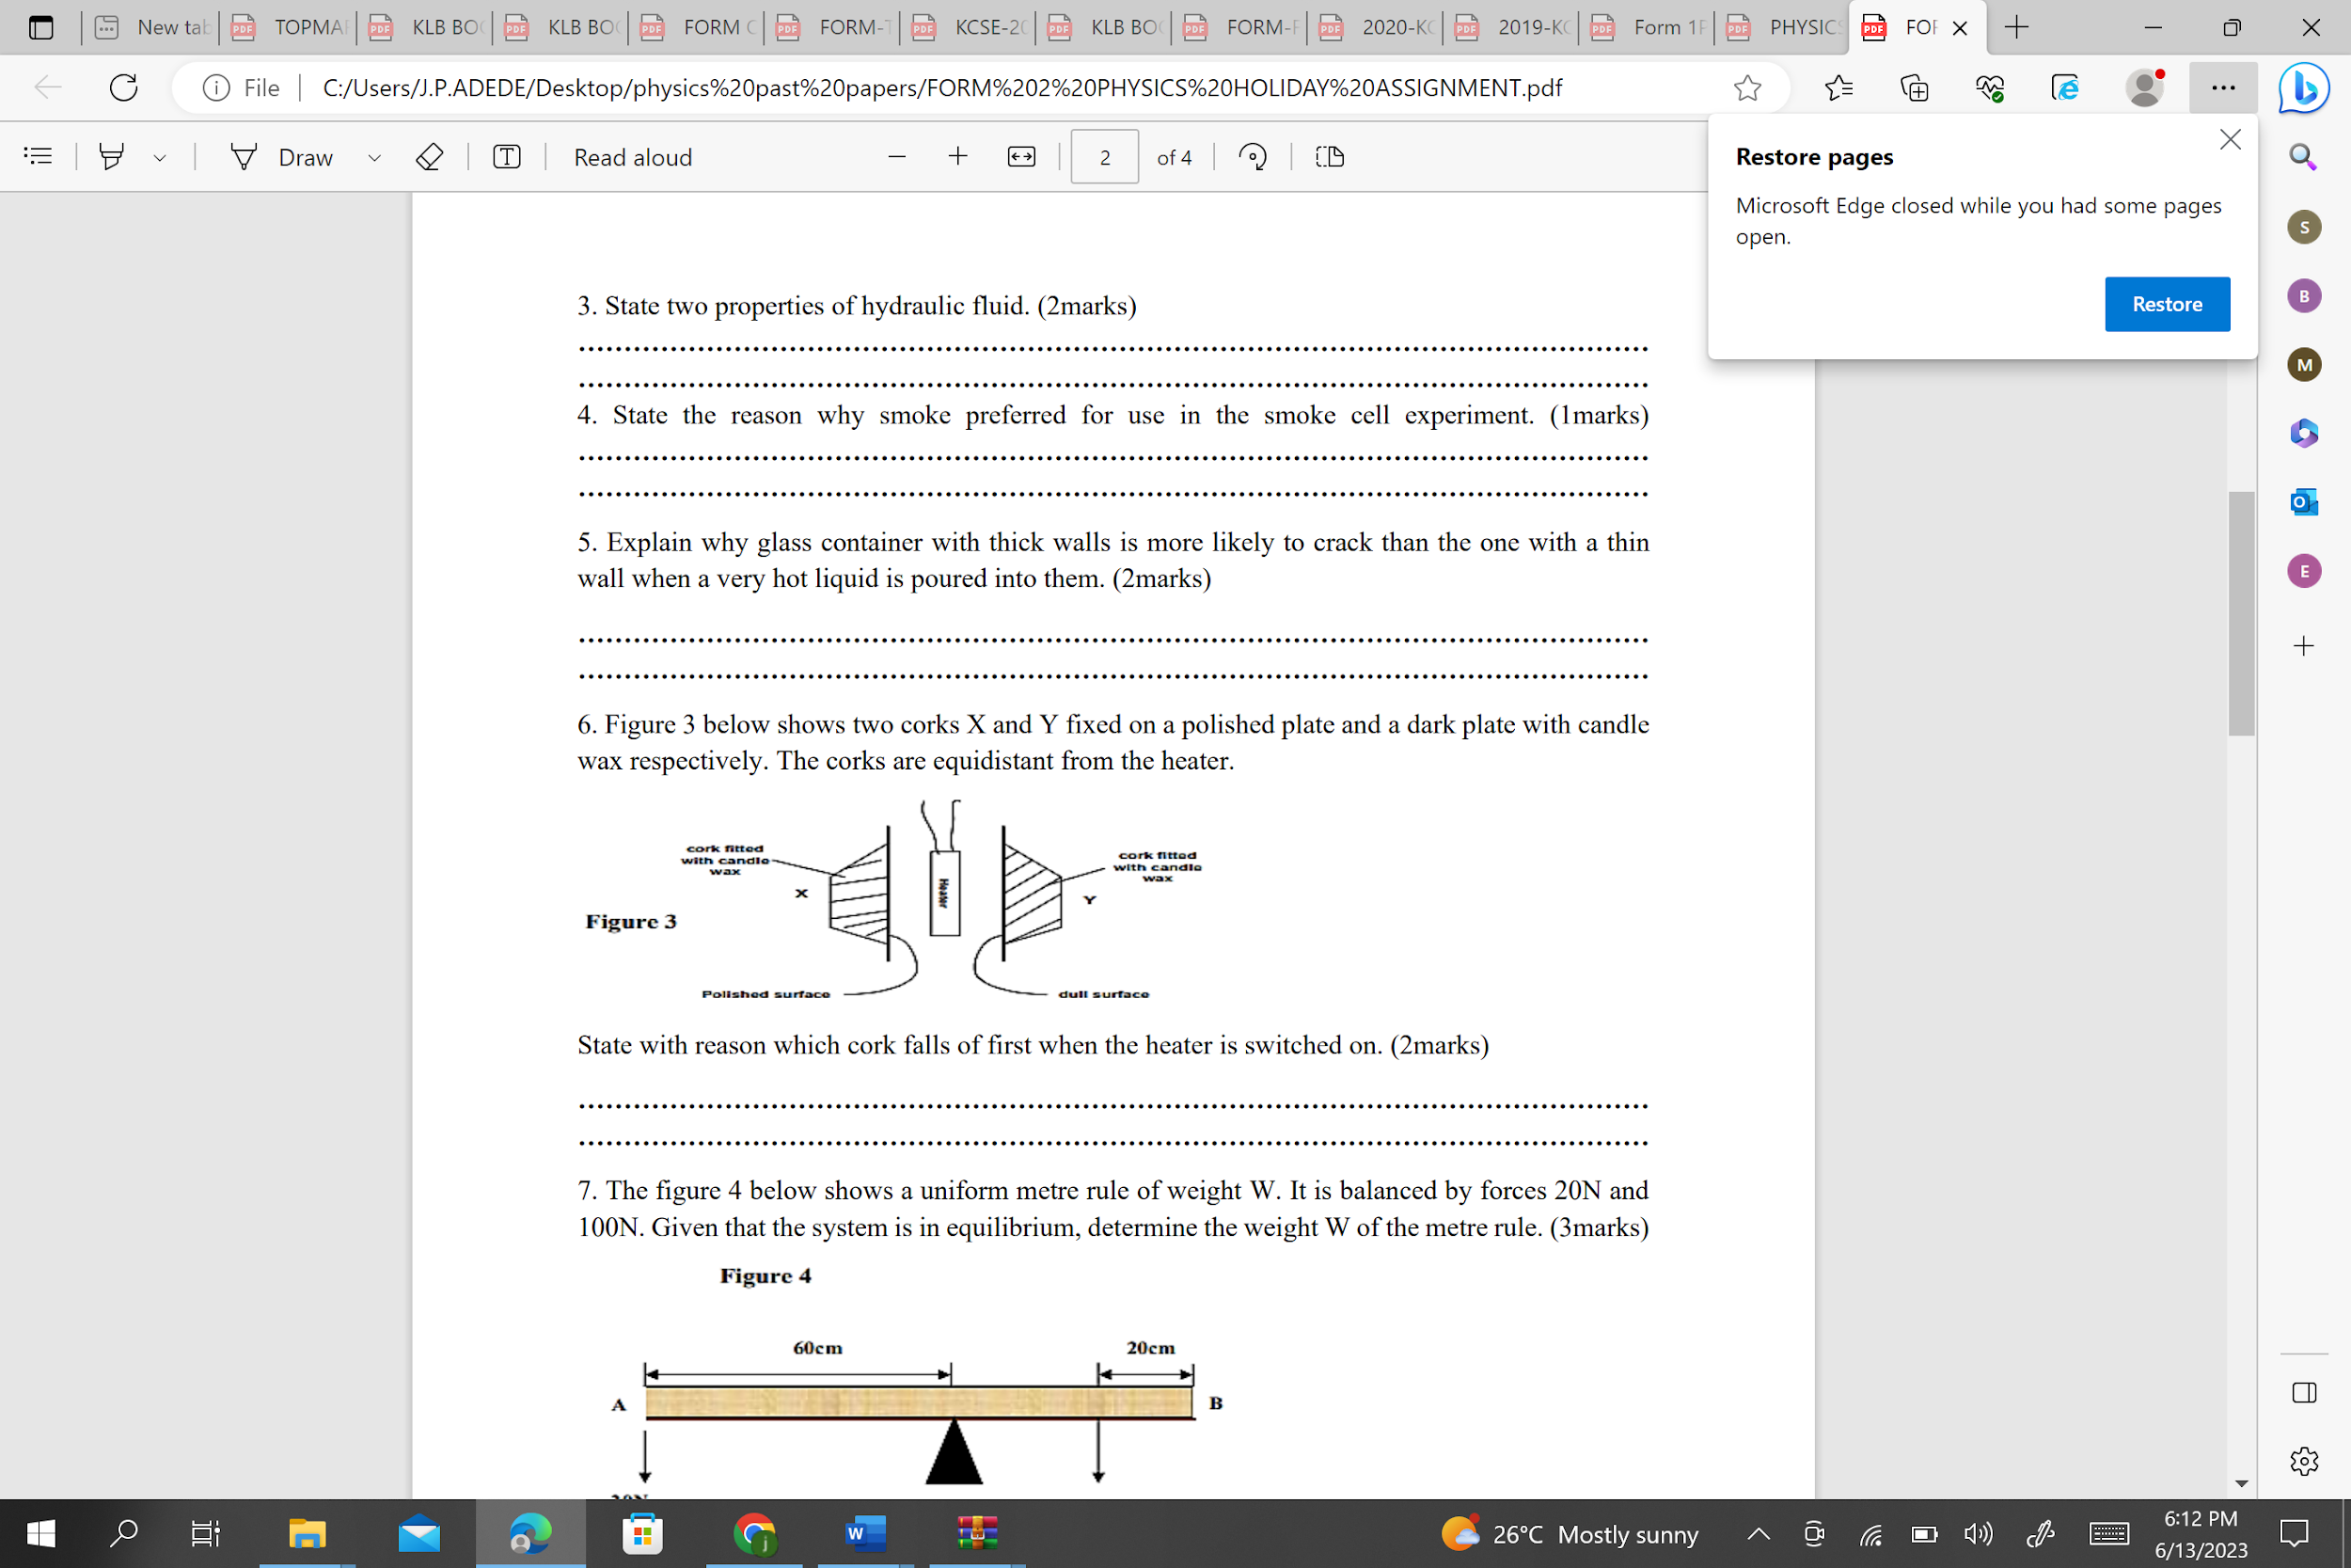
Figure 2
……………………………………………………………………………………………………… ……………………………………………………………………………………………………… 18. Differentiate between cohesive and adhesive forces. (2 marks) ……………………………………………………………………………………………………… ………………………………………………………………………………………………………

19. Explain the cause of random motion of smoke particles as observed in Brownian motion experiment using a smoke cell. (1 mark) ……………………………………………………………………………………………………… ………………………………………………………………………………………………………

20. The Figure 2 shows two identical thermometers. Thermometer A has a blackened bulb while thermometer B has a silvery bulb. A candle is placed equidistant between the two Thermometers. State with a reason the observations made after sometime. (2 marks)

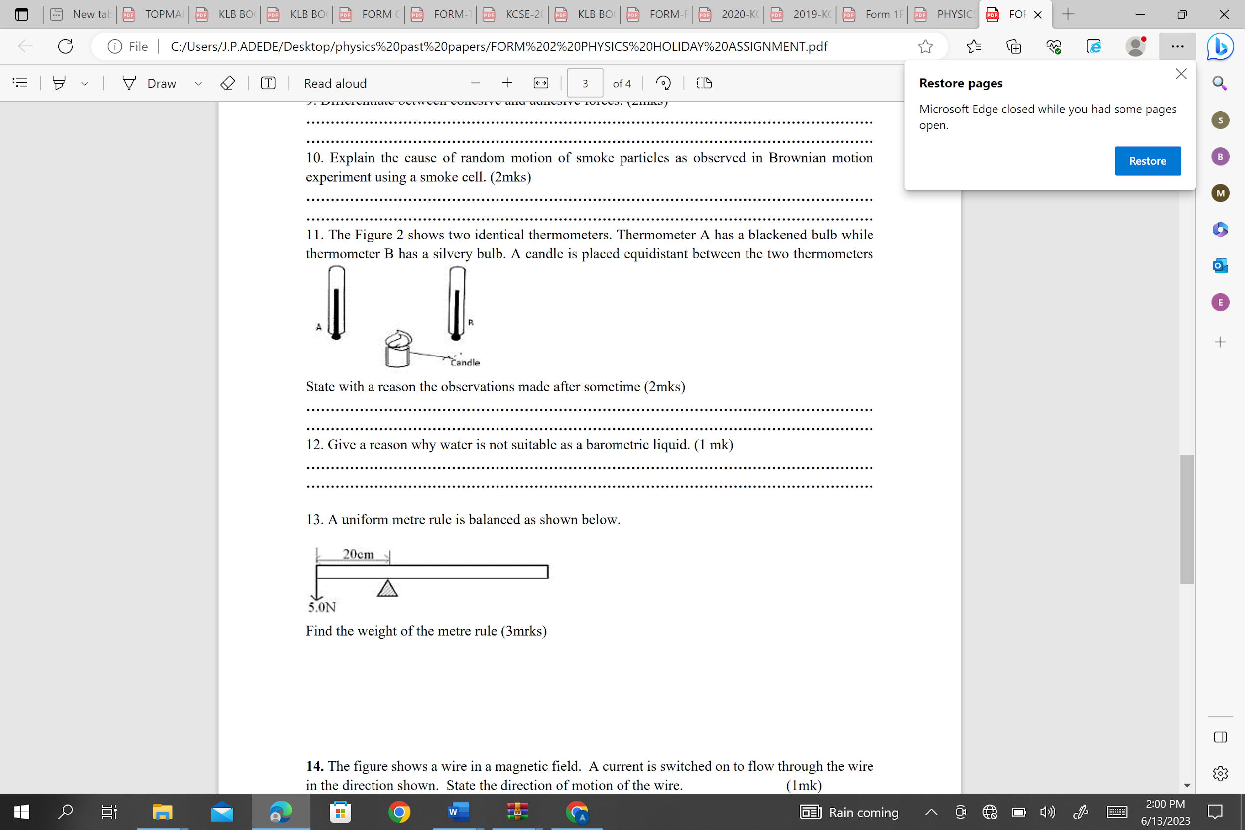
Figure 3
……………………………………………………………………………………………………… ………………………………………………………………………………………………………
21. Give a reason why water is not suitable as a barometric liquid. (1 mark) ……………………………………………………………………………………………………… ………………………………………………………………………………………………………

22. The height of mercury column in a barometer is found to be 76cm at a certain place. What would be the height on a water barometer in the same place? (Density of water is 1000kg/m3 and density of mercury is$13600\frac{kg}{m^{3}}$. (3 Marks)

……………………………………………………………………………………………… ……………………………………………………………………………………………….
……………………………………………………………………………………………… ………………………………………………………………………………………………
……………………………………………………………………………………………… ………………………………………………………………………………………………

23. State the reason why thermal conductivity of a metal increases with the increase in the cross-section area of the conductor? (1 mark)
……………………………………………………………………………………………………. ……………………………………………………………………………………………………. ……………………………………………………………………………………………………..
24. The set up in figure 4 below shows water being heated at the top.

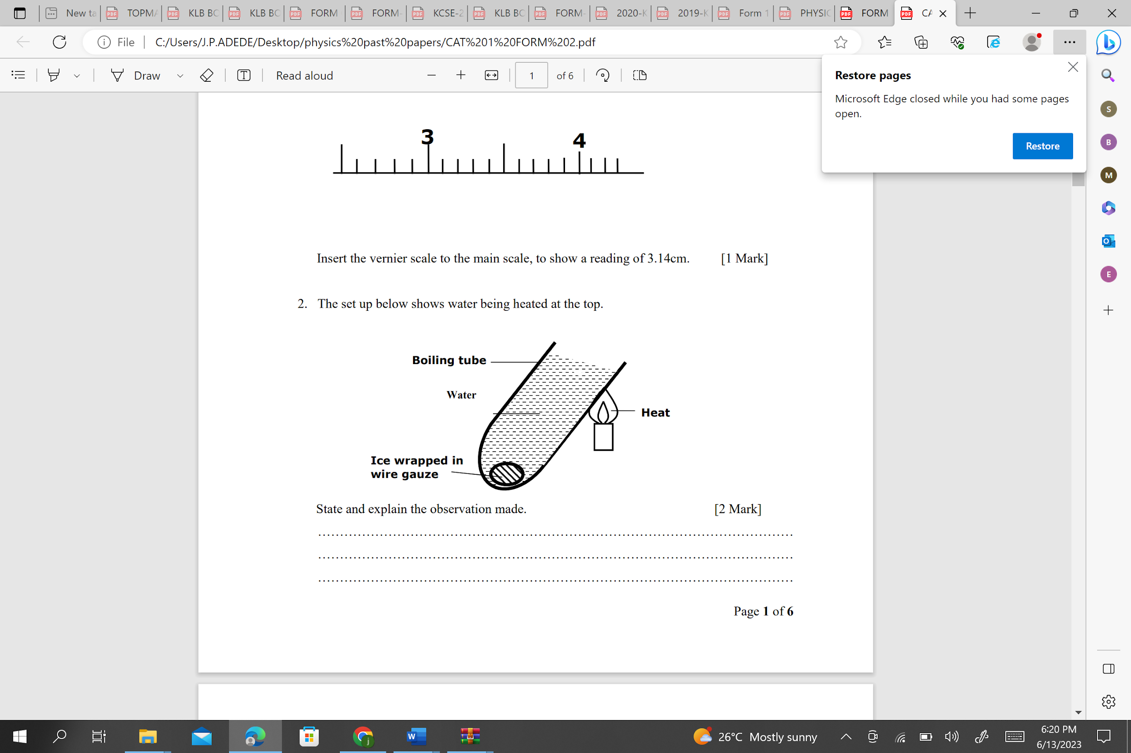
Figure 4
State and explain the observation made. (2 Marks) …………………………………………………………………………………………………. …………………………………………………………………………………………………. ………………………………………………………………………………………………..
25. The set-up shown in the figure 5 below is used to investigate the rate of diffusion of two gases. B and C are cotton wools soaked in hydrochloric acid and ammonia solution respectively.

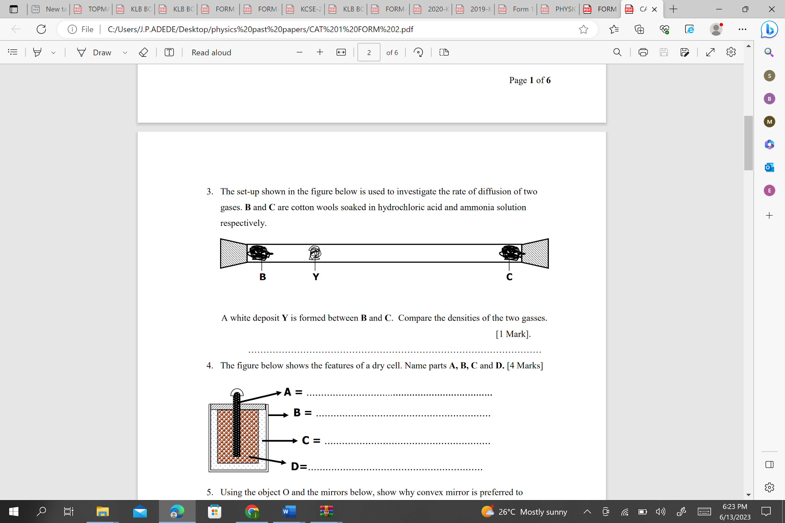
Figure 5
A white deposit Y is formed between B and C. Compare the densities of the two gasses (1 Mark)
……………………………………………………………………………………………..
………………………………………………………………………………………………

26. Figure 6 below shows a force pump. Briefly describe the working of the pump. (3 Marks)
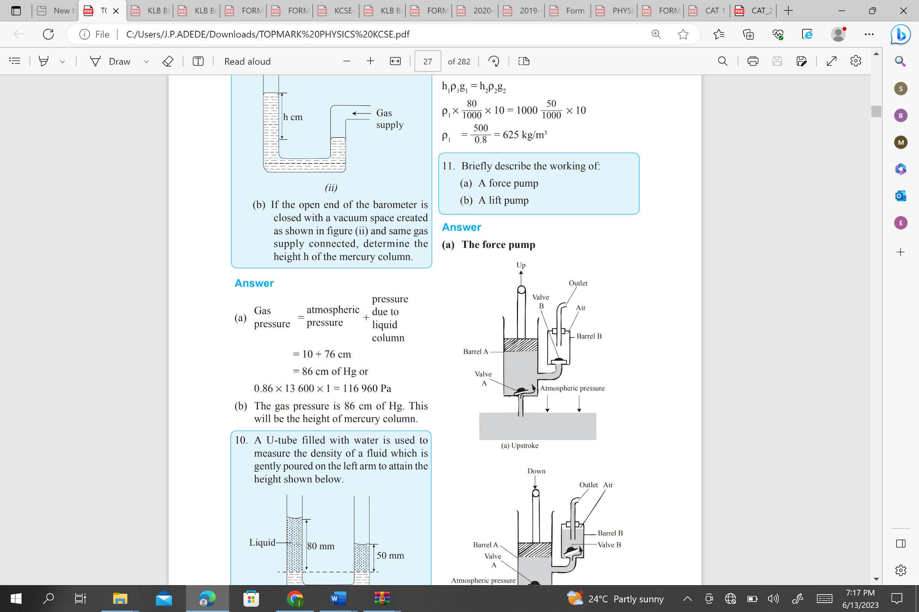
Figure 6
……………………………………………………………………………………………… ……………………………………………………………………………………………… ………………………………………………………………………………………………

#END#

