TERM 2 - 2023
PHYSICS THEORY – PAPER 2 (232/2)
FORM THREE (3)
Time - 2 Hours
Name …………………………………………….……… Admission Number …………….
Candidate’s Signature ………………….…...……….. Class ……………………………
Instructions to Candidates
- Write your name, admission number, class and signature in the spaces provided at the top of the page. This paper consists of two sections; A and B.
- Answer ALL the questions in the spaces provided.
- Mathematical tables and electronic calculator may be used.
- All working MUST be clearly shown.
- This paper consists of 15 printed pages.
- Candidates should answer the questions in English and check to ensure that no question(s) is missing.
FOR EXAMINER’S USE ONLY

SECTION | QUESTIONS | MAXIMUM SCORE | CANDIDATE’S SCORE
A | 1 – 12 | 25
B | 13 | 11
B | 14 | 15
B | 15 | 11
B | 16 | 8
B | 17 | 10
TOTAL SCORE |  | 80

This paper consists of 13 printed pages. Candidates should check and ascertain that all questions are printed as indicated and that no questions are missing. TURN OVER

SECTION A: 25 MARKS
- Give one difference between luminous and non-luminous sources of light. (1 mark)
....................................................................................................................................................................................................................................................................................................................................................................................................................................................................................
- When a negatively charged rod is brought near the cap of a leaf electroscope, the leaf rises. Explain this observation. (2 marks)
................................................................................................................................................................................................................................................................................................................................................................................................................................................................................................................................................................................................................................................
- Figure 1 represents a displacement-time graph for a wave.
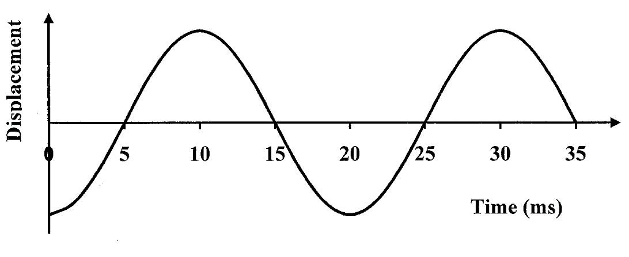
Figure 1
Determine the frequency of the wave. (3 marks)
................................................................................................................................................................................................................................................................................................................................................................................................................................................................................................................................................................................................................................................

- State the conditions necessary for a wave incident on a slit to be diffracted. (2 marks)
………………………………………………………………………………………………………………………………………………………………………………………………………………………………………………………………………………………………………………………………………………………………………………………………
- Figure 2 shows the magnetic field pattern round a current-carrying conductor. Indicate on the conductor the direction of the current. (1 mark)

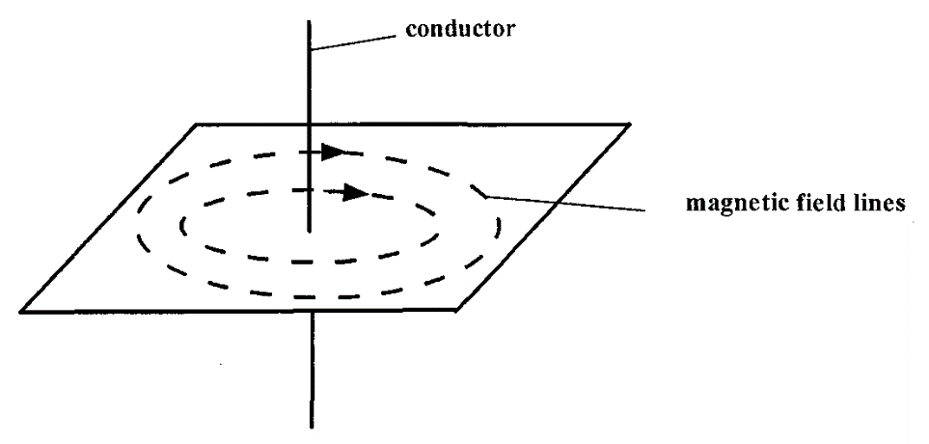
Figure 2

- In an experiment to determine the focal length of a concave mirror, magnification M was determined for various image distances v. Figure 3 shows a graph of magnification M against image distance v for the results from the experiment.
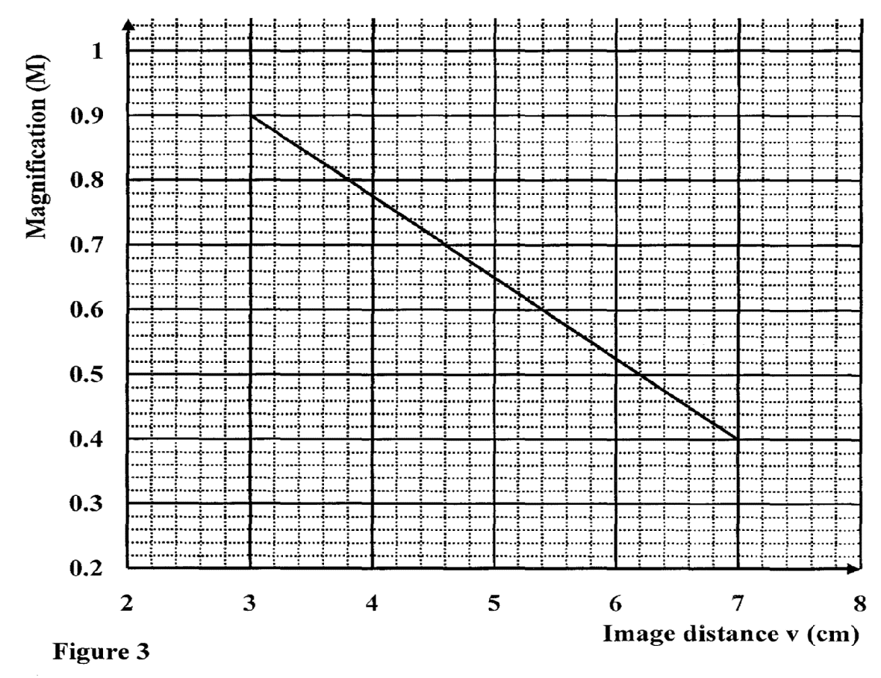
Figure 3
Given that M = 1 -, determine the focal length f of the mirror. (3 marks)
................................................................................................................................................................................................................................................................................................................................................................................................................................................................................................................................................................................................................................................

- Why is repulsion the sure test for a magnet? (1 mark)
............................................................................................................................................................................................................................................................................................................

- A positively charged material was brought close to an insulated metallic ball as shown in
Fig 4. State and explain the distribution of charge in the ball (2 marks)

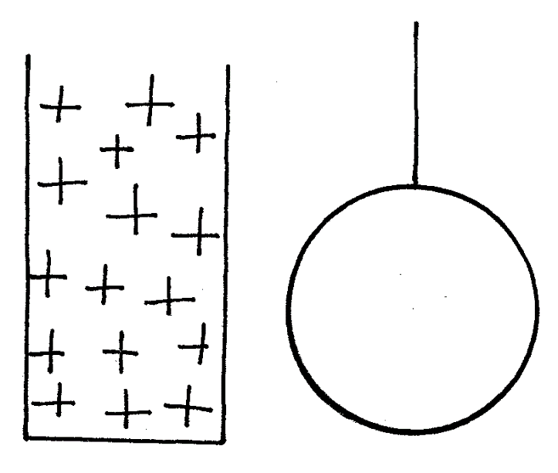
Figure 4

………………………………………………………………………………………………………
………………………………………………………………………………………………………
………………………………………………………………………………………………………
………………………………………………………………………………………………………

- Figure 5 shows a ray of light incident on an air bubble which is inside water,

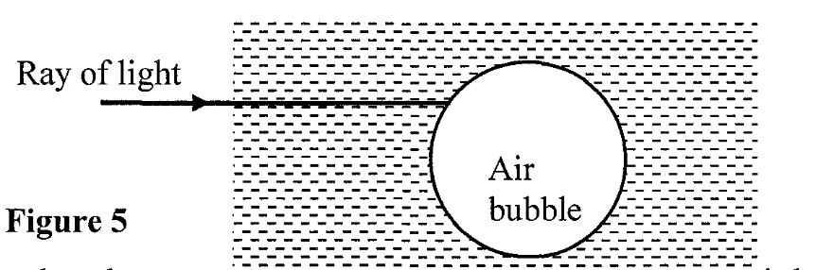
Figure 5
Complete the ray to show the path it follows through the air bubble. (1 mark)

- Explain how polarization of a cell increases the cell’s internal resistance. (2 marks)
………………........................................................................................................................................................................................................................................................................................................................................................................................................................................................................................................................................................................................................................

- Explain why sound cannot be heard from far when one shouts in a forest (1 mark)
………………………………………………………………………………………………………
………………………………………………………………………………………………………

- A cell of internal resistance O.5 is in a circuit containing a 10 resistor. A current
of 2A flows in the circuit. Determine the emf of the cell. (3 marks)
................................................................................................................................................................................................................................................................................................................................................................................................................................................................................................................................................................................................................................................
- A glass of thickness 14 cm is placed on a mark drawn on a plain paper. The mark is viewed is normally through the glass. Calculate the apparent depth of the mark and hence the vertical displacement (Refractive index of glass = 3/2) (3 marks)

………………………………………………………………………………………………………………………………………………………………………………………………………………………………………………………………………………………………………………………………………………………………………………………………………………………………

SECTION B. (55 MARKS)
Answer all questions in this section
- (a) State the laws of refraction. (2 marks)

………………………………………………………………………………………………………………………………………………………………………………………………………………………………………………………………………………………………………………………………………………………………………………………………………………………………
(b) Give two advantages of totally internally reflecting prisms over plane mirrors. (2 marks)
………………………………………………………………………………………………………
………………………………………………………………………………………………………
(c) A ray of light is incident on a kerosene water interface as shown in figure 6 below.

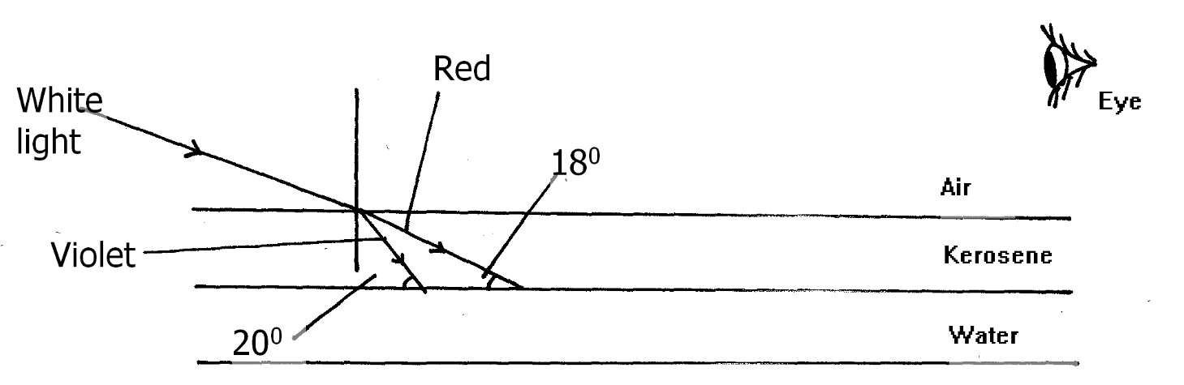
Figure 6
Given that the refractive index of water and kerosene are 1.33 and 1.44 respectively,
Determine
(i) The refractive index for the kerosene – water interface (3 marks)
………………………………………………………………………………………………………
………………………………………………………………………………………………………
………………………………………………………………………………………………………
………………………………………………………………………………………………………
………………………………………………………………………………………………………
………………………………………………………………………………………………………
(ii) determine and show on the figure the path of the rays of light between the
Kerosene-water surface (3marks)
………………………………………………………………………………………………………
………………………………………………………………………………………………………
………………………………………………………………………………………………………
………………………………………………………………………………………………………
………………………………………………………………………………………………………
………………………………………………………………………………………………………
(iii) Why does the colors of the light separate at the kerosene layer? (1mark)
………………………………………………………………………………………………………
………………………………………………………………………………………………………
- State and explain the observation that the eye above the two surfaces would see. (2 marks)
………………………………………………………………………………………………………
………………………………………………………………………………………………………
………………………………………………………………………………………………………
……………………………………………………………………………………………………… 15. (a) State Ohm’s law (1 mark)
………………………………………………………………………………………………………
………………………………………………………………………………………………………
(b) State two factors that affect the resistance of a metallic conductor. (1 mark) (1mark) ………………………………………………………………………………………………………………………………………………………………………………………………………………

(c) Use the circuit in figure 7 below to answer the questions that follow (i) Calculate the total resistance in the circuit. (3 marks)
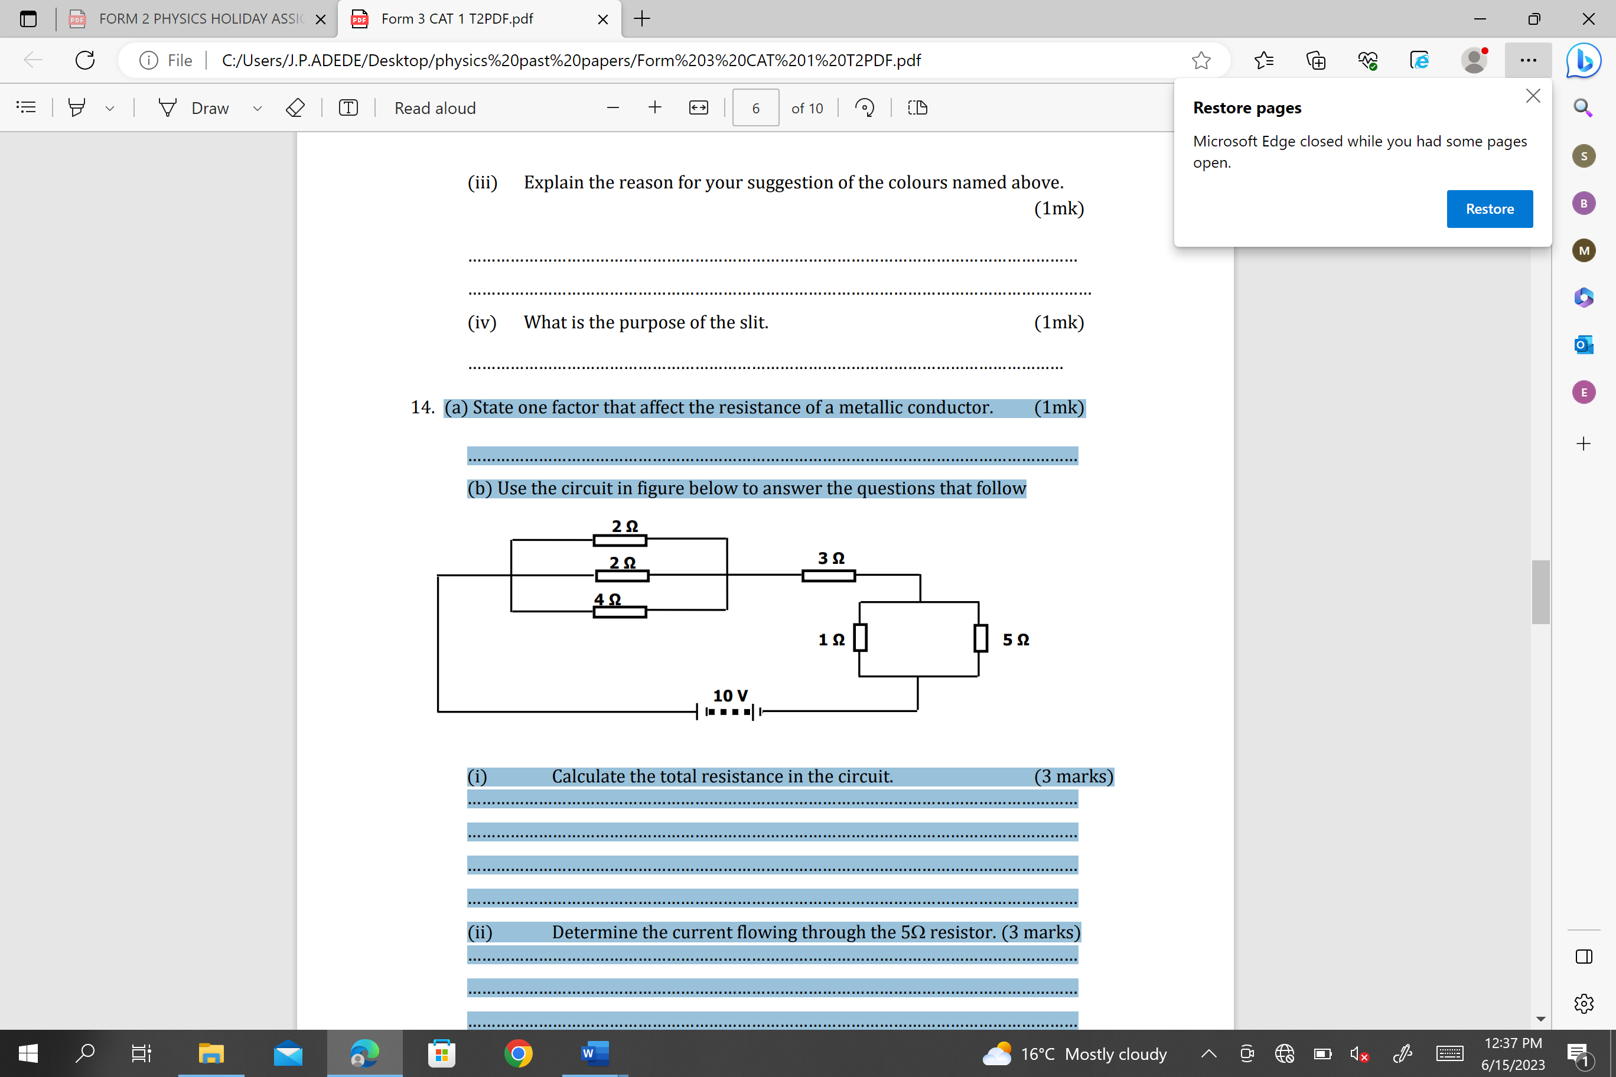
Figure 7
………………………………………………………………………………………………………………………………………………………………………………………………………………………………………………………………………………………………………………………………………………………………………………………………………………………………

(ii) Determine the current flowing through the 5Ω resistor. (3 marks) ………………………………………………………………………………………………………………………………………………………………………………………………………………………………………………………………………………………………………………………(d) The figure 8 below shows a simple cell.

Bulb
C
B

A
Figure 8

- Name the electrolyte A………………………………….. (1 mark)

- When the switch is closed the current flows in the direction shown making the bulb to glow for a while. Name the metals B and C (2 marks)

B…………………………………….

C…………………………………….

- How can the bulb be made to light again for a longer period. (1 mark)

………………………………………………………………………………………………………………………………………………………………………………………………………………………………………………………………………………….

- (a) Define capacitance of a capacitor (1 mark)
................................................................................................................................................................................................................................................................................................................................................................................................................................................
(b) The figure 9 below shows a charged electroscope two aluminium plates A and B arranged a shown
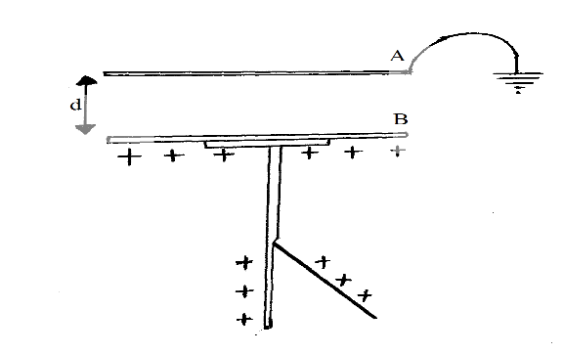
Figure 9
State and explain the observations made when:
(i) d is reduced (2 marks)
...............................................................................................................................................................................................................................................................................................................................................................................................................................................

(ii) The plate A is more horizontally (2 marks)
..............................................................................................................................................................................................................................................................................................................................................................................................................................................
(iii) A sheet of polythene is placed between A and B (2 marks)
...............................................................................................................................................................................................................................................................................................................................................................................................................................................

(c) The figure 10 below shows an arrangement of three capacitors of 4 µF, 6 µF, and 8 µF connected to a 12.0 V d.c power supply.

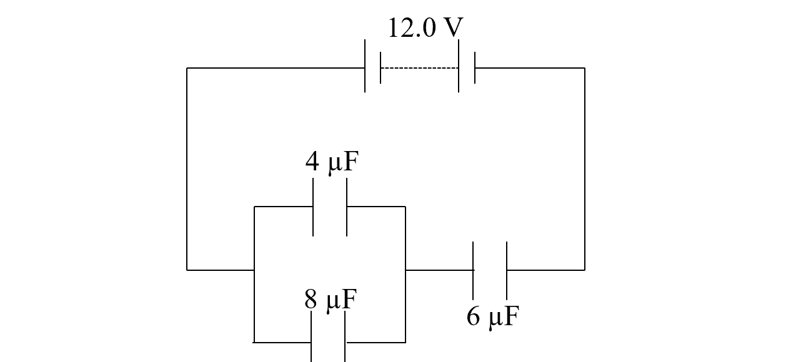
Figure 10
(i) Calculate the effective capacitance of the arrangement. (3 marks)

………………………………………………………………………………………………………………………………………………………………………………………………………………………………………………………………………………………………………………………
(ii) Calculate the charge on the 8 µF capacitor. (3 marks)

……………………………………………………………………………………………………………………………………………………………………………………………………………………………………………………………………………………………………………………………….……………………………………………………………………………………………

- In an experiment to study interference in sound waves, two identical loudspeakers are connected to an audio frequency generator so that they act as coherent sources S1 and S2 as shown in the figure 11 below
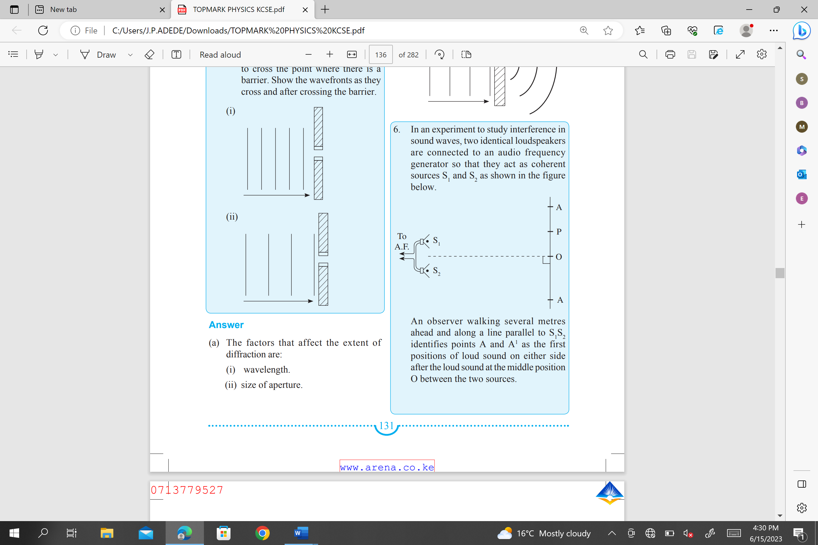
Figure 11
An observer walking several meters ahead and along a line parallel to S1 S2 identifies points A and A1 as the first positions of loud sound on either side after the loud sound at the middle position O between the two sources
- What is meant by the term coherent sources? (1 mark)
………………………………………………………………………………………………………………………………………………………………………………………………………………………………………………………………………………………………………………………

- Name the type of interference occurring at points O, A andA1. (1 mark)
………………………………………………………………………………………………………………………………………………………………………………………………………………

- What name is given to the interference that occurs at point P exactly midway between O and A? (1 mark)
………………………………………………………………………………………………………………………………………………………………………………………………………………
- What is an echo? (1 mark)
………………………………………………………………………………………………………………………………………………………………………………………………………………

(e) A person standing 110 m from the foot of a cliff claps his hands and hears a sound 0.75 seconds later. Find the speed of sound in air. (3 marks)
………………………………………………………………………………………………………………………………………………………………………………………………………………………………………………………………………………………………………………………………………………………………………………………………………………………………

- (a) State Fleming’s left-hand rule. (1mark)
………………………………………………………………………………………………………………………………………………………………………………………………………………………………………………………………………………………………………………………………………………………………………………………………………………………………
- The figure 12 below shows a coil PQRS lying between two unlike magnetic pole of pieces A and B of an electric motor.
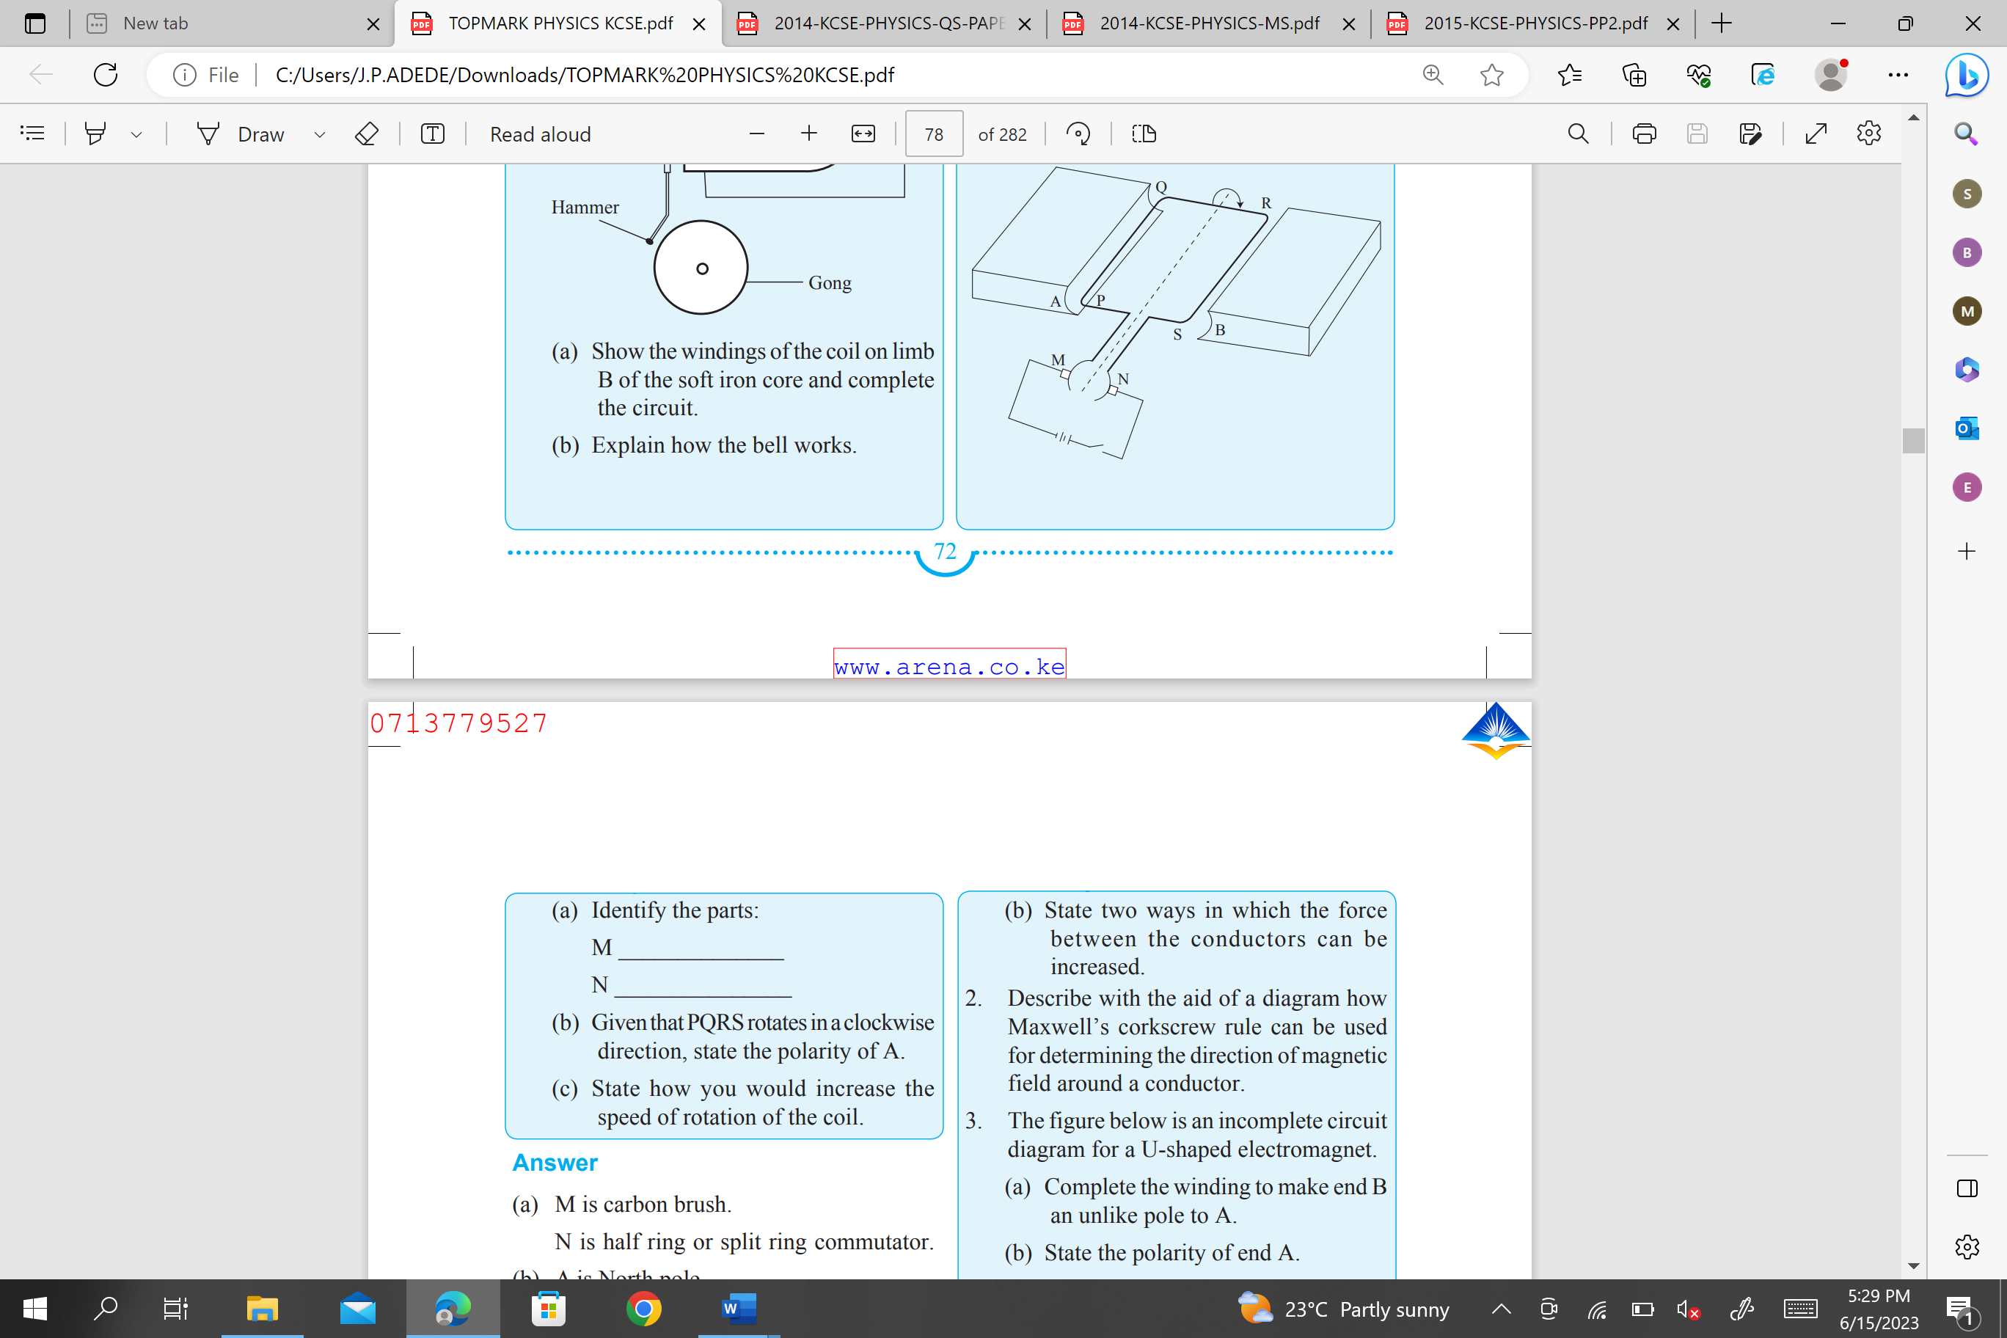
Figure 12

- Identify the parts: ( 2 marks)
M. ………………………………………………………………………………………………………………………………………………………………………………………………………………
N.
………………………………………………………………………………………………………………………………………………………………………………………………………………
- Given that PQRS rotates in a clockwise direction, state the polarity of A. (1 mark)
………………………………………………………………………………………………………………………………………………………………………………………………………………
- State three ways how you would increase the speed of rotation of the coil. (3 marks)
………………………………………………………………………………………………………………………………………………………………………………………………………………
………………………………………………………………………………………………………………………………………………………………………………………………………………
………………………………………………………………………………………………………………………………………………………………………………………………………………

- (i) Distinguish between soft and hard magnetic materials. (1 mark)
………………………………………………………………………………………………………………………………………………………………………………………………………………………………………………………………………………………………………………………………………………………………………………………………………………………………

(ii) Which of the two types of materials is suitable for use as:
• Compass needle? (1 mark)
………………………………………………………………………………………………………………………………………………………………………………………………………………

• Core of an electromagnet? (1 mark)
………………………………………………………………………………………………………………………………………………………………………………………………………………

END

