NAME:…………………………………………………………………………………...…………
SCHOOL:…………………………………………………………………………………………..
A.D.M NO:……………………………………….. DATE:………………………………………
SIGNATURE:……………………………………

312/1
GEOGRAPHY
END TERM 2- 2014
PAPER 1

EDUCATOR EXAM SERIES
FORM THREE
GEOGRAPHY P1

Answer All Questions
1. The diagram below shows the structure of the earth. use it to answer (a)
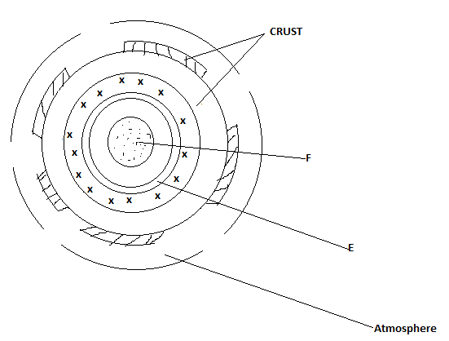
(a) Name the parts marked E and F (2mks)
(b) State three characteristics of the atmosphere (3mks)
2 (a) Identify two forms of rock metamorphism (2mks)
(b) State the exclusive equivalent of the following intrusive igneous rocks
(i) Granite (1mk)
(ii) Diorite (1mk)
(iii) Gabbro (1mk)
3 (a) What is a seismic wave? (2mks)
(b) State three ways in which earth quakes affect human activities. (3mks)
4. (a) Differentiate between illuviation and salinization. (2mks)
(b) State three importance of water as a soil property. (3mks)
5 (a) Identify two types of deltas. (2mks)
(b) State three conditions ideal for the formation of a delta (3mks)
6. Study the data in the following table and answer questions (a) and (b). Kenyas leading imports by value (Ksh Million)
Crop/year | Wheat | Maize | Rice | Coca
2006 | 5400 | 4700 | 2000 | 700
2007 | 7200 | 3800 | 2600 | 420
2008 | 6400 | 1400 | 1900 | 580
2009 | 6800 | 4600 | 2400 | 800
(a) Calculate the percentage increase in expenditure on importation of wheat in the year 2006 and 2007 (2mks)
(b) (i) Draw a compound bar graph to represent the Kenya’s leading import crops by value between 2006 and 2009 (8mks)
(ii) State two advantages of using compound bar graphs to represent data (2mks)
(c) State four reasons why Kenya imports maize, wheat and rice and she still produces them? (4mks)
c)(i) State physical conditions favouring wheat growing in Kenya (3mks)
(ii) Explain three reasons why Canada produces more wheat than Kenya (
7 Differentiate between fissure and vent eruption (2mks)
(b) Describe how the following features are formed
(i) Batholiths (6mks)
(ii) Volcanic plug (5mks)

(c) Explain three negative effects of volcanicity on human activities (6mks)
(d) You are planning to carry out a field study on features formed by volcanicity on the landscape
(i) Formulate two null hypotheses for the study (2mks)
(ii) Name two drainage features you are likely to study (2mks)
(iii) State two methods you would use to record information during the study. (2mks)
8. (i) What is reverse fault? (2mks)
(ii) The diagram bellow represents an area affected by faulting Name the parts marked E,F and G (3mks)
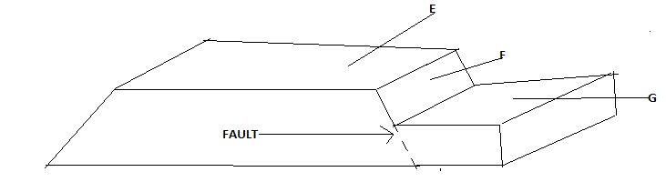
b Describe the processes involved in the formation of the following features
(i) Fault steps (5mks)
(ii) Rift valley by anticlinal arching
c Explain four ways in which block mountains influence climate
9. Name two mountains in East Africa where congelifraction is common (2mks)
(b) Describe the following types of weathering
(i) Pressure release (5mks)
(ii) Hydration (4mks)
(iii) Oxidation (4mks)
(c) Explain three ways in which plants cause weatherings (6mks)
(d) What is an avalanche? (1mk)
(ii) State three effects of avalanche (3mks)

MARKING SCHEME
1. (a) E – Gutenberg discontinuity
F – Inner core
(b) - It is the life supporting layer
- Temperatures decrease with increase in height /latitude/environmental lapse rate/ normal lapse rate occurs
- Pressure falls/decrease with increase in height
- Effect of gravity decrease with increase in height
- The speed of winds increase with increase in height.
2. (a) - Thermal metamorphism
- Dymanic metamorphism
- Thermo – dynamic metamorphism/region

3. (a) - They are shock waves that originate from the seismic focus and travel
outwards causing ground to tremble and shake
(b) - Disturbances on the crystal rocks cause landslides which crush and burry
people and property
- Can cause tsunamis if it occurs on ocean beds causing a rise in sea level
hence death to people property and cause death to people
- May trigger fires that may burn the environment
- Can cause permanent displacement of the land hence tearing roads bridges,
railways and pipelines a part

4. (a) -illuviation is the process by which dissolved minerals from horizon A are
removed, precipitated, and redeposited in horizon B while salinization is the process by which dissolved salts are move by capillary action from lower horizon to the surface of the soil and precipitate out as crystals as evaporation occurs.

(b). – contains dissolved minerals needed by plants
-is essential for photosynthesis
- supports soil organic life
-excess soil water results int water logging.
5(a) -arcuate delta
-birds foot delta
-estuarine delta.
(b)- the river must carry a large load to be deposited
The rivers speed should reduce on entering the sea
-the rivers curse should be free of filters that can reduce the amount of sediments reaching the mouth.
-the sediments should be deposited faster than they are removed by sea currents and waves

6(a) 7200-5400x100
5400 =180000 =33.3%
5400

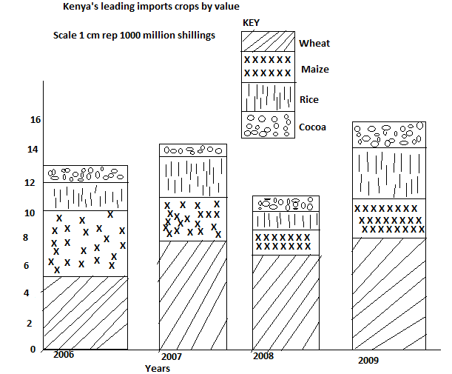

Kenya shillings (“000” millions)

(b)(ii).- provides clear visual impression of the total value
-it is easy to interpret
Used for comparison purposes

(c) - crop failure due to frequent droughts leads to shortages
-Kenya is not self sufficient in production of these crops
-Low production due to increasing costs of farm input
-Occasional illegal exports and smuggling which lead to artificial shortages.
-Pests and diseases reduce amount of grain to be harvested

(c)(i) - cool to warm temperature conditions(11-20⁰c)
-Low rainfall
-sunny and dry conditions for harvesting
- Presence of light clay and heavy loam soils
-gentle slopping landscape
(ii). – There are more extensive tracts of land for wheat farming in Canada while in Kenya farms are relatively small
-Large and many machines are used in Canada while in Kenya a few machines are shared among farmers.
- In Canada farmers specialize in wheat farming while in Kenya farmers practice mixed farming.
-Farmers in Canada are more experienced due to long history of wheat farming while in Kenya the technology of wheat farming is not advancing fast
-More capital in Canada enable farmers sustain large scale production while in Kenya there is inadequate capital.
7(a) Fissure eruption is the process where magma reaches the surface of the earth through cracks while vent eruption is the process by which magma reaches earth’s surface through a pipe or hole

(b) (i) Batholiths
- Large mass of thick/viscous magma under high pressure moves in the earth’s
crust covering an extensive area
- The magma cools and solidifies
- A big dome – shaped mass of igneous rock extending to great depth is formed
- This is s batholiths

(ii) Volcanic – plug
- Volcanic eruption through a vent leads to the formation of a volcano
- Magma cools and solidifies in the vent forming a volcanic rock
- Over time, the soft upper part of the volcano is worn away by agents of erosion.
- The volcanic rock in the centre is left standing and is called volcanic plug

(c)- Some volcanic features eg craters form barriers hindering transport and communication
- Volcanic eruption emits poisonous gases eg sulphur which is poisonous
- Volcanic lava damage property eg houses
- Leewards slopes of volcanic mounts are dry hence discourage agriculture
- Recent lava flow form immature soils unsuitable for farming
- Volcanic eruption in ocean bed may causetsunamis which kill people and destroy property

(d)(i)- The volcanic mountains in the area are not active
- Human settlement in the area is not influenced by the rugged nature of the landscape (accept any correct)

(ii)- Crater/caldera lake
- Hot springs
- Gayser

(iii)- Photographing
- Taking notes
- Sketching diagrams
- Tapping
- Labelling samples

8 (i)- is a fracture/crack on the earths crust formed by compressional forces

(ii)- E – Upthrow
F – Faultscarp/escarpment
G – Downthrow

(b) (i)- Rocks of the earth’s crust are subjected to tensional/ compressional forces
- A series of faults form of the crust
- Blocks of land between faults subside at different levels
- The subsided blocks form a series of benches on the landscape
- The benches form faultsteps

(ii)- Compressional forces act on crustal rocks
- Crust is forced to bend upwards
- Alarge anticline is formed
- Continued compression create tension on the crust of anticline
- Several faults form on the anticline
- The side blocks are forced to upthrust
- Middle block left in leading to formation of rift valley.

(c) - Windward sides of block mountains receive relief rainfall leading to wet climate
- Leeward sides receive little rainfall leading to dry climate
- The top of block mountains have cool/cold climate because temperatures decrease
with increase in height
- The top of Block Mountains have lower pressure while lower parts have higher
atmospheric pressure

9 (a) - Mt Kenya
- Mt Kilimanjaro
- Mt Ruwenzori

(b)(i) - Rocks under the earth’s surface are subjected to great pressure due to
overlying material
- Denudation occurs on the earth’s surface
- Pressure is slowly released
- The rock expands fractures and splits in sheet like layers
- This is pressure release.

(ii) - Minerals in rocks absorb water
- The minerals expands
- The expansion causes stress in the rocks
- Eventually the rock disintegrates.
(iii) - Oxygen dissolved in water/existing in air reacts with iron in rocks to form
oxides.
- Brownish/yellowish crust forms on the rocks surface
- The crust then disintegrates making the rock to breakdown

(c) - As plants grow their roots penetrate into rock cracks/ joints causing them
to widen and eventually the rocks disintegrates
- Plants absorb minerals from rocks weakening the rocks hence causing
disintegration
- When plants rot on rocks, they release acids which react with minerals in
the rocks leading rock disintegration.

(d)(i) - Is a large mass of snow/ice mixed with rocks falling from a steep
mountain slope to the valley bottom

(ii) - May cause loss of human life
- May cause damage to property
- Creates scars on the mountain slopes
- Leads to accumulation of debri at the base of the slope

