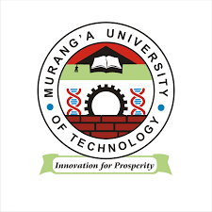
MURANG’A UNIVERSITY OF TECHNOLOGY
MASTER OF EDUCATION IN EDUCATIONAL PSYCHOLOGY

COURSE CODE: PHSY 809

COURSE TITLE: COGNITIVE PROCESSES

YEAR 1 SEMESTER 1

DECEMBER- 2016
SCHOOL-BASED
MAIN CAMPUS
TIME: 3HOURS

Answer Question ONE and any TWO questions
- Discuss the four major approaches to Cognitive psychology (20mks)
- Examine four stages of language development according to Vygosky(20mks)
- Discuss the four stages of cognitive development according to Piaget(20mks)
- Examine any five areas of Application of Cognitive Psychology(20mks)
- Analyse vygotskys four stages of concept formation (20mks)

