JARAMOGI OGINGA ODINGA UNIVERSITY OF SCIENCE AND TECHNOLOGY SCHOOL OF SPATIAL PLANNING
UNIVERSITY EXAMINATION FOR THE DEGREE OF BACHELOR OF SCIENCE IN PUBLIC HEALTH AND BACHELOR OF SCIENCE IN COMMUNITY HEALTH
SEMESTER 2 2016/2017 ACADEMIC YEAR

CENTRE: MAIN AND BUSIA CAMPUS
COURSE CODE: HPD 3311
COURSE TITLE: TECHNICAL DRAWING AND DESIGN
EXAM VENUE: STREAM: HEALTH
DATE: EXAM SESSION:
TIME: 2 HOURS
Instructions:
- Answer question 1 ( compulsory ) and ANY other 2 questions.
- Candidates are advised not to write on the question paper.
- Candidates must hand in their answer booklets to the invigilator while in the examination room.

1a) Explain the meaning of Technical Drawing and Design. (5 marks)
b) Giving examples, discuss the various types of Technical Drawing (9 marks)
- A group of Public Health students were in a discussion on computer aided design when one of them said, "If there is one thing that has changed the design of buildings is the computer." Discus this statement highlighting the impact of computers on production of architectural drawings. (6marks)
- Use your own measurements to draw the following figure on A3 paper (10 marks)

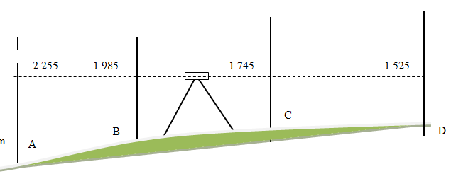

2a) With illustrations, differentiate between isometric projection and oblique projection.
(10 marks)
b) Use technical drawing equipment to illustrate one point and two point perspective projections. (10 marks)
3a) Discuss why Technical Drawing and Design is termed as a creative activity. (4 marks)
b) Discuss the technical considerations a Public Health Officer will use in recommending a building plan for approval (6 marks)
c) Draw to scale a floor plan and front elevation of a VIP latrine. (10 marks)

4a) Discuss the factors that you will consider in recommending a building plan for approval. (10 marks)
b) Measure and draw the following figure to a scale of 1:2. (10 marks)

5) Draw a sketch of the figure below (20 marks)

