Name………………………..………………………………………Index No...............................

Candidate’s Signature………………………... Date………………………..

443/1
AGRICULTURE
Paper 1
Time: 2 Hours

SMARTPASS EXAMINATION
Kenya Certificate of Secondary Education (KCSE)
MODEL ONE 2019

443/1
AGRICULTURE PAPER 1

INSTRUCTIONS TO THE CANDIDATES
- Write your name and index number in the spaces provided above
- Sign and write the date of the examination in the spaces provided above.
- This paper consists of THREE sections A, B and C.
- Answer all the questions in the sections A and B.
- Answer any TWO questions in section C.
- All answers should be written in the spaces provided.
- This paper consist of 15 printed pages.
- Candidates should check the question pare to ascertain that all the pages are printed as indicated and that no questions are missing.
- Candidates should answer the questions in English.

FOR EXAMINERS ONLY
SECTION | QUESTION | MAXIMUM SCORE | CANDIDATE’S SCORE
A | 1-21 | 30
B | 22-26 | 20
C | 27-29 | 40
TOTAL SCORE |  | 90

SECTION: A 30 MARKS
Answer all the questions from this section.
- Give TWO forms of collective land tenure system in Kenya. (1 mark)
…………………………………………………………………………………………………………………………………………………………………………………………………………………………………………………………………………………………………………………………………………………………………………………………………………
- State TWO causes of hard pans in a crop field. (1 mark)
…………………………………………………………………………………………………………………………………………………………………………………………………………………………………………………………………………………………………………………………………………………………………………………………………………
- Define the following the term economic injury level as used in pest management.
(1 mark)
………………………………………………………………………………………………………………………………………………………………………………………………………………………………………………………………………………………………………
- Name the disease which cause a mass of dark spores on flowering parts of maize.
(½ mark)
…………………………………………………………………………………………………
- Give the reasons the following practices are carried out in pastures. (1 mark)
- Top dressing
……………………………………………………………………………………………………………………………………………………………………………………………………
…………………………………………………………………………………………………
- Topping.
……………………………………………………………………………………………………………………………………………………………………………………………………
- Give TWO fresh market varieties of carrots. (1 mark)
…………………………………………………………………………………………………………………………………………………………………………………………………………………………………………………………………………………………………………………………………………………………………………………………………………
- Distinguish between seed dressing seed inoculation. (1 mark)
…………………………………………………………………………………………………………………………………………………………………………………………………………………………………………………………………………………………………………………………………………………………………………………………………………
- a) What is biological weed control? (1 mark)
…………………………………………………………………………………………………………………………………………………………………………………………………………………………………………………………………………………………………………………………………………………………………………………………………………
- TWO advantages of biological weed control. (1 mark)
…………………………………………………………………………………………………………………………………………………………………………………………………………………………………………………………………………………………………………………………………………………………………………………………………………
- State FOUR uses of gross margin analysis in agricultural production. (2 marks)
…………………………………………………………………………………………………………………………………………………………………………………………………………………………………………………………………………………………………………………………………………………………………………………………………………

- State FOUR uses of a green house in a farm. (2 marks)
…………………………………………………………………………………………………………………………………………………………………………………………………………………………………………………………………………………………………………………………………………………………………………………………………………
- Name a crop that will require the following training. (1 mark)
- Propping
…………………………………………………………………………………………………
- Trelishing
…………………………………………………………………………………………………
- State FOUR soil factors that would influence the crop grown by the farmer. (2 marks)
…………………………………………………………………………………………………………………………………………………………………………………………………………………………………………………………………………………………………………………………………………………………………………………………………………
- a) What is elasticity of demand? (1 mark)
…………………………………………………………………………………………………………………………………………………………………………………………………………………………………………………………………………………………………………………………………………………………………………………………………………
b) State FOUR reasons why an agricultural commodity may have its price elastic.
(2 marks)
…………………………………………………………………………………………………………………………………………………………………………………………………………………………………………………………………………………………………………………………………………………………………………………………………………
……………………………………………………………………………………………………………………………………………………………………………………………………
- State TWO factors that favour surface irrigation. (1 mark)
…………………………………………………………………………………………………………………………………………………………………………………………………………………………………………………………………………………………………………………………………………………………………………………………………………
- a. Give FOUR characteristics of a crop that a farmer would use to prepare green manure.
(2 marks)
…………………………………………………………………………………………………………………………………………………………………………………………………………………………………………………………………………………………………………………………………………………………………………………………………………
- Mention any TWO crops that can be used as a green manure crop. (1 mark)
…………………………………………………………………………………………………………………………………………………………………………………………………………………………………………………………………………………………………………………………………………………………………………………………………………
- State TWO problems experienced by failing to carry out cutting back in pyrethrum.
(1 mark)
…………………………………………………………………………………………………………………………………………………………………………………………………………………………………………………………………………………………………………………………………………………………………………………………………………
- Give THREE conditions which make it necessary to use a nursery in a crop establishment. (1½ mark)
…………………………………………………………………………………………………………………………………………………………………………………………………………………………………………………………………………………………………………………………………………………………………………………………………………
……………………………………………………………………………………………………………………………………………………………………………………………………
- Differentiate between a cash book and a ledger. (1 mark)
…………………………………………………………………………………………………………………………………………………………………………………………………………………………………………………………………………………………………………………………………………………………………………………………………………
- State TWO biological methods of weed control. (1 mark)
…………………………………………………………………………………………………………………………………………………………………………………………………………………………………………………………………………………………………………………………………………………………………………………………………………
- State FOUR effects of late defoliation. (2 marks)
……………………………………………………………………………………………………………………………………………………………………………………………………………………………………………………………………………………………………………………………………………………………………………………………………………………………………………………………………………………………………………………………………………………………………………………………………………………………………………………………………………………………………………………………………………………………………………………………………………………
- How does foreign exchange earned from agriculture contribute to economic development? (1 mark)
…………………………………………………………………………………………………………………………………………………………………………………………………………………………………………………………………………………………………………………………………………………………………………………………………………

SECTION B: 20 MARKS
Answer all the questions from this section.
- The diagram below illustrates methods of raising seedlings. Study it and answer the questions that follow.
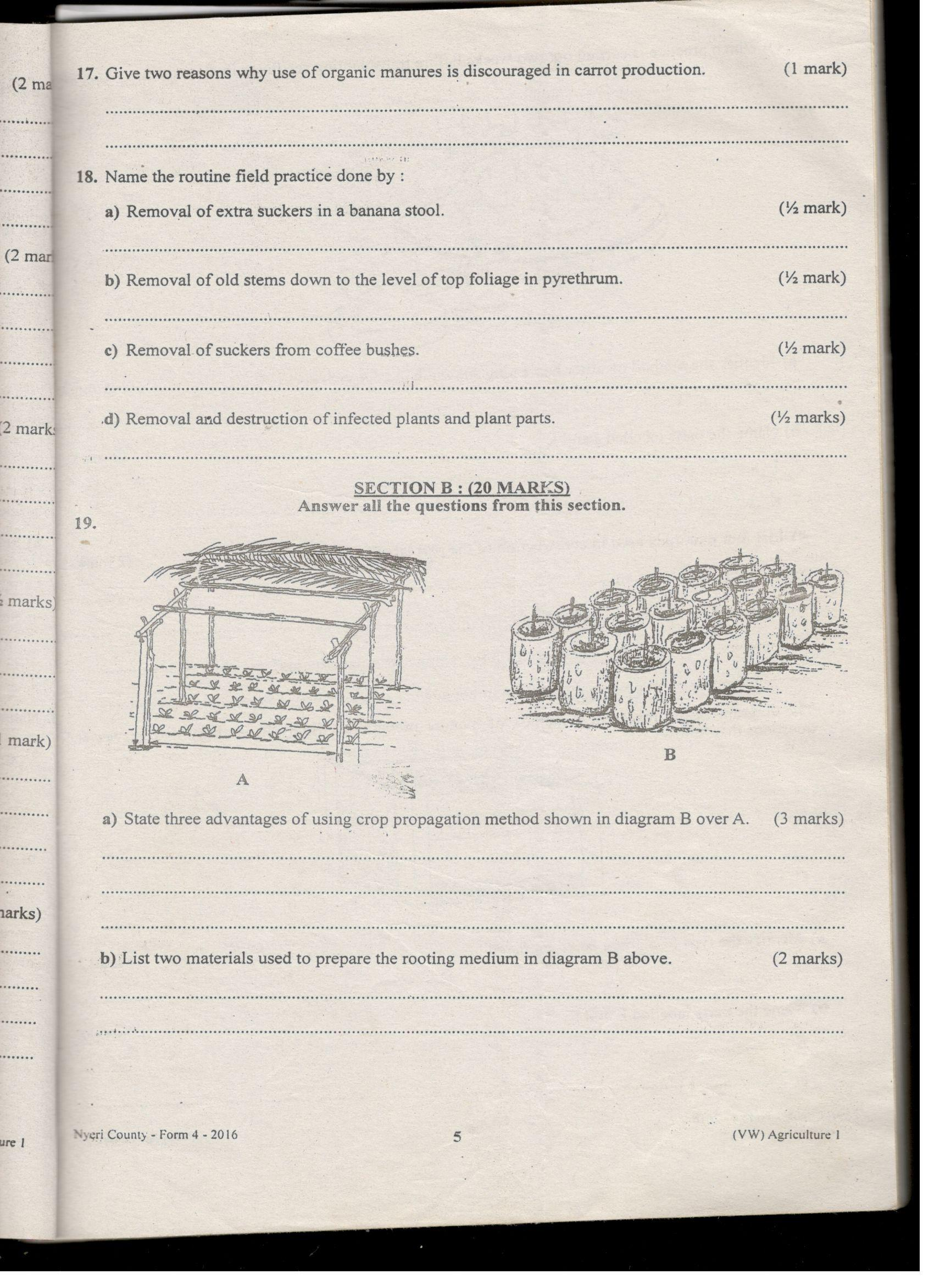
- State THREE advantages of using crop propagation method shown in diagram B and A.
(3 marks)
………………………………………………………………………………………………………………………………………………………………………………………………………………………………………………………………………………………………………………………………………………………………………………………………………………………………………………………………………………………………………………………………………………………………………………………………………………
- List TWO materials used to prepare the rooting medium in diagram B above. (2 marks)
…………………………………………………………………………………………………………………………………………………………………………………………………………………………………………………………………………………………………………………………………………………………………………………………………………

- Which practice is carried out two weeks before transplanting seedlings from diagram A?
(1 mark)
…………………………………………………………………………………………………………………………………………………………………………………………………………………………………………………………………………………………………………………………………………………………………………………………………………
- The diagram below illustrate methods of tree harvesting.
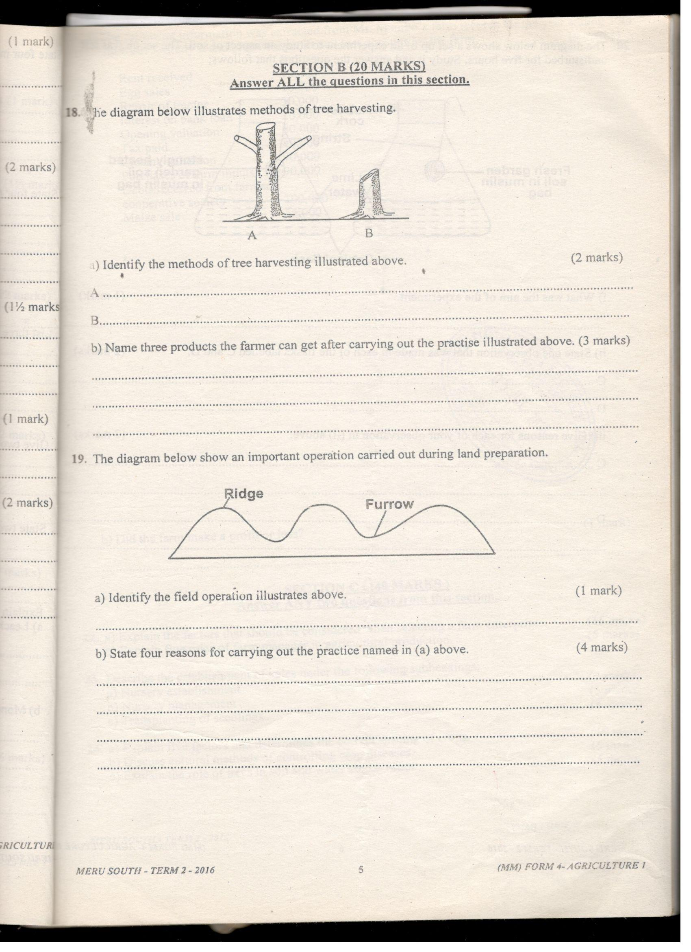
- Identify the methods of trees harvesting illustrated above. (1 mark)
A-
B-
- Name THREE products the farmer can get after carrying out the practice illustrated above. (1½ marks)
………………………………………………………………………………………………………………………………………………………………………………………………………………………………………………………………………………………………………………………………………………………………………………………………………………………………………………………………………………………………………………………………………………………………………………………………………………

- The diagram below shows a weed. Study it then answer questions below it.
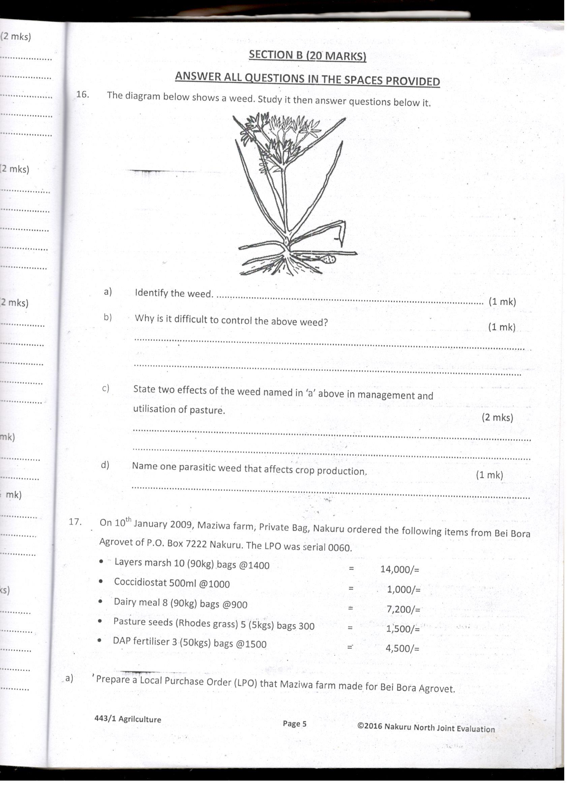
- Identify the weed. (1 mark)
…………………………………………………………………………………………………
- Why is it difficult to control the above weed? (1 mark)
……………………………………………………………………………………………………………………………………………………………………………………………………
- State TWO effect of weed named in (a) above in management and utilization of pasture.
(2 marks)
…………………………………………………………………………………………………………………………………………………………………………………………………………………………………………………………………………………………………………………………………………………………………………………………………………
- Name one parasitic weed that affects cereals. (1 mark)
…………………………………………………………………………………………………
- The method below shows a method used in preparation of compost manure. Study it and answer the questions that follow.
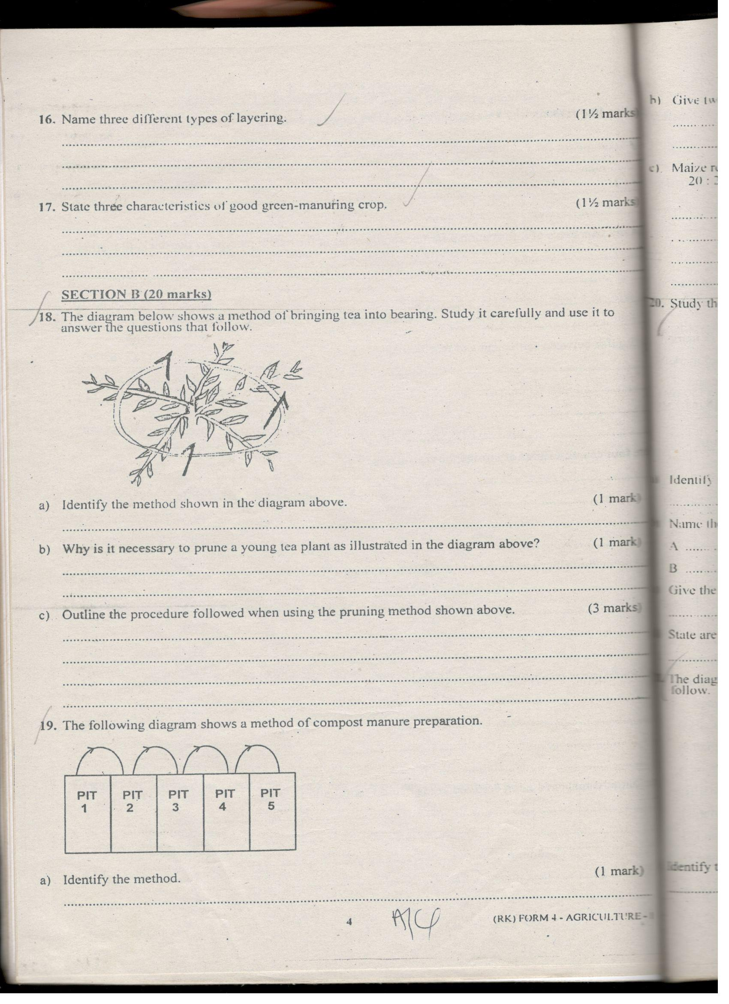
- Name the illustrated method. (1 mark)
…………………………………………………………………………………………………
- Give TWO factors to consider when siting the area to establish the method. (2 marks)
…………………………………………………………………………………………………………………………………………………………………………………………………………………………………………………………………………………………………………………………………………………………………………………………………………
- What do the arrows represent? (1 mark)
……………………………………………………………………………………………………………………………………………………………………………………………………
- a) Identify the condition illustrated below as observed in the field production of tomatoes.
(1 mark)
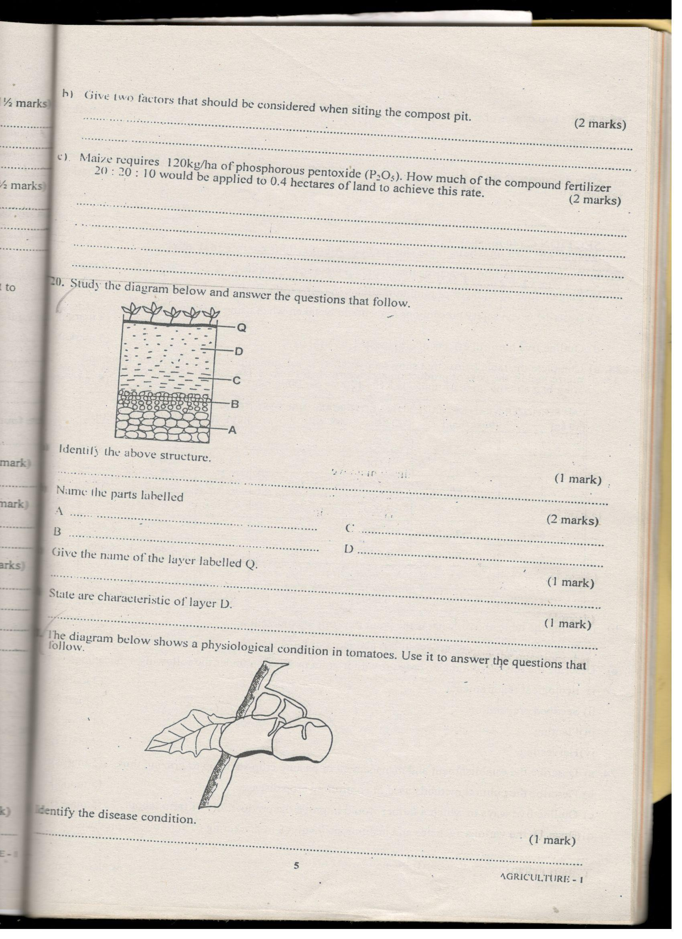
b) State TWO conditions that predisposes a tomato plant to the condition stated in (a) above. (1 mark)
……………………………………………………………………………………………………………………………………………………………………………………………………
c) Suggest TWO ways of controlling bacterial wilt in tomatoes. (1 mark)
…………………………………………………………………………………………………………………………………………………………………………………………………………………………………………………………………………………………………………………………………………………………………………………………………………

SECTION C- 40 MARKS
Answer any TWO questions in this section.
- a) Explain THREE soil properties that are influenced by soil texture. (6 marks)
………………………………………………………………………………………………………………………………………………………………………………………………………………………………………………………………………………………………………………………………………………………………………………………………………………………………………………………………………………………………………………………………………………………………………………………………………………………………………………………………………………………………………………………………………………………………………………………………………………………………………………………………………………………………………………………………………………………………………………………………………………………………………………………………………………………………………………………………………………………………………………………………………………………………
b. Discuss the importance of timely weed control. (5 marks)
………………………………………………………………………………………………………………………………………………………………………………………………………………………………………………………………………………………………………………………………………………………………………………………………………………………………………………………………………………………………………………………………………………………………………………………………………………………………………………………………………………………………………………………………………………………………………………………………………………………………………………………………………………………………………………………………………………………………………………………………………………………………………………………………………………………………………………………………………………………………………………………………………………………………

- Explain water management in a flooded rice field. (9 marks)
………………………………………………………………………………………………………………………………………………………………………………………………………………………………………………………………………………………………………………………………………………………………………………………………………………………………………………………………………………………………………………………………………………………………………………………………………………………………………………………………………………………………………………………………………………………………………………………………………………………………………………………………………………………………………………………………………………………………………………………………………………………………………………………………………………………………………………………………………………………………………………………………………………………………………………………………………………………………………………………………………………………………………………………………………………………………………………………………………………………………………………………………………………………………………………………………………………………………………………………………………………………………………………………………………………………………………………………………………………………………………………………………………………………………………………………………………………………………………………………………………………………………………………………………………………………………………………………………………………………………………………………………………………………………………………………………………………………………………………………………………………………………………………………………………………………………………………………………………………………………………………………………………………………………………………………………………………………………………………………………………………………………………………………………………………………………………………………………………………………………………………………………………………………………………………………………………………………………………………………………………………………………………………………………………………
- a) Explain SIX roles of a farm manager in agricultural production. (6 marks)
……………………………………………………………………………………………………………………………………………………………………………………………………………………………………………………………………………………………………………………………………………………………………………………………………………………………………………………………………………………………………………………………………………………………………………………………………………………………………………………………………………………………………………………………………………………………………………………………………………………………………………………………………………………………………………………………………………………………………………………………………………………………………………………………………………………………………………………………………………………………………………………………………………………………………………………………………………………………………………………………………………………………………………………………………………………………………………………………………………………………………………………………………………………………………………………………………………………………………………………………………………………………………………………………………………
b) Explain that factors that are considered when selecting a farm enterprise. (14 marks)
…………………………………………………………………………………………………………………………………………………………………………………………………………………………………………………………………………………………………………………………………………………………………………………………………………………………………………………………………………………………………………………………………………………………………………………………………………………………………………………………………………………………………………………………………………………………………………………………………………………………………………………………………………………………………………………………………………………………………………………………………………………………………………………………………………………………………………………………………………………………………………………………………………………………………………………………………………………………………………………………………………………………………………………………………………………………………………………………………………………………………………………………………………………………………………………………………………………………………………………………………………………………………………………………………………………………………………………………………………………………………………………………………………………………………………………………………………………………………………………………………………………………………………………………………………………………………………………………………………………………………………………………………………………………………………………………………………………………………………………………………………………………………………………………………………………………………………………………………………………………………………………………………………………………………………………………………………………………………………………………………………………………………………………………………………………………………………………………………………………………………………………………………………
29.a) Discuss establishment and management of grass pasture crop stand up to grazing.
(12 marks)
………………………………………………………………………………………………………………………………………………………………………………………………………………………………………………………………………………………………………………………………………………………………………………………………………………………………………………………………………………………………………………………………………………………………………………………………………………………………………………………………………………………………………………………………………………………………………………………………………………………………………………………………………………………………………………………………………………………………………………………………………………………………………………………………………………………………………………………………………………………………………………………………………………………………………………………………………………………………………………………………………………………………………………………………………………………………………………………………………………………………………………………………………………………………………………………………………………………………………………………………………………………………………………………………………………………………………………………………………………………………………………………………………………………………………………………………………………………………………………………………………………………………………………………………………………………………………………………………………………………………………………………………………………………………………………………………………………………………………………………………………………………………………………………………………………………………………………………………
b. Mention and discuss FOUR agencies involved in marketing agricultural produce.
(8 marks)
………………………………………………………………………………………………………………………………………………………………………………………………………………………………………………………………………………………………………………………………………………………………………………………………………………………………………………………………………………………………………………………………………………………………………………………………………………………………………………………………………………………………………………………………………………………………………………………………………………………………………………………………………………………………………………………………………………………………………………………………………………………………………………………………………………………………………………………………………………………………………………………………………………………………………………………………………………………………………………………………………………………………………………………………………………………………………………………………………………………………………………………………………………………………………………………………………………………………………………………………………………………………………………………………………………………………………………………………………………………………………………

