Name………………………..………………………………………Index No...............................

Candidate’s Signature………………………... Date………………………..

443/2
AGRICULTURE
Paper 2
Time: 2 Hours

SMARTPASS EXAMINATION
Kenya Certificate of Secondary Education (KCSE)
MODEL ONE 2019

443/2
AGRICULTURE PAPER 2

INSTRUCTIONS TO THE CANDIDATES
- Write your name and index number in the spaces provided above
- Sign and write the date of the examination in the spaces provided above.
- This paper consists of THREE sections A, B and C.
- Answer all the questions in the sections A and B.
- Answer any TWO questions in section C.
- All answers should be written in the spaces provided.
- This paper consist of 13 printed pages.
- Candidates should check the question pare to ascertain that all the pages are printed as indicated and that no questions are missing.
- Candidates should answer the questions in English.

FOR EXAMINERS ONLY
SECTION | QUESTION | MAXIMUM SCORE | CANDIDATE’S SCORE
A | 1-19 | 30
B | 20-24 | 20
C | 25-27 | 40
TOTAL SCORE |  | 90

SECTIONA 30: MARKS
Answer all the questions in this section.
- State the complementary tool equipment. (1 mark)
Canula-
…………………………………………………………………………………………………
Cold chisel
…………………………………………………………………………………………………
- State FOUR advantages of using corrugated iron sheets for roofing instead of asbestos.
(2 marks)
……………………………………………………………………………………………………………………………………………………………………………………………………………………………………………………………………………………………………………………………………………………………………………………………………………………………………………………………………………………………………………………………………………………………………………………………………………………………………………………………………………………………………………………………………………………………………………………………………………………
- State FOUR practices through a farmer would ensure that no engine knock out occurs in a tractor. (2 marks)
……………………………………………………………………………………………………………………………………………………………………………………………………………………………………………………………………………………………………………………………………………………………………………………………………………………………………………………………………………………………………………………………………………………………………………………………………………………………………………………………………………………………………………………………………………………………………………………………………………………

- Name the vectors for each of the following livestock diseases. (1½ marks)
  - East Coast Fever
…………………………………………………………………………………………………
  - Typanasomiasis
…………………………………………………………………………………………………
  - Nairobi sheep disease
…………………………………………………………………………………………………
- List TWO implements that can be connected to the power take off shaft (PTO). (1 mark)
……………………………………………………………………………………………………………………………………………………………………………………………………
- State the function of the following parts found in a tractor. (2 marks)
- Carburetor
……………………………………………………………………………………………………………………………………………………………………………………………………
- Spark plug
……………………………………………………………………………………………………………………………………………………………………………………………………
- a. Name two livestock diseases controlled by the same vaccine. (1 mark)
……………………………………………………………………………………………………………………………………………………………………………………………………
b. Mention the name of the vaccine. (½ mark)
…………………………………………………………………………………………………
- State the roles of the following hormones in the milk production. (2 marks)
…………………………………………………………………………………………………………………………………………………………………………………………………………………………………………………………………………………………………………………………………………………………………………………………………………

- Give FOUR reason for dim light in a deep litter house in poultry production. (2 marks)
……………………………………………………………………………………………………………………………………………………………………………………………………………………………………………………………………………………………………………………………………………………………………………………………………………………………………………………………………………………………………………………………………………………………………………………………………………………………………………………………………………………………………………………………………………………………………………………………………………………
- Give THREE problems associated with lambing. (1 mark)
………………………………………………………………………………………………………………………………………………………………………………………………………………………………………………………………………………………………………………………………………………………………………………………………………………………………………………………………………………………………………………………………………………………………………………………………………………
- Give TWO feeding characteristics of goats which make them less vulnerable to internal parasites. (1 mark)
…………………………………………………………………………………………………………………………………………………………………………………………………………………………………………………………………………………………………………………………………………………………………………………………………………
- a. Name the camel breed that can be used better as a quick means of transport in Kenya.
(½ mark)
…………………………………………………………………………………………………
b. Give a reason for your answer in (a) above. (½ mark)
……………………………………………………………………………………………………………………………………………………………………………………………………

- Give TWO qualities of creep feed. (1 mark)
…………………………………………………………………………………………………………………………………………………………………………………………………………………………………………………………………………………………………………………………………………………………………………………………………………
- State FOUR advantages of using stones as construction materials over timber. (2 marks)
……………………………………………………………………………………………………………………………………………………………………………………………………………………………………………………………………………………………………………………………………………………………………………………………………………………………………………………………………………………………………………………………………………………………………………………………………………………………………………………………………………………………………………………………………………………………………………………………………………………
- Give FOUR situations that necessitate the handling of livestock. (2 marks)
……………………………………………………………………………………………………………………………………………………………………………………………………………………………………………………………………………………………………………………………………………………………………………………………………………………………………………………………………………………………………………………………………………………………………………………………………………………………………………………………………………………………………………………………………………………………………………………………………………………
- Name TWO diseases that affect female animals only. (1 mark)
…………………………………………………………………………………………………………………………………………………………………………………………………………………………………………………………………………………………………………………………………………………………………………………………………………
- State FOUR reasons why daily maintenance of a tractor in necessary. (2 marks)
……………………………………………………………………………………………………………………………………………………………………………………………………………………………………………………………………………………………………………………………………………………………………………………………………………………………………………………………………………………………………………………………………………………………………………………………………………………………………………………………………………………………………………………………………………………………………………………………………………………
- State the functions of the following parts of a combined harvester. (2 marks)
  - Reel
……………………………………………………………………………………………………………………………………………………………………………………………………
  - Auger
……………………………………………………………………………………………………………………………………………………………………………………………………
  - Front beater
……………………………………………………………………………………………………………………………………………………………………………………………………
  - Threshing drum
……………………………………………………………………………………………………………………………………………………………………………………………………
- Name FOUR nutritional diseases. (2 marks)
………………………………………………………………………………………………………………………………………………………………………………………………………………………………………………………………………………………………………………………………………………………………………………………………………………………………………………………………………………………………………………………………………………………………………………………………………………………………………………………………………………………………
SECTION B 20 MARKS
Answer all the questions in this section in the spaces provided.
- Study the illustration below of a hard floor foundation of a farm structure.
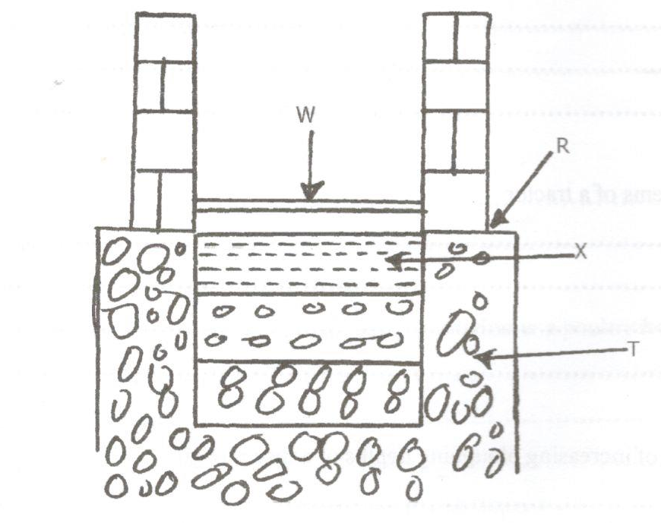
  - Name the parts labelled. (2 marks)
R……………………………………………………………………………………

T……………………………………………………………………………………

X……………………………………………………………………………………

W……………………………………………………………………………………
  - State TWO advantages of concrete floors. (2 marks)
…………………………………………………………………………………………………………………………………………………………………………………………………………………………………………………………………………………………………………………………………………………………………………………………………………

- Study the illustration of power transmission system of a tractor and answer the questions that follow.
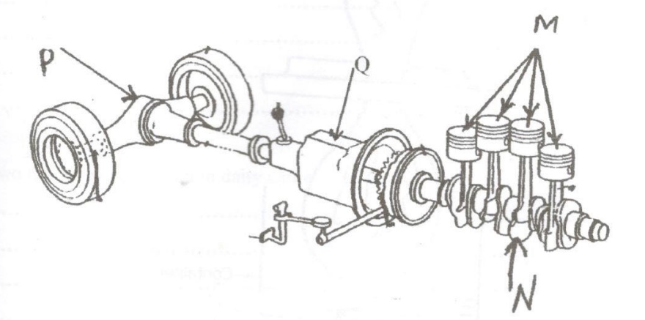
  - Identify and name the parts labelled. (1½ marks)
M……………………………………………………………………………………

N……………………………………………………………………………………

P……………………………………………………………………………………
b) State THREE functions of part labelled Q (1½ marks)
………………………………………………………………………………………………………………………………………………………………………………………………………………………………………………………………………………………………………………………………………………………………………………………………………………………………………………………………………………………………………………………………………………………………………………………………………………
- Use the diagram given below to answer the questions that follow.
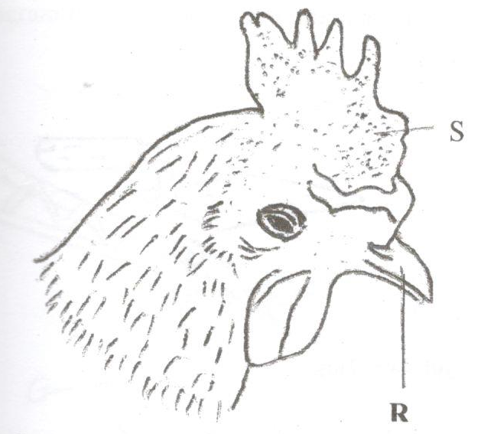
- i. Name the routine practice carried out on the part labeled R. (1 mark)
…………………………………………………………………………………………………
ii. Give TWO reasons for carrying out the practice named in (a) (i) above. (2 marks)
…………………………………………………………………………………………………………………………………………………………………………………………………………………………………………………………………………………………………………………………………………………………………………………………………………
b.i. Name one disease that affect the part labelled S. (1 mark)
…………………………………………………………………………………………………
ii. State TWO control measure of the disease named in ( b i) above. (2 marks)
…………………………………………………………………………………………………………………………………………………………………………………………………………………………………………………………………………………………………………………………………………………………………………………………………………
- Assume you have a piece of sawn timber with dimensions as shown below.
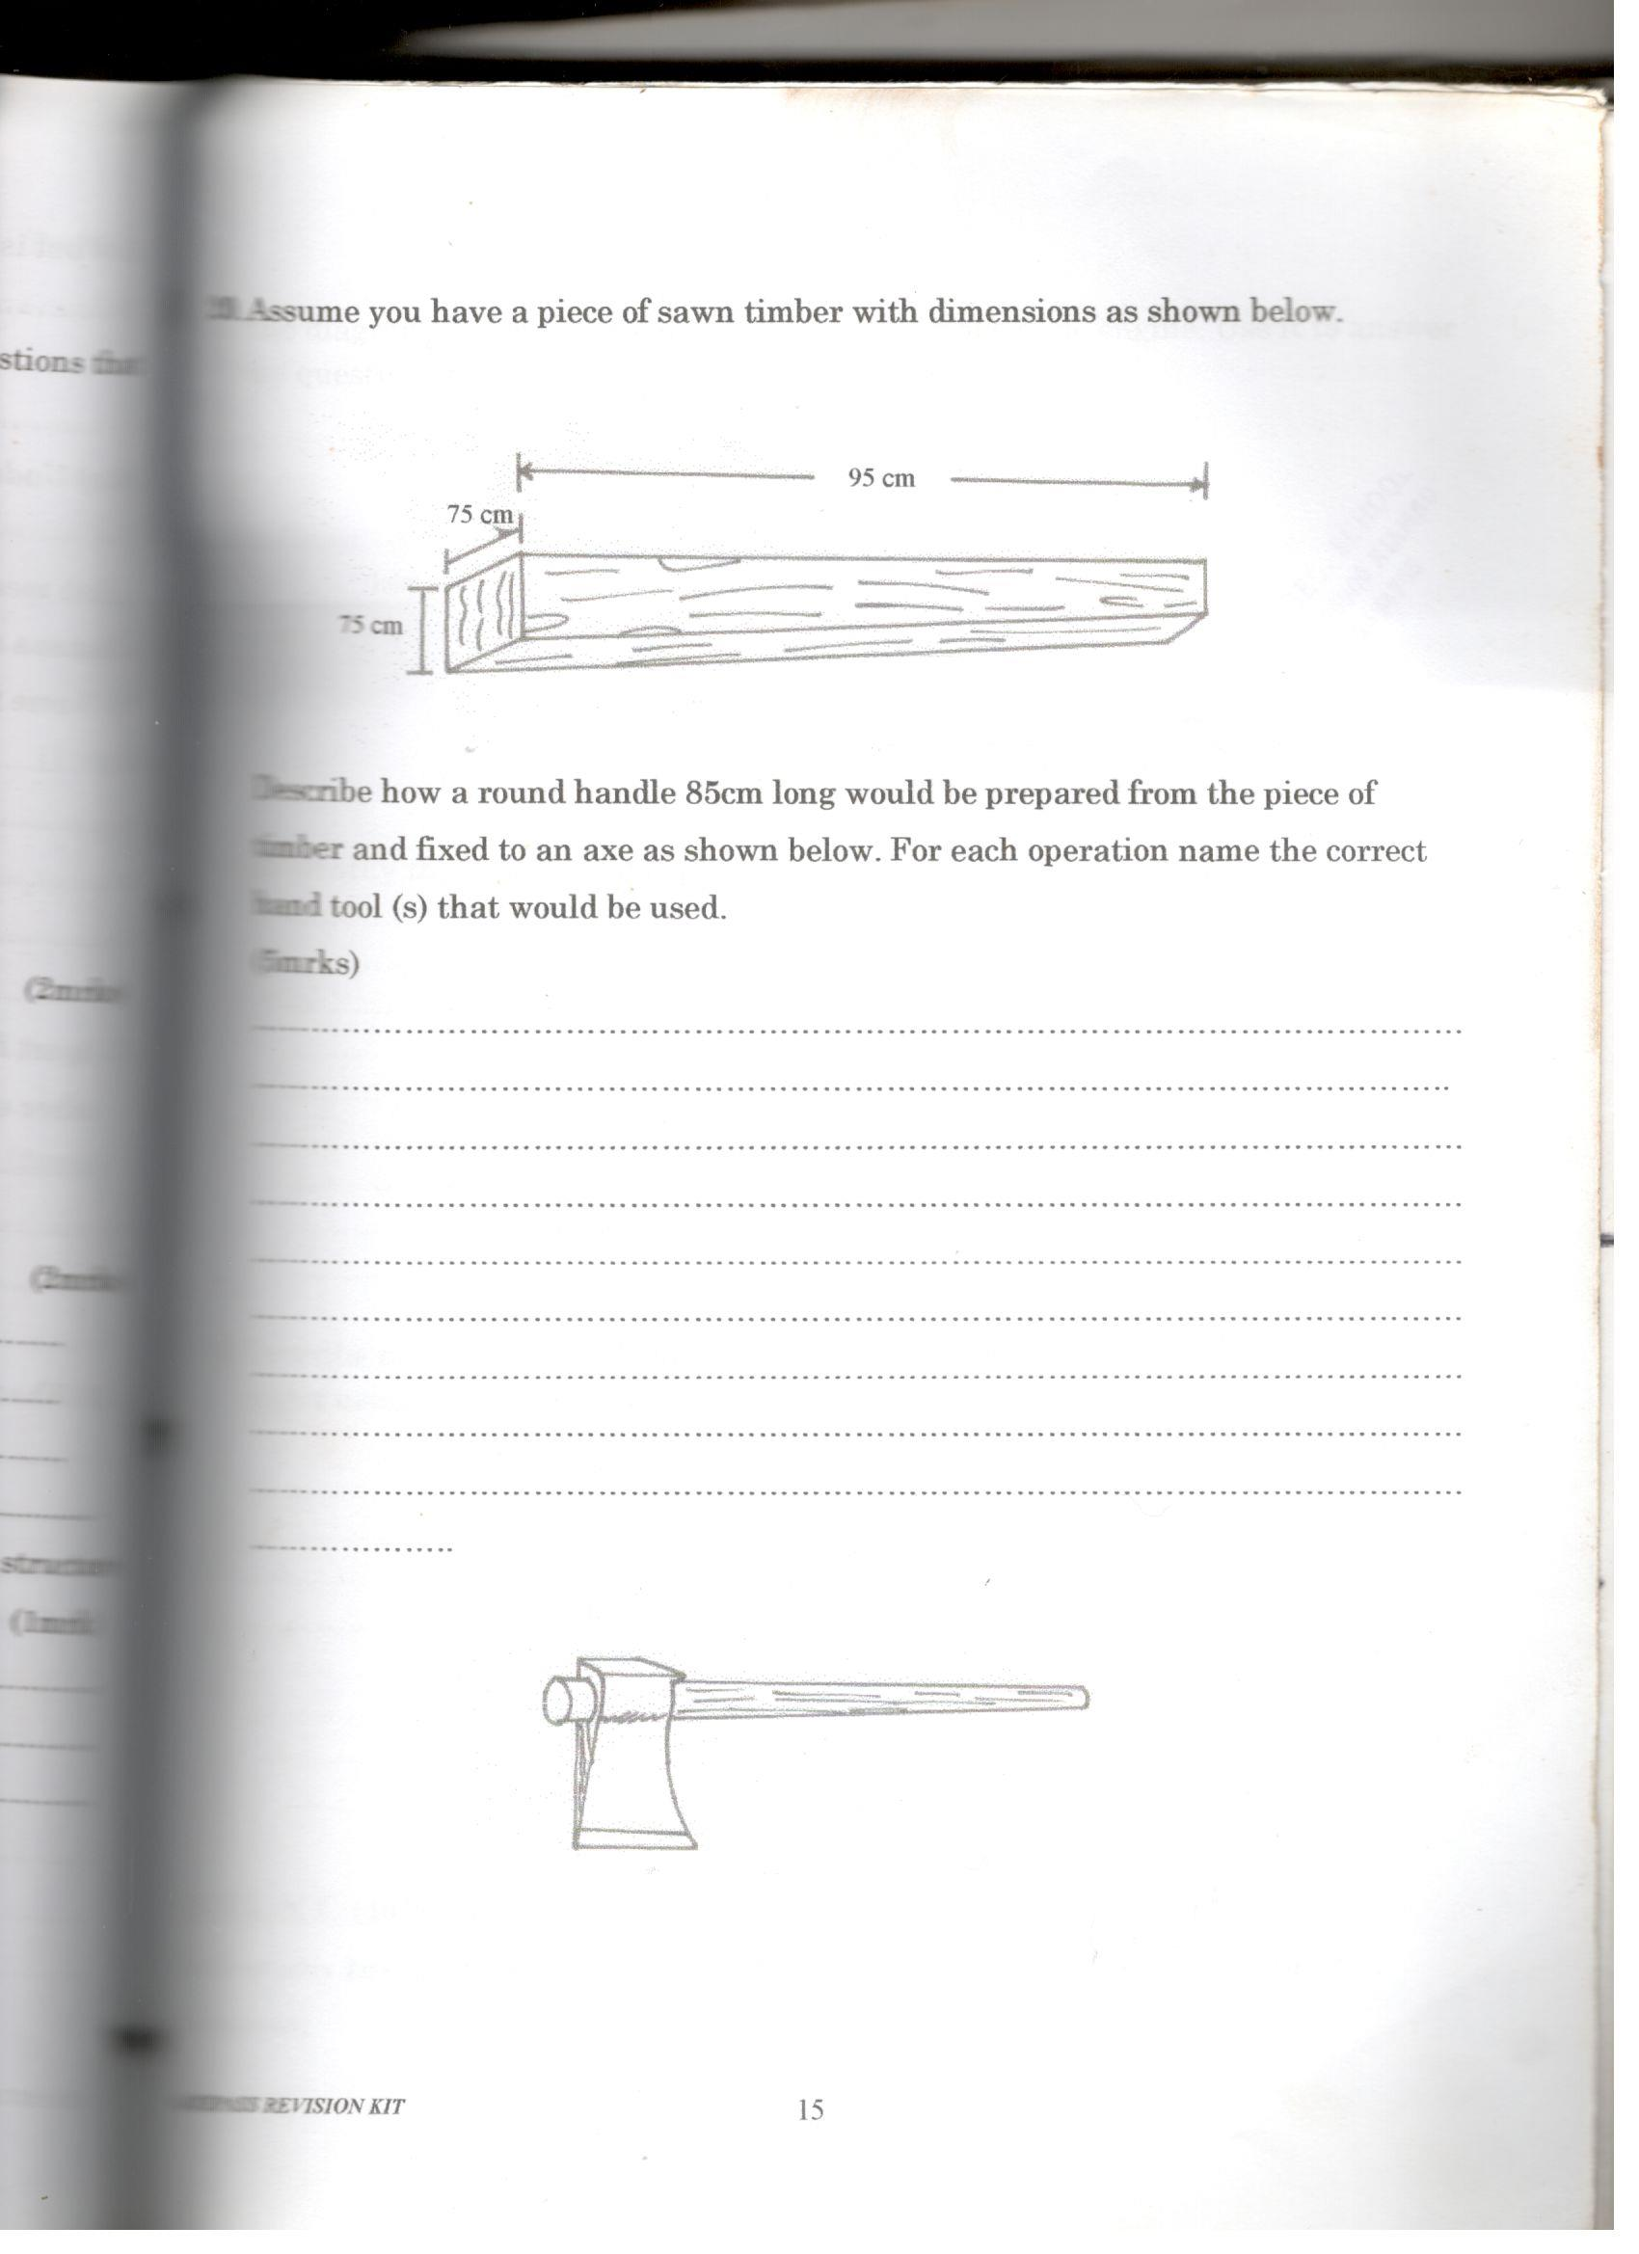
Describe how a round handle 85cm long would be prepared from the piece of timber and fixed to an axe as shown below. For each operation name operation name the correct hand tool(s) that would be used. (4 marks)
……………………………………………………………………………………………………………………………………………………………………………………………………………………………………………………………………………………………………………………………………………………………………………………………………………………………………………………………………………………………………………………………………………………………………………………………………………………………………………………………………………………………………………………………………………………………………………………………………………………
…………………………………………………………………………………………………………………………………………………………………………………………………………………………………………………………………………………………………………………………………………………………………………………………………………
- The illustration below show different livestock families. Use it to answer the question that follow.
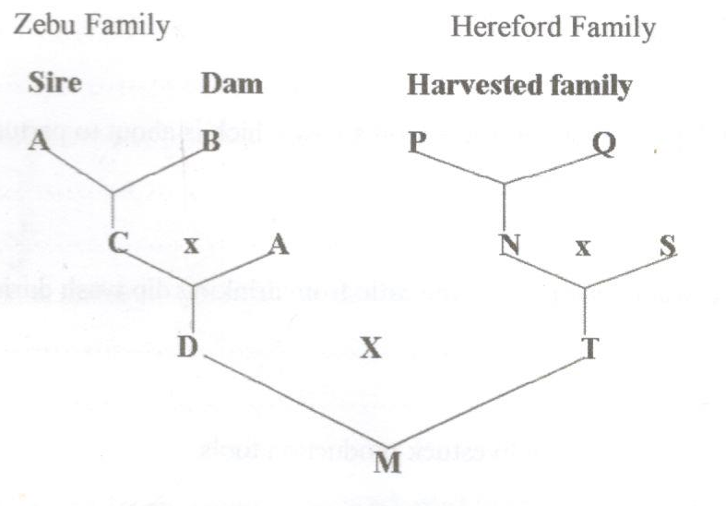
- Identify the breeding system between.
    - C and A (½ mark)
…………………………………………………………………………………………………
ii) D and T (½ mark)
…………………………………………………………………………………………………

  - State the advantage of the breeding system identified in a(ii) above. (1 mark)
……………………………………………………………………………………………………………………………………………………………………………………………………
  - Why is the breeding system identified in a (i) not recommended in dairy cattle?
(1 mark)
……………………………………………………………………………………………………………………………………………………………………………………………………

SECTION C 40 MARKS
Answer any TWO questions in this section.

- Describe the management of a dairy heifer calf from birth until it is mature for service.
(20 marks)
………………………………………………………………………………………………………………………………………………………………………………………………………………………………………………………………………………………………………………………………………………………………………………………………………………………………………………………………………………………………………………………………………………………………………………………………………………………………………………………………………………………………………………………………………………………………………………………………………………………………………………………………………………………………………………………………………………………………………………………………………………………………………………………………………………………………………………………………………………………………………………………………………………………………………………………………………………………………………………………………………………………………………………………………………………………………………………………………………………………………………………………………………………………………………………………………………………………………………………………………………………………………………………………………………………………………………………………………………………………………………………………………………………………………………………………………………………………………………………………………………………………………………………………………………………………………………………………………………………………………………………………………………………………………………………………………………………………………………………………………………………………………………………………………………………………………………………………………………………………………………………………………………………………………………………………………………………………………………………………………………………………………………………………………………………………………………………………………………………………………………………………………………………………………………………………………………………………………………………………………………………………………………………………………………………………………………………………………………………………………………………………………………………………………………………………………………………………………………………………………………………………………………………………………………………………………………………………………………………………………………………………………………………………………………………………………………………………………………………………………………………………………………………………………………………………………………………………………………………………………………………………………………………………………………………………………………………………………………………………………………………………………………………………………………………………………………………………………………………………………………………………………………………………………………………………………………………………………………………………………………………………………………………………………………………………………………………………………………………………………………………………………………………………………………………………………………………………………………………………………………………………………………………………………………………………………………………………………………………………………………………………………………………………………………………………………

- Describe fish management under the following sub headings
  - Procedure for establishing a pond. (10 marks)
…………………………………………………………………………………………………………………………………………………………………………………………………………………………………………………………………………………………………………………………………………………………………………………………………………………………………………………………………………………………………………………………………………………………………………………………………………………………………………………………………………………………………………………………………………………………………………………………………………………………………………………………………………………………………………………………………………………………………………………………………………………………………………………………………………………………………………………………………………………………………………………………………………………………………………………………………………………………………………………………………………………………………………………………………………………………………………………………………………………………………………………………………………………………………………………………………………………………………………………………………………………………………………………………………………………………………………………………………………………………………………………………………………………………………………………………………………………………………………………………………………………………………………………………………………………………………………………………………………………………………………………………………………………………………………………………………………………………………………………………………………………………………………………………………………………………………………………………………………………………………………………………………………………………………………………………………………………………………………………………………………………………………………………………………………………………………………………………………………………………………………………………………………
  - Stocking the pond. (3 marks)
…………………………………………………………………………………………………………………………………………………………………………………………………………………………………………………………………………………………………………………………………………………………………………………………………………
…………………………………………………………………………………………………………………………………………………………………………………………………………………………………………………………………………………………………………………………………………………………………………………………………………
  - Management practices that would ensure maximum harvest of fish from the pond.
(5 marks)
………………………………………………………………………………………………………………………………………………………………………………………………………………………………………………………………………………………………………………………………………………………………………………………………………………………………………………………………………………………………………………………………………………………………………………………………………………………………………………………………………………………………………………………………………………………………………………………………………………………………………………………………………………………………………………………………………………………………………………………………………………………………………………………………………………………………………………………………………………………………………………………………………………………………
  - Methods of preserving fish. (2 marks)
…………………………………………………………………………………………………………………………………………………………………………………………………………………………………………………………………………………………………………………………………………………………………………………………………………
- a. Describe the procedure followed when hand spraying cattle to ensure effective use of acaricide. (10 marks)
…………………………………………………………………………………………………………………………………………………………………………………………………………………………………………………………………………………………………………………………………………………………………………………………………………………………………………………………………………………………………………………………………………………………………………………………………………………………………………………………………………………………………………………………………………………………………………………………………………………………………………………………………………………………………………………………………………………………………………………………………………………………………………………………………………………………………………………………………………………………………………………………………………………………………………………………………………………………………………………………………………………………………………………………………………………………………………………………………………………………………………………………………………………………………………………………………………………………………………………………………………………………………………………………………………………………………………………………………………………………………………………………………………………………………………………………………………………………………………………………………………………………………………………………………………………………………………………………………………………………………………………………………………………………………………………………………………………………………………………………………………………………………………………………………………………………………………………………………………………………………………………………………………………………………………………………………………………………………………………………………………………………………………………………………………………………………………………………………………………………………………………………………………
b. Explain the uses of various hand tools in the construction of a bee hive. (10 marks)
…………………………………………………………………………………………………………………………………………………………………………………………………………………………………………………………………………………………………………………………………………………………………………………………………………………………………………………………………………………………………………………………………………………………………………………………………………………………………………………………………………………………………………………………………………………………………………………………………………………………………………………………………………………………………………………………………………………………………………………………………………………………………………………………………………………………………………………………………………………………………………………………………………………………………………………………………………………………………………………………………………………………………………………………………………………………………………………………………………………………………………………………………………………………………………………………………………………………………………………………………………………………………………………………………………………………………………………………………………………………………………………………………………………………………………………………………………………………………………………………………………………………………………………………………………………………………………………………………………………………………………………………………………………………………………………………………………………………………………………………………………………………………………………………………………………………………………………………………………………………………………………………………………………………………………………………………………………………………………………………………………………………………………………………………………………………………………………………………………………………………………………………………………

