443/1 – AGRICULTURE PAPER 1 – MARKING SCHEME

- Olericulture is the growing of vegetables while Pomoculture is the growing of fruits.
(Mark as a whole) (1 x 2 = 2mks)

  - Has improved soil structure.
  - Has reduced leaching.
  - Has improved water holding capacity.
  - Has increased cation exchange capacity.
  - Has high micro organisms which increases decomposition of organic mater which decompose to release nutrients. (4 x ½ = 2mks)

  - Facilitates aeration.
  - Facilitates drainage.
  - Breaks hard pans / facilitate water infiltration.
  - Brings up leached nutrients.
  - Facilitates development of deep rooted crops.
  - Exposes lower soil layers to weathering.
  - Exposes soil borne pests and pathogens.
  - Removes deep rooted weeds. (4 x ½ = 2mks)

  - Centrifugal / Rotar dynamic pump
  - Reciprocating / piston pump.
  - Hydram pump
  - Rotary pump (4 x ½ = 2mks)

  - Rapid growth rate.
  - Production of abundant foliage.
  - Rich in plant nutrients / leguminous / rich in nitrogen.
  - Ability to decay quickly.
  - Adaptable to wide range of conditions / hardy. (4 x ½ = 2mks)

  - Date of treatment.
  - Symptoms of disease.
  - Animals affected.
  - Drugs which were used.
  - Cost of treatment. (4 x ½ = 2mks)

  - To obtain seed suitable to ecological conditions.
  - To obtain pure planting material.
  - To increase germination percentage.
  - To remove pests and disease infested planting material. (4 x ½ = 2mks)

  - Watering
  - Weed control.
  - Pricking out
  - Pest control
  - Disease control
  - Hardening off (5 x ½ = 1½mks)

  - Rogueing is the uprooting and destruction of crops that are infested with pests and diseases. Thinning is the uprooting / removal of excess seedlings to allow space for the remaining seedlings. (Mark as a whole) (1 x 2 = 2mks)

  - Damping off
  - Black rot
  - Downy mildew (3 x ½ = 1½mks)

  - Altitude should be 0 – 2100m above sea level.
  - Rainfall should range between 760 – 1300mm per year.
  - Temperature should range between 18 – 29⁰C
  - The soil pH should be between 5.5 – 6.5 (4 x ½ = 2mks)

  - High price of commodity.
  - Taxation.
  - Expected decrease in price of the commodity.
  - Advertisement reduction.
  - Decrease in population size.
  - Reduced income of consumers / inflation.
  - Lower tastes and preferences by consumer / reduced fashion of commodity.
  - When price of substitute decreases. (4 x ½ = 2mks)

  - Protection of trees.
  - Pruning.
  - Training.
  - Grafting old trees. (4 x ½ = 2mks)

  - Rotational grazing / controlled grazing.
  - Proper stocking rate.
  - Conserve excess pasture.
  - Timely defoliation.
  - Practice zero grazing.
  - Graze different classes / species of animals. (4 x ½ = 2mks)

  - The name and signature of owner of the land / identification number of owner.
  - The size of land.
  - The land parcel number.
  - Type of owner, if any.
  - Seal of issuing officer and signature of issuing officer.
  - The date of registration. (4 x ½ = 2mks)

SECTION B

- (a) (i) By planting grass / suitable vegetation.
(ii) Channel / trench.
(b) - Measure and mark the layout of drain.
- Dig and remove soil from the channel and heap it on the lowerr side of the drain.
(4x ½ = 2mks)
- (a) H – Gutter (1 x 1 = 1mk)
K – Drainage pipe (1 x 1 = 1mk)
(b) Let out excess water (1 x 1 = 1mk)

- (i) X – Loam
Y – Sand
Z – Clay (3 x ½ = 1½mks)
(ii) Soil Y (sandy) ( ½ mk)
(iii) It has drained the highest amount of water as opposed to others. (1mk)
(iv) Soil Z / Clay soil (1mk)
(v) It is not easily drained / does not loose water easily when flooded for rice production.

- (i) - Mallow weed / Malva verticillata. (1 x 1 = 1mk)
(ii) - Poisonous / Toxic to livestock. (1 x 1 = 1mk)
(iii) - Mechanical (Acc. any specific method)
  - Biological
  - Cultural (Acc. any specific method)
  - Chemical (Acc. any correct chemical)
Rej. Legislative. (any 2 x ½ = 1mk)
- Presence of underground storage structures / rhizomes which are difficult to control. (1mk)

- (a) F – Granular structure (½mk)
G – Platy structure (½mk)

(b) X – Humus with clay (½mk)
Y – Air space (½mk)

- - Impedes drainage / water infiltration.
  - Prevent root penetration.
  - Influence soil aeration. (any 2x1 = 2mks)

SECTION C

- (i) (a) Field preparation
  - The field should be cultivated to a fine tilth.
  - Construct / repair bund around the field.
  - Flood the field 4 days after transplanting.
  - Flood the field up to 10cm above the surface.
  - Puddle the soil to the required tilth / rotavate the soil.
  - Level the field by dragging a board to obtain level seedbed.
  - Construct inlet and outlet. (5 x 1 = 5mks)

(b) Water control
  - Increase water level from 5cm to 15cm.
  - Water is increased gradually.
  - Allow water to flow slowly through the fields / allow fresh water at 2 – 3 weeks interval.
(3 x 1 = 3mks)
(c) Field management
- Control weeds by uprooting / use of appropriate herbicide
- Control birds by scaring or by destroying breeding colonies.
- Water should be changed every 2 – 3 weeks / let water flow slowly through the field.
- Drain water 3 weeks before harvesting / when heads turn down.
- Maintain level of water at ¹/₃ height of plants until 3 weeks before harvesting.
- Top dress with sulphate of ammonia at 250kg/ha in two portions.
- Top dress just before transplanting and after 40 days.
- Control diseases i.e. Anthracnose by growing resistant varieties, use clean seeds. Or bacteria blight uprooting and destroying infected plants or spray with colliar oxychloride. (5x1 = 5mks)

(ii) (a) Pyrethrum
- Picked flowers are put into open woven baskets to allow proper ventilation.
- Only dry flowers are picked to avoid fermentation and heating up.
- Flowers are not compacted in the basket to avoid heating up and fermentation.
(3x1 = 3mks)
(b) Tea
- Tea leaves are not compressed in a basket.
- Harvested tea leaves are kept cool under a shade as harvesting continues.
- Tea leaves are delivered to the factory on the same day after harvesting. (1x3 = 3mks)
- (a) - Consumable goods inventory records.
- Permanent goods inventory records. (2 x ½ = 1mk)

- Helps in decision making
- Enables the farmers to predict future returns.
- Helps farmer to avoid incurring losses by investing in less profitable enterprises.
- It ensures a periodic analysis of the farm business.
- It acts as a record which can be used for future reference.
- It pin points efficiency or weakness in farm operations.
- Enables farmers to secure loans from financial institutions. (6 x 1 = 6mks)

(c)
KIPSINENDE FARM
BALANCE SHEET
AS AT 01 – 06 – 2011
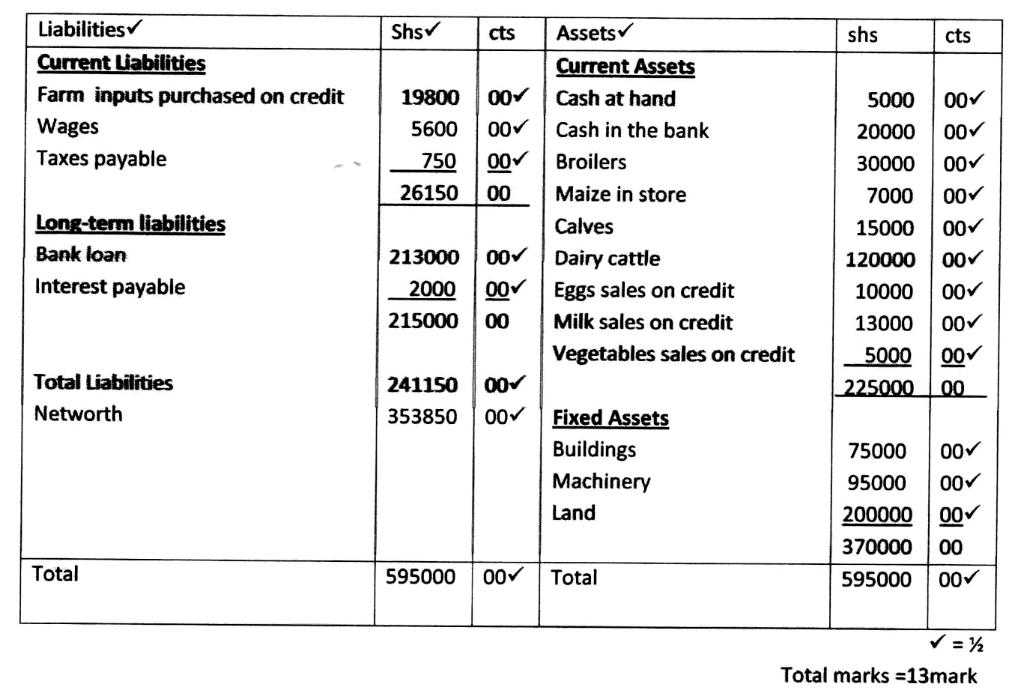

(½ x 26)
- (a)
- Stage I – Filtration at the water intake.
  - Water is made to pass through series of sieves so that large particles are trapped.
- Stage II – Softening of water
  - Water is mixed with soda ash (NAHCO₂) in small tank to soften it.
- Stage III – Coagulation and sedimentation
  - Allum is added to water to facilitate coagulation and sedimentation.
  - Water stays in the tank for 36 hours to kill bilharzias.
  - Tanks open to remove bad small / odour and for aeration.
- Stage IV – Filtration
  - Water passes through filtration tank where all remains solid particles removed.
- Stage V – Chlorination
  - Water enters chlorination tank where chlorine is added to kill germs.
- Stage VI – Storage
  - Treated water is stored in large tanks before distribution.
(stage mentioned – 1mk, explanation – 1mk) (6 x 2 = 12mks)
(b)
- Nature of soil e.g. sandy soils are easily eroded whereas clay is resistant to erosion.
- Shape of the land – the steeper the shape of the land the higher the erosivity.
- Rainfall intensity – the higher the intensity of rain the higher the erosion.
- Rainfall amount – the higher the amount of rainfall the higher the erosion.
- Strength of wind – the stronger the wind the higher the erosive power.
- Bareness of the land – bare land are prone to erosion.
(5 explained points) (5 x 1 = 5mks) NB: No mark for just stating.
(c)
- One type of nutrient is used leading to its exhaustion.
- Nutrient is used from a certain zone where roots can reach.
- Leads to build up of certain pests and diseases. (3 x 1 = 3mks)

