NAME: …………………………………………. INDEX NO: ……………………………….

SCHOOL:……………………………………….. DATE : ……………………………………

CANDIDATE’S SIGNATURE:………………….

GOLDEN ELITE EXAMINATIONS

Kenya Certificate of Secondary Education (K.C.S.E.)
AGRICULTURE
PAPER 2
TIME: 2 HOURS

INSTRUCTIONS TO CANDIDATES:

- Write your name and Index number in the spaces provided above.
- Sign and write the date of examination in the spaces provided above.
- This paper consists of THREE sections A, B and C.
- Answer ALL questions in Section A and B.
- Answer any TWO questions in section C.
- Answers should be written in the spaces provided.
- This paper consists of 10 printed pages.
- Candidates should check the question paper to ascertain that all the pages are printed as indicated and no questions are missing.
- Candidates should answer the questions in English.

FOR EXAMINER’S USE ONLY
SECTION | QUESTIONS | MAX. SCORE | CANDIDATE SCORE
A | 1 – 19 | 30
B | 20 – 24 | 20
C |  | 20
C |  | 20
Total Score |  | 90

SECTION A (30 MARKS)
Answer ALL Questions in the Spaces Provided
- Why is Irish potatoes not recommended for feeding non-ruminant animals? (½mk)
…………………………………………………………………………………………………………………………………………………………………………………………………………………………
- Give four characteristics of succulent roughages. (2mks)
……………………………………………………………………………………………………………………………………………………………………………………………..…………………………………………………………………………………………………………………………………………………………………………………………………………………………………………………….
- List two camel species reared in arid and semi-arid areas. (1mk)
…………………………………………………………………………………………………………………………………………………………………………………………………………………………
- Give four practices other than application of preservatives that can be carried out on wooden fencing posts to make them last long. (2mks)
…………………………………………………………………………………………………………….
………………………………………………………………………………………………………………………………………………………………………………………………………………………………………………………………………………………………………………………………………
- Give four physical characteristics of a dairy cow. (2mks)
……………………………………………………………………………………………………………………………………………………………………………………………………………………………………………………………………………………………………………………………………………………………………………………………………………………………………………………
- State four reasons for steaming up a dairy cow 2 months before calving down. (2mks)
…………………………………………………………………………………………………………………………………………………………………………………………………………………………………………….……………………………………………………………………………………………………………………………………………………………
- State the causes of infertility in dairy cattle. (2mks)
……………………………………………………………………………………………………………………………………………………………………………………………………………………………………………………………………………………………………………………………………….
- State two circumstances which would lead a farmer to cull a high producing dairy cow.(1mk)
…………………………………………………………………………………………………………………………………………………………………………………………………………………………
- State the difference between crutching and raddling. (2mks)
…………………………………………………………………………………………………………………………………………………………………………………………………………………………
- Give four importance of keeping livestock healthy. (2mks)
……………………………………………………………………………………………………………………………………………………………………………………………………….……………………………………………………………………………………………………………………………………………………………………………………………………………………………………………
- How does isolation help in livestock disease control? (1mk)
……………………………………………………………………………………………………………
- What are the effects of parasites on livestock? (2mks)
………………………………………………………………………………………………………………………………………………………………………………………………………………………….
- State four methods of controlling liverflukes. (2mks)
…………………………………………………………………………………………………………………………………………………………………………………………………………………………………………………………………………………………………………………………………………………………………………………………………………………………………………………….
- Give two feeding rearing practices in livestock. (1mk)
………………………………………………………………………………………………………………………………………………………………………………………………………………………….
- State three properties of a good vaccine. (1½mk)
………………………………………………………………………………………………………………………………………………………………………………………………………………………………………………………………………………………………………………………………………
- Give two symptoms of brucellosis in cows. (1mk)
………………………………………………………………………………………………….……………………………………………………………………………………………………………………….
- State three ways of increasing ploughing depth when using a disc plough. (1½mks)
……………………………………………………………………………………………………………………………………………………………………………………………………………………………………………………………………………………………………………………………………….
- (a) Explain the term Epistasis as used in breeding. (½mks)
………………………………………………………………………………………………………………………………………………………………………………………………………………
(b) State three methods used in selection of livestock for breeding. (1½mks)
………………………………………………………………………………………………………………………………………………………………………………………………………………………………………………………………………………………………………………………
- Give three factors that may inhibit milk let down in dairy cattle. (1½mks)
………………………………………………………………………………………………………………………………………………………………………………………………………………………………………………………………………………………………………………………………………………………………………
SECTION B (20 MARKS)
Answer all questions in the spaces provided in this section

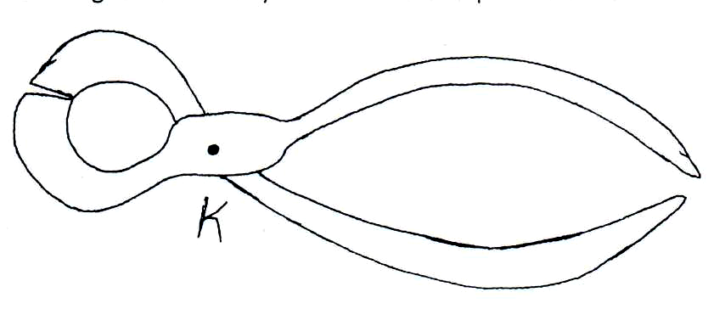
- Study the following tools carefully and answer the questions that follow.
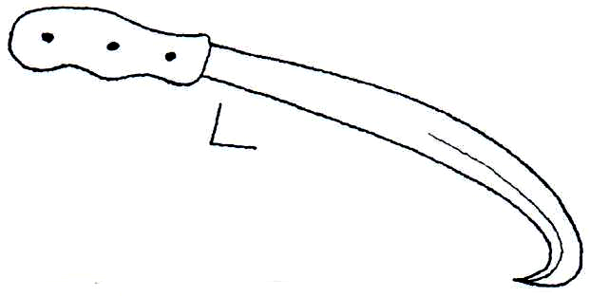

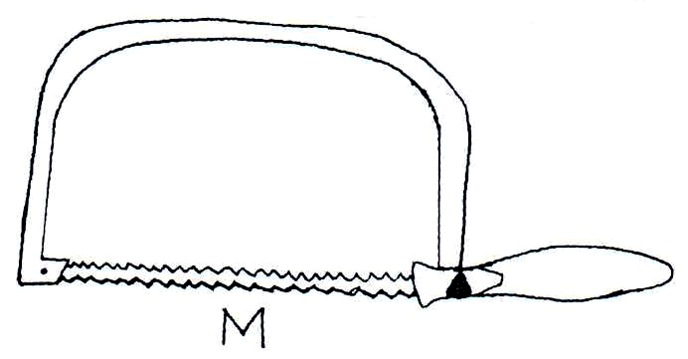
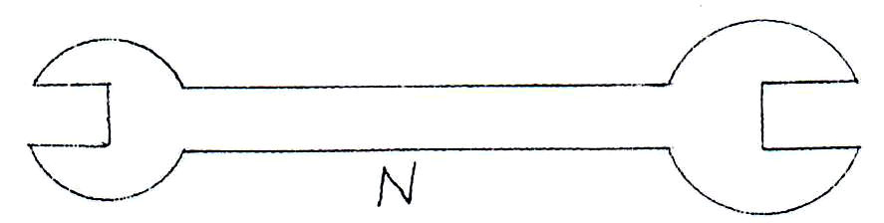

  - Identify the structures labeled K, L, M and N.
K……………………………………………………………………………… (½mk)
L……………………………………………………………………………… (½mk)
M……………………………………………………………………………… (½mk)
N……………………………………………………………………………… (½mk)
  - State the use of tools labeled K and N. (2mks)
K…………………………………………………………………………………………………….
N…………………………………………………………………………………………………….
  - Give two maintenance practices of the tool labeled M. (2mks)
............................................................................................................................................................................................................................................................................................
- (a) Define the term feed conversion ratio as used in livestock production. (1mk)
………………………………………………………………………………………………………
………………………………………………………………………………………………………
- A bull gained 100kg of live weight after eating 400kg of beef concentrates over a period of time. Calculate the feed conversion ratio. (2mks)

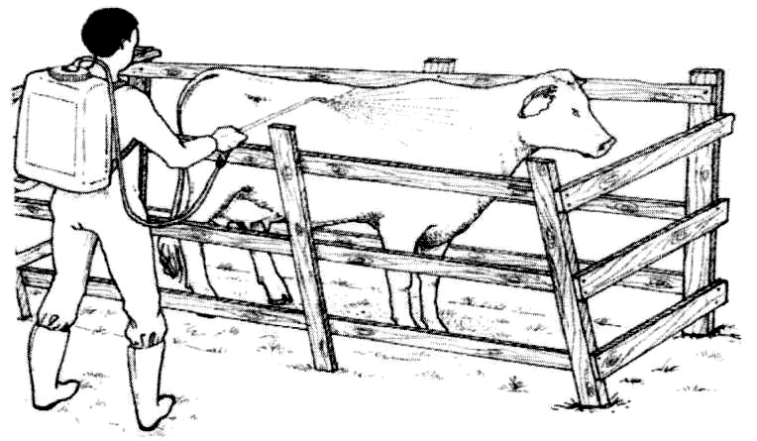
- Below is an illustration of a livestock routine management practice. Study it and answer questions that follow.

    - State the reason for carrying out the routine practice shown above. (1mk)
…………………………………………………………………………………………………….
    - Give three factors that affect the effectiveness of the chemical used above. (1½mks)
……………………………………………………………………………………………………………………………………………………………………………………………………………………………………………………………………………………………………………………………………………………………………………………………………………………………………………………………………………………………………………………………………………………………………………………………………………………………….
- Study the illustration below and answer questions that follow.
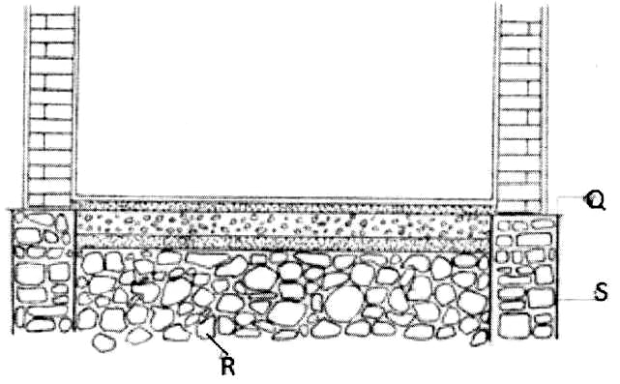
    - Name the parts labeled Q, R and S. (1½mks)
Q:……………………………………………………………………………………………….
R:………………………………………………………………………………………………..
S:……………………………………………………………………………………………….
    - Give the function of the part labeled Q. (½mk)
…………………………………………………………………………………………………………………………………………………………………………………………………………
    - State four factors that determine the type of materials to use in construction of the wall. (2mks)
…………………………………………………………………………………………………………………………………………………………………………………………………………………………………………………………………………………………………………………………………………………………………………………………………………………..
- Below is an illustration of a practice carried out in livestock production. Study it carefully and answer the following questions:
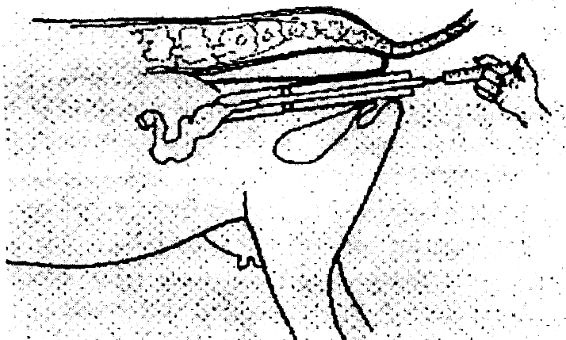
    - Identify the practice illustrated above. (1mk)
…………………………………………………………………………………………………….
    - Study four advantages of the above practice. (2mks)
…………………………………………………………………………………………………………………………………………………………………………………………………………………………………………………………………………………………………………………………………………………………………………………………………………………..
    - State three limitations associated with the above practice. (1½mks)
……………………………………………………………………………………………………………………………………………………………………………………………………………………………………………………………………………………………………………….

SECTION C (40 MARKS)
Answer any two questions from this section in the spaces provided
- (a) Describe milk fever disease under the following sub-headings:
    - Animals affected. (1mk)
    - Causal agent (1mk)
    - Symptoms of attack (4mks)
    - Control measures (4mks)
(b) Explain the factors to consider when selecting livestock for breeding. (10mks)

- Describe the management of a day old layer chick up to the end of brooding. (20mks)

- (a) Describe the components of a cooling system of a tractor. (10mks)
- Outline five care and maintenance practices of a tractor battery. (5mks)
- State five uses of solar energy. (5mks)
…………………………………………………………………………………………………..…………………………………………………………………………………………………………………………………………………………………………………………………………………………………………………………………………………………………………………………………………………………………………………………………………………………………………………………………………………………………………………………………………………………………………………………………………………………………………………………………………………………………………………………………………………………………………………………………………………………………………………………………………………………………………………………………………………………………………………………………………………………………………………………………………………………………………………………………………………………………………………………………………………………………………………………………………………………………………………………………………………………………………………………………………………………………………………………………………………………………………………………………………………………………………………………………………………………………………………………………………………………………………………………………………………………………………………………………………………………………………………………………………………………………………………………………………………………………………………………………………………………………………………………………………………………………………………………………………………………………………………………………………………………………………………………………………
…………………………………………………………………………………………………..………………………………………………………………………………………………………………………………………………………………………………………………………………………………………………………………………………………………………………………………………………………………………………………………………………………………………………………………………………………………………………………………………………………………………………………………………………………………………………………………………………………………………………………………………………………………………………………………………………………………………………………………………………………………………………………………………………………………………………………………………………………………………………………………………………………………………………………………………………………………………………………………………………………………………………………………………………………………………………………………………………………………………………………………………………………………………………………………………………………………………………………………………………………………………………………………………………………………………………………………………………………………………………………………………………………………………………………………………………………………………………………………………………………………………………………………………………………………………………………………………………………………………………………………………………………………………………………………………………………………………………………………………………………………………………………………………………………………………………………………………………………………………………………………………………………………………………………………………………………………………………………………………………………………………………………………………………………………………………………………………………………………………………………………………………………………………………………………………………………………………………………………………………………………………………………………………………………………………………………………………………………………………………………………………………………………………………………………………………………………………………………………………………………………………………………………………………………………………………………………………………………………………………………………………………………………………………………………………………………………………………………………………………………………………………………………………………………………………………………………………………………………………………………………………………………………………………………………………………………………………………………………………………………………………………………………………………………………………………………………………..………………………………………………………………………………………………………………………………………………………………………………………………………………………………………………………………………………………………………………………………………………………………………………………………………………………………………………………………………………………………………………………………………………………………………………………………………………………………………………………………………………………………………………………………………………………………………………………………………………………………………………………………………………………………………………………………………………………………………………………………………………………………………………………………………………………………………………………………………………………………………………………………………………………………………………………………………………………………………………………………………………………………………………………………………………………………………………………………………………………………………………

