NAME _______________________________________
ADM NO__________CLASS__________
TERM 1 2023
Answer all the questions in the spaces provided.
SECTION A (75 MARKS)
- Define the term agriculture correctly ( 1 mk)

- Give four practices that show that agriculture is an art ( 4 mks)

- State four area of study that shows that agriculture is a science ( 4 mks)

- State two ways in which agriculture contributes to development of industries in Kenya. (2 mks)

- State three ways by which agriculture contributes to national development (3 mks)

- List five branches of agriculture (5 mks)

- State four factors considered when identifying a farming system in an area (4mks)

- State four characteristics of large scale farming system (4mks)

- State two reasons which make small scale farming common to majority of farmers in Kenya ( 2mks)

- Define the term pomology as used in crop production (1 mk)

- State two reasons why nomads move with their livestock from place to place (2mks)

- State four climatic factors that influence agricultural production in Kenya (4mks)

- What is agroforestry (1mk)

- State four problems associated with shifting cultivation (4mks)

- State two effects of HIV/AIDs in agriculture (2mks)

- State three ways how agriculture as an occupation provides employment (3mks)

- State four important aspects of rainfall to a farmer (4mks)

- State five biotic factors that affect agricultural production (5mks)

- State four advantages of mixed farming (4mks)

- a) Give three effects of low temperature in crop production (3mks)

b) State four harmful effects of wind in crop production (3mks)

- Name two categories of crops on the basis of photosynthetic light requirement (2mks)

SECTION B( 25 MKS)
- Below is a diagram illustrating a soil profile; study it carefully and answer the questions that follow.
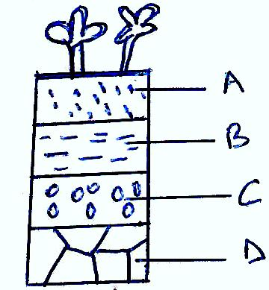

- Name parts labeled A,B,C and D above (4mks)
A____________
B___________
C_________
D____________

- State three properties of the part labeled A above ( 3mks)

- State four factors that influence soil formation (4mks)

- The diagram below shows an experiment set up using different soil type A,B and C.
The observation was made after 24 hours.
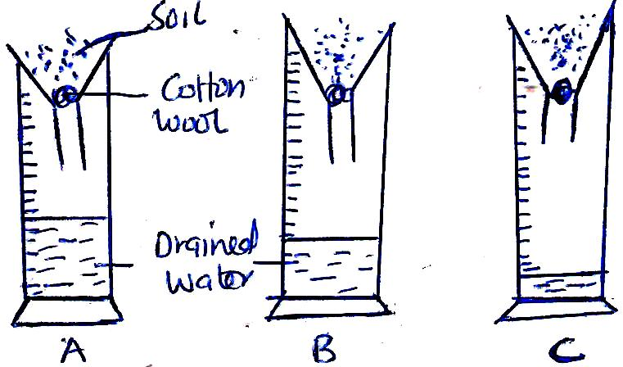

- State what the experiment was designed to study (1mk)

- Name the soil type labeled A,B,C (3mks)
A________
B________
C_______
- State three ways in which soil structure influences crop production (3mks)

- Distinguish between soil structure and soil texture (2mks)

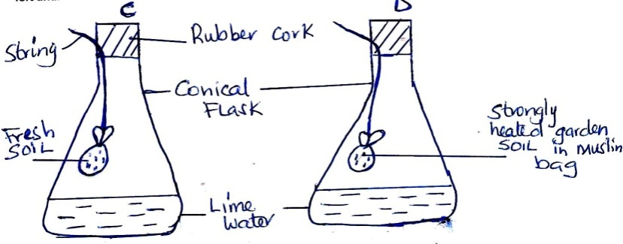
- The diagrams below show a set up of an experiment to study an aspect of soil. The set up was 6

- What was the aim of the experiment (1mk)

- State one observation that was made in each of the flasks labeled C and D
C_____________________ (1mk)

D_____________________ (1mk)

- Give a reason for each of your answers in (b) above (1 mk)
C________________ (1 mk)
D_______________ (1 mk)

