NAME:…………………………………………………………………………………...…………
SCHOOL:…………………………………………………………………………………………..
A.D.M NO:……………………………………….. DATE:………………………………………
SIGNATURE:……………………………………

442/1
AGRICULTURE
PAPER 1
2 HOURS

SECTION A (30MKS)

1 State four factors which determines the farming systems adapted by farmers (2mks)

2. Give four reasons for sub in maize field (2mk)

3. Name two types of inventories in the farm (1mk)

4. State four negative of HIV/AIDS to agriculture (2mks)

5. State four effect of soil erosion (2mks)

6. State four deficiency symptoms of nitrogen in plants (2mks)

7. Highlight two effect of land title deed to farm (1mk)

8. State two methods of controlling headsmat in maize (1mk)

9. Give two forms of large scale farming practiced in Kenya (1mk)

10. State two ways in which parent rode influences soil characteristics (1mk)

11. Give four farming practices carried out to achieve minimum tillage (2mks)

12. State two characteristics of plantation farming (1mk)

13. Give three classes of weeds under growth cycle (1 ½ mks)

14. State four post-harvesting practices on crops (2mks)

15. List four advantages of mulching in Agriculture line (2mks)

16. State three benefits of using certified seeds (2mks)

17. State four importance of air in soil (2mks)

18. State four factors used in classification of inorganic fertilizer (2mks)

19. State one cause of hard pan in soil

SECTION B (20MKS)
Answer All questions

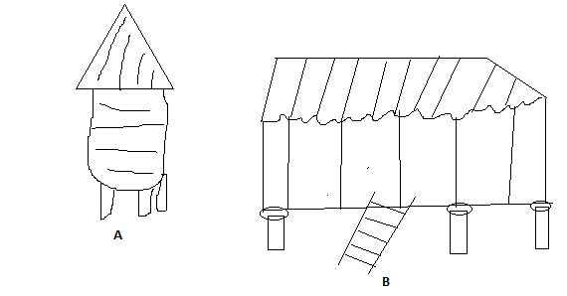

20. The diagram labeled A and B illustrate storage structures study the diagram carefully and
answer the question that follows.

- Identify the structures (2mks)
A
B

- State four structural differences between (A and B)

(c) State four maintenance practices carried out on stradine (2mks)

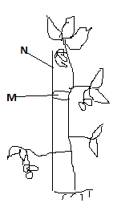

21. (a) Identify the practice illustrated (1mk)

(b) Name material used in N and M and then uses (2mks)

- List down four problems faced by a farmer who does not carry out the practice (4mks)

22. The diagram below illustrates a method of propagating some of the common field crop.
Study the diagram and answer the questions that follows

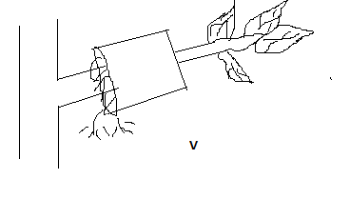
- Identify the method illustrated (1mk)

- Name two field crop which can be propagated using above method (2mks)
- State two conditions to be ensured at point V to ensure full rooting (2mks)

SECTION C 40MKS

23. Discuss the production of bean under the following sub-headings (20mks)
(a) Land preparation (4mks)
(b) Selecting and treatment of planting materials (4mks)
(c) Planting (4mks)
(d) Field management practices (4mks)
(e) Harvesting of bean (4mks)

24. State five advantages and disadvantages of overhead irrigation (10mks)
(b) State factors used in choosing irrigation methods (5mks)
(c) What are the uses of water in livestock farm (5mks)

25. What factors determine the number of secondary cultivation during land preparation (5mks)
(b) Give reasons why minimum tillage may be carried out (6mks)
(c) Explain the activities carried out in tertiary cultivation (6mks)
(d) What are the factors that determine the depth of ploughing (3mks)

