Name: ______________________________________Index No: ________________________

School: _____________________________ Candidate’s Sign___________________

Date: ____________________________

443/2
AGRICULTURE
Paper 2(Theory)
MARCH/APRIL 2020
Time: 2 Hours

ARISE AND SHINE TRIAL 1 EXAM
MACHI/APRIL-2020

Instructions to Candidates:
- Write your name and index number in spaces provided above
- This paper consists of THREE sections: A, B and C
- All answers should be written in the spaces provided on this question paper.
- Candidates should answer the questions in English.

For Examiner’s use only

Section | Questions | Maximum Score | Candidate’s Score
A | 1 – 18 | 30
B | 19 - 23 | 20
C | 24 | 20
C | 25 | 20
C | 26 | 20
TOTAL SCORE |  | 90

SECTION A [30 MARKS]
Answer All The Questions in The Spaces Provided.

- Name four exotic beef cattle breeds most reared in Kenya. [2 marks]
(i) ……………………………………………………………………………………………….
(ii) ………………………………………………………………………………………………
(iii) ……………………………………………………………………………………………..
(iv). …………………………………………………………………………………………….
- If a sow was successfully served on 27th September 2019, state the date she is likely to have furrowed. [1mark]
(i) ……………………………………………………………………………………………….
(ii) ………………………………………………………………………………………………
- Give two importance of docking in rams. [1 mark]
(i) ……………………………………………………………………………………………….
(ii) ………………………………………………………………………………………………
- Mention four causes of stress in a flock of Birds (2 marks)
(i) ………………………………………………………………………………………………
(ii) ………………………………………………………………………………………………
(iii) ……………………………………………………………………………………………..
(iv). …………………………………………………………………………………………….
- Name two nutritional disease of cattle. [1 marks]
(i) ……………………………………………………………………………………………….
(ii) ………………………………………………………………………………………………
- State four methods of preserving fish. [2 marks]
(i) ……………………………………………………………………………………………….
(ii) ………………………………………………………………………………………………
(iii) ……………………………………………………………………………………………..
(iv). …………………………………………………………………………………………….
- State four disadvantages of free range system of poultry rearing. (2 marks)
(i) ……………………………………………………………………………………………….
(ii) ………………………………………………………………………………………………
(iii) ……………………………………………………………………………………………..
(iv). …………………………………………………………………………………………….

- State four advantages of a Kenya top bar hive. [2 marks]
(i) ……………………………………………………………………………………………….
(ii) ………………………………………………………………………………………………
(iii) ……………………………………………………………………………………………..
(iv). …………………………………………………………………………………………….
- Name two diseases that affect female animals only. [1 mark]
(i) ……………………………………………………………………………………………….
(ii) ………………………………………………………………………………………………
- Name four tick borne diseases [2 marks]
(i) ……………………………………………………………………………………………….
(ii) ………………………………………………………………………………………………
(iii) ……………………………………………………………………………………………..
(iv). …………………………………………………………………………………………….
- State four ways of vaccinating livestock. [2 marks]
(i) ……………………………………………………………………………………………….
(ii) ………………………………………………………………………………………………
(iii) ……………………………………………………………………………………………..
(iv). …………………………………………………………………………………………….
- Name three notifiable livestock diseases in Kenya. [1 ½ marks]
(i) ……………………………………………………………………………………………….
(ii) ………………………………………………………………………………………………
(iii) ……………………………………………………………………………………………..
- State four ways of identifying livestock. [2 marks]
(i) ……………………………………………………………………………………………….
(ii) ………………………………………………………………………………………………
(iii) ……………………………………………………………………………………………..
(iv). …………………………………………………………………………………………….
- List four safety precautions taken into consideration when using with farm tools.[2 marks]
(i) ……………………………………………………………………………………………….
(ii) ………………………………………………………………………………………………
(iii) ……………………………………………………………………………………………..
(iv). …………………………………………………………………………………………….

15. State three causes of piglet mortality. [1 ½ mark]
(i) ……………………………………………………………………………………………….
(ii) ………………………………………………………………………………………………
(iii) ……………………………………………………………………………………………..
- Give four characteristics of roughages feeds. (2 marks)
(i) ……………………………………………………………………………………………….
(ii) ………………………………………………………………………………………………
(iii) ……………………………………………………………………………………………..
(iv). …………………………………………………………………………………………….
- Give four reasons why camels are suited to living in arid areas. (2 marks)
(i) ……………………………………………………………………………………………….
(ii) ………………………………………………………………………………………………
(iii) ……………………………………………………………………………………………..
(iv). …………………………………………………………………………………………….
- Name the parental breeds of the dorper. (1 mark)
(i) ……………………………………………………………………………………………….

SECTION B [20 MARKS]

Answer all questions in this section in the spaces provided.

- A poultry farmer has maize containing 8% DCP and Soya beans containing 43% DCP. If the farmer wants to make 100kg of a feed, using the person’s method calculate the proportions in which the two ingredients would have to be mixed to make a feedstuff containing 15% DCP. (Show your working). (5 marks)
____________________________________________________________________________________________________________________________________________________________
______________________________________________________________________________
______________________________________________________________________________
______________________________________________________________________________
____________________________________________________________________________________________________________________________________________________________
______________________________________________________________________________
______________________________________________________________________________
20. Below is an illustration of a fish pond. Study it carefully and then answer the following questions.
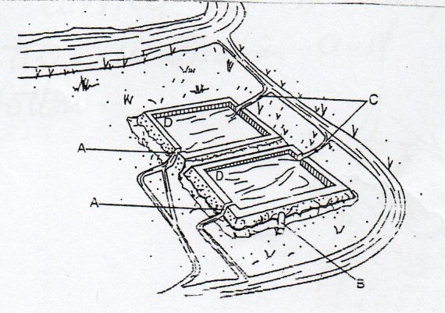
21. a). Give the reason why part D is usually deeper than the rest of the pond. (1 mark)
__________________________________________________________________________________________________________________________________________________________________________________________________________________________________________
(b). Name the part labelled A, B and C. (1 ½ mark)
A
B
C
(c). State three maintenance practices that should be carried out on the fish pond. (1 ½ mark)
(i) ……………………………………………………………………………………………….
(ii) ………………………………………………………………………………………………
(iii) ……………………………………………………………………………………………..
(d). Give two reason why a fence should be constructed around the fish pond. (1 marks)
(i) ……………………………………………………………………………………………….
(ii) ………………………………………………………………………………………………
22. The following illustration represent a certain practice carried out in sheep management. Study the illustration and answer the questions that follow.
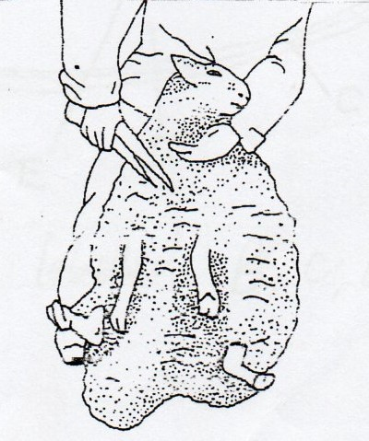
(a). Identify the practice. (1 mark)
____________________________________________________________________________________________________________________________________________________________(b). Name the tool being used in carrying out the practice. (1 mark)
______________________________________________________________________________(c). State two precautions that should be take when carrying out this practice. (2 marks)
(i) ……………………………………………………………………………………………….
(ii) ………………………………………………………………………………………………
(d). Name a breed of sheep reared for wool production. (1 mark)
(i) ……………………………………………………………………………………………….
22. The following is diagram of an egg. Study it carefully and answer the questions that follow.
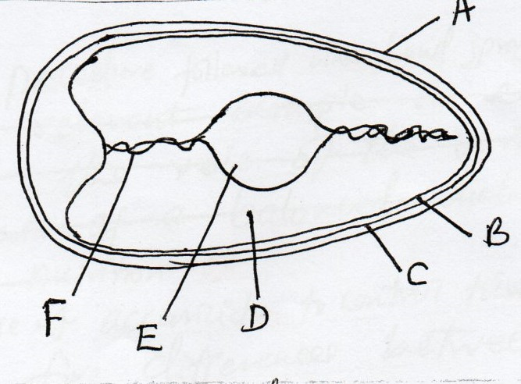
(a). Name the part labelled B,C,D and F. (2 marks)
B
C
D
F
(b). State two qualities of the part labelled A that should be considered when selecting egg for incubation. (2 marks)
(i) ……………………………………………………………………………………………….
(ii) ………………………………………………………………………………………………
(c). What is the function of the part labelled E in a fertilized egg? (1 mark)
________________________________________________________________________ ___________________________________________________________________________

SECTION C. (40 MARKS)

Answer any two questions in this section in space provided at the back..

24. (a). Describe the feeding of bees under bee keeping. (5 marks)
(b). Describe the management practices that a farmer should carry out to improve milk production in a low yielding herd of dairy cattle. (15 marks)

25. (a). Outline the procedure followed when hand spraying cattle to ensure effective use of accaricide to control ticks. (10 marks) (b). Outline five differences between exotic cattle breeds and indigenous cattle breed. (5 marks)
(c). Outline five qualities of a good grain store. (5 mark)

26. (a). Describe the role of the various components of a balanced diet in livestock nutrition.
(10 marks)

(b). Give five reasons of keeping livestock healthy. (5 marks)
____________________________________________________________________________________________________________________________________________________________________________________________________________________________________________________________________________________________________________________________________________________________________________________________________________________________________________________________________________________
(c). Outline five predisposing factors of mastitis in lactating cows. (5 marks)
____________________________________________________________________________________________________________________________________________________________________________________________________________________________________________________________________________________________________________________________________________________________________________________________________________________________________________________________________________________
______________________________________________________________________________________________________________________________________________________________________________________________________________________________________________________________________________________________________________________________________________________________________________________________________________________________________________________________________________________________________________________________________________________________________________________________________________________________________________________________________________________________________________________________________________________________________________________________________________________________________________________________________________________________________________________________________________________________________________________________________________________________________________________________________________________________________________________________________________________________________________________________________________________________________________________________________________________________________________________________________________________________________________________________________________________________________________________________________________________________________________________________________________________________________________________________________________________________________________________________________________________________________________________________________________________________________________________________________________________________________________________________________________________________________________________________________________________________________________________________________________________________________________________________________________________________________________________________________________________________________________________________________________________________________________________________________________________________________________________________________________________
______________________________________________________________________________
______________________________________________________________________________
______________________________________________________________________________
________________________________________________________________________________________________________________________________________________________________________________________________________________________________________________________________________________________________________________________________________________________________________________________________________________________________________________________________________________________________________________________________________________________________________________________________________________________________________________________________________________________________________________________________________________________________________________________________________________________________________________________________________________________________________________________________________________________________________________________________________________________________________________________________________________________________________________________________________________________________________________________________________________________________________________________________________________________________
______________________________________________________________________________
______________________________________________________________________________
______________________________________________________________________________
________________________________________________________________________________________________________________________________________________________________________________________________________________________________________________________________________________________________________________________________________________________________________________________________________________________________________________________________________________________________________________________________________________________________________________________________________________________________________________________________________________________________________________________________________________________________________________________________________________________________________________________________________________________________________________________________________________________________________________________________________________________________________________________________________________________________________________________________________________________________________________________________________________________________________________________________________________________________
______________________________________________________________________________
______________________________________________________________________________
______________________________________________________________________________
______________________________________________________________________________
______________________________________________________________________________
________________________________________________________________________________________________________________________________________________________________________________________________________________________________________________________________________________________________________________________________________________________________________________________________________________________________________________________________________________________________________________________________________________________________________________________________________________________________________________________________________________________________________________________________________________________________________________________________________________________________________________________________________________________________________________________________________________________________________________________________________________________________________________________________________________________________________________________________________________________________________________________________________________________________________________________________________________________________________________________________________________________________________________________________________________________________________________________________________________________________________________________________________________________________________________________________________________________________________________________________________________________________________________________________________________________________________________________________________________________________________________________________________________________________________________________________________________
______________________________________________________________________________
______________________________________________________________________________
______________________________________________________________________________
____________________________________________________________________________________________________________________________________________________________________________________________________________________________________________________________________________________________________________________________________________________________________________________________________________________________________________________________________________________
______________________________________________________________________________
______________________________________________________________________________
________________________________________________________________________________________________________________________________________________________________________________________________________________________________________________________________________________________________________________________
______________________________________________________________________________
______________________________________________________________________________
________________________________________________________________________________________________________________________________________________________________________________________________________________________________________________________________________________________________________________________
______________________________________________________________________________
______________________________________________________________________________
____________________________________________________________________________________________________________________________________________________________
______________________________________________________________________________
______________________________________________________________________________
____________________________________________________________________________________________________________________________________________________________
______________________________________________________________________________
______________________________________________________________________________
____________________________________________________________________________________________________________________________________________________________
______________________________________________________________________________
______________________________________________________________________________
____________________________________________________________________________________________________________________________________________________________
______________________________________________________________________________
______________________________________________________________________________
____________________________________________________________________________________________________________________________________________________________
______________________________________________________________________________
______________________________________________________________________________
____________________________________________________________________________________________________________________________________________________________
______________________________________________________________________________
______________________________________________________________________________
___________________________________________________________________________________________________________________________________________________________
______________________________________________________________________________
______________________________________________________________________________
______________________________________________________________________________
____________________________________________________________________________________________________________________________________________________________
______________________________________________________________________________
______________________________________________________________________________
____________________________________________________________________________________________________________________________________________________________
______________________________________________________________________________
______________________________________________________________________________
___________________________________________________________________________________________________________________________________________________________
______________________________________________________________________________
______________________________________________________________________________
______________________________________________________________________________
____________________________________________________________________________________________________________________________________________________________
______________________________________________________________________________
______________________________________________________________________________
____________________________________________________________________________________________________________________________________________________________
______________________________________________________________________________
______________________________________________________________________________
______________________________________________________________________________
___________________________________________________________________________________________________________________________________________________________
______________________________________________________________________________
______________________________________________________________________________
______________________________________________________________________________
____________________________________________________________________________________________________________________________________________________________
______________________________________________________________________________
______________________________________________________________________________
____________________________________________________________________________________________________________________________________________________________
______________________________________________________________________________
______________________________________________________________________________
______________________________________________________________________________
___________________________________________________________________________________________________________________________________________________________
______________________________________________________________________________
______________________________________________________________________________
______________________________________________________________________________
____________________________________________________________________________________________________________________________________________________________
______________________________________________________________________________

