OPENER EXAMINATION YEAR 2021 TERM 2
NAME __________________________________ADM NO._____________CLASS………….
FORM 3
443/1 AGRICULTURE
PAPER 1
TIME: 2 HOURS

SECTION A (30MARKS)
Answer ALL the questions in the spaces provided
- Give four biotic factors which influence Agriculture positively. (2 marks)
_______________________________________________________________________________________________________________________________________________________________________________________________________________________________________________________________________________________________________________________________________________________________________________________________________________________________
- State two farming practices which enhance organic farming. (1 mark)
_________________________________________________________________________________________________________________________________________________________________________________________________________________________________________________________
- Which chemical are used during water treatment to; (1½ marks)
- Coagulate solid particles _____________________________________________________________
- Soften the water _____________________________________________________________
- Kill pathogens _____________________________________________________________
- Give two reasons that makes phosphatic fertilizers good for use during planting time. (1 mark)
_________________________________________________________________________________________________________________________________________________________________________________________________________________________________________________________
- List down four qualities of a good farm record. (2 marks)
_______________________________________________________________________________________________________________________________________________________________________________________________________________________________________________________________________________________________________________________________________________________________________________________________________________________________
- What do you understand by the following terms? (1½ marks)
- Seed dressing
______________________________________________________________________________________________________________________________________________________________________
- Seed inoculation
______________________________________________________________________________________________________________________________________________________________________
- Chitting
______________________________________________________________________________________________________________________________________________________________________
State three problems associated with land fragmentation in Kenya? (1½ marks)
____________________________________________________________________________________________________________________________________________________________________________________________________________________________________________________________________________________________________________________________________________
- Outline four land Reforms Programmes which have been carried out in Kenya since independence. (2 marks)
_______________________________________________________________________________________________________________________________________________________________________________________________________________________________________________________________________________________________________________________________________________________________________________________________________________________________
- List down four common methods of harvesting water. (2 marks)
_______________________________________________________________________________________________________________________________________________________________________________________________________________________________________________________________________________________________________________________________________________________________________________________________________________________________
- Give three methods of breaking seed dormancy. (1½ marks)
____________________________________________________________________________________________________________________________________________________________________________________________________________________________________________________________________________________________________________________________________________
- What do you understand by the following terms as used in pests classification according to mode of action. (2 marks)
- Stomach poisons
______________________________________________________________________________________________________________________________________________________________________
- Systemic poisons
______________________________________________________________________________________________________________________________________________________________________
- Contact poisons
______________________________________________________________________________________________________________________________________________________________________
- Suffocants

12.Give two reasons why farmers are encouraged to practice organic farming. (1 mark)
________________________________________________________________________________________________________________________________________________________________________
13.State three advantages of shifting cultivation. (1½ marks)
____________________________________________________________________________________________________________________________________________________________________________________________________________________________________________________________
14.List four methods of farming. (2 marks)
________________________________________________________________________________________________________________________________________________________________________________________________________________________________________________________________________________________________________________________________________________
15.Outline three effects of soil organisms which benefit crop growth. (1½ marks)
____________________________________________________________________________________________________________________________________________________________________________________________________________________________________________________________
16.State two harmful effects of strong wind on crop production. (1 mark)
________________________________________________________________________________________________________________________________________________________________________
17.State three advantages of adding organic matter to sandy soil. (1½ marks)
____________________________________________________________________________________________________________________________________________________________________________________________________________________________________________________________
18.State three ways by which biological agents can enhance the process of soil formation. (1½ marks)
____________________________________________________________________________________________________________________________________________________________________________________________________________________________________________________________
19.Outline four main reasons for secondary tillage. (2 marks)
________________________________________________________________________________________________________________________________________________________________________________________________________________________________________________________________________________________________________________________________________________
SECTION B (20 MARKS)
Answer ALL the questions in the spaces provides
20.Below are two types of soil structures A and B.
A
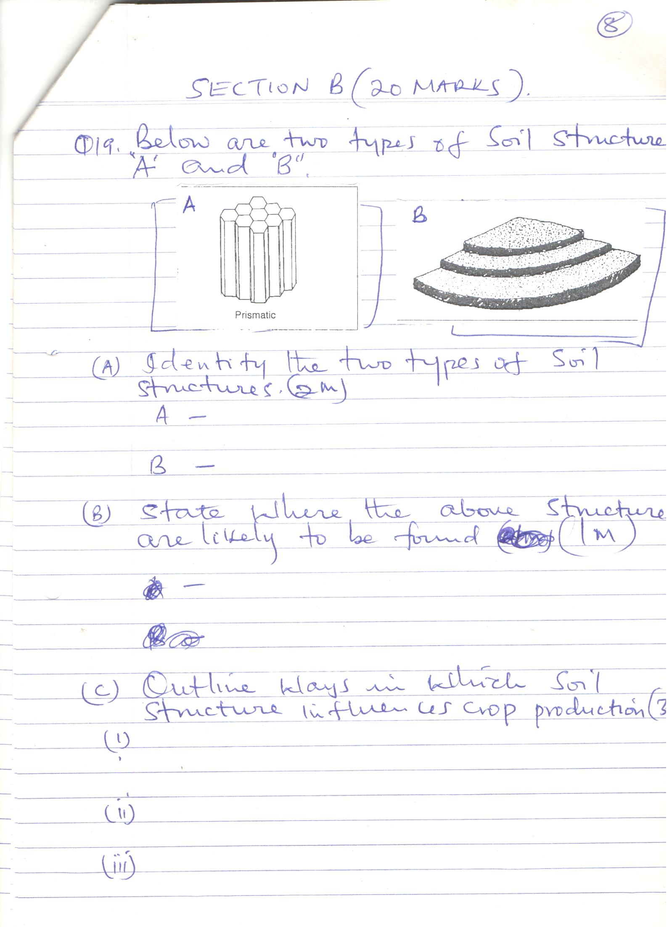

B
- Identify the two- types of soil structures. (2 marks)
A _________________________________________________________________________________
B _________________________________________________________________________________
- State where the above soil structures are likely to be found. (1 mark)
___________________________________________________________________________________
- Outline ways which soil structure influences crop production. (3 marks)
21 a) Study the diagram below and answer the questions that follow.
i) What is layering? (1 mark)
______________________________________________________________________________________________________________________________________________________________________
ii) Identify the type of layering shown below. (1 mark)
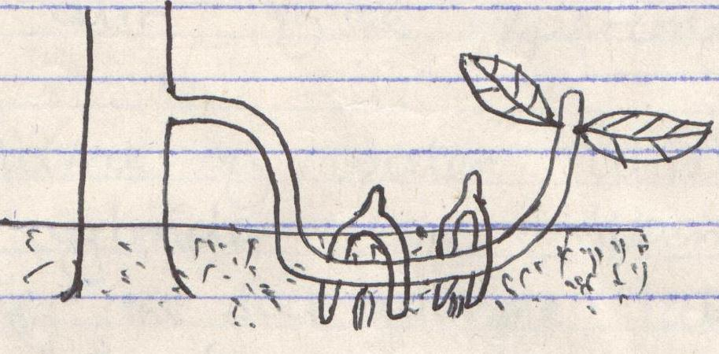
- Give two advantages of tissue culture in crop production. (2 marks)
____________________________________________________________________________________________________________________________________________________________________________________________________________________________________________________________________________________________________________________________________________

22a) Maize requires 120kg/ha of phosphorus pentoxide (P₂O₅). How much of the compound
fertilizer 20:20:10 would be applied to 0.4 hectare of land to achieve this rate.
(show your working). (3 marks)

b) Distinguish between straight fertilizers and compound fertilizers. (2 marks)
____________________________________________________________________________________________________________________________________________________________________________________________________________________________________________________________________________________________________________________________________________
23.The diagram below shows a cabbage seedling which has been attacked by a certain pest.
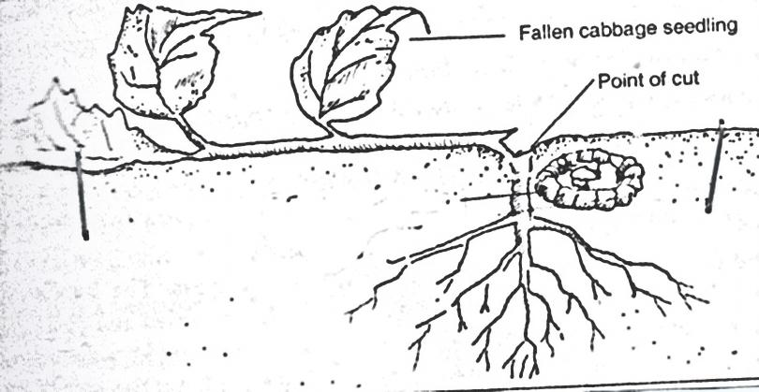
Point of cut
Fallen cabbage seedling
- Identify the pest (1 mark)
___________________________________________________________________________________
- State three methods of controlling the above pest (3 marks)
________________________________________________________________________________________________________________________________________________________________________

SECTION C (40MARKS)
Answer any TWO questions in this section in the spaces provided after question 25
24.a) Outline the factors affecting rooting of cuttings. (5 marks)
b) State and explain human factors that influence Agricultural production. (10 marks)
c) Highlight the management practices carried out in a nursery. (5 marks)

25.a) State and explain five ways through which soil loses its fertility. (10 marks)
b) Describe five characteristics of Nitrogenous fertilizers. (5 marks)
c) Outline five methods used in application of inorganic fertilizers. (5 marks)
26.a) Explain seven cultural methods of controlling crop diseases. (7 marks)
b) Describe precautions taken during the harvesting of coffee. (4 marks)
c) Given that a crop of cabbage is planted at a spacing of 60cm × 60cm, calculate the plant
population in a plot of land measuring 4m × 3m. (show your working). (4 marks)
d) Give five factors that determine spacing of cabbages in the field. (5 marks)

____________________________________________________________________________________________________________________________________________________________________________________________________________________________________________________________________________________________________________________________________________________________________________________________________________________________________________________________________________________________________________________________________________________________________________________________________________________________________________________________________________________________________________________________________________________________________________________________________________________________________________________________________________________________________________________________________________________________________________________________________________________________________________________________________________________________________________________________________________________________________________________________________________________________________________________________________________________________________________________________________________________________________________________________________________________________________________________________________________________________________________________________________________________________________________________________________________________________________________________________________________________________________________________________________________________________________________________________________________________________________________________________________________________________________________________________________________________________________________________________________________________________________________________________________________________________________________________________________________________________________________________________________________________________________________________________________________________________________________________________________________________________________________________________________________________________________________________________________________________________________________________________________________________________________________________________________________________________________________________________________________________________________________________________________________________________________________________________________________________________________________________________________________________________________________________________________________________________________________________________________________________________________________________________________________________________________________________________________________________________________________________________________________________________________________________________________________________________________________________________________________________________________________________________________________________________________________________________________________________________________________________________________________________________________________________________________________________________________________________________________________________________________________________________________________________________________________________________________________________________________________________________________________________________________________________________________________________________________________________________________________________________________________________________________________________________________________________________________________________________________________________________________________________________________________________________________________________________________________________________________________________________________________________________________________________________________________________________________________________________________________________________________________________________________________________________________________________________________________________________________________________________________________________________________________________________________________________________________________________________________________________________________________________________________________________________________________________________________________________________________________________________________________________________________________________________________________________________________________________________________________________________________________________________________________________________________________________________________________________________________________________________________________________________________________________________________________________________________________________________________________________________________________________________________________________________________________________________________________________________________________________________________________________________________________________________________________________________________________________________________________________________________________________________________________________________________________________________________________________________________________________________________________________________________________________________________________________________________________________________________________________________________________________________________________________________________________________________________________________________________________________________________________________________________________________________________________________________________________________________________________________________________________________________________________________________________________________________________________________________________________________________________________________________________________________________________________________________________________________________________________________________________________________________________________________________________________________________________________________________________________________________________________________________________________________________________________________________________________________________________________________________________________________________________________________________________________________________________________________________________________________________________________________________________________________________________________________________________________________________________________________________________________________________________________________________________________________________________________________________________________________________________________________________________________________________________________________________________________________________________________________________________________________________________________________________________________________________________________________________________________________________________________________________________________________________________________________________________________________________________________________________________________________________________________________________________________________________________________________________________________________________________________________________________________________________________________________________________________________________________________________________________________________________________________________________________________________________________________________________________________________________________________________________________________________________________________________________________________________________________________________________________________________________________________________________________________________________________________________________________________________________________________________________________________________________________________________________________________________________________________________________________________________________________________________________________________________________________________________________________________________________________________________________________________________________________________________________________________________________________________________________________________________________________________________________________________________________________________________________________________________________________________________________________________________________________________________
____________________________________________________________________________________________________________________________________________________________________________________________________________________________________________________________________________________________________________________________________________________________________________________________________________________________________________________________________________________________________________________________________________________________________________________________________________________________________________________________________________________________________________________________________________________________________________________________________________________________________________________________________________________________________________________________________________________________________________________________________________________________________________________________________________________________________________________________________________________________________________________________________________________________________________________________________________________________________________________________________________________________________________________________________________________________________________________________________________________________________________________________________________________________________________________________________________________________________________________________________________________________________________________________________________________________________________________________________________________________________________________________________________________________________________________________________________________________________________________________________________________________________________________________________________________________________________________________________________________________________________________________________________________________________________________________________________________________________________________________________________________________________________________________________________________________________________________________________________________________________________________________________________________________________________________________________________________________________________________________________________________________________________________________________________________________________________________________________________________________________________________________________________________________________________________________________________________________________________________________________________________________________________________________________________________________________________________________________________________________________________________________________________________________________________________________
________________________________________________________________________________________________________________________________________________________________________________________________________________________________________________________________________________________________________________________________________________________________________________________________________________________________________________________________________________________________________________________________________________________________________________________________________________________________________________________________________________________________________________________

