NAME ……………………………….....…… ADM NO…………… CLASS…………
SCHOOL …………………………………… SIGN………………… DATE……..……
443/1
AGRICULTURE
PAPER 1
DECEMBER, 2020
TIME: 2 HOURS

LANET CLUSTER JOINT EXAMINATION (LANJET) -2020
443/1
AGRICULTURE
PAPER 1
DECEMBER, 2020
TIME: 2 HOURS

INSTRUCTIONS TO CANDIDATES
- Write your name, index number and class in the spaces provided above.
- This paper consists of THREE SECTIONS, A, B and C.
- Answer all questions in sections A and B and two questions in section C.
- All your answers must be written in the spaces provided in this question paper.
FOR EXAMINERS USE ONLY
SECTION | QUESTIONS | MAXIMUM SCORE | CANDIDATES SCORE
A | 1-17 | 30
B | 18-21 | 20
C | 22-24 | 40
TOTAL |  | 90

This paper consists of 12 printed pages. Candidates should check the question paper to ascertain that all pages are printed as indicated and that no pages are missing
SECTION A (30 MARKS)
Answer all questions from this section
- What do the following terms mean? (1 ½ mks)
- Gross domestic product (G.D.P)
……………………………………………………………………………………………….
……………………………………………………………………………………………….
- Gross national income (GNI)
……………………………………………………………………………………………….
……………………………………………………………………………………………….
- Per capita income
……………………………………………………………………………………………….
……………………………………………………………………………………………….

- a) What does the term opportunity cost in farming mean? (1mk)
……………………………………………………………………………………………….
……………………………………………………………………………………………….

b) State two situations when opportunity cost is nil or zero (2mks)
……………………………………………………………………………………………….
……………………………………………………………………………………………….

- List four advantages of individual owner tenure system (2mks)
……………………………………………………………………………………………….
……………………………………………………………………………………………….
……………………………………………………………………………………………….
……………………………………………………………………………………………….

4. State two ways to show how check dams reduce soils erosion (1mks)
5. Identify four soil constituents. (2mk)
……………………………………………………………………………………………….
……………………………………………………………………………………………….
……………………………………………………………………………………………….
……………………………………………………………………………………………….

6. Mention four ways of classifying herbicides (2mks)
……………………………………………………………………………………………….
……………………………………………………………………………………………….
……………………………………………………………………………………………….
……………………………………………………………………………………………….

7 (a) List two ways of controlling smut disease in the field. (1mk)
……………………………………………………………………………………………….
……………………………………………………………………………………………….
(b) Name any two pests that attack bean pods in the field (1mk)
……………………………………………………………………………………………….
……………………………………………………………………………………………….

8. What four factors should a farmer consider for effective control of pests in the field ……………………………………………………………………………………………….
……………………………………………………………………………………………….
……………………………………………………………………………………………….
……………………………………………………………………………………………….
(2mks)

9. Mr. Wotsula Applied 150kg N.P.K 25:20:15 to his one hectare of groundnuts in his Kakamega
farm. Calculate how many kilograms of each of the fertilizer element he applied. (3mks)

10.State five marketing functions (2 ½mks)
……………………………………………………………………………………………….
……………………………………………………………………………………………….
……………………………………………………………………………………………….
……………………………………………………………………………………………….
……………………………………………………………………………………………….

11. State five functions of cooperative societies (2½ mks)
……………………………………………………………………………………………….
……………………………………………………………………………………………….
……………………………………………………………………………………………….
……………………………………………………………………………………………….
……………………………………………………………………………………………….

12. List three characteristics of green manure crops (1 ½ mks)
……………………………………………………………………………………………….
……………………………………………………………………………………………….
……………………………………………………………………………………………….

13.Name three types of water pumps to be used on the farm. (1 ½ mks)
……………………………………………………………………………………………….
……………………………………………………………………………………………….
……………………………………………………………………………………………….
14. Name four species of trees commonly used in agroforestry (2mks)
……………………………………………………………………………………………….
……………………………………………………………………………………………….
……………………………………………………………………………………………….
……………………………………………………………………………………………….
15. List four factors that determine the competitive ability of weeds (2 mks)
……………………………………………………………………………………………….
……………………………………………………………………………………………….
……………………………………………………………………………………………….
……………………………………………………………………………………………….

SECTION B: (20 MARKS)
Answer all questions in this section
16. The diagrams labeled A_{1,} A₂, A_{3,} and B below illustrate materials and methods of vegetative
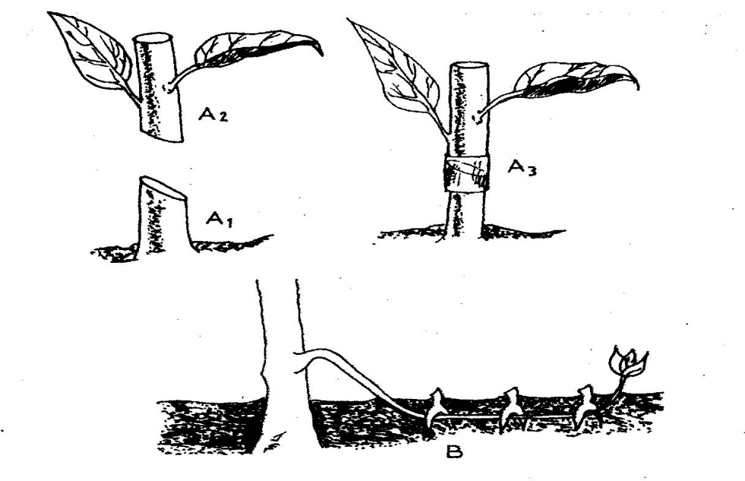
propagation. Study them and answer the questions that follow.

(a) Name the parts labeled A₁, and A₂ (2 mks)
A₁ ₋ ……………………………………………………………………………………………….
A₂ ₋ ……………………………………………………………………………………………….

(b) Name the methods of propagation illustrated in diagrams A₃ and B (2 mks)
A₃ …………………………………………………………………………………………..….
B- ……………………………………………………………………………………………….

17. The diagram below illustrates some soil structures. Study it and answer the questions that follow.
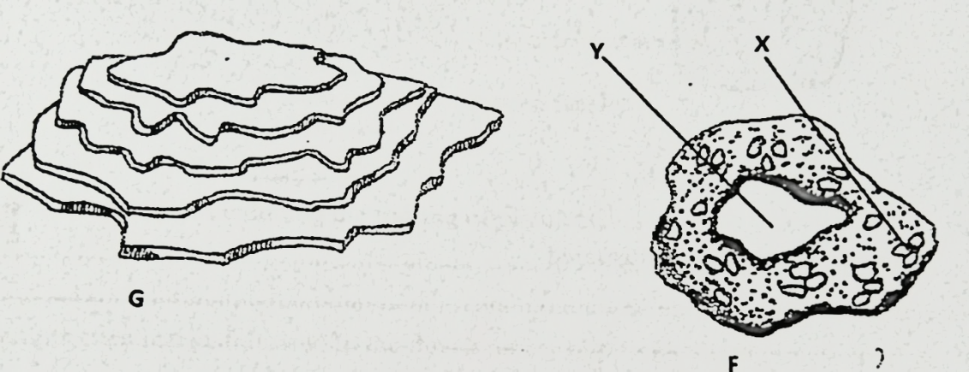

- Identify the soil structures F and G (2mks)
……………………………………………………………………………………………….

- Name the parts labeled X and Y in diagram F (1mk)
……………………………………………………………………………………………….
……………………………………………………………………………………………….
……………………………………………………………………………………………….

- Sate two ways through which structure G influences crop production (2mks)
……………………………………………………………………………………………….
……………………………………………………………………………………………….

18. Below is an illustration of a maize cob attacked by smut disease. Study it carefully and
answer the questions that follow:
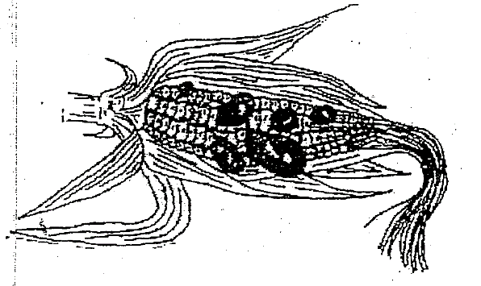

a) Beside what is visible on the maize cob, state two other symptoms of the disease (2mks) …………………………………………………………………………………………….
………………………………………………………………………………………….
b) State three control measures of the above disease. (3mks)
……………………………………………………………………………………………….
……………………………………………………………………………………………….
……………………………………………………………………………………………….
19. The diagram below shows a set up used to study an aspect of soil. The set up was left undisturbed
for five hours. Study it and answer the questions that follow.
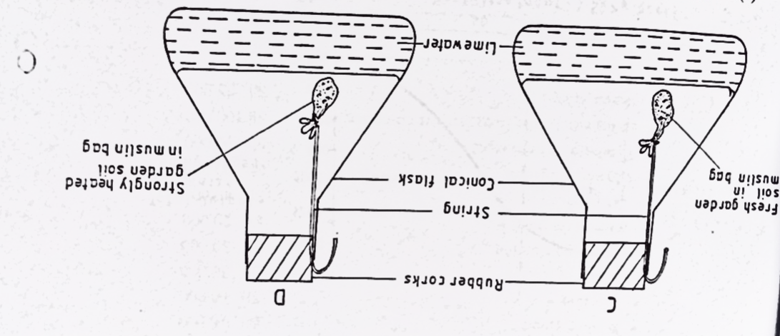
- What was the aim of the experiment? (1mk)
……………………………………………………………………………………………….
- State one observation that was made in each of the flasks labelled C and D (2mks)

C- …………………………………………………………….……………………….

D-……………………………………………………………………………………….
- Give a reason for your answer in (b) above (2mks)
……………………………………………………………………………………………….
- Apart from the aspect under the study above, state any other soil component that could be studied
(1mk)
……………………………………………………………………………………………….
…………….……………………………………………………………………………….

SECTION C: (40 MARKS)
Answer any TWO questions from this section
20. The following table shows an illustration of production of maize (in tons) using various levels of
inputs.
Units of variable input (Man hours) | Total output of maize  (Tons) | Marginal Product | Average product
0 | 0
1 | 6
2 | 18
3 | 33
4 | 40
5 | 45
6 | 48
7 | 48
8 | 40
- Work out the marginal product and average product and fill in the table (9mks)
- On the same graph paper, plot the graph showing total output, marginal product and average product against variable input (8mks)
- On the graph draw lines to show the following zones (3mks)
- Increasing return production function
- Decreasing return Production function
- Diminishing return production function

21(a) Outline five benefits of trees and shrubs to the economic wellbeing of Kenyans (5mks)
b) Explain 7 ways on how farmers overcome risks and uncertainties in a farming business (7mks)
c) Explain the factors that influence the type of irrigation to be used in a farm (8 mks)

22 (a) State the principles involved in planning a crop rotation programme. (6mks)
(b) Discuss the production of maize under the following subheadingsMaize
I Seedbed preparation (2mks)
- Planting (2mks)
- Weed control (2mks)
- Field management practices (2mks)
- Pests control (2mks)
- Disease control (2mks)
- Harvesting (2mks)
……………………………………………………………………………………………….
……………………………………………………………………………………………….
……………………………………………………………………………………………….
……………………………………………………………………………………………….
……………………………………………………………………………………………….
……………………………………………………………………………………………….
……………………………………………………………………………………………….
……………………………………………………………………………………………….
……………………………………………………………………………………………….
……………………………………………………………………………………………….
……………………………………………………………………………………………….
……………………………………………………………………………………………….
……………………………………………………………………………………………….
……………………………………………………………………………………………….
……………………………………………………………………………………………….
……………………………………………………………………………………………….
……………………………………………………………………………………………….
……………………………………………………………………………………………….
……………………………………………………………………………………………….
……………………………………………………………………………………………….
……………………………………………………………………………………………….
……………………………………………………………………………………………….
……………………………………………………………………………………………….
……………………………………………………………………………………………….
……………………………………………………………………………………………….
……………………………………………………………………………………………….
……………………………………………………………………………………………….
……………………………………………………………………………………………….
……………………………………………………………………………………………….
……………………………………………………………………………………………….
……………………………………………………………………………………………….
……………………………………………………………………………………………….
……………………………………………………………………………………………….
……………………………………………………………………………………………….
……………………………………………………………………………………………….
……………………………………………………………………………………………….
……………………………………………………………………………………………….
……………………………………………………………………………………………….
……………………………………………………………………………………………….
……………………………………………………………………………………………….
……………………………………………………………………………………………….
……………………………………………………………………………………………….
……………………………………………………………………………………………….
……………………………………………………………………………………………….
……………………………………………………………………………………………….
……………………………………………………………………………………………….
……………………………………………………………………………………………….
……………………………………………………………………………………………….
……………………………………………………………………………………………….
……………………………………………………………………………………………….
……………………………………………………………………………………………….
……………………………………………………………………………………………….
……………………………………………………………………………………………….
……………………………………………………………………………………………….
……………………………………………………………………………………………….
……………………………………………………………………………………………….
……………………………………………………………………………………………….
……………………………………………………………………………………………….
……………………………………………………………………………………………….
……………………………………………………………………………………………….
……………………………………………………………………………………………….
……………………………………………………………………………………………….
……………………………………………………………………………………………….
……………………………………………………………………………………………….
……………………………………………………………………………………………….
……………………………………………………………………………………………….
……………………………………………………………………………………………….
……………………………………………………………………………………………….
……………………………………………………………………………………………….
……………………………………………………………………………………………….
……………………………………………………………………………………………….
……………………………………………………………………………………………….
……………………………………………………………………………………………….
……………………………………………………………………………………………….
……………………………………………………………………………………………….
……………………………………………………………………………………………….
……………………………………………………………………………………………….
……………………………………………………………………………………………….
……………………………………………………………………………………………….
……………………………………………………………………………………………….
……………………………………………………………………………………………….
……………………………………………………………………………………………….

