NAME………………………...……………….… ADM.NO……..…… CLASS/STREAM……….…… SCHOOL……….…………
SIGNATURE………………………. DATE ……….……………

443/1
AGRICULTURE
PAPER 1
Time: 2 HOURS

MAGS JOINT EXAMINATION

CYCLE 7 MARCH TERM 1 2020

INSTRUCTION TO CANDIDATES

- This paper consists of THREE sections: A, B and C.
- Answer ALL questions in section A.and B
- ANY Two questions from section C.

SECTION | MARKS | CAND. SCORE
A | 30
B | 20
C | 40
TOTAL SCORE | 90

SECTION A (30MKS)
Answer all the questions from this section in the spaces provided.

- Give two characteristics of plantation farming. (1mk)

…………………………………………………………………………………………………………………………….
…………………………………………………………………………………………………………………………….
- Name two chemical processes of weathering. (1mk)

…………………………………………………………………………………………………………………………….
…………………………………………………………………………………………………………………………….
- State two advantages of organic farming. (1mk)

…………………………………………………………………………………………………………………………….
…………………………………………………………………………………………………………………………….

- Outline two effects of soil organisms which benefit plant growth. (1mk)

…………………………………………………………………………………………………………………………….
…………………………………………………………………………………………………………………………….

- Give two ways in which organic mulch help to conserve water in the soil. (1mk)

…………………………………………………………………………………………………………………………….
…………………………………………………………………………………………………………………………….
- Give two types of labour records. (1mk)

…………………………………………………………………………………………………………………………….
…………………………………………………………………………………………………………………………….

- Outline four ways in which land consolidation helps to improve farm management. (2mks)

…………………………………………………………………………………………………………………………….
…………………………………………………………………………………………………………………………….
- State four importance of raising seedlings in a nursery bed. (2mks)

…………………………………………………………………………………………………………………………….
…………………………………………………………………………………………………………………………….
…………………………………………………………………………………………………………………………….
…………………………………………………………………………………………………………………………….
- Give four ways of controlling weeds in a field of maize. (2mks)

…………………………………………………………………………………………………………………………….
…………………………………………………………………………………………………………………………….
…………………………………………………………………………………………………………………………….
…………………………………………………………………………………………………………………………….
- State three reasons for top dressing pasture. ( 1¹/₂mks)

…………………………………………………………………………………………………………………………….
…………………………………………………………………………………………………………………………….
…………………………………………………………………………………………………………………………….

- Give four reasons for training crops as a field practice . ( 2mks)

…………………………………………………………………………………………………………………………….
…………………………………………………………………………………………………………………………….
…………………………………………………………………………………………………………………………….
…………………………………………………………………………………………………………………………….

- State three activities the farmer carries out on a store before storing grains. (1¹/₂mks)

…………………………………………………………………………………………………………………………….
…………………………………………………………………………………………………………………………….
…………………………………………………………………………………………………………………………….
…………………………………………………………………………………………………………………………….

- Give four desirable characteristics of certified seeds. (2mks)

…………………………………………………………………………………………………………………………….
…………………………………………………………………………………………………………………………….
…………………………………………………………………………………………………………………………….
…………………………………………………………………………………………………………………………….

- (a) Outline two characteristics of nitrogenous fertilizers. (1mk)

…………………………………………………………………………………………………………………………….
…………………………………………………………………………………………………………………………….

(b) Give the forms in which the following elements are available to plants: (1mk)

- Phosphorous: ……………………………………….

- Potassium: ………………………………………

- Give four factors that influence the choice of tools and equipment used in Primary cultivation. (2mks)

…………………………………………………………………………………………………………………………….
…………………………………………………………………………………………………………………………….
…………………………………………………………………………………………………………………………….
…………………………………………………………………………………………………………………………….
- State four factors that contribute to competitive ability of weeds. (2mks)

…………………………………………………………………………………………………………………………….
…………………………………………………………………………………………………………………………….
…………………………………………………………………………………………………………………………….
…………………………………………………………………………………………………………………………….

- Define the following terms as used in crop production.
(a) Trelishing (1mk)

…………………………………………………………………………………………………………………………….
…………………………………………………………………………………………………………………………….
(b) Stooking (1mk)
…………………………………………………………………………………………………………………………….
…………………………………………………………………………………………………………………………….
- Give two advantages of strip grazing (1mk)
…………………………………………………………………………………………………………………………….
…………………………………………………………………………………………………………………………….
- State four advantages of mixed pasture. (2mks)
…………………………………………………………………………………………………………………………….
…………………………………………………………………………………………………………………………….
…………………………………………………………………………………………………………………………….
…………………………………………………………………………………………………………………………….
SECTION B. (20 MARKS)
Answer ALL questions in this section in the spaces provided

- Study the diagram below and answer the questions that follow. The illustrations represent a method of crop propagation.
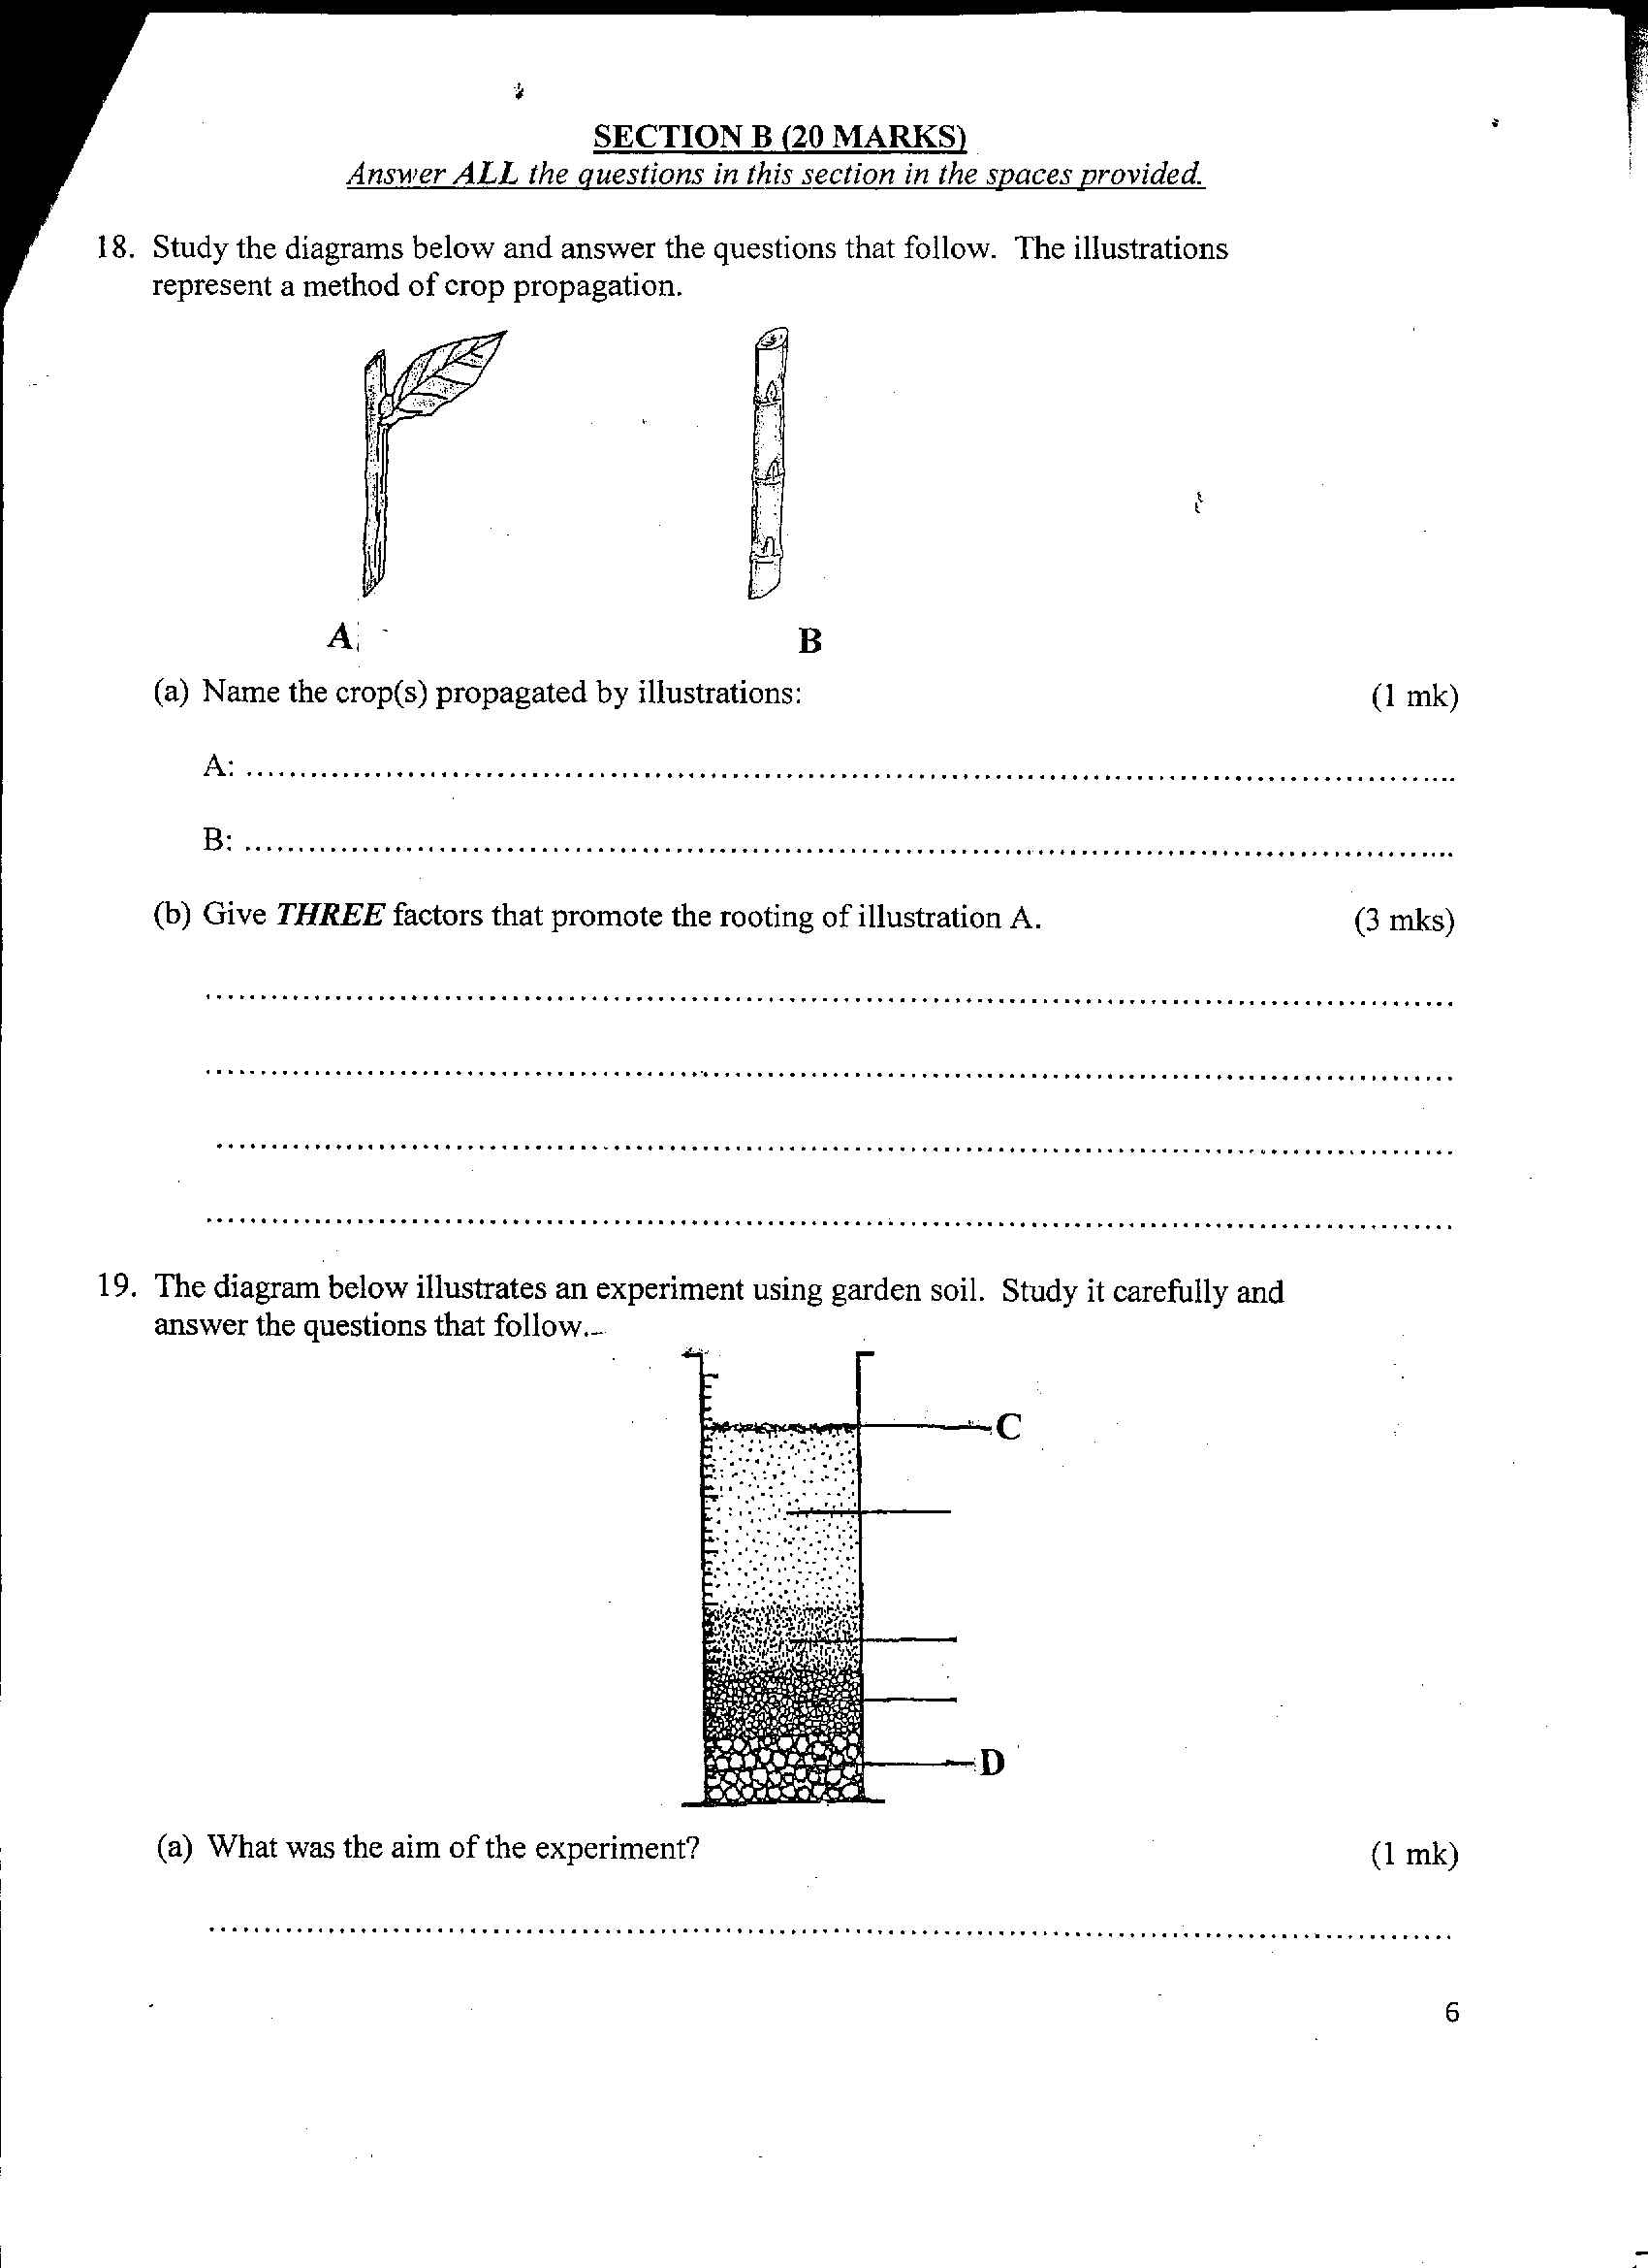

(a) Name the crops (s) propagated by illustrations: (1mrk)

…………………………………………………………………………………………………………………………….
…………………………………………………………………………………………………………………………….
(b) Give three factors that promote the rooting of illustration A. (3mrks)

…………………………………………………………………………………………………………………………….
…………………………………………………………………………………………………………………………….
…………………………………………………………………………………………………………………………….
…………………………………………………………………………………………………………………………….

- The diagram below illustrates an experiment using garden soil. Study it carefully and answer the question that follow.

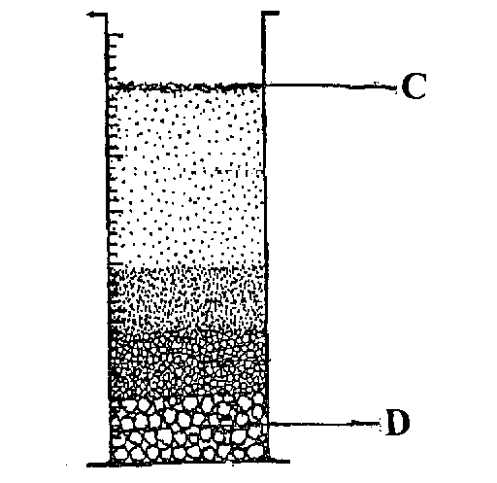

(a) What was the aim of the experiment? (1mrk)

…………………………………………………………………………………………………………………………….
…………………………………………………………………………………………………………………………….

(b) Name the parts labeled C and D. (2mrks)

C…………………………………………………………………………………………………………………………….
D…………………………………………………………………………………………………………………………….

(c) Name the property of soil being investigated. (1mrk)

…………………………………………………………………………………………………………………………….
…………………………………………………………………………………………………………………………….

- The illustration below shows a type of soil erosion. Study it carefully and answer the questions that follow.
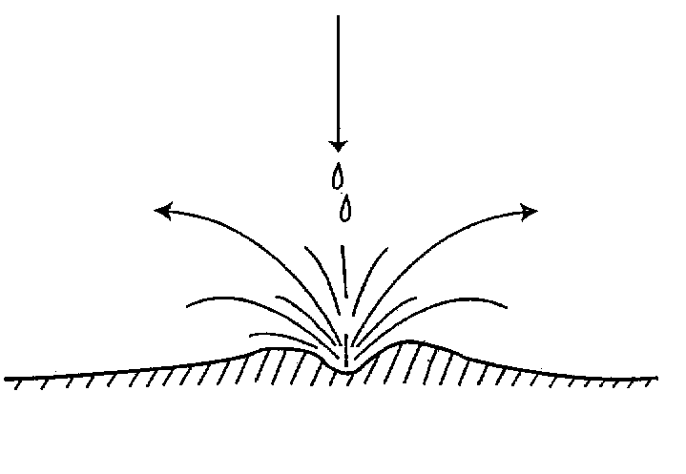

(a) Identify the type of erosion illustrated. (1mrk)

…………………………………………………………………………………………………………………………….

(b) Give two soil factors that influence the rate of soil erosion. (2mrks)

…………………………………………………………………………………………………………………………….
…………………………………………………………………………………………………………………………….

(c) Name one agent of soil erosion. (1mrk)

…………………………………………………………………………………………………………………………….

- The diagram below illustrate a method of irrigation carried out on the farm
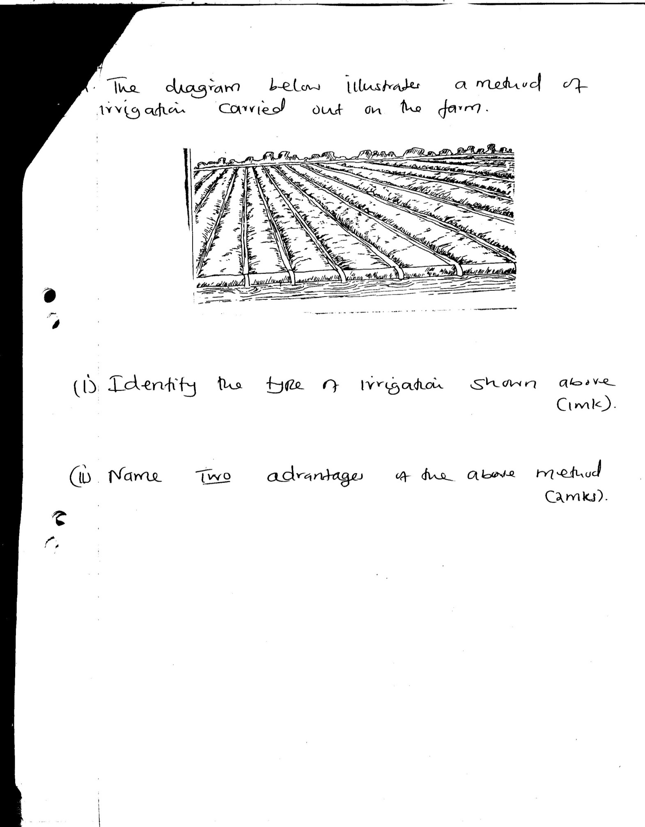

(i) Identify the type of irrigation shown above. (1mk)

…………………………………………………………………………………………………………………………….

(ii) Name two advantages of the above method. (2mks)

…………………………………………………………………………………………………………………………….
…………………………………………………………………………………………………………………………….

- The diagram below represent a method of manure preparation. Study it carefully and answer the questions that follow.
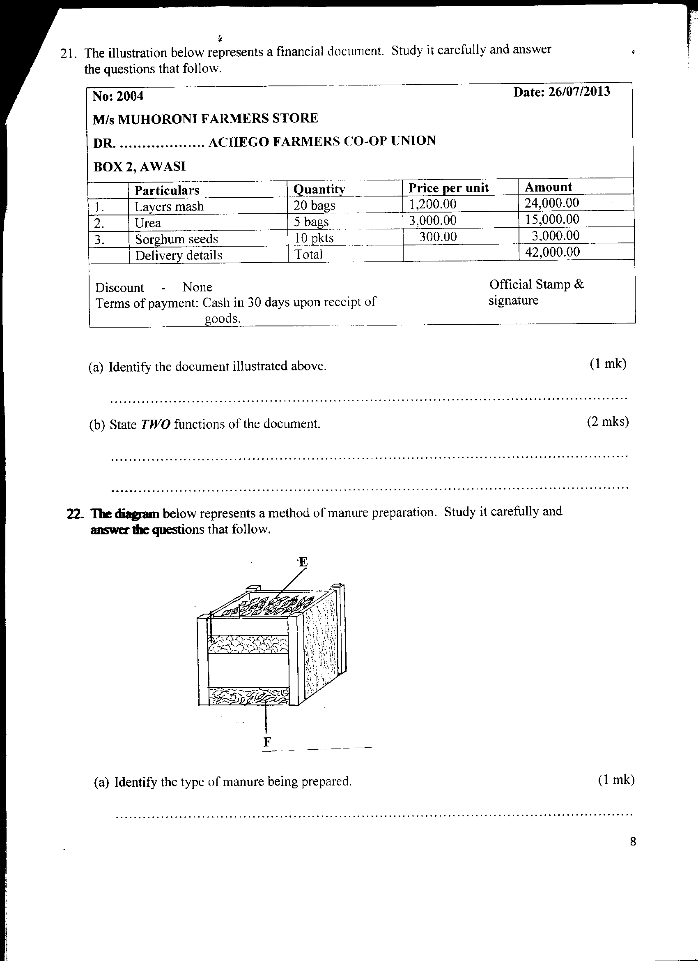

(a) Identify the type of manure being prepared. (1mrk)

…………………………………………………………………………………………………………………………….

(b) Name the parts labeled E and F. (1mrk) .

E…………………………………………………………………………………………………………………………….
F…………………………………………………………………………………………………………………………….

(c) Give three disadvantages of manures. (3mrks)

…………………………………………………………………………………………………………………………….
…………………………………………………………………………………………………………………………….
…………………………………………………………………………………………………………………………….
…………………………………………………………………………………………………………………………….

SECTION C (40MARKS)

Answer any TWO question from the section in the spaces provided

- (a) Give six precautions observed in pruning mature tea (6 mks)

…………………………………………………………………………………………………………………………….
…………………………………………………………………………………………………………………………….
…………………………………………………………………………………………………………………………….
…………………………………………………………………………………………………………………………….
…………………………………………………………………………………………………………………………….
…………………………………………………………………………………………………………………………….
…………………………………………………………………………………………………………………………….
…………………………………………………………………………………………………………………………….

(b) Describe the procedure followed when collecting a soil sample form the field for testing in the
laboratory (6 mks)

…………………………………………………………………………………………………………………………….
…………………………………………………………………………………………………………………………….
…………………………………………………………………………………………………………………………….
…………………………………………………………………………………………………………………………….
…………………………………………………………………………………………………………………………….
…………………………………………………………………………………………………………………………….
…………………………………………………………………………………………………………………………….
(c) Outline four advantages of intercropping crops (4 mks)

…………………………………………………………………………………………………………………………….
…………………………………………………………………………………………………………………………….
…………………………………………………………………………………………………………………………….
…………………………………………………………………………………………………………………………….

(d) State four factors considered before selecting a farm enterprise. (4 mks)

…………………………………………………………………………………………………………………………….
…………………………………………………………………………………………………………………………….
…………………………………………………………………………………………………………………………….
…………………………………………………………………………………………………………………………….

- Describe the production of tomatoes under the following sub-headings:

i) Ecological requirements of tomato plants (5mks)

…………………………………………………………………………………………………………………………….
…………………………………………………………………………………………………………………………….
…………………………………………………………………………………………………………………………….
…………………………………………………………………………………………………………………………….
…………………………………………………………………………………………………………………………….
…………………………………………………………………………………………………………………………….
…………………………………………………………………………………………………………………………….

ii) Land preparations (4mks)

…………………………………………………………………………………………………………………………….
…………………………………………………………………………………………………………………………….
…………………………………………………………………………………………………………………………….
…………………………………………………………………………………………………………………………….

iii) Transplanting (7mks)

…………………………………………………………………………………………………………………………….
…………………………………………………………………………………………………………………………….
…………………………………………………………………………………………………………………………….
…………………………………………………………………………………………………………………………….

iv) Disease control (4mks)

…………………………………………………………………………………………………………………………….
…………………………………………………………………………………………………………………………….
…………………………………………………………………………………………………………………………….
…………………………………………………………………………………………………………………………….

27. a) State five factors that influence soil productivity. (5mks)

…………………………………………………………………………………………………………………………….
…………………………………………………………………………………………………………………………….
…………………………………………………………………………………………………………………………….
…………………………………………………………………………………………………………………………….
…………………………………………………………………………………………………………………………….
…………………………………………………………………………………………………………………………….
…………………………………………………………………………………………………………………………….
…………………………………………………………………………………………………………………………….

b) State five qualities of mother plant used during grafting. (5mks)

…………………………………………………………………………………………………………………………….
…………………………………………………………………………………………………………………………….
…………………………………………………………………………………………………………………………….
…………………………………………………………………………………………………………………………….
…………………………………………………………………………………………………………………………….
…………………………………………………………………………………………………………………………….
…………………………………………………………………………………………………………………………….
…………………………………………………………………………………………………………………………….

c) Give two types of mulching materials. (2mks)

…………………………………………………………………………………………………………………………….
…………………………………………………………………………………………………………………………….
…………………………………………………………………………………………………………………………….
…………………………………………………………………………………………………………………………….

d) State four agricultural practices which pollute water. (4mks)

…………………………………………………………………………………………………………………………….
…………………………………………………………………………………………………………………………….
…………………………………………………………………………………………………………………………….
…………………………………………………………………………………………………………………………….

e) Describe precautions followed when harvesting coffee. (4mks)
…………………………………………………………………………………………………………………………….…………………………………………………………………………………………………………………………….…………………………………………………………………………………………………………………………….…………………………………………………………………………………………………………………………….…………………………………………………………………………………………………………………………….…………………………………………………………………………………………………………………………….…………………………………………………………………………………………………………………………….…………………………………………………………………………

