MAGS 2 CYCLE 7 2020
Name……………………………………….Index No……………………Class………….
Sign:………………….
443/2
AGRICULTURE
PAPER 2
2 Hours
INSTRUCTIONS TO THE CANDIDATES
-Write your name, admission number in the space provided above
-This paper consists of three sections: A, B and C. Answer all questions in sections A and B.
-Answer any two questions from section C
-Answers to all questions must be written in the spaces provided in this booklet.
FOR EXAMINER’S USE ONLY
SECTION | QUESTION | MAXIMUM SCORE | CANDIDATES SCORE
A | 1-17 | 30
B | 18-20 | 20
C | 21-23 | 20
C |  | 20
TOTAL |  | 90

SECTION A (30 Marks)
Answer all the questions in this section in the space provided.
SECTION A (30 MARKS)
Answer all questions in this section in the spaces provided.
- Name the camel breed with two humps. (1 mark)
……………………………………………………………………………………
2. List four disadvantages of animal drawn implements. (2 marks)
………………………………………………………………………………………
………………………………………………………………………………………
………………………………………………………………………………………
3. Name the vectors for each of the following livestock diseases. (2 marks)
- East coast fever……………………………………………………………………
- Rift valley fever…………………………………………………………………...
- Trypanosomiasis………………………………………………………………….
- Nairobi sheep disease……………………………………………………………...
4. Give four factors considered when selecting a site for fish pond. (2 marks)
………………………………………………………………………………………
………………………………………………………………………………………
………………………………………………………………………………………
………………………………………………………………………………………
5.List four implements that can be connected to the power take off shaft (PTO) of a Tractor. (2 marks)
………………………………………………………………………………………………………………………………………………………………………………..................................

6.State two methods of increasing the depth of penetration of a disc harrow. (2 marks)
…………………………………………………………………………………………………………………………………………………………………………………………................
7. (a) Name the tools used in ( 2 marks)
(i) Cutting curves on thin wood………………………………………
(ii)Measuring the inner diameter of a circular object/surface…………………………..
(iii)Cutting thin sheets of metal………………………………………………………
(iv)Tightening wires during fencing………………………………………………….

b) State two care and maintenance practices of masonry tools and equipment. (1 mark)
……………………………………………………………………………
……………………………………………………………………………
8. State four pre-disposing factors of mastitis disease in cattle. (2 marks)
………………………………………………………………………………………
………………………………………………………………………………………
………………………………………………………………………………………
……………………………………………………………………………………….
9. Outline four factors which would be considered when culling layers. (2 marks)
……………………………………………………………………………………………………………………………………………………………………………………………………………………………………………………………………………………………………………………………………………………………………………………………………….

10. Give three reasons for choosing corrugated iron sheets in roofing of farm stores instead of tiles. (3 marks)
………………………………………………………………………………………………………………………………………………………………………………………………………………………………………………………………………………………………………

11. What is the purpose of fixing a ring around nostrils of a bull. (1 mark)
………………………………………………………………………………………….…………………………………………………………………………………………………………
12. State one use of each of the following parts found in a tractor.
- Carburetor……………………………………………………………… (1 mark)
- Spark plug ……………………………………………………………… (1 mark)

13. Name the mineral whose deficiency symptom is Grass tetany in livestock. (½ mark)
…………………………………………………………………………………………
14. Give three post-milking activities in dairy cattle. (1½ marks) …………………………………………………………………………………………...
…………………………………………………………………………………………..
………………………………………………………………………………………….
15. Name two livestock diseases controlled by the same vaccine and name the (1½ marks) Vaccine ……………………………………………………………………..
(i) …………………………………………………………………………….
(ii) …………………………………………………………………………….
16. State the role of the following hormones in livestock production. (2 marks)
Prolactin………………………………………………………………………….
Oxytocin ……………………………………………………………………………
17. Name one parasite of bees. (½ mark)
…………………………………………………………………………………………….

SECTION B (20 Marks)
Answer all the questions from this section.
18.Diagram below show a plunge dip.

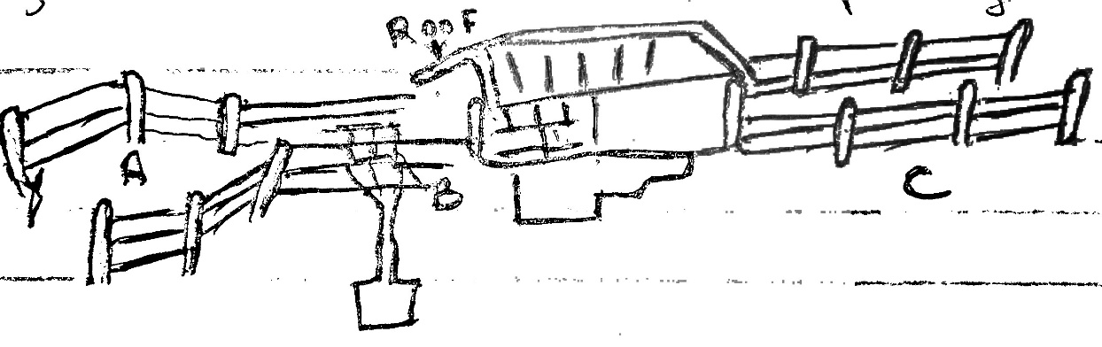

- Using a arrow on the diagram show the movement of cattle (½mark)

- State one use of parts A, B and C (3marks)
A……………………………………………………………………………………………
B……………………………………………………………………………………………
C……………………………………………………………………………………………
- State two precautions a farmer should take on dip to ensure effective dipping (2marks)
(i)………………………………………………………………………………………………………………………………………………………………………………………………..
ii)…………………………………………………………………………………………………………………………………………………………………………………………………
(d). State two uses of the roof of the dip (2marks)
(i)…………………………………………………………………………………………………………………………………………………………………………………………………
(ii)…………………………………………………………………………………………………………………………………………………………………………………….……………
b) State three disadvantages of a plunge dip (3marks) ……………………………………………………………………………………………………………………………………………………………………………………………………………………………………………………………………………………………………………………………………………………………………………………………………………………………………………………………………………………………………………………………………………………………………………………………………….………

19a) i) Identify the tools below (1mark)

X ………………………………………………………………………..
Y ……………………………………………………………………….
ii) State the use of tools x and y (2marks)
X ………………………………………………………………………………………………………………………………………………………………………………………………
Y ………………………………………………………………………………………………………………………………………………………………………………………………
iii) Explain two maintenance practices carried on tool X (2marks)
i)……………………………………………………………………………………………………………………………………………………………………………………………
ii)……………………………………………………………………………………………………………………………………………………………………………………………

b) Name the tools used in conjunction of following tools (2marks)
- Trocar
………………………………………………………………………………………
- Hypodermic needle
………………………………………………………………………………………
- Wood chisel
………………………………………………………………………………………
- Star headed screw
………………………………………………………………………………………

20a) Diagram below show reproductive system of a female cow
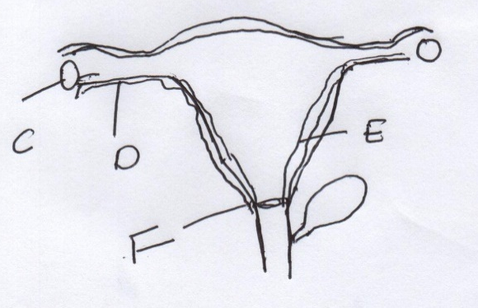

- Name the part marked (1mark)
D ………………………………………………………………………………………………
F ………………………………………………………………………………………………
- State the function of parts marked (1mark)
C ………………………………………………………………………………………………
E ………………………………………………………………………………………………
b) At what stage should a gilt be mated? (½mark)
………………………………………………………………………………………………

SECTION C (40 Marks)
Answer any two questions in this section in the spaces provided after each question.
21.(a)Describe five pre-disposing factor of livestock diseases. (5marks)
…………………………………………………………………………………………………………………………………………………………………………………………………………………………………………………………………………………………………………………………………………………………………………………………………………………………………………………………………………………………………………………………………………………………………………………………………………………………………………………………………………………………………………………………………………………………………………………………………………………………………………………………………………………………………………………………………………………………………………………………………………………………………………………………………………………………………………………………………………………………………………………………………………………………………………………………………………………………………………………………………………………………………………………………………………………………………………………………………………………………………………………………………………………………………………………………………………………………………………
- Describe six mechanical methods of controlling ticks (6 marks)
…………………………………………………………………………………………………………………………………………………………………………………………………………………………………………………………………………………………………………………………………………………………………………………………………………………………………………………………………………………………………………………………………………………………………………………………………………………………………………………………………………………………………………………………………………………………………………………………………………………………………………………………………………………………………………………………………………………………………………………………………………………………………………………………………………………………………………………………………………………………………………………………………………………………………………………………………………………………………………………………………………………………………………………………………………………………………………………………………………………………………………………………………………………………………………………………………………………………………………
(c)Describe the factors that affect milk composition of a cow (9 marks)
…………………………………………………………………………………………………………………………………………………………………………………………………………………………………………………………………………………………………………………………………………………………………………………………………………………………………………………………………………………………………………………………………………………………………………………………………………………………………………………………………………………………………………………………………………………………………………………………………………………………………………………………………………………………………………………………………………………………………………………………………………………………………………………………………………………………………………………………………………………………………………………………………………………………………………………………………………………………………………………………………………………………………………………………………………………………………………………………………………………………………………………………………………………………………………………………………………………………………………
22.(a)(i) Explain five advantages of animal power. (5marks)
……………………………………………………………………………………………………………………………………………………………………………………………………………………………………………………………………………………………………………………………………………………………………………………………………………………………………………………………………………………………………………………………………………………………………………………………………………………………………………………………………………………………………………………………………………………………………………………………………………………………………………………………………………………………………………………………………………………………………………………………………………………………………………………………………………………………………………………………………………………………………………………………………………………………………………………………………………………………………………………………………………………………………………………………………………………………………………………………………………………………………………………………………………………………………………………………………………….…………………………
(ii)Describe three operational differences between disc plough and mouldboard plough. (6 marks)
…………………………………………………………………………………………………………………………………………………………………………………………………………………………………………………………………………………………………………………………………………………………………………………………………………………………………………………………………………………………………………………………………………………………………………………………………………………………………………………………………………………………………………………………………………………………………………………………………………………………………………………………………………………………………………………………………………………………………………………………………………………………………………………………………………………………………………………………………………………………………………………………………………………………………………………………………………………………………………………………………………………………………………………………………………………………………………………………………………………………………………………………………………………………………………………………………………………………………………
(b)Describe the use of various materials in construction of a Kenya to hive (4 marks)
………………………………………………………………………………………………………………………………………………………………………………………………………………………………………………………………………………………………………………………………………………………………………………………………………………………………………………………………………………………………………………………………………………………………………………………………………………………………………………………………………………………………………………………………………………………………………………………………………………………………………………………………………………………………………………………………………………………………………………………………………………………………………………………………………………………………………………………………………………………………………………………………………………………………………………………………………………………………………………………………………………………………………………………………………………………………………………………………………………………………………………………………………………………………………………………………………………………
(c) Outline the care and maintenance of a tractor water cooling system. (5marks)
………………………………………………………………………………………………………………………………………………………………………………………………………………………………………………………………………………………………………………………………………………………………………………………………………………………………………………………………………………………………………………………………………………………………………………………………………………………………………………………………………………………………………………………………………………………………………………………………………………………………………………………………………………………………………………………………………………………………………………………………………………………………………………………………………………………………………………………………………………………………………………………………………………………………………………………………………………………………………………………………………………………………………………………………………………………………………………………………………………………………………………………………………………………………………………………………………………………
23.(a)(i) State four physiological body processes considered when assessing on animal health. (4marks)
………………………………………………………………………………………………………………………………………………………………………………………………………………………………………………………………………………………………………………………………………………………………………………………………………………………………………………………………………………………………………………………………………………………………………………………………………………………………………………………………………………………………………………………………………………………………………………………………………………………………………………………………………………………………………………………………………………………………………………………………………………………………………………………………………………………………………………………………………………………………………………………………………………………………………………………………………………………………………………………………………………………………………………………………………………………………………………………………………………………………………………………………………………………………………………………………………………………
(ii)Explain nine factors considered when selecting a breeding stock. (9marks)
………………………………………………………………………………………………………………………………………………………………………………………………………………………………………………………………………………………………………………………………………………………………………………………………………………………………………………………………………………………………………………………………………………………………………………………………………………………………………………………………………………………………………………………………………………………………………………………………………………………………………………………………………………………………………………………………………………………………………………………………………………………………………………………………………………………………………………………………………………………………………………………………………………………………………………………………………………………………………………………………………………………………………………………………………………………………………………………………………………………………………………………………………………………………………………………………………………………
(b)Describe Brucellosis disease in Cattle under the following sub-headings.
(i)the cause of the disease (1mark)
…………………………………………………………………………………………………

(ii)Symptoms of the disease (4marks)
………………………………………………………………………………………………………………………………………………………………………………………………………………………………………………………………………………………………………………………………………………………………………………………………………………………………………………………………………………………………………………………………………………………………………………………………………………………………………………………………………………………………………………………………………………………………………………………………………………………………………………………………………………………………………………………………………………………………………
(iii)Control measures (2marks)
…………………………………………………………………………………………………………………………………………………………………………………………………………………………………………………………………………………………………………………………………………………………………………………………………………

