NAME ………………………………………………………. ADM NO…………

CLASS……………………….. DATE …………………........ SIGN …………….
443/2
AGRICULTURE
PAPER 2
2 HOURS

FORM FOUR END OF TERM TWO 2020
AGRICULTURE
Paper 2
2 Hours.
INSTRUCTIONS TO CANDIDATES
- Write your name, admission number and class in the spaces provided above.
b) Sign and write the date of the examination in the spaces provided above.
c) This paper consists of three sections : A, B and C.
d) Answer all question in section A and B.
e) Answer any two questions in section C.
f) All answers should be written in the spaces provided.
g) This paper consists of 14 printed pages.
h) Candidates should check the question paper to ascertain that all pages
are printed as indicated and that no questions are missing.
i) Candidates must answer all the questions in English.
For Examiner’s Use Only

SECTION | Question | Maximum Score | Candidate’s Score
A | 1 – 18 | 30
B | 19 – 22 | 20
C |  | 20
 |  | 20
TOTAL SCORE |  | 90

SECTION A (30 marks)

Answer all the questions in the spaces provided.

- Name any two dairy cattle breeds reared in Kenya. (1mk)
………………………………………………………………………………………………………………………………………………………………………………………………………………
- List four materials that can be used in constructing a Kenya Top Bar Hive. (2mks)
………………………………………………………………………………………………………………………………………………………………………………………………………………………………………………………………………………………………………………………………………………………………………………………………………………………………
- a) What is a zoonotic disease? (½mk)
………………………………………………………………………………………………………
b) Give one example of zoonotic disease. ( ½mk)
………………………………………………………………………………………………………
- a) State four factors affecting feed digestibility in livestock. (2mks)
……………………………………………………………………………………………………………………………………………………………………………………………………………………………………………………………………………………………………………………………………………………………………………………………………………………………….
b) State two functions of crop in poultry digestive system. (1mk)
……………………………………………………………………………………………………………………………………………………………………………………………………………….

- Give three limitations of using solar power on the farm. (1½mks)
………………………………………………………………………………………………………………………………………………………………………………………………………………………………………………………………………………………………………………………
- State three reasons for carrying out egg candling before incubation. (1½mks)
……………………………………………………………………………………………………………………………………………………………………………………………………………………………………………………………………………………………………………………….
- State two functions of a queen bee in a colony. (1mk)
………………………………………………………………………………………………………………………………………………………………………………………………………………
- Give two categories of tractor drawn implements on the basis of the mode of attachment. (1mk)
………………………………………………………………………………………………………………………………………………………………………………………………………………
- State two advantages of natural calf rearing. (1mk)
………………………………………………………………………………………………………………………………………………………………………………………………………………

- Distinguish between each of the following terms as used in livestock rearing practices.
a) Steaming up and flushing. (2mks)
……………………………………………………………………………………………………….……………………………………………………………………......................................................................................................................................................................................................................

b) Kindling and farrowing. (2mks)
………………………………………………………………………………………………………………………………………………………………………………………………………………………………………………………………………………………………………………………
- Give four reason of using litter in a deep litter poultry rearing system. (2mks)
……………………………………………………………………………………………………………………………………………………………………………………………………………………………………………………………………………………………………………………………………………………………………………………………………………………………..
- Give four factors considered when sitting a fish pond in a farm. (2mks)
………………………………………………………………………………………………………………………………………………………………………………………………………………………………………………………………………………………………………………………………………………………………………………………………………………………………
- State four reasons for castrating male kids not required for breeding in a farm. (2mks) ………………………………………………………………………………………………………………………………………………………………………………………………………………………………………………………………………………………………………………………………………………………………………………………………………………………………
- Mention four physical characteristics of exotic beef cattle breeds. (2mks)
……………………………………………………………………………………………………………………………………………………………………………………………………………………………………………………………………………………………………………………………………………………………………………………………………………………………………………………

- State four reasons that necessitate handling of livestock in the farm. (2mks)
…………………………………………………………………………………………………………………………………………………………………………………………………………………………………………………………………………………………………………………………………………………………………………………………………………………………………………………..
- List three factors that influence the strength of concrete. (1½mks)
………………………………………………………………………………………………………………………………………………………………………………………………………………………………………………………………………………………………………………………
- Name three routes through which vaccines can be administered in livestock. (1½mks)
………………………………………………………………………………………………………………………………………………………………………………………………………………………………………………………………………………………………………………………
- Name four ways of increasing ploughing depth of the disc plough. (2mks)
………………………………………………………………………………………………………………………………………………………………………………………………………………………………………………………………………………………………………………………………………………………………………………………………………………………………

SECTION B (20 Marks)
Answer all the questions in the spaces provided.
- a) Using a Pearson’s square, Calculate how much of wheat (35% D.C.P) would be mixed with sunflower seedcake (10% DCP) to come up with duck mash (20 % DCP ) on a ration weighing 200kg. (show your working) (4mks)

b) Apart from the Pearson’s square method, Name the other method used in livestock feed computation. (1mk)
……………………………………………………………………………………………………
- The diagrams below represent some farm tools and equipment. Study them carefully and answer the questions that follow.
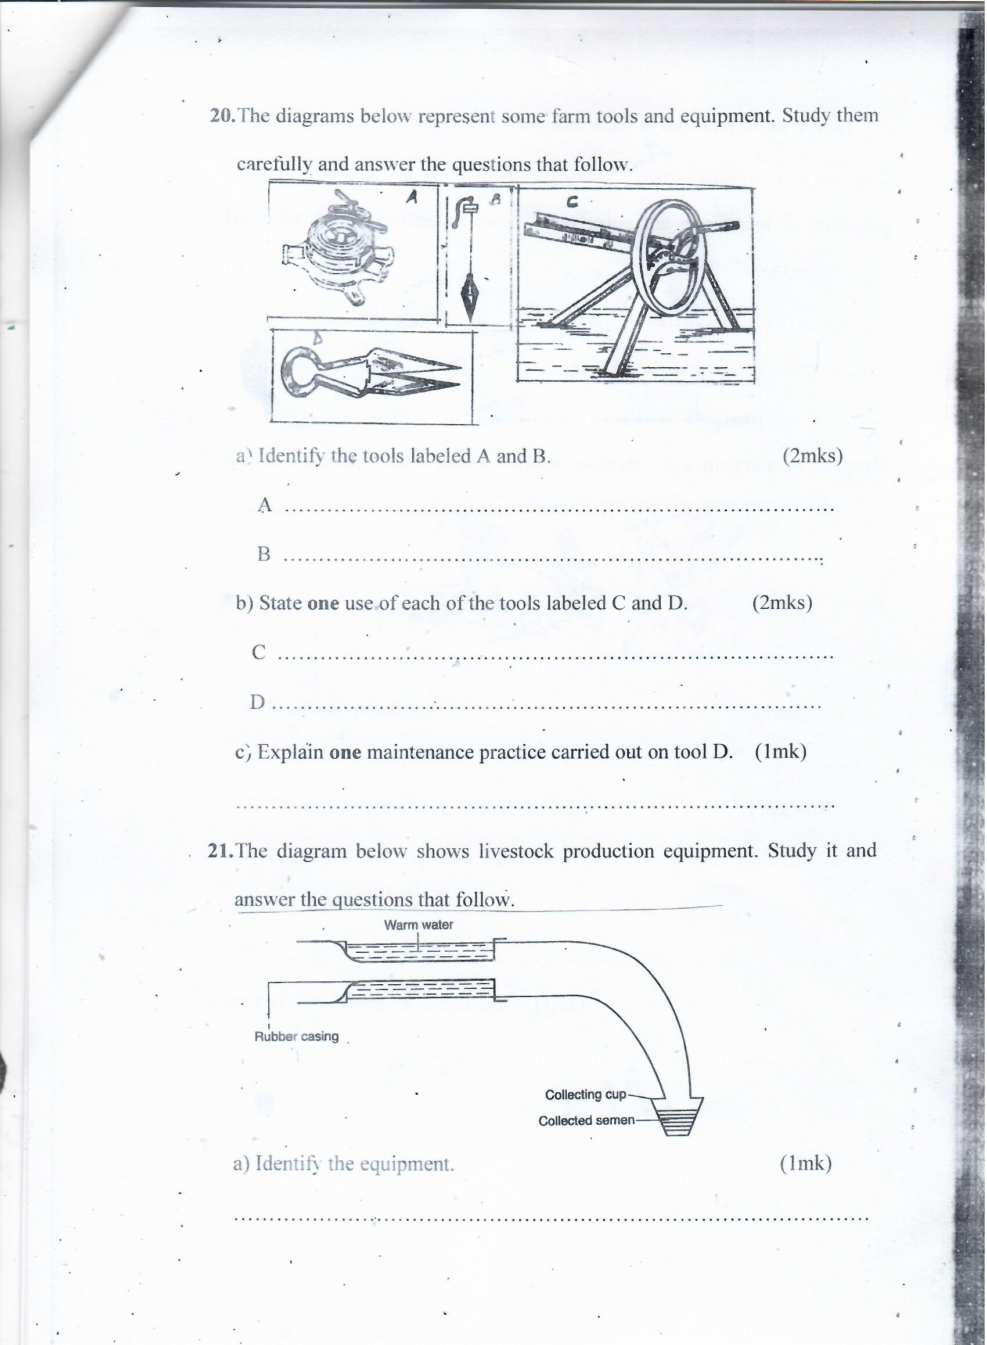

a) Identify the tools labeled A and B. (2mks)
A ………………………………………………………………………………………………
B ………………………………………………………………………………………………
b) State one use of each of the tools labeled C and D. (2mks)
C ………………………………………………………………………………………………
D ………………………………………………………………………………………………
c) Explain one maintenance practice carried out on tool D. (1mk)
……………………………………………………………………………………………………
- The diagram below shows livestock production equipment. Study it and answer the questions that follow.

a) Identify the equipment. (1mk)
………………………………………………………………………………
b) What is the importance of the warm water in the equipment. (1mk)
………………………………………………………………………………
- Describe the procedure followed when using the equipment in collecting semen. (3mks)

……………………………………………………………………………………………………………………………………………………………………………………………………………………………………………………………………………………………………………………………………….
- The diagram below shows various methods of a practice in livestock production.
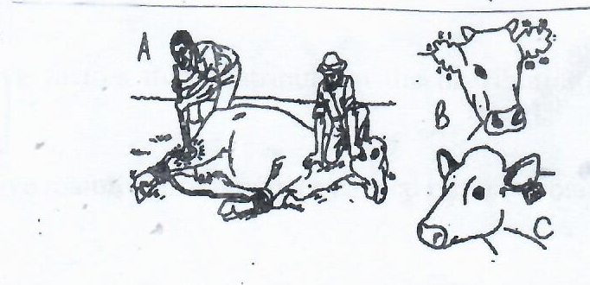
a) Name the practice. (1mk)
……………………………………………………………………………………………………….
b) Name the methods A, B, and C (3mks )
A ………………………………………………………………...........
B ………………………………………………………………………
C ……………………………………………………………………..
c) State one disadvantages of method A. (1mk)
…………………………………………………………………………………………………….

SECTION C (40 Marks)

Answer any two questions from this section in the spaces provided after question 25;

- a) State five signs of parturition in a cow. (5mks)
.
b) State five control measures of Round worms (Ascaris lumbricoides) in livestock.
(5mks)
c) Describe Coccidiosis disease under the following sub-headings.
- Animals attacked. (2mks)

- Symptoms of attack. (5mks)

- Control (3mks)

- a) Outline five factors that contribute to the distribution of livestock in Kenya. (5mks)

b) Describe five maintenance practices carried out on a rotary mower . (5mks)

c) Discuss five factors affecting milk composition in livestock production. (10mks)

- a) Describe the artificial rearing of layers chick from one day up to the end of brooding. (10mks)
b) Outline the uses of fences in the farm. (10mks)

………………………………………………………………………………………………………………………………………………………………………………………………………………………………………………………………………………………………………………………………………………………………………………………………………………………………………………………………………………………………………………………………………………………………………………………………………………………………………………………………………………………………………………………………………………………………………………………………………………………………………………………………………………………………………………………………………………………………………………………………………………………………………………………………………………………………………………………………………………………………………………………………………………………………………………………………………………………………………………………………………………………………………………………………………………………………………………………………………………………………………………………………………………………………………………………………………………………………………………………………………………………………………………………………………………………………………………………………………………………………………………………………………………………………………………………………………………………………………………………………………………………………………………………………………………………………………………………………………………………………………………………………………………………………………………………………………………………………………………………………………………………………………………………………………………………………………………………………………………………………………………………………………………………………………………………………………………………………………………………………………………………………………………………………………………………………………………………………………………………………………………………………………………………………………………………………………………………………………………………………………………………………………………………………………………………………………………………………………………………………………………………………………………………………………………………………………………………………………………………………………………………………………………………………………………………………………………………………………………………………………………………………………………………………………………………………………………………………………………………………………………………………………………………………………………………………………………………………………………………………………………
………………………………………………………………………………………………………………………………………………………………………………………………………………………………………………………………………………………………………………………………………………………………………………………………………………………………………………………………………………………………………………………………………………………………………………………………………………………………………………………………………………………………………………………………………………………………………………………………………………………………………………………………………………………………………………………………………………………………………………………………………………………………………………

……………………………………………………………………………………………………………………………………………………………………………………………………………………………………………………………………………………………………………………………………………………………………………………………………………………………………………………………………………………………………………………………………………………………………………………………………………………………………………………………………………………………………………………………………………………………………………………………………………………………………………………………………………………………………………………………………………………………………………………………………………………………………………………………………………………………………………………………………………………………………………………………………………………………………………………………………………………………………………………………………………………………………………………………………………………………………………………………………………………………………………………………………………………………………………………………………………………………………………………………………………………………………………………………………………………………………………………………………………………………………………………………………………………………………………………………………………………………………………………………………………………………………………………………………………………………………………………………………………………………………………………………………………………………………………………………………………………………………………………………………………………………………………………………………………………………………………………………………………………………………………………………………………………………………………………………………………………………………………………………………………………………………………………………………………………………………………………………………………………………………………………………………………………………………………………………………………………………………………………………………………………………………………………………………………………………………………………………………………………………………………………………………………………………………………………………………………………………………………………………………………………………………………………………………………………………………………………………………………………………………………………………………………………………………………………………………………………………………………………………………………………………………………………………………………………………………………………………………………………………………………………………………………………………………………………………………………………………………………………………………………………………………………………………………………………………………………………………………………………………………………………………………………………………………………………………………………………………………………………………………………………………………………………………………………………………………………………………………………………………………………………………………………………………………………………………………………………………………………………………………………………………………………………………………………………………………………………………………………………………………………………………………………………………………………………………………………………………………………………………………………………………………………………………………………………………………………………………………………………………………………………………………………………………………………………………………………………………………………………………………………………………………………………………………………………………………………………………………………………………………………………………………………………………………………………………………………………………………………………………………………………………………………………………………………………………………………………………………………………………….
……………………………………………………………………………………………………………………………………………………………………………………………………………………………………………………………………………………………………………………………………………………………………………………………………………………………………………………………………………………………………………………………………………………………………………………………………………………………………………………………………………………………………………………………………………………………………………………………………………………………………………………………………………………………………………………………………………………………………………………………………………………………………………………………………………………………………………………………………………………………………………………………………………………………………………………………………………………………………………………………………………………………………………………………………………………………………………………………………………………………………………………………………………………………………………………………………………………………………………………………………………………………………………………………………………………………………………………………………………………………………………………………………………………………………………………………………………………………………………………………………………………………………………………………………………………………………………………………………………………………………………………………………………………………………………………………………………………………………………………………………………………………………………………………………………………………………………………………………………………………………………………………………………………………………………………………………………………………………………………………………………………………………………………………………………………………………………………………………………………………………………………………………………………………………………………………………………………………………………………………………………………………………………………………………………………………………………………………………………………………………………………………………………………………………………………………………………………………………………………………………………………………………………………………………………………………………………………………………………………………………………………………………………………………………………………………………………………………………………………………………………………………………………………………………………………………………………………………………………………………………………..
……………………………………………………………………………………………………………………………………………………………………………………………………………………………………………………………………………………………………………………………………………………………………………………………………………………………………………………………………………………………………………………………………………………………………………………………………………………………………………………………………………………………………………………………………………………………………………………………………………………………………………………………………………………………………………………………………………………………………………………………………………………………………………………………………………………………………………………………………………………………………………………………………………………………………………………………………………………………………………………………………………………………………………………………………………………………………………………………………………………………………………………………………………………………………………………………………………………………………………………………………………………………………………………………………………………………………………………………………………………………………………………………………………………………………………………………………………………………………………………………………………………………………………………………………………………………………………………………………………………………………………………………………………………………………………………………………………………………………………………………………………………………………………………………………………………………………………………………………………………………………………………………………………………………………………………………………………………………………………………………………………………………………………………………………………………………………………………………………………………………………………………………………………………………………………………………………………………………………………………………………………………………………………………………………………………………………………………………………………………………………………………………………………………………………………………………………………………………………………………………………………………………………………………………………………………………………………………………………………………………….

