NAME ……………………………………..……………….. DATE …………………………………

ADM NO. …………….……….……..…..… CANDIDATE’S SIGNATURE …………..…..………..

443/2
AGRICULTURE
PAPER 2 (THEORY)
TIME: 2 HOURS

SUKELLEMO - JOINT EVALUATION TEST, 2020

Kenya Certificate of Secondary Education

443/2
AGRICULTURE
PAPER 2 (THEORY)
DECEMBER, 2020
TIME: 2 HOURS

INSTRUCTIONS TO CANDIDATES
- Write your name and ADM number in the spaces provided above.
- This paper has THREE sections: A , B and C
- Answer ALL the questions in section A and B and any TWO questions in section C
- ALL answers MUST be written in the spaces provided.
- Do not remove any pages from this booklet.
- This paper consists of 10 printed pages. Candidates should check to ensure that all pages are printed as indicated and no questions are missing

FOR EXAMINER’S USE ONLY

 | Questions | Maximum score | Candidate’s score
A | 01 - 16 | 30 marks
B | 17 - 20 | 20 marks
C | 21 - 23 | 40 marks
 |  | Total score

SECTION A (30MARKS)
Answer All the questions in this section in the spaces provided.
- a) List two dairy goat breeds (1mk)
……………...……………………………………………………………………………………………………………………………………………………………………………………………
b) Give two advantages of keeping a Jersey cow instead of a Friesian. (1mk)
…………………………………………………………………………………………………………………………………………………………………………………………………………
- Give two importance of keeping health records in a farm. (1mk)
…………………………………………………………………………………………………………………………………………………………………………………………………………
- a) What is pica as used in livestock production. (½mk)
…………………………………………………………………………………………………………………………………………………………………………………………………………
b) State three importance of keeping livestock healthy. (1½mks)
…………………………………………………………………………………………………………………………………………………………………………………………………………
4. Name an intermediate host for each of the following parasites.
i) Tapeworm (Taenia solium) (½mk)
…………………………………………………………………………………………………………………………………………………………………………………………………………
ii) Liver Fluke (Fasciola hepatica) (½mk)
…………………………………………………………………………………………………………………………………………………………………………………………………………

- a) Name the type of breeding system represented below. (½mk)
Ayrshire Sire x Boran Dam F1 Heifer x Hereford
………………………………………………………………………………………………………..
b) Outline two characteristics of livestock that are used in mass selection. (1mk)
…………………………………………………………………………………………………………………………………………………………………………………………………………
- State four management practices that would ensure maximum harvest of fish from a fish pond. (2mks)
…………………………………………………………………………………………………………………………………………………………………………………………………………
- Distinguish between crutching and ringing as used in livestock production. (1mk)
…………………………………………………………………………………………………………………………………………………………………………………………………………
8. Give four reasons why young Lambs should be docked (2mks)
…………………………………………………………………………………………………………………………………………………………………………………………………………
- a) State three disadvantages of natural incubation in poultry production (1½mks)
…………………………………………………………………………………………………………………………………………………………………………………………………………
b) Why is it necessary to supplement domestic poultry diet with grit. (½mk)
…………………………………………………………………………………………………………………………………………………………………………………………………………
- Name four properties of a good vaccine (2mks)
…………………………………………………………………………………………………………………………………………………………………………………………………………

- State four factors considered when formulating a livestock ration. (2mks)
…………………………………………………………………………………………………………………………………………………………………………………………………………
- Name two Larval developmental stages of liver fluke that occur outside the intermediate host. (1mk)
…………………………………………………………………………………………………………………………………………………………………………………………………………
- List four methods of preserving fish after harvesting. (2mks)
…………………………………………………………………………………………………………………………………………………………………………………………………………
- Mention three ways that indigenous livestock farmers use to improve their cattle. (1½mks)
…………………………………………………………………………………………………………………………………………………………………………………………………………
15. Differentiate between
i) Gilt and Sow (1mk)
…………………………………………………………………………………………………………………………………………………………………………………………………………
ii) Marking gauge and mortise gauge. (1mk)
…………………………………………………………………………………………………………………………………………………………………………………………………………
- Outline three possible causes of damage to the hide of cattle when the animal. (1½mks)
…………………………………………………………………………………………………………………………………………………………………………………………………………

- Highlight three functions of ventilation in an animal house. (1½mks)
…………………………………………………………………………………………………………………………………………………………………………………………………………
- State four factors that determine the power output in an animal. (2mks)
…………………………………………………………………………………………………………………………………………………………………………………………………………
SECTION B (20MARKS)
Answer All the questions in this section in the spaces provided.
19. The diagram below represents farm tools.

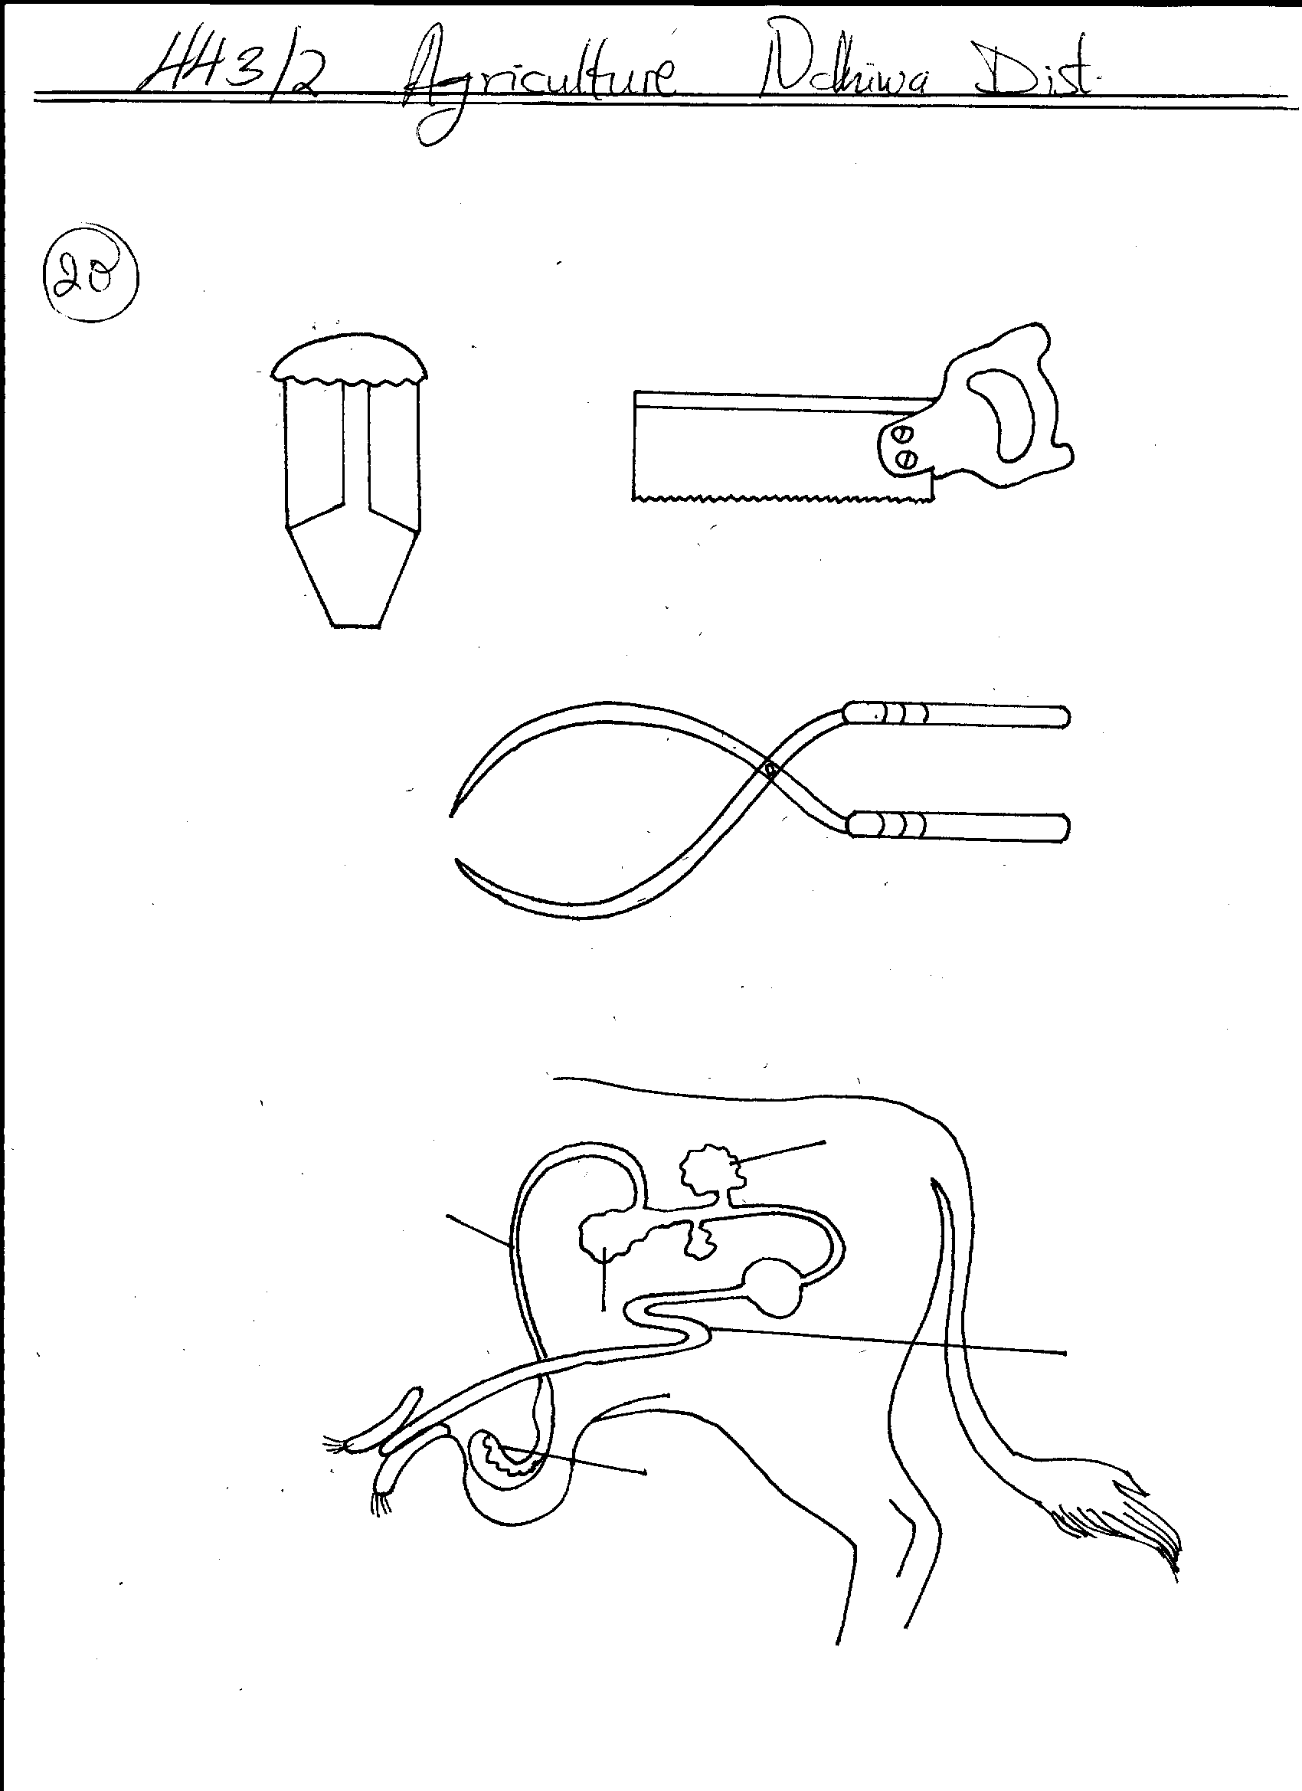
B
A
C

- Identify the tools labelled A and B (1mk)
…………………………………………………………………………………………………………………………………………………………………………………………………………
- Give one use of each of the tools mentioned in (i) above (2mks)
…………………………………………………………………………………………………………………………………………………………………………………………………………

- Give the two maintenance practices which should be carried out on tool C (2mks)
…………………………………………………………………………………………………………………………………………………………………………………………………………
20. The diagram below represents an implement
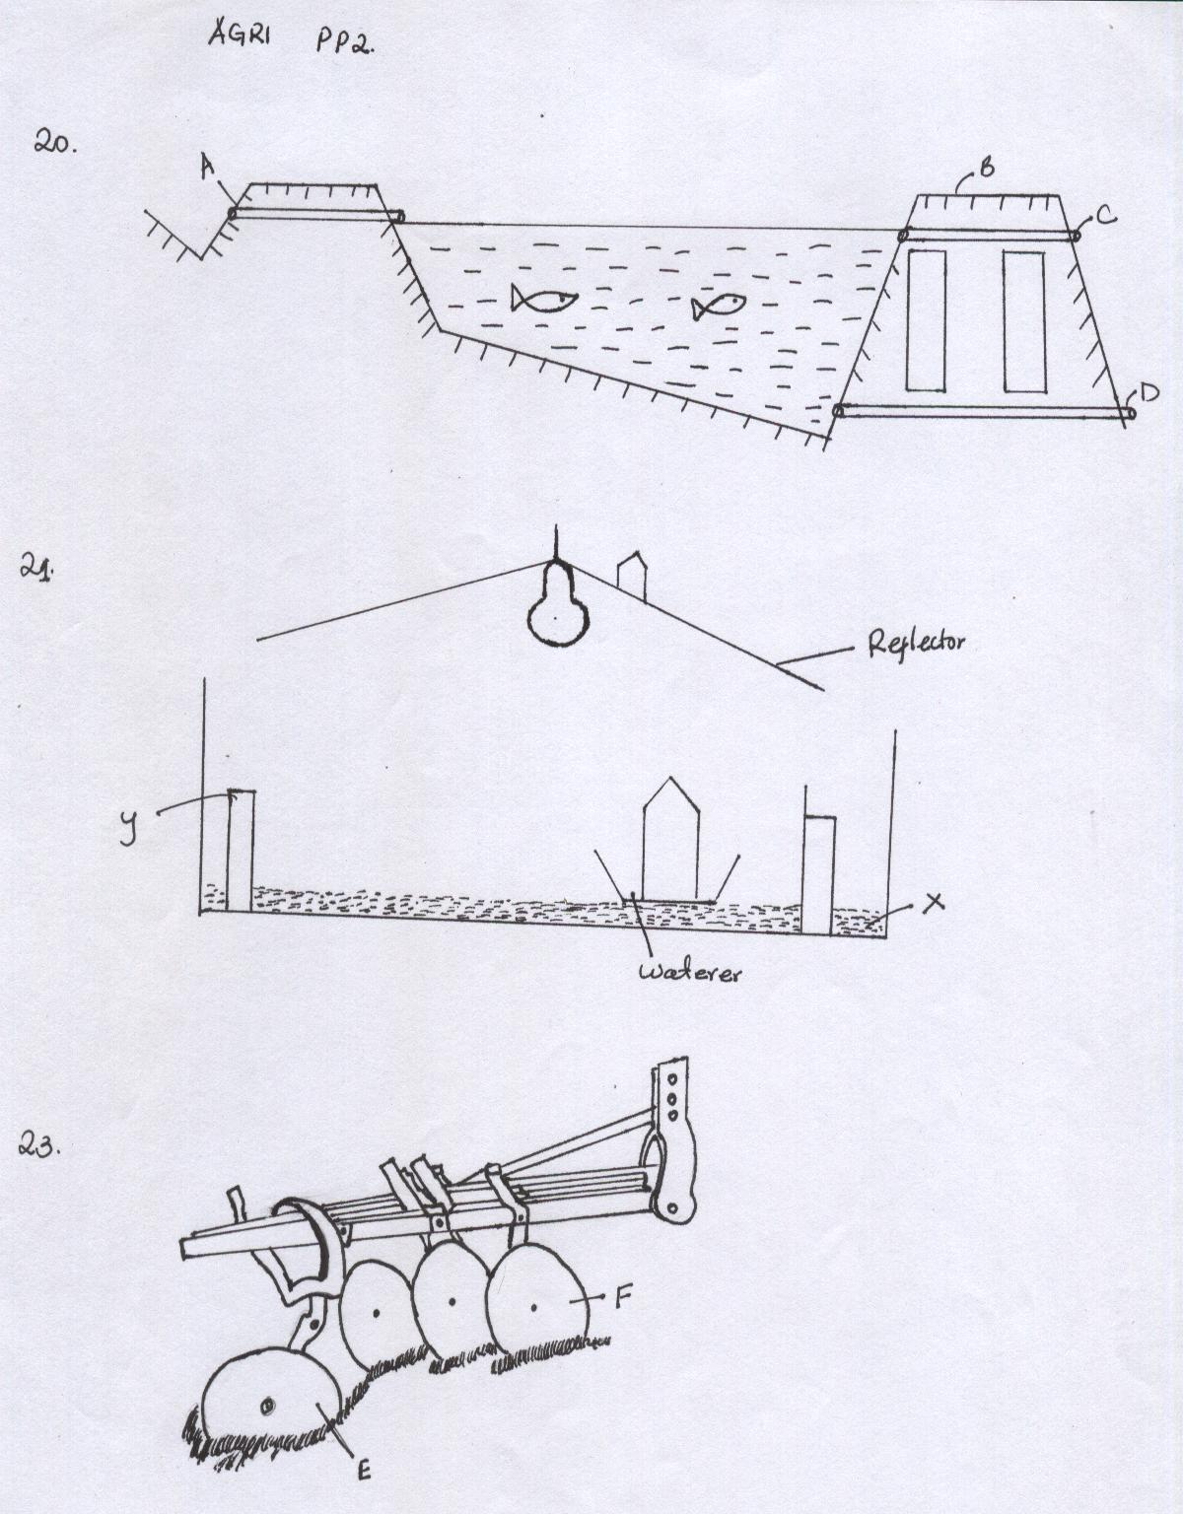

- Identify the implement. (1mk)
…………………………………………………………………………………………………………………………………………………………………………………………………………
- Name the parts labeled E and F and give one function of each. (2mks)
…………………………………………………………………………………………………………………………………………………………………………………………………………
- State four maintenance practices carried out on the implement shown in the diagram. (2mks)

…………………………………………………………………………………………………………………………………………………………………………………………………………
21. Study the diagram below and answer the questions that follow.
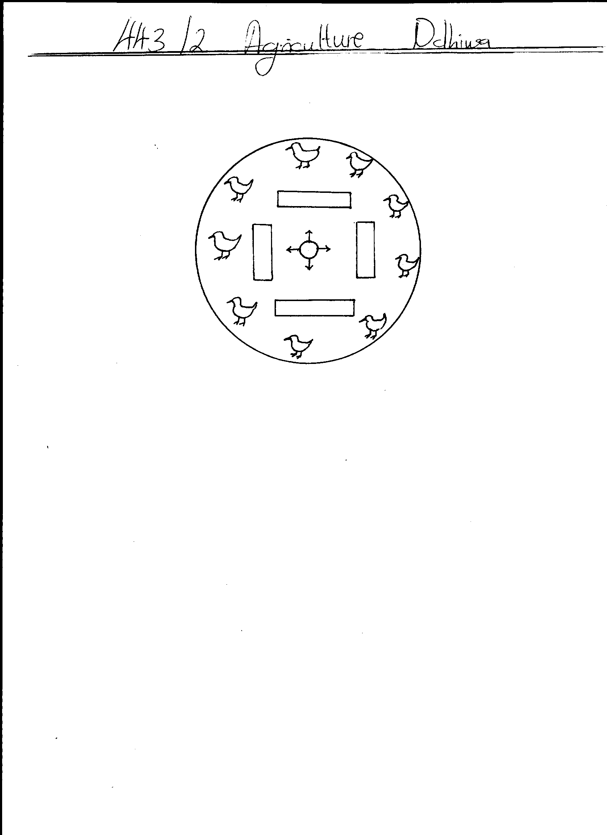
WATER
WATER
WATER
WATER

- Name the structure illustrated above. (1mk)
…………………………………………………………………………………………………………………………………………………………………………………………………………

- Why should structure be round and not rectangular or square shaped. (1mk)
…………………………………………………………………………………………………………………………………………………………………………………………………………
- Describe the heat situation in the structure. (1mk)
…………………………………………………………………………………………………………………………………………………………………………………………………………
- Give one reason to support your answer in (iii) above. (1mk)
…………………………………………………………………………………………………………………………………………………………………………………………………………

- Why is saw dust not suitable for use as litter in the structure. (1mk)
…………………………………………………………………………………………………………………………………………………………………………………………………………
22. Below is a breeding cycle of a ewe in relation to the feeding regime accompanying it. Use it to answer the following questions.
TUPPING
(iii)
(i)

WEANING
LAMBING
(ii)
- Name the management practice represented by (i),(ii) and (iii) (3mks)
i)………..…………………………………………………………………………………
ii)……….…………………………………………………………………………………
iii)………………………………………………………………………………………………

- Give the importance of practice (i) (3mks)
……………………………………………………………………………………………………………………………………………………………………………………………………………………

SECTION C (40MARKS)
Answer any two questions from this section in the spaces provided
23. a) Five diseases of internal parasites attack in livestock. (10mks)
b) Explain the factors to consider when planning a farm layout. (10mks)
24. a) Outline ten management practices a farmer should carry out to maintain good healthy in a herd of cattle. (10mks)
b) Discuss the management of layers in a deep litter system. (10mks)
25. a) Describe five design requirement of a calf pen. (10mks)
b) Describe Milk Fever disease under the following sub headings.
i) Animals affected (2mks)
ii) Symptoms (5mks)
iii) Control and treatment (3mks)
…………………………………………………………………………………………………………………………………………………………………………………………………………………………………………………………………………………………………………………………………………………………………………………………………………………………………………………………………………………………………………………………………………………………………………………………………………………………………………………………………………………………………………………………………………………………………………………………………………………………………………………………………………………………………………………………………………………………………………………………………………………………………………………………………………………………………………………………………………………………………………………………………………………………………………………………………………………………………………………………………………………………………………………………………………………………………………………………………………………………………………………………………………………………………………………………………………………………………………………………………………………………………………………………………………………………………………………………………………………………………………………………………………………………………………………………………………………………………………………………………………………………………………………………………………………………………………………………………………………………………………………………………………………………………………………………………………………………………………………………………………………………………………………………………………………………………………………………………………………………………………………………………………………………………………………………………………………………………………………………………………………………………………………………………………………………………………………………………………………………………………………………………………………………………………………………………………………………………………………………………………………………………………………………………………………………………………………………………………………………………………………………………………………………………………………………………………………………………………………………………………………………………………………………………………………………………………………………………………………………………………………………………………………………………………………………………………………………………………………………………………………………………………………………………………………………………………………………………………………………………………………………………………………………………………………………………………………………………………………………………………………………………………………………………………………………………………………………………………………………………………………………………………………………………………………………………………………………………………………………………………………………………………………………………………………………………………………………………………………………………………………………………………………………………………………………………………………………………………………………………………………………………………………………………………………………………………………………………………………………………………………………………………………………………………………………………………………………………………………………………………………………………………………………………………………………………………………………………………………………………………………………………………………………………………………………………………………………………………………………………………………………………………………………………………………………………………………………………………………………………………………………………………………………………………………………………………………………………………………………………………………………………………………………………………………………………………………………………………………………………………………………………………………………………………………………………………………………………………………………………………………………………………………………………………………………………………………………………………………………………………………………………………………………………………………………………………………………………………………………………………………………………………………………………………………………………………………………………………………………………………………………………………………………………………………………………………………………………………………………………………………………………………………………………………………………………………………………………………………………………………………………………………………………………………………………………………………………………………………………………………………………………………………………………………………………………………………………………………………………………………………………………………………………………………………………………………………………………………………………………………………………………………………………………………………………………………………………………………………………………………………………………………………………………………………………………………………………………………………………………………………………………………………………………………………………………………………………………………………………………………………………………………………………………………………………………………………………………………………………………………………………………………………………………………………………………………………………………………………………………………………………………………………………………………………………………………………………………………………………………………………………………………………………………………………………………………………………………………………………………………………………………………………………………………………………………………………………………………………..

END

