Name…………………………………………………………..

ADM …………………….

CLASS………………

TERM 2 2022 OPENER EXAM FORM 3
AGRICULTURE
Time: 2 Hours

INSTRUCTION TO CANDIDATES
- Write your name class and admission number in the spaces provided above.
- This paper consists of THREE section A, B and C
- Answer ALL the questions in section A and B and any one questions in section C.
- Answers should be written in the spaces provided.

SECTION A ( 30 Marks)
- What is the gestation period of the following animals (2 marks)
- Cow
- Sow
- Ewe
- Rabbit

- Differentiate between the following breed of livestock. (2 marks)
- New Zealand white and Californian white

- Large white and landrace

- State four characteristics of fertile soil (2marks)

- List four different type of drainage. (2marks)

- Name four reasons for carrying out minimum tillage. (2marks)

- State four precautions a farmer should take when using workshop tools. (2marks)

- State four ways in which the level of education and technology affects agriculture development in Kenya (2 marks)

- Name four types of livestock farming. (2marks)

- Stare four signs of parturition in goat. (2marks)

- Name four methods of identification in livestock. (2 marks)

- Name four methods of preserving fish. (2marks)

- State four symptoms caused by Round Worms in cattle. (2 marks)

- Name four factors that may predispose an animal to diseases. (2marks)

- Name any four common vegetables grown in Kenya. (2marks)

- List four post-harvesting practices. (2 marks)

SECTION B (50 MARKS)

- a. Differentiate between ruminant and non-ruminant. (6marks)

b. Using the pearson’s square method, compute a 100kg ration with 20% DCP from Oats which contains 10% DCP and Simsim seed which containing 60% DCP. (4marks)

- The diagram below show a practice in crop production.
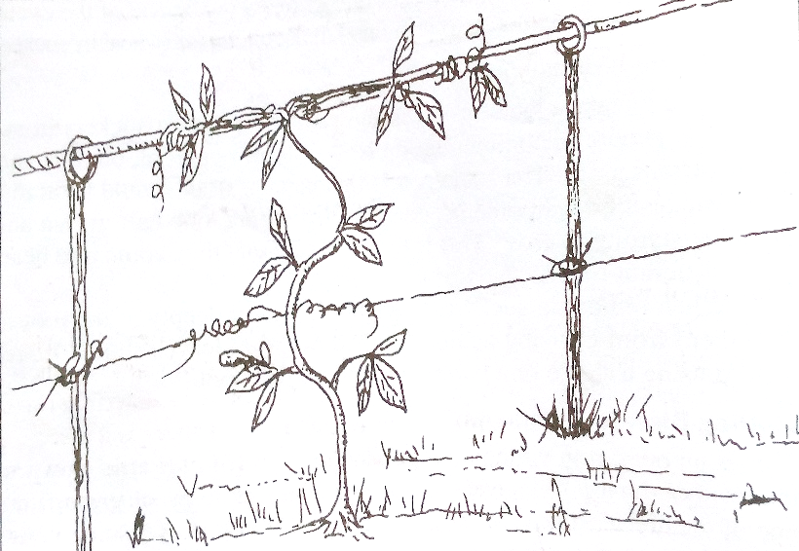
- Give the identity of the management practice illustrated above. (1mark)

- Give two reason for carrying out the above field management practice. (2mark)

- A plot measuring 4m X 3m was prepared for planting cabbages at a spacing of 60cm X60 cm. calculate the plant population in the plot. Show your working (3marks)

- A famer was advised to apply 150kg CAN/ha while topdressing the maize crop. CAN contains 21% N. Calculate the amount of Nitrogen applied per hectare (3marks)

- The drawing below shows the cross-section of a house under construction. Study it carefully and answer questions that follow.
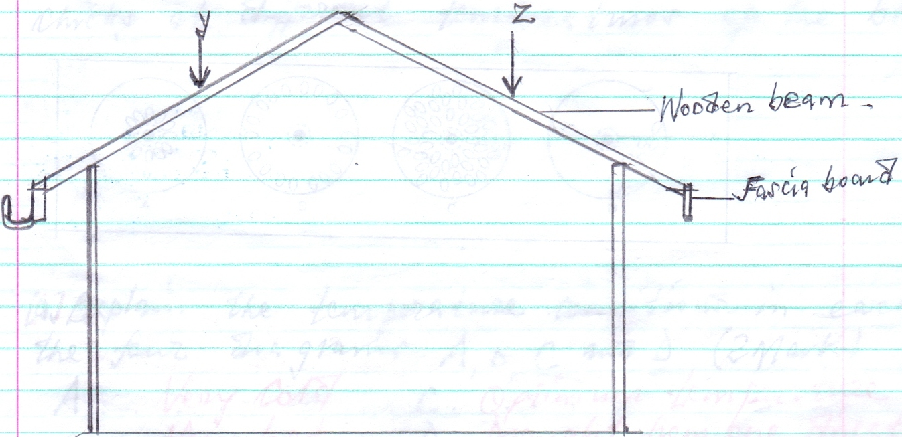
- On the diagram, draw cross tie . (1mark)

- If timber was used to build the truss, why would it be important to season it.(2marks)

- State two importance of the fascia board in the farm building.(2marks)

- Name any six uses of crushes in livestock production. (6 marks)

- The illustration below shows a pig farrowing pen .Study it and answer questions that follow.
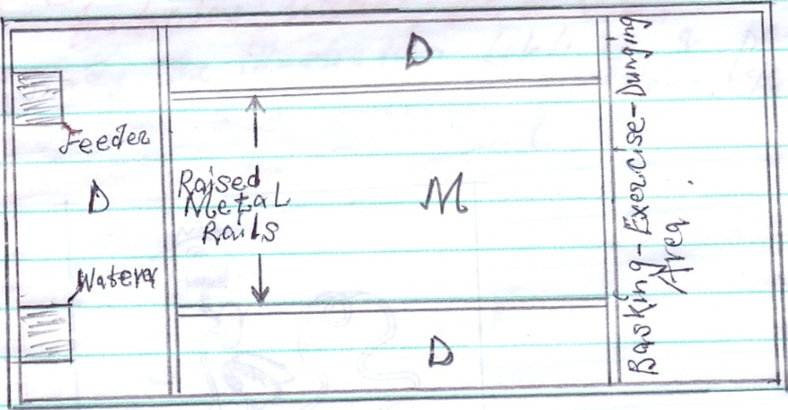
- What is the use of the raised metal rails. (1mark)

- Give two uses for the parts labeled D (2marks)

- Name seven sign of farrowing. (7 marks)

- Below is an illustration representing a practice carried out in sheep? Study it and answer questions that follow.
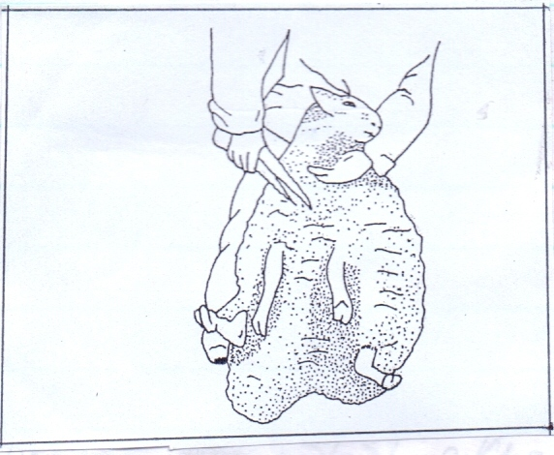
- Identify the practice illustrated above. (1mark)

- Name the tool used in the above practice (1mark)

- State three precautions taken when carrying out the above practice.(3marks)

- Name five methods used in docking. (5marks)

SECTION C (20 MARKS)
(Answer one question between 21 and 22)
- Describe the factors to consider when selecting a breeding stock (20marks)
- Discuss the process of egg formation in poultry (20 marks)

