NAME………………………………………………………………INDEX No…………………….................

CANDIDATE’S SIGNATURE………………………………………..DATE…………………………………

442/1
ART AND DESIGN
Paper 1
March 2019
Time: 1 ½ hours

TRIAL ONE EVALUATION TEST-2019

ART AND DESIGN

INSTRUCTIONS TO CANDIDATES

Write your name and index number in the spaces provided above
Sign and write the date of the examination in the spaces provided above.
This question paper consists of three sections A, B and C.
Answer all questions in section A and B.
Answer any one question in section C
Answers to all the questions must be written in the spaces provided in this booklet.
Do not remove any paper from this booklet.

For Official Use Only

Section | Question | Maximum score | Score
A | 1 | 20
B | 2 | 05
B | 3 | 05
B | 4 | 05
B | 5 | 05
B | 6 | 05
C |  | 15
Max. Score Paper 1 |  | 60

Candidates should check the question paper to ascertain that
All the pages are printed as indicated and that no questions are missing

SECTION A: 20MKS
1. a) Distinguish between subject and content as components of a work of art. (2mks)
………………………………………………………………………………………………………………………………………………………………………………………………………………………………………………………………………………………………………………………………………………………………………………………………………………………………………………………………………………………………………………………………………
b) Define rhythm in Art and Design. (1mk)
………………………………………………………………………………………………………………………………………………………………………………………………………………
c) What is a design brief? (2mks)
………………………………………………………………………………………………………………………………………………………………………………………………………………………………………………………………………………………………………………………………………………………………………………………………………………………………
d) What type of balance is employed in the picture below (1mk)
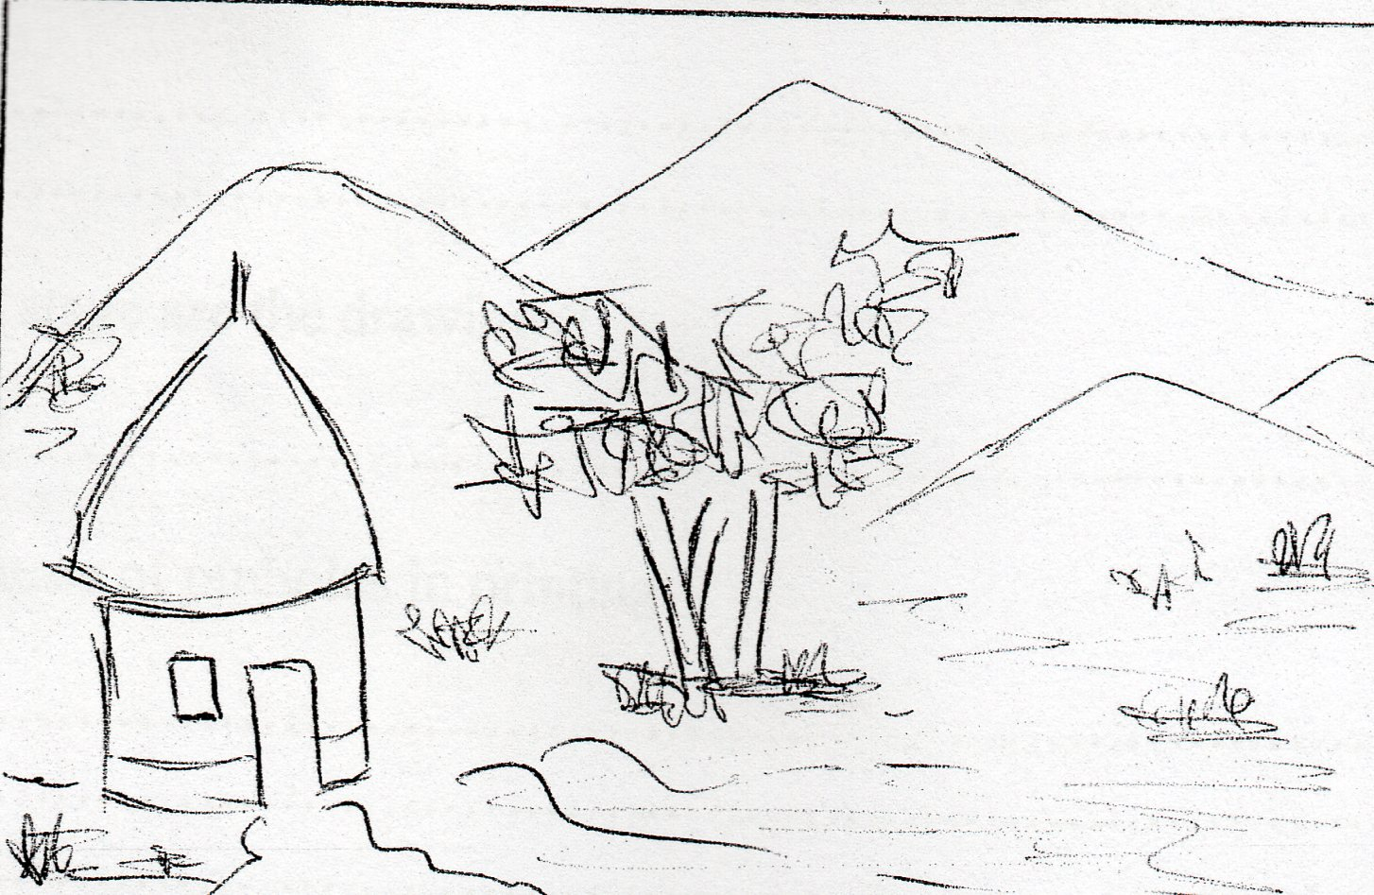

e) Explain the term “character” with reference to line as an element of Art and Design. (1mk)
………………………………………………………………………………………………………………………………………………………………………………………………………………
f) Name any two ingredients required to form glaze. (1mk)
………………………………………………………………………………………………………………………………………………………………………………………………………………
g) Study the drawings below and answer the questions that follow.

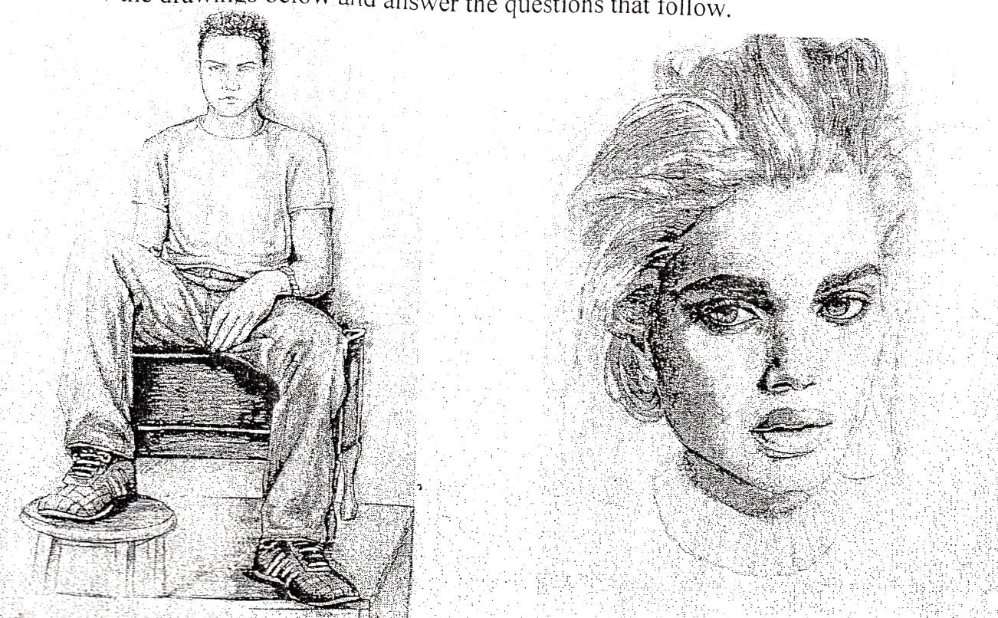
(a)
(b)

- State the category to which each of the drawings belongs. (2mks)
………………………………………………………………………………………………………………………………………………………………………………………………………………
- At which stage are the drawings? (1mk)
………………………………………………………………………………………………………
h) Give two causes of pinholes in printing. (2mks)
………………………………………………………………………………………………………………………………………………………………………………………………………………………………………………………………………………………………………………………
i) What is a cartoon strip? (1mk)
………………………………………………………………………………………………………………………………………………………………………………………………………………
j) List two main uses of voids in a sculpture. (2mks)
………………………………………………………………………………………………………………………………………………………………………………………………………………
k) Briefly describe the following terms as used in mosaic (2mks)
- Tesserae
………………………………………………………………………………………………………………………………………………………………………………………………………………
- Interstices
………………………………………………………………………………………………………………………………………………………………………………………………………………
l) Why are fabrics decorated with random patterns preferred for making clothes. (2mks)
………………………………………………………………………………………………………………………………………………………………………………………………………………
SECTION B: 25MKS
2. Below is a used in the weaving process.
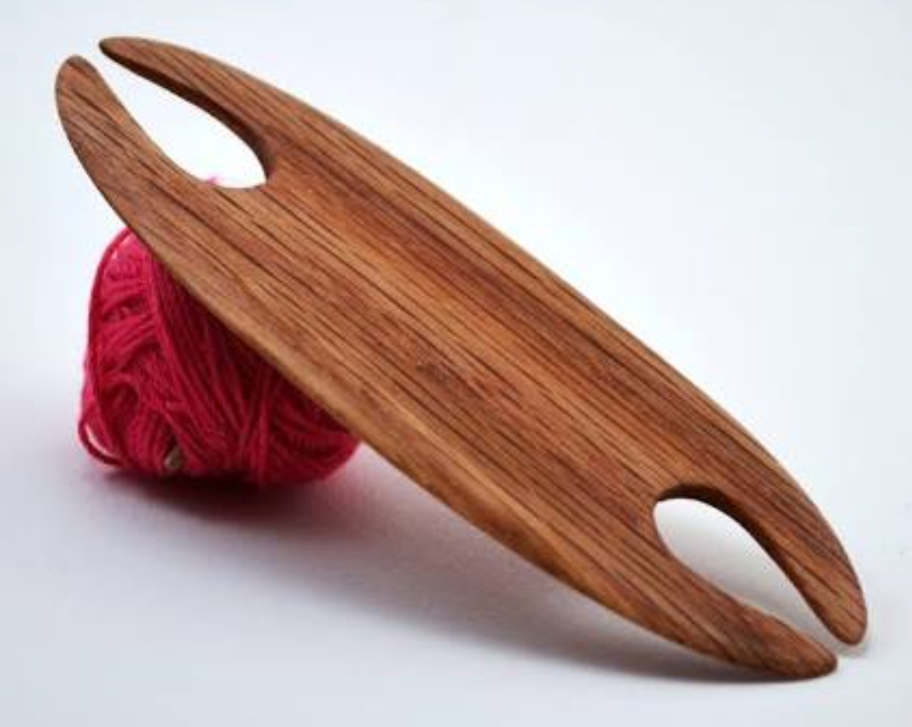
a) Name the tool. (1mk)
………………………………………………………………………………………………………
b) State its function. (1mk)
………………………………………………………………………………………………………………………………………………………………………………………………………………
c) List any three factors to be considered when calculating the length of warps before the weaving process. (3mks)
………………………………………………………………………………………………………………………………………………………………………………………………………………………………………………………………………………………………………………………………………………………………………………………………………………………………
3. Study the process below and carefully answer the questions that follow.
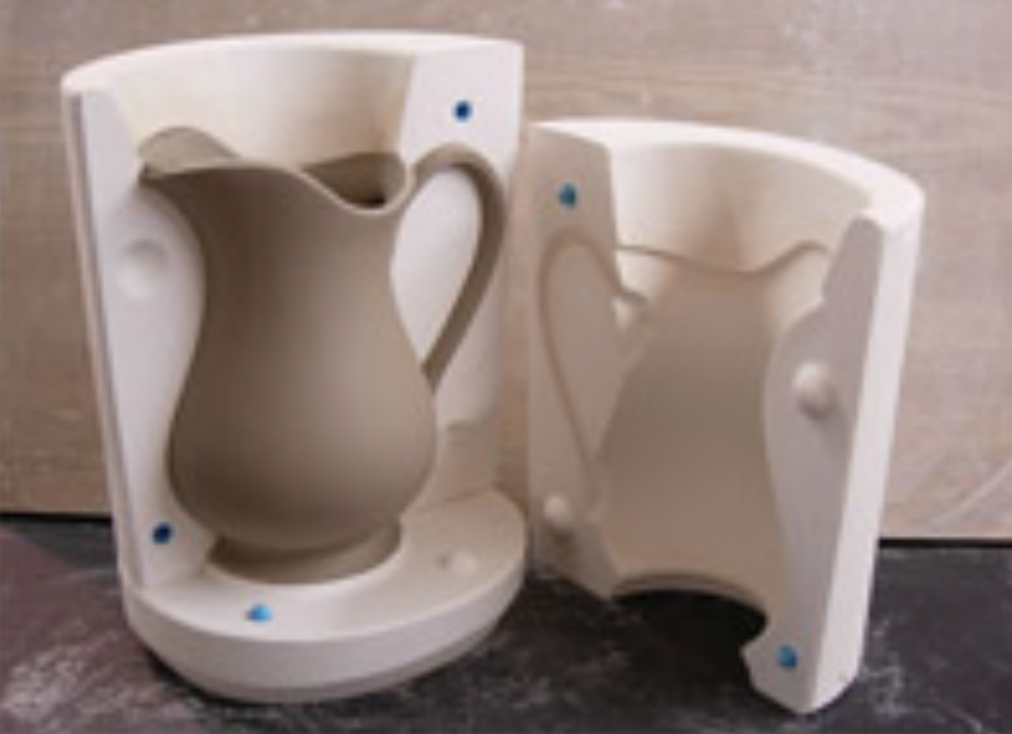
a) Name the process (2mks)
………………………………………………………………………………………………………
b) Name the main equipment used in the process. (1mk)
………………………………………………………………………………………………………
c) Give two advantages of using the above technique over others. (2mks)
………………………………………………………………………………………………………………………………………………………………………………………………………………………………………………………………………………………………………………………
4. a) State the function of common salt (Sodium chloride) in the fabric dyeing process. (1mk)
………………………………………………………………………………………………………………………………………………………………………………………………………………
b) Draw and label a tjanting in the space below. (3mks)

c) Name two ways in which texture can be achieved on fabric decorated using batik. (1mk)
………………………………………………………………………………………………………………………………………………………………………………………………………………
5. Rewrite the first stanza of the Kenya National Anthem in calligraphy (English version). (5mks)

6. Outline the process of firing bone dry clay items using the open firing process. (5mks)
………………………………………………………………………………………………………………………………………………………………………………………………………………………………………………………………………………………………………………………………………………………………………………………………………………………………………………………………………………………………………………………………………………………………………………………………………………………………………………………………………………………………………………………………………………………
SECTION C:
7. a) Differentiate an Ornament from Jewellery. (2mks)
b) Explain any 4 factors that should be considered in designing ornaments. (4mks)
c) State three properties of copper that make it a suitable metal for ornament making. (3mks)
d) When is a shield considered an ornament? (2mks)
e) What is a spacer? (2mks)
f) What is the function of spacers? (2mks)
8. a) What is collage? (2mks)
b) State 3 reasons why montage is regarded as a type of collage. (3mks)
c) Distinguish Mosaic and Collage. (10mks)
9. a) Explain the use of the following materials in a clay body.
(i)Ball clay
(2mks)
(ii)Fire clay
(2mks)
(iii)Grog (2mks)

b) Describe the process of modeling a water jug using a combination of slab and coil methods (9mks)

