Name...…………………………………………........................ Index Number…….....…………. Candidate’s Signature……………….................. Date: ……………........
231/1 (THEORY)
BIOLOGY PAPER 1
TIME: 2 HOURS

SMARTPASS EXAMINATION
Kenya Certificate of Secondary Education (KCSE)
MODEL ONE 2019
231/1 (THEORY)
BIOLOGY PAPER 1

INSTRUCTIONS TO CANDIDATES
- Write your name and index number in the spaces provided above.
- Sign and write the date of examination in the spaces provided above.
- Answer ALL the questions in this question paper.
- All answers must be written in the spaces provided after each question.
- This paper consists of 10 printed pages.
- Candidates should check the question paper to ensure that all the pages are printed as indicated and no question is missing.
- Candidates should answer all the questions in English.

For Examiner’s Use Only
Questions | Maximum score | Candidate’s score
1-25 | 80

1. The graph below represents the growth pattern of animals in a certain phylum.
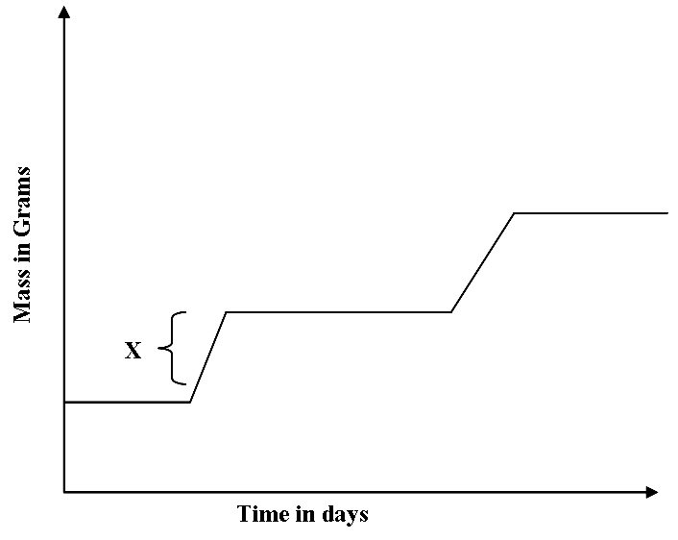
(a) Name the type of growth curve shown above. (1 mark)
…………………………………………………………………………………………………..
(b) (i) Identify the process represented by X. (1 mark)
…………………………………………………………………………………………………..
(ii) Name the hormone responsible for the process in b(i) above. (1mark)
…………………………………………………………………………………………………..
(c) State the importance of the growth of a pollen tube to a plant. (1 mark)
………………………………………………………………………………………………….
2. (a) What is the function of Sodium hydrogen Carbonate that is added to test solution of non-reducing sugar. (1 mark) ………………………………………………………………………………………………………....................................................................................................................................
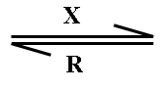
(b) The equation below represents a process X which is controlled by enzymes.
Glucose + Fructose Sucrose + Water
(i) Name the process X and enzyme R
Process X ……………………………………………………… (1 mark)
Enzyme R ………………………………………………………. (1 mark)
3. The diagram shows an epidermal cell undergoing mitotic cell division.
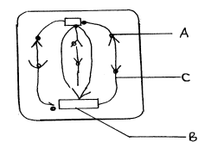
(a) Name the stage of mitosis it represents ……………………………………… (1 mark)
(b) Name the structures
A ……………………………………………………………………. (1 mark)
C…………………………………………………………………….. (1 mark)

- What is the effect of gibberellins on the shoots of plants? (4 marks)

…………………………………………………………………………………………………

…………………………………………………………………………………………………

…………………………………………………………………………………………………

…………………………………………………………………………………………………

…………………………………………………………………………………………………

…………………………………………………………………………………………………

5. (a) Give two forms in which carbon (IV) oxide is transported in human blood. (2 marks)

…………………………………………………………………………………………………

…………………………………………………………………………………………………

(b) Name the enzyme that enhances the loading and off – loading of carbon (IV) oxide in the
human blood. (1 mark)
…………………………………………………………………………………………………

…………………………………………………………………………………………………

6. (a) What is the importance of the counter current flow in the exchange of gases in a fish?
(2 marks)
…………………………………………………………………………………………………….
…………………………………………………………………………………………………..………………………………………………………………………………………………………..
(b) State two ways in which the tracheoles of an insect are adapted to their functions.
(2 marks)
…………………………………………………………………………………………………..
…………………………………………………………………………………………………..

7. The equation below represents a reaction that occurs during respiration in a cell.
K + Phosphate Adnenosine triphosphate
(a) Identify the compound K. (1 mark)
…………………………………………………………………………………………………..
(b) State two differences between K and ATP. (2 marks)

…………………………………………………………………………………………………..
…………………………………………………………………………………………………..

(c) Name the organelle responsible for the production of energy in a cell muscle. (1 mark)

…………………………………………………………………………………………………..
8. Explain how crops grown along roads can be a source of lead poisoning to human beings. (2 marks)
………………………………………………………………………………………………………
.......………………………………………………………………………………………………… ………………………………………………………………………………………………………
9. Explain why plants growing in low altitude areas grow faster than those in high altitudes.
(3 marks)
………………………………………………………………………………………………............
………………………………………………………………………………………………………
……………………………………………………………………………………………………….......………………………………………………………………………………………………….…….......…………………………………………………………………………………………….
10. List down four phenotypic characteristics that have been selected for the production of strains suitable for modern agricultural purposes. (4 marks)
……………………………………………………………………………………………………….......………………………………………………………………………………….…………………….......…………………………………………………………………….………………………………….......……………………………………………………….………………………………………………………………………………………………………………………………………………………………………………………………
11. Name the type of eye defects that can be corrected by;
(i) Use of bifocal lens (1 mark)
………………………………………………………………………………………………

(ii) Use of artificial lens (1 mark)
………………………………………………………………………………………………

(iii) Use of concave lens (1 mark)
………………………………………………………………………………………………
12. (a) The length from the tail tip to the anus of a certain tilapia fish is 10 cm. The length from the tail tip to the mouth is 35cm. Calculate the tail power of the fish. (Show all your working). (2 marks)
………………………………………………………………………………………………………
.......………………………………………………………………………………………………… ………………………………………………………………………………………………………
.......…………………………………………………………………………………………………
(b) What is the significance of high tail power in fish? (1 mark)

………………………………………………………………………………………………
13. List down three differences between the endocrine system and nervous system. (3 marks)
Endocrine system | Nervous system
i. ………………………………………………  ………………………………………………  ………………………………………………  ii ………………………………………………  ………………………………………………  ………………………………………………  iii ………………………………………………  ………………………………………………  ……………………………………………… | i. ………………………………………………  ………………………………………………  ………………………………………………  ii ………………………………………………  ………………………………………………  ………………………………………………  iii ………………………………………………  ………………………………………………  ………………………………………………
14. Distinguish between the struggle for existence and survival for the fittest as used in the theory of natural selection. (2 marks)
………………………………………………………………………………………………………
.......………………………………………………………………………………………………… ………………………………………………………………………………………………………
.......…………………………………………………………………………………………………
………………………………………………………………………………………………………
.......………………………………………………………………………………………………… ………………………………………………………………………………………………………
.......…………………………………………………………………………………………………

15. The body temperatures of two animals A and B varied as below with environmental
Temperature
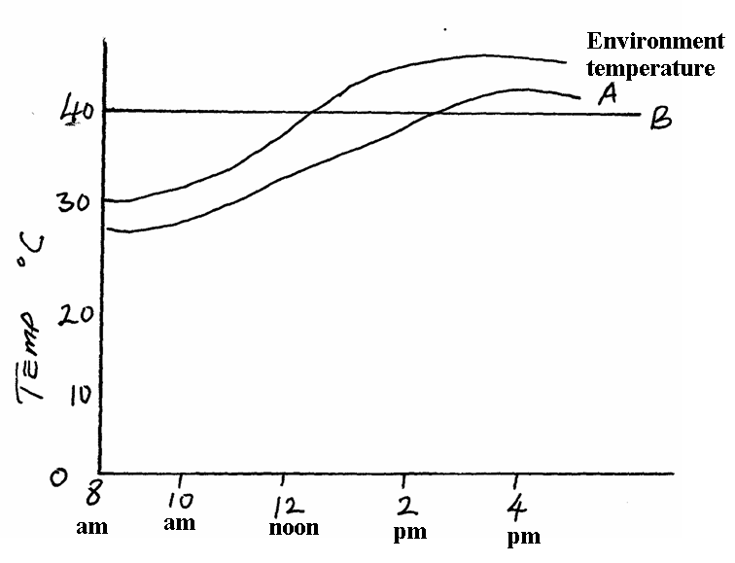

(a) Which of the animals is;
(i) Endothermic …………………………………………………….. (1 mark)
(ii) Ectothermic ……………………………………………………… (1 mark)
(b) With a reason, state which of the animals is likely to be widely distributed.
(2 marks)
…………………………………………………………………………………………………
…………………………………………………………………………………………………
…………………………………………………………………………………………………

16. State three roles of oestrogen during the menstrual cycle (3 marks)
…………………………………………………………………………………………………
…………………………………………………………………………………………………
…………………………………………………………………………………………………

17. State three characteristics of cells at the zone of cell division in an apical meristem.
(3 marks)
…………………………………………………………………………………………………
…………………………………………………………………………………………………
…………………………………………………………………………………………………
18. Below are diagrams of three leaves A, B and C. Construct a two step dichotomous
key which can be used to identify each of them. (4 marks) 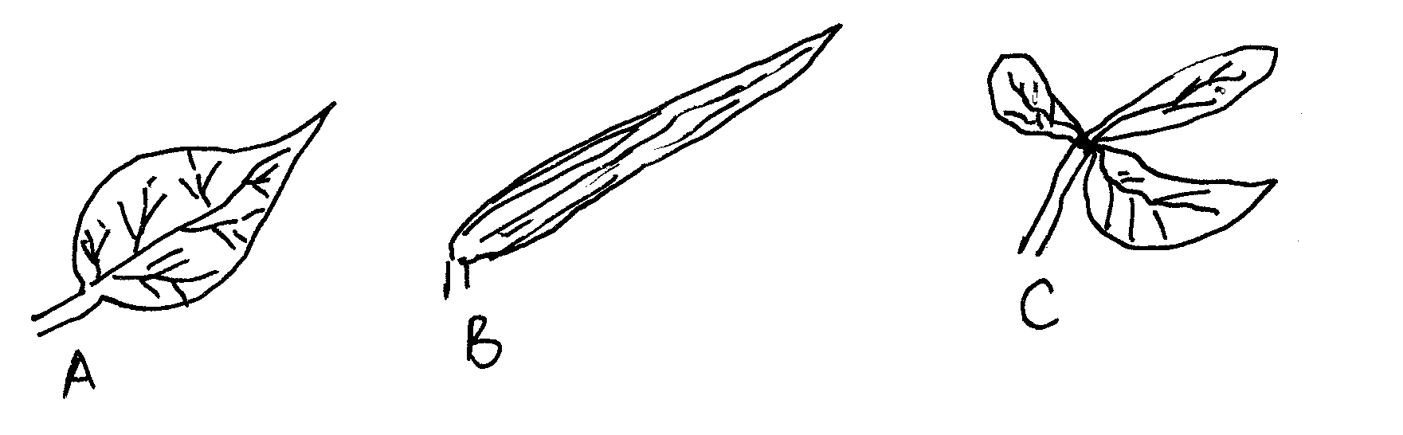
…………………………………………………………………………………………………
…………………………………………………………………………………………………
…………………………………………………………………………………………………
…………………………………………………………………………………………………
…………………………………………………………………………………………………
…………………………………………………………………………………………………
19. (a) Name two mutagenic agents. (2 marks)
……………………………………………………………………………………..
……………………………………………………………………………………..
b) Identify the type of gene mutations represented by the following pairs of words.
i) Shirt instead of skirt ……………………………………………… (1 mark)
ii) Hopping instead of shopping ……………………………………… (1 mark)
20. Liver damage leads to impaired digestion of fats. Explain this statement. (2 marks)
………………………………………………………………………………………………
………………………………………………………………………………………………

21. Explain why several lateral buds sprout when a terminal bud in a young tree is removed.
(3 marks)
……………………………………………………………………………………………………….……………………………………………………………………………………………………..….…………………………………………………………………………………………………..………………………………………………………………………………………………………
………………………………………………………………………………………………………

22. (a) State two structural adaptations that make xylem vessels suitable for transport of water and mineral salts. (2 marks)
……………………………………………………………………………………………………………………………………………………………………………………………………………….……………………………………………………………………………..………………………………………………………………………………………………
(b) List any three adaptations of the root hair cells to their functions (3 marks)
……………………………………………………………………………………………………………………………………………………………………………………………………………….……………………………………………………………………………...………………………………………………………………………………………………………………………………….…………………………………………………………..……………………………………………………………………………………………...
23. (a) Define the following terms:- (2 marks)
(i) Species
………………………………………………………………………………………………………
.......………………………………………………………………………………………………… ………………………………………………………………………………………………………
.......…………………………………………………………………………………………………
………………………………………………………………………………………………………

(ii) Binomial nomenclature
………………………………………………………………………………………………………
.......………………………………………………………………………………………………… ………………………………………………………………………………………………………
.......…………………………………………………………………………………………………
………………………………………………………………………………………………………
.......…………………………………………………………………………………………………
24. What is the significance of active transport in the human body? (3 marks)
……………………………………………………………………………………………………………………………………………………………………………………………………………….……………………………………………………………………………..……………………………………………………………………………………………………………………………………….…………………………………………………….…..…..………………………………………………………………………………………
25. Explain how the biceps and triceps muscles bring about the movement at the hinge joint of
the elbow in man. (2 marks)
……………………………………………………………………………………………………………………………………………………………………………………………………………………………………………………………………………….
……………………………………………………………………………………………………………………………………………………………………………………………………………………………………………………………………………….

