231/2 SMARTPASS BIOLOGY PAPER 2 MARKING SCHEME MODEL ONE 2019
Marking scheme
SECTION A (40 MARKS)
Answer all questions in this section.
1. a) W – Polar nuclei;
X – Ovum (egg cell);
Y- Integuments; (3mks)
b) - Dissolves the tissues of the stroma, style and ovary;
- Forms pathway for the male nuclei to reach the embryo sac; (2mks)
c) - They disintegrate ; (1mk)
d) - Male nuclei; carry out double fertilization. (2mks)

2. a) Sodium hydroxide ; To absorbs the carbon (IV) oxides produced:
b) To maintain an almost constant temperature during the period of the experiment ; a small rise in temperature causes air to expand ; a small fall in temperature causes air to contract ; leading to erroneous results; (3mks)
c) The level of water in the capillary would rise; (1mk)
d) The insect respired taking up oxygen ; releasing carbon (IV) oxide which is absorbed by Sodium Hydroxide; up take of oxygen caused a decrease in air pressure within the flask ; (3mks)
e) A control can be set up by substituting a living insert with a dead one;

- a) K- eye piece
M-coarse adjustment knob.
b) P-concentrate the light/focuses the light
Q- magnification of the image.
c) i) – N
ii) – Eyepiece magnification X objective lens magnification
d) i) For light to pass through easily;
ii) To make the features more clear and distinguishable;
iii) For cells to remain turgid;

- Parental phenotype : Black mouse : Brown mouse
Parental genotype : BB : bb ;

Gamete : B B : b b ;

F1 generation : Bb Bb : Bb Bb ;

b) i) F2 offspring’s are BB, Bb, Bb, bb:
Genotypic ratio = 1BB:2Bb:1bb;
ii) Phenotypic ratio -1brown: 3black ;
iii) ¼ x 96 = 28 ;

5. a) Diffusion;
b) i) Reducing sugars/simple sugars/glucose;
ii) Diastase converts starch to reducing sugars; so present in visking tubing then due to small sized molecules of reducing sugar and semi-permeability of the visking tubing; the molecules moved across the semi-permeable to the beaker; so present both in the visking tubing and the beaker.(Rej- Second mark:-If size and semi permeability are not indicated)
c) i) Proteins; reject Amino acids
ii) The molecules of proteins are large/big so cannot pass through the pores of the semi-permeable membrane visking tubing
- Turgid; Accept turgidity

SECTION B ( 40 MARKS)
Answer questions 6 (compulsory) and either questions 7 or 8 in the spaces provided questions 8
6. (a) (i) At 45 minutes 0.660 mg/ mp; (1 mark)
At 75 minutes 0.580 – 0.582 mg/ ml;
(ii) Check graph (6 marks)
(iii) At 37.5 minutes 0.670 0.05 mg/ ml (1 mark)
(Evidence on graph to earn mark)
(iv) To obtain reliable results; (1 mark)
(v) The rats may have been different in terms of weight, sex, age; or had
different rates of metabolism; (2 marks)
(vi) Glucose decreased; due to conversion into glycogen; utilization to
release energy; (2 marks)
(b) It is highly soluble, therefore easily transported to the sites of respiration; it
requires relatively low oxygen to oxidise a unit mass of glucose than the other substrates; (3 marks)
- Oxidized to give energy, carbon (IV) oxide and water; converted to glycogen and
stored in the liver; converted to fats and stored under the skin, around the kidneys etc; (3 marks)

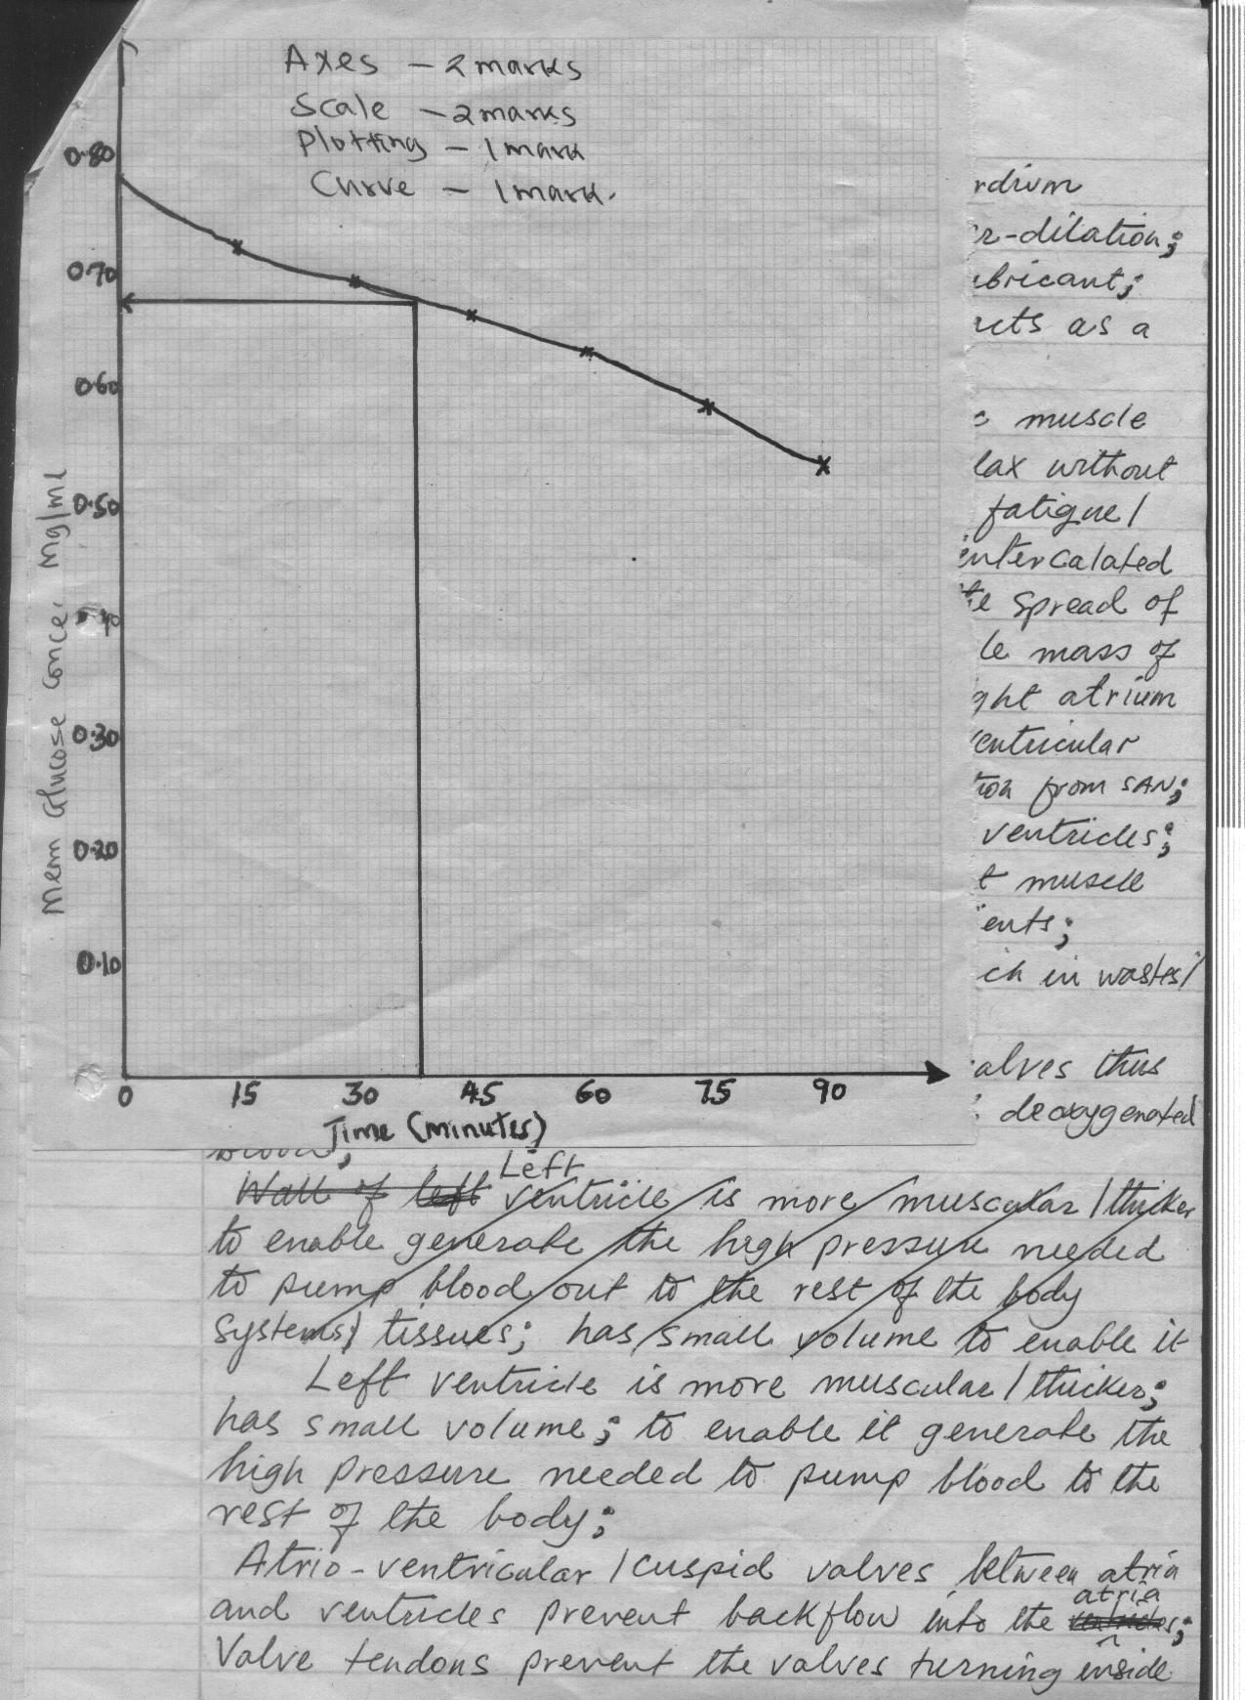

7. a)
Answers
- The animals when released mix freely and evenly with others;
- Marked animals will have enough time to mix freely and evenly with
others;
- No immigration / emigration / migration of animals during the study
period;
- No animal dies / born during the study period / the man does not change the balance of the animals or the others. (5mks)
b)
Answers:
- Using a fish net ; catch as many fish as possible ; place the caught fish in a basin / pail with water ; count; mark the fish with a light coloured water proof paint / nail vanish; record the number caught and marked / first marked (FM);
- Release the fish back to the pond;
- After 24 hrs to 3 days ; use the same net to catch as many fish as possible ;
- Second catch (sc); and those caught with marks ie marked recapture (MR) turn all the fish back to the pond;
If p is total population ;

Then

Hence P = ;
Must define terms to award (15 marks)

8. (a) Process by which nature selects those individuals which are sufficiently well
adapted to the environment and allow them to survive; but rejects those that are
poorly adapted.(2mks)
(b) Individuals of same species show certain variations; which are caused by genes; and the variations can be passed from parents to their offsprings; through genetic inheritance; some of the variations or characters become more suited to the prevailing environment condition; due to selection pressure or competition; most organisms tend to produce more offsprings that the environment can support; this leads to struggle for existence; among the individual species e.g food, water, shelter, mates; due to stiff competition; individuals that posses characteristics that enable them to have competitive advantage stand a better chance of survival in the struggle; the result is that well adapted individuals survive; and their reproductive age; from where they pass on their desirable genes/ trails to their offsprings; those that are poorly adapted; fail to reach their reproductive age; and hence does not pass over the poor traits to their offsprings; and thus perish to allow the fittest survive. (Max 18mks)

