Name…………………………………………………. Index No………………….../………
Candidate’s Signature…………………………… Date ………………………………..

231/3
BIOLOGY
(PRACTICAL)
Paper 3
1³/₄ Hours

SMARTPASS EXAMINATION
Kenya Certificate of Secondary Education (KCSE)
MODEL ONE 2019
231/3
BIOLOGY
(PRACTICAL)
Paper 3

INSTRUCTIONS TO CANDIDATES

- Write your name and Index Number in the spaces provided above.
- Sign and write date of examination in the spaces provided above.
- Answer ALL questions in the spaces provided in the question paper.
- You are not allowed to start working with the apparatus for the first 15 minutes of the 1 3/4 hours allowed for this paper. This time is to enable you to read the question paper and make sure you have all the chemicals and apparatus that you may need.

For Examiners use only.
Section | Question | Maximum Score | Candidates Score
 | 1 | 16
 | 2 | 14
 | 3 | 10
 | Total score | 40

This paper consists of 7 printed pages. Candidates should check the question paper to ensure that all the papers are printed as indicated and no questions are missing

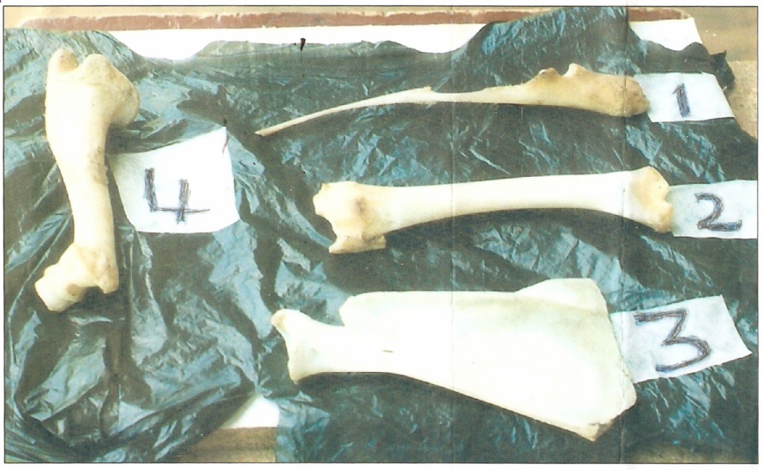
1. The diagram below shows bones obtained from the same mammal.

(a) Give the identity of each of the above bones. (4 marks)

1……………………………………………………………………………………………
2……………………………………………………………………………………………
3…………………………………………………………………………..…..….…………
4..……………………………………………………………………………………………

(b) Draw a diagram of the bones, arranged as they appear in the mammal from which they were obtained from. (3 marks)

(c) On your diagram indicate by naming the types of joints between the bones. (2 marks)
(d) (i) Give three adaptations of bone labeled 3 to its functions. (3 marks)
……………………………………………………………………………………………………….….………………………………………………………………………………………………………..………………………………………………………………………
……………………………………………………………………………………………………….….………………………………………………………………………………………………………..………………………………………………………………………

(ii) Give three adaptations of bone labeled 4 to its functions (4 marks)
……………………………………………………………………………………………………….….………………………………………………………………………………………………………..………………………………………………………………………
……………………………………………………………………………………………………….….………………………………………………………………………………………………………..………………………………………………………………………
……………………………………………………………………………………………………….….………………………………………………………………………………………………………..………………………………………………………………………

2. You are provided with solution labeled J, use the reagents provided to test for the food
substances.
(a) Use the iodine solution to test for the food substance in solution J.
Food substance (1 mark)
………………………………………………………………………………………………………Procedure (1 mark)
………………………………………………………………………………………………………………………………………………………………………………………………………………
………………………………………………………………………………………………………………………………………………………………………………………………………………

Observation (1 mark)
………………………………………………………………………………………………………………………………………………………………………………………………………………

Conclusion (1 mark)
………………………………………………………………………………………………………………………………………………………………………………………………………………
………………………………………………………………………………………………………………………………………………………………………………………………………………

(b) Use Benedict’s solution to test for the presence of the food substance in solution J.
Food substance (1 mark)
………………………………………………………………………………………………………
Procedure (1 mark)
………………………………………………………………………………………………………………………………………………………………………………………………………………
………………………………………………………………………………………………………………………………………………………………………………………………………………
………………………………………………………………………………………………………

Observation (1 mark)
………………………………………………………………………………………………………………………………………………………………………………………………………………
………………………………………………………………………………………………………………………………………………………………………………………………………………
Conclusion (1 mark)
………………………………………………………………………………………………………………………………………………………………………………………………………………
………………………………………………………………………………………………………………………………………………………………………………………………………………

(c) Use DCPIP solution provided to test for the presence of the food substance in solution J
Food substance (1 mark)
………………………………………………………………………………………………………
Procedure (1 mark)
………………………………………………………………………………………………………………………………………………………………………………………………………………
………………………………………………………………………………………………………………………………………………………………………………………………………………

Observation (1 mark)
……………………………………………………………………………………………………………………………………………………………………………………………….……………...………………………………………………………………………………………………………………………………………………………………………………………………………………
Conclusion (1 mark)
……………………………………………………………………………………………………………………………………………………………………………………………….…………………………………………………………………………………………………………………………………………………………………………………………………………………………...

(d) When testing for non-reducing sugars explain the role of the following substances.
(i) Dilute hydrochloric acid. (1 mark)
……………………………………………………………………………………………………………………………………………………………………………………………….……………..………………………………………………………………………………………………………
………………………………………………………………………………………………………
(ii) Sodium hydrogen carbonate (1 mark)
……………………………………………………………………………………………………………………………………………………………………………………………….……………..………………………………………………………………………………………………………………………………………………………………………………………………………………
3. Study photograph labeled V which is a display of internal organs of a small mammal. Photograph F is an inset of internal structure of part labeled L. Study them carefully.
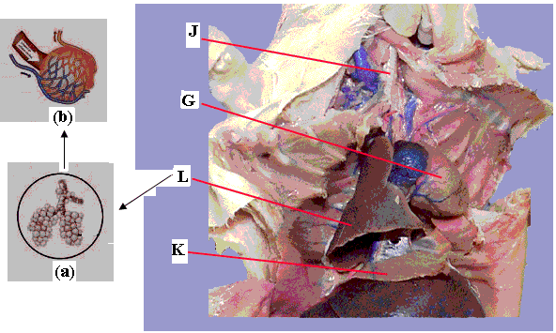

Photograph F Photograph V

(a) Name the part of the mammalian body where the organs shown in the photograph are found. (1 mark)

……………………………………………………………………………………………………………………………………………………………………………………………….……………...………………………………………………………………………………………………………………………………………………………………………………………………………………

(b) Identify the organ system that consists of parts J and L in the photographs. (1 mark)

………………………………………………………………………………………………………

(c) (i) Name the parts labelled J and K. (2 marks)

J……………………………………………………………………………………………………..K………………………………………………………………………………………….…………

(ii) Give the function of the part labelled G. (1 mark)

……………………………………………………………………………………………………………………………………………………………………………………………….……………...

(d) State two adaptations of organ in L to its functions (2 marks)

……………………………………………………………………………………………………………………………………………………………………………………………….……………..………………………………………………………………………………………………………………………………………………………………………………………………………………

(e) F (a) is an inset of the internal structure of part L showing the position of the functional units
of L. One of these functional units is shown in the inset F (b).
(i) Identify the functional unit shown in inset F(b) and give its function. (2 marks)
Identity:

………………………………………………………………………………………………
Function:

………………………………………………………………………………………………………………………………………………………………………………………………

(ii) Give one observable feature in the structure you have named in (e)(i) above that
adapt it to its function. (1 mark)
………………………………………………………………………………………………………………………………………………………………………………………………

