231/3 SMARTPASS BIOLOGY PAPER 3 MARKING SCHEME MODEL ONE 2019
Marking scheme
1. (a) 1 - Ulna
2 - Radius
3 - Scapula
4 - Humerus
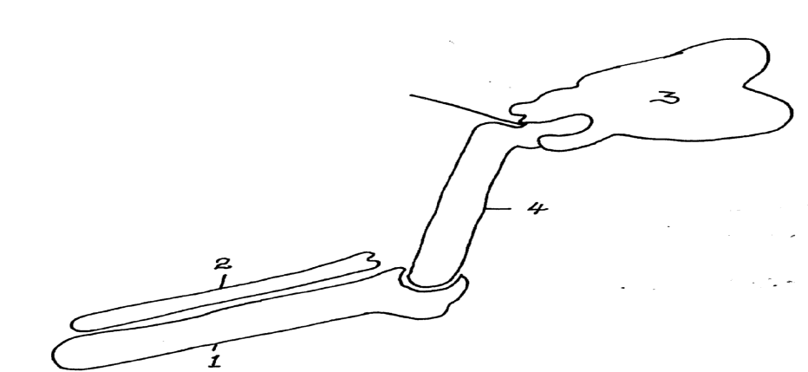
(b)
Scapula
-Correct arrangement of bones -1mk
- Labelling the bones – 1mk
-Proportionality
of the bones – 1mk

Ball and socket joint (1 mark)

Radius

Humerus

Hinge joint; (1 mark)
Ulna

(d) (i)
- Broad and flattened surface to provide a large surface area for attachment of shoulder muscles; rej flat
- Has a spine to increase surface area for muscle attachment;
- Has a glenoid cavity for articulating with the head of humerus; rej joining for articulation
- Has coracoid process for attachment of ligaments that connect it to the humerus; (Any three)
(ii)
- Has a long shaft to act as a lever for easy movement of the limb
- Has a long shaft to provide a large surface area for attachment of biceps and triceps muscles;
- Has a head (ball) for articulating with the scapula to form a ball and socket joint;
- Has trochlea at one end for articulating with the sigmoid notch of the ulna;
- Has olecranon fosa into which the olecranon process on the ulna fits to stop overstretching of the lower arm backwards. (Any 2)

2. (a)
Food substance; Starch;
Procedure; Add iodine solution to J

Observation; Blue- Black/ black/ blue colour is observed;
rej. Bluish/
blackish
Conclusion; Starch present;
(b) Food substance; Reducing sugar
Procedure; To solution J, add Benedict’s solution, Boil
Rej . benedicts/Benedicts, warm for boiling ( in a water bath)
Observation; The colour remains blue/ blue colour persists;
rej No Change
Conclusion: Reducing sugar absent;
(c) Food substance; Vitamin C/ Ascorbic acid;
Procedure: Add solution J into DCPIP; drop by drop.
Rej. Without drop by drop
Observation: DCPIP is decolourised;
Conclusion: Vitamin c/ Ascorbic acid present;
(e) i) to hydrolise any disaccharide present.
ii) to neutralize excess hydrochloric acid. rej. Without excess.

3. (a) Thorax/Thoracic region/Thoracic cavity; Rej chest
- Gaseous exchange system; Rej Respiratory system.
(c)(i) J: Trachea; Rej wind pipe K: Diaphragm;
(ii) Pumping blood to various parts of the body;
(d)- Highly vascularised in alveoli for gases to diffuse and get transported;
- Spongy to accommodate more air; Acc. elastic
- Numerous alveoli to increase surface area for maximum gaseous exchange;
- Well ventilated/connected to bronchus/bronchioles to allow free movement of gases in and out during breathing;
- Has alveoli with moist lining where gases dissolve to facilitate gaseous exchange due to their rapid diffusion; (1st two)
(e) (i) Identity: Alveolus; Rej alveoli, air sac
Function: The surface in the lungs where gaseous exchange occurs;
(ii) Highly vascularised for gases to diffuse into to enhance their transportation;
Well ventilated to enhance movement of gases in and out; (1st one)

