END OF TERM 2 EXAMS
BIOLOGY
FORM 1

NAME: ..................................................................CLASS: .............ADM: ......................

- State the name given to the study of (2mks)
- Insects
……………………………………………………………………………………………
- Classification of living organisms.
……………………………………………………………………………………………

- (a) Name the products of complete hydrolysis of sucrose. (1mk)
………………………………………………………………………………………………
………………………………………………………………………………………………
(b) What happens to these products named in (a) above, when they are excess in the
body of man. (2mks)
………………………………………………………………………………………………
………………………………………………………………………………………………
3. (a) State the roles of light in plant nutrition. (2mks)
………………………………………………………………………………………………
………………………………………………………………………………………………
(b) Give a reason why glucose formed at the end of photosynthesis is converted at once
into starch. (1mk)
………………………………………………………………………………………………..............................................................................................................................................
- (a) State the formula for calculating linear magnification of a specimen when using a hand lens. (1mk)
………………………………………………………………………………………………
………………………………………………………………………………………………
(b) Give one functional advantage of use of the following microscopes. (2mks)
(i) Light Microscope
……………………………………………………………………………………………
(ii) Electron Microscope.
……………………………………………………………………………………………

- An investigation was set up as shown in the diagram below.
Glass rod
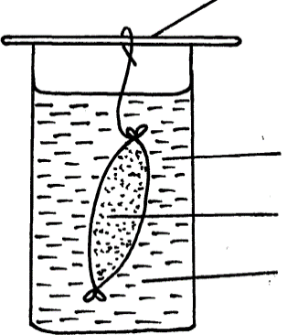

Visking tubing

Starch suspension
Iodine solution

After 30 minutes, starch suspension had turned blue-black while iodine solution retained its colour.
- Name the physiological process that was being investigated in the experiment. (1mk)
………………………………………………………………………………………………
- Account for the results observed after 30 minutes. (3mks)
……………………………………………………………………………………………
………………………………………………………………………………………………
………………………………………………………………………………………………
…………………………………………………………………………………………
- Define the term osmosis. (2mks)
................................................................................................................................................................................................................................................................................................
- (a) Distinguish between homodonts and heterodonts. (1mk)
………………………………………………………………………………………………
………………………………………………………………………………………………
(b)A certain mammal has no incisors, no canines, 6 premolars and 6 molars in the upper jaw.
In the lower jaw, there are 6 incisors, 2 canines, 6 premolars and 6 molars.
- Write down the dental formular of this mammal. (1mk)
……………………………………………………………………………………………
………………………………………………………………………………………………
- What is the mode of nutrition of this mammal? ( 1mk)
……………………………………………………………………...........................................

- The reaction represented by equation below occurs in the body
Hydrogen peroxide Oxygen + Water

(a) Name enzyme Z (1mk)
………………………………………………………………………………………………
(b) Name an organ in the human body where this reaction occurs (1mk)
………………………………………………………………………………………………
(c) State the biological importance of the reaction above (1mk)
………………………………………………………………………………………………

9. State how each of the cells below are specialized to carry out their functions
(a) Palisade cell (1mk)
……………………………………………………………………………………………
(b) A sperm cell (1mk)
……………………………………………………………………………………………
- State the functions of each of the following organelles.
(i) Ribosomes (1mk)
…………………………………………………………………………………………………
(ii) Golgi apparatus (1mk)
…………………………………………………………………………………………………

- Name the bond that exists between amino acids during condensation process of forming proteins? (1mk)
………………………………………………………………………………………………

………………………………………………………………………………………………
- Explain how the following factors affect the rate of photosynthesis
(a) Concentration of carbon (iv) oxide. (1mk)
………………………………………………………………………………………………
………………………………………………………………………………………………
(b) Light intensity (1mk)
………………………………………………………………………………………………………………………………………………………………………………………………

- Study the figure below which shows a type of epithelial tissue
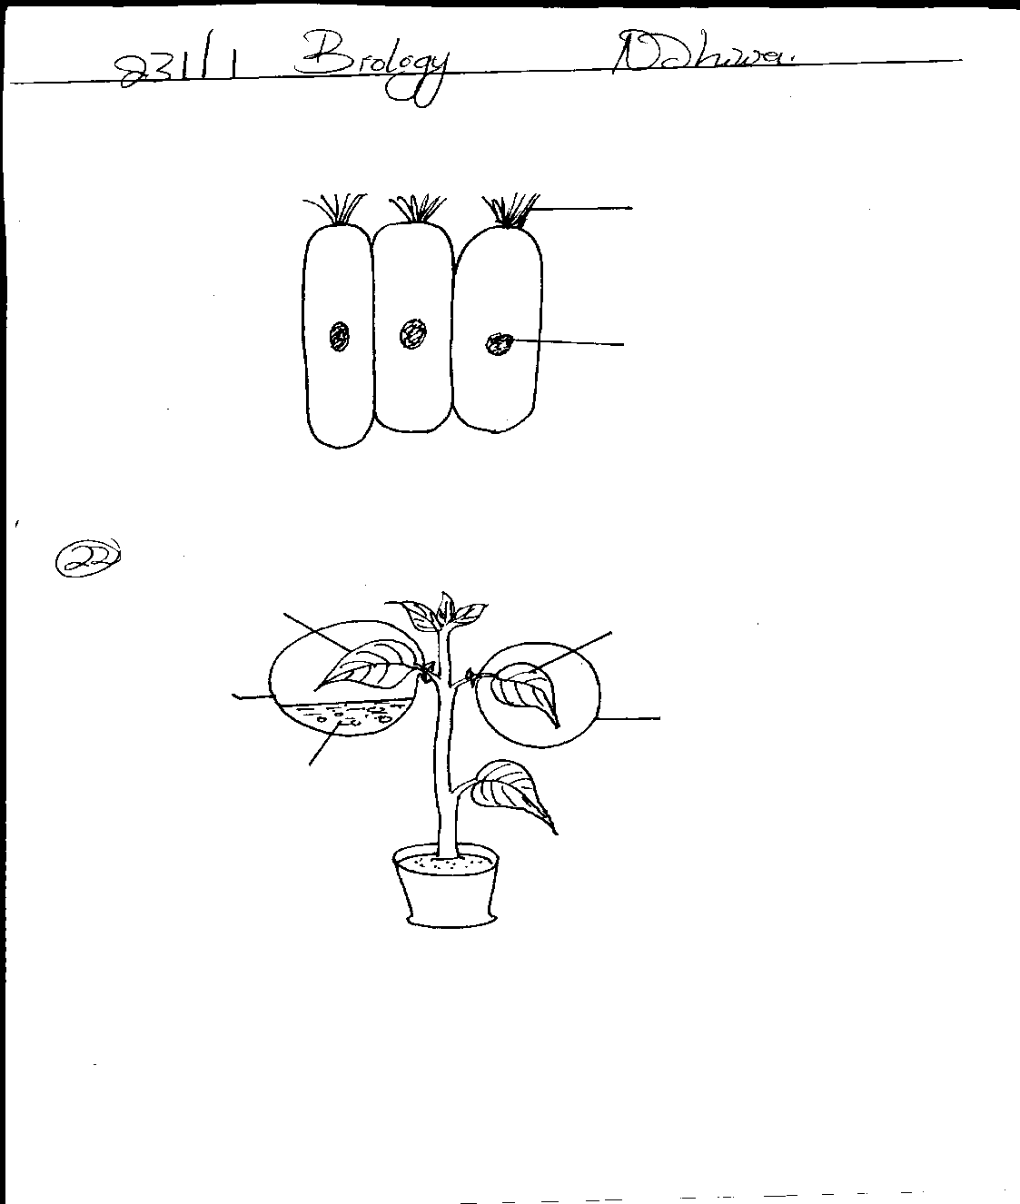
A
B

- State the name of structure A. (1mk)
………………………………………………………………………………………………
………………………………………………………………………………………………
- Give an example in humans where this epithelium is found (1mk)
………………………………………………………………………………………………

- The diagram below represents part of the human digestive system.
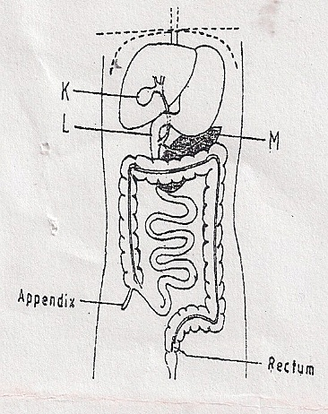
Name the organs labeled L and M. (2mks)
L: ………………………………………………………………………………………………
M: ……………………………………………………………………………………………..

- Some form one students wanted to collect the following animals for study in the
Laboratory. State the suitable apparatus they should use.
i) Flying insects ........................................................... (1mark)
ii) Crawling stinging insects .................................................... (1mark)
iii) Small animals from tree barks ................................................... (1mark)

- Study the diagram below and answer the questions that follows
a) Identify the structures labeled A and B (2marks)
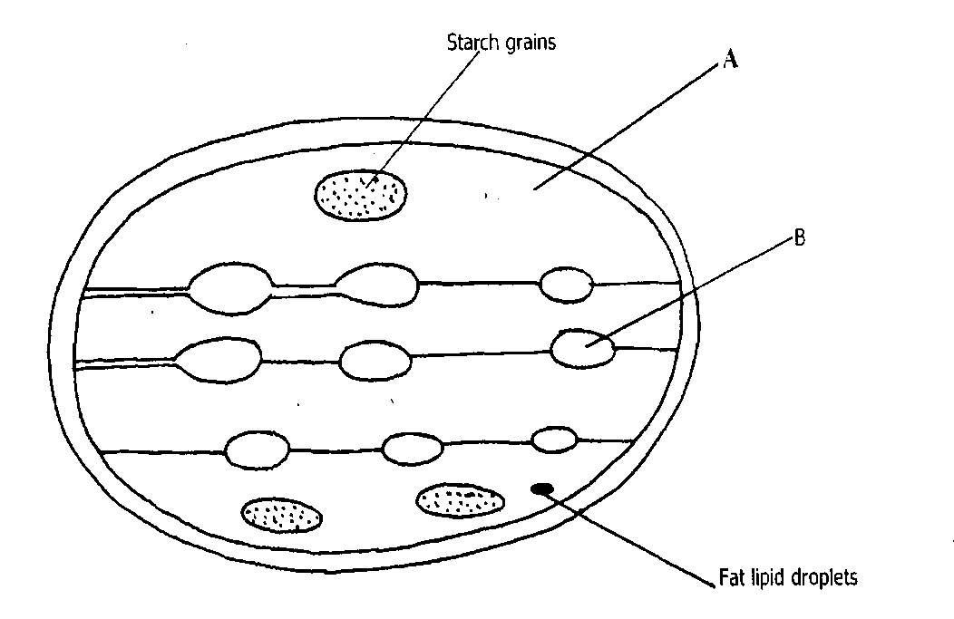

b) b) What process takes place in the parts labeled A and B (2mark)

- A student estimated the diameter of a field of view to be 2.8mm. The diameter was occupied by four onion cells. Estimate in micrometers the diameter of onion cell. Show your working. (2 marks)

- The diagram below represents structure found in the walls of ileum.
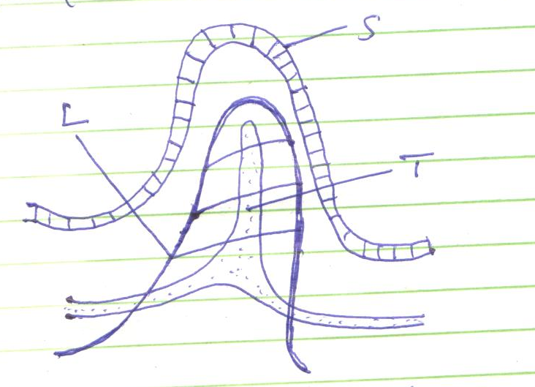
L
T
S
- Identify the structure shown in the diagram. (1 mark)

- Name parts labeled S, T and L. (3 marks)
S .................................................................
T .................................................................
L .................................................................
- Name products of digestion which are absorbed into; (2 marks)
L ..............................................................................
T ...............................................................................
- State how the above structure is adapted to its function. (2 marks)
........................................................................................................................................................................................................................................................................................................

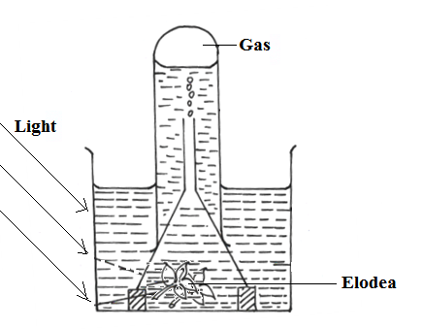
- The diagram below represents a set up that was used to investigate a certain process in a plant.

- State the process that was being investigated. (1 mark)
……………………………………………………………………………………………………………….………………………………………………………………………………………………………………………………

- Other than the factors shown, state two factors that would affect the process named in (a) above. ( 2 mark)
……………………………………………………………………………………………………………….………………………………………………………………………………………………………………………………

- Outline two roles of active transport in human beings. ( 2 marks)
……………………………………………………………………………………………………………….………………………………………………………………………………………………………………………………....................................................................................

- Write the role of the following parts of microscope. (3marks)
- Mirror
............................................................................................................................................................................................................................................................................................................ ii) Diaphragm
............................................................................................................................................................................................................................................................................................................
- Coarse adjustment knob
......................................................................................................................................................................................................................................................................................................................

- Explain w hy plant cells do not burst when immersed in distilled water.(2mks)
................................................................................................................................................................................................................................................................................................................................................................................................................................................................................................................................................................................................................................................................................................
- (a)State two functions of bile juice in the digestion of food? (2marks)
........................................................................................................................................................................................................................................................................................................................................................................................................................................................................................................................
(b) How does substances concentration affect the rate of enzyme reaction? (1mark)
........................................................................................................................................................................................................................................................................................................................................................................................................................................................................................................................

- The diagram below represents a cell
X
Y

- Name the parts labeled X and Y (2marks)
X ...........................................................................................................................
Y ..........................................................................................................................
- State why the structures labeled X would be more on one side than the other side.(1mark)
....................................................................................................................................................................................................................................................................................................................................................................................................................................................................................

- a) What is diffusion (2marks)
........................................................................................................................................................................................................................................................................................................................................................................................................................................................................................................................
- How does diffusion gradient affect the rate of diffusion? (1mark)
............................................................................................................................................................................................................................................................................................................................................................

