NAME:………………………………………………………………ADM:………CLASS:……………

BIOLOGY
MID TERM 1 2023
FORM 2
- The Diagrams below show a Red Blood cell that was subjected to acertain treatment.

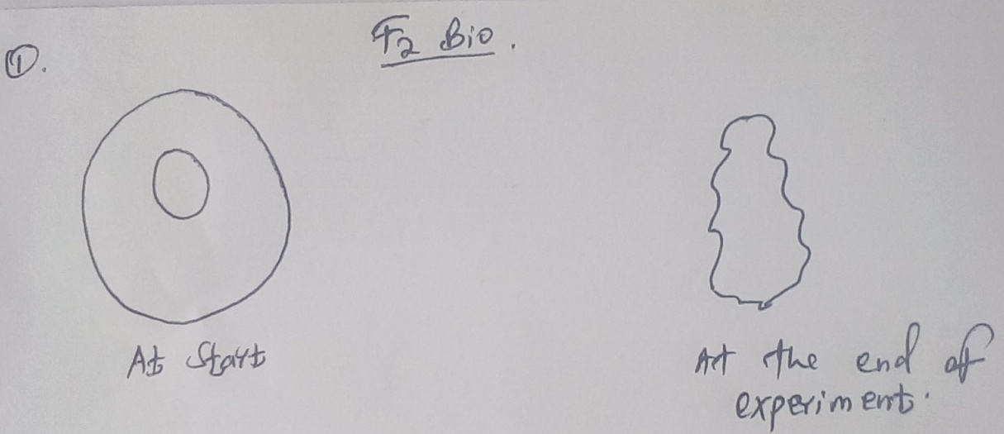

At the end of experiment
At start
- Account for the shape of the cell at the end of the experiment. (2mks)

- Draw a diagram to illustrate how a plant cell would appear if subjected to the same treatment. . (2mks)

- The diagram below shows a human tooth.
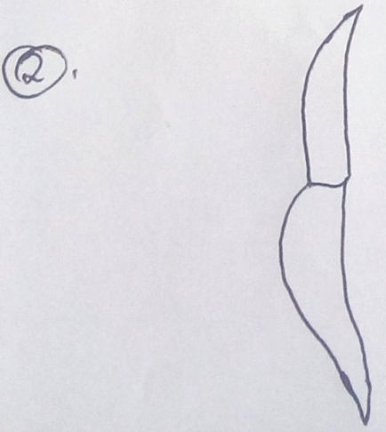
- Identify the tooth. (1mk)

- How is the tooth adapted to its functions. (2mks)

- The diagram below represents a transverse section through a plant organ.

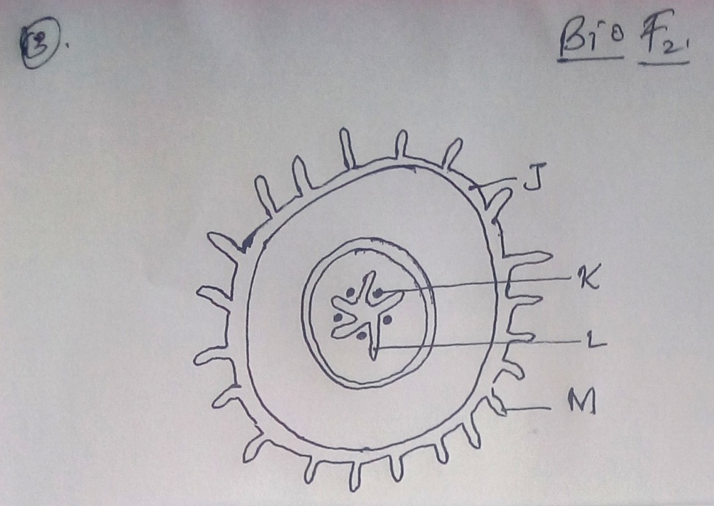

- From which plant organ was the section obtained. (1mk)
- Give two reasons for your answer in (a) above (2ks)

- Name the parts labeled J K and L. (3mks)

- State two functions of the part labeled M. (2mks)

- Explain how each of the following factors affects the rate of photosynthesis
- Temperature (2mks)

- Chlorophyll concentration. (2mks)

- Name the tissues in plants responsible for: (2mks)
- Transport of water and mineral salts

- Transport of carbohydrates

- State one adaptation of xylem vessels to their functions . (1mk)

- (a) Why are people with blood group O universal donors? (2mks)

(b)A person whose blood group is AB requires a blood transfusion. Name the blood groups of the donors. (2mks)

- Name the organelles that performs the following functions in a cell (2mks)
- Protein synthesis

- Transport of cell secretions

- State one use for each of the following apparatus in the study of living organisms. (2mks)
- Pooter

- Pitfall trap

- A ‘dolf’ is an offspring between a wolf and a dog. This animal is infertile. Give a reason for this. . (1mk)

- State the role of light in photosynthesis (2mks)

- Name a disease caused by lack of each of the following in human diet. (2mks)
Vitamin D-

Iodine

- The following is the dental formula of a certain mammal.
I 0/3 C 0/1 pm 3/3, molar 3/3

- State the likely mode of feeding for the mammal. (1mk)

- Give a reason for your answer in (a) above. (1mk)

- Explain why the rate of transpiration is reduced when humidity is high? (2mks)

- Why are plants able to accumulate most of their waste products for long. (1mk)

- State two ways by which acquired immune deficiency syndrome (AIDS) virus is transmitted. . (2mks)

- State three structural differences between arteries and veins. (3mks)

- State three difference between open and closed circulatory systems. (3mks)

- Explain two protective functions of blood. (2mks)

