FORM ONE 2022 FIRST TERM BIOLOGY EXAM
NAME:
ADM NO:
Answer all the questions in the spaces provided (100mks)
- a) Name one product of the light stage during photosynthesis (1mk)

b) Name the process by which water molecules are split by light during photosynthesis (1mk)

- What name is given to the process whereby :
- Red blood cells wrinkle after losing their water to a hypertonic solution? (1mk)

- Plant cells become flaccid after losing their water to a hypertonic solution? (1mk)

- Four equal strips A,B,C and D were cut from a potato whose cells had a sugar concentration of 28.5%.The strips were placed in sugar solutions of different concentrations as follows:
A: 10%, B: 15%, C: 25%, D: 35%
- What changes would you expect in strips A and D? (2mks)

- Account for the change in strip D (3mks)

- The figure below shows a small piece of visking tubing which is filled with potassium permanganate solution. Its free ends were tied tightly to prevent leakage .It was then dipped in a beaker full of distilled water. The set up was left for 2 hours. It was observed that the distilled water was coloured purple.
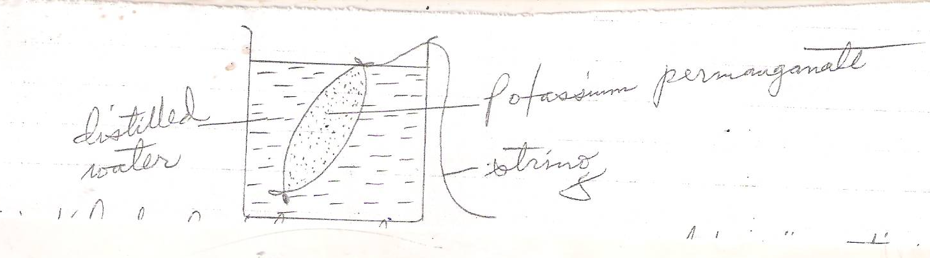
- What physiological process was being investigated? (1mk)

- Account for the observation made in (a) above. (3mks)

- a) State three factors that affect enzyme activities (3mks)

- Name the structures on an enzyme where substrate molecules fix themselves during an enzyme reaction. (1mk)

c) State what would happen to an enzyme molecule if the temperature is:-
i) Raised above 40˚c (1mk)

ii) Lowered below 10˚c. (1mk)

- The diagram below represents a set up that was used to investigate a certain process in a plant.
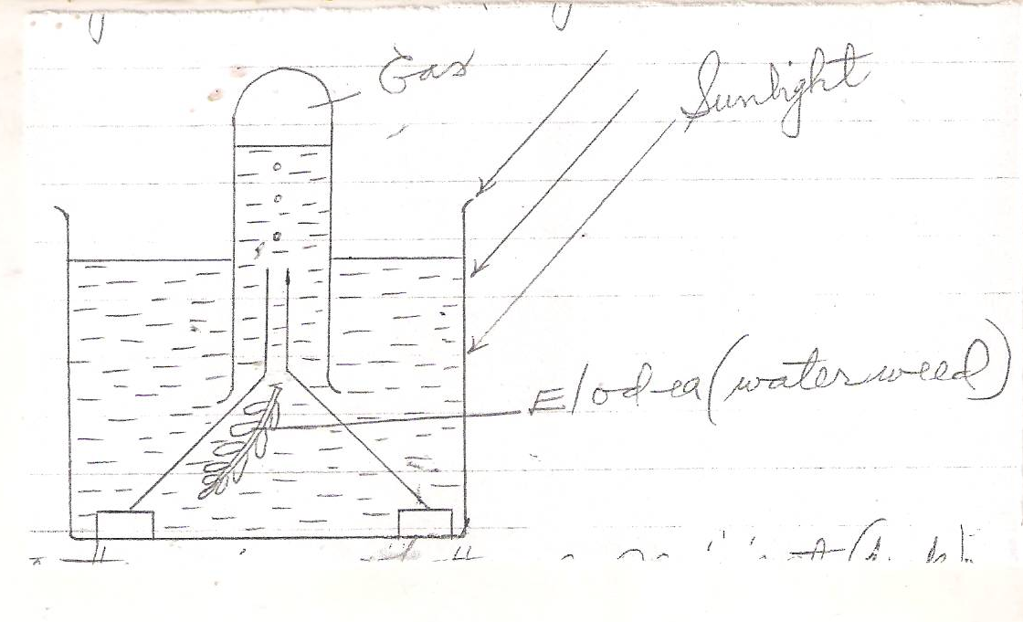
- State the aim of the experiment (1mk)

- State a factor that would affect the process (1mk)

- State the importance of nucleic acids to an organisms (1mk)

- State the significance of the following to a leaf:-
- Thinness (1mk)

- Presence of air spaces (1mk)

- Stomata (1mk)

- What is the role of roof hairs in plants (1mk)

- What is meant by the term organ systems in organisms? (1mk)

- State three factors that affect the rate of diffusion (3mks)

- What is compensation point? (1mk)

- a) State two properties of monosaccharide (2mks)

b) What is the main function of monosaccharide in organisms? (1mk)

- State the formula for calculating magnification when using the following
- Hand lens/naked eyes (1mk)

- A light microscopic (1mk)

- Explain why a mule, a product of mating between a horse and a donkey is sterile. (1mk)

- State two factors considered while grouping the organisms in the same species (2mk)

- Describe how you would carry out food tests to test the presence of starch and reducing sugars on a food sample.
- Test for starch (3mks)

- Test for reducing sugar (4mks)

- Explain how surface area to volume ratio idea may be applied to explain rate of diffusion in organisms. (2mks)

- Which organelles in a cell perform the following functions
- Manufacture of ribosomes (1mk)

- Package cell secretions (1mk)

- Energy production (1mk)

- Synthesis of carbohydrates (1mk)

- Name the taxonomic unit with:
- The greatest number of organism. (1mk)

- The least number of organisms (1mk)

- a. Define the term cell (1mk)

b. When onion epidermal cells were placed and focused along the diameter of the field of view, 10 cells were viewed and counted. Calculate the length of each epidermal cell in micrometers (1mm = 1000micrometers).Assume the diameter of field of view= 3mm (2mks)

- Name the kingdom in which the organisms named below belong.
- Bacteria (1mk)

- Paramecium (1mk)

- Yeast (1mk)

- State the deficiency disease caused by deficiency of the following vitamins
  - Vitamins A (1mk)

  - Vitamin D (1mk)

  - Vitamin B₁ (1mk)

- a. State and explain how the ileum is adapted to perform its function. (4mks)

b. State two functions of the colon during digestion. (2mks)

- a. Name two diseases that affect human teeth. (2mks)

b. (i) write the dental formula of an adult human. (1mk)

(ii) Work out the total number of teeth from the formula above (1mk)

- In an experiment to investigate a factor affecting photosynthesis, a leaf of a potted plant which had been kept in the dark overnight was covered with aluminium foil as shown in the diagrams below.

The set up was kept in sunlight for three hours after which a food test was carried out on the leaf.
- Which factor was being investigated in the experiment? (1mk)

- Which food test was carried out? (1mk)

- i) Sate the results of the food test. (2mks)

ii) Account for the results in (c) (i) above. (2mks)

- Why was it necessary to keep the plant in darkness before the experiment? (1mk)

- a. Distinguish between the term s homodont and heterodont (2mks)

b. Name the gap between incisors and premolars in some herbivores and state its function. (2mks)

- State and explain how palisade cells are adapted to perform their function. (3mks)

- a. Define the term active transport. (2mks)

b. State four factors that affect active transpiration. (4mks)

30. State the function of the following parts of a light microscope.
a. Coarse adjustment knob. (1mk)

b. Diaphragm (1mk)

c. Condenser (1mk)

31. Name the first four taxa in taxonomy starting from the highest level

