BIO MARKING SCHEME PP3 2020 FORM 4 TERM 1 ENTRY EXAMS

- You are provided with specimen labelled F. Examine the specimen.
- With reasons state the type of fruit specimen F is. (1mk)
Legume
Reason (1mk)
Pericarp has longitudinal margins (lines of weakness).
-Pericarp enclose the seeds inform of a pod.
-Marginal placentation, develops from superior ovary
- Carefully open specimen F to expose it’s contents
- State the type of placentation in the specimen. (1mk)
Marginal placentation
- Draw and label the opened specimen. (5mks)
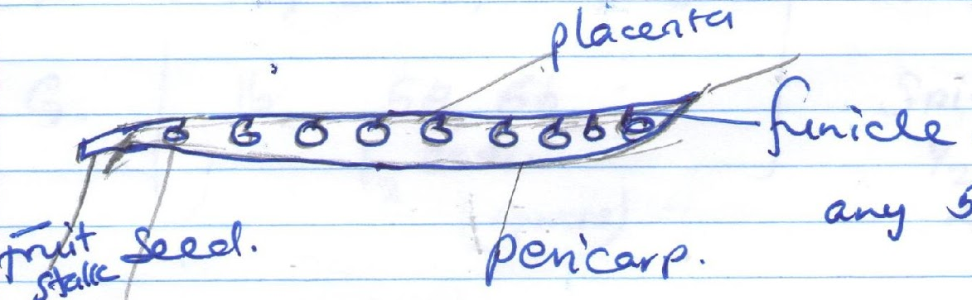
- Work out your magnification. (2mks)
Magnification = Length of diagram
Actual length of the specimen
- Remove the seeds and crush them suing a motar and pestal to make a paste. Add alittle water to make about 10ml solution of the paste.
Using the reagents provided test for the food substances present in the juice. Record the food substances being tested, procedures, observation and conclusion in the table below.
FOOD SUBSTANCE BEING TESTED | PROCEDURE | OBSERVATION | CONCLUSION
Starch | -To the solution add 2 drops of iodine solution | Colour of iodine turns to blue black | Starch present
Proteins | To the solution add sodium Hydroxide solution followed by copper (II) sulphate solution drop wise | Purple colour is observed | Protein present
Reducing sugars | To the solution add equal amounts of benedicts solution and gently heat to boil | Blue colour of Benedict’s turns to green- yellow orange | Reducing sugar present
- Identify the specimens in the photograph using the key and outline the steps followed to identify each specimen. (8mks)
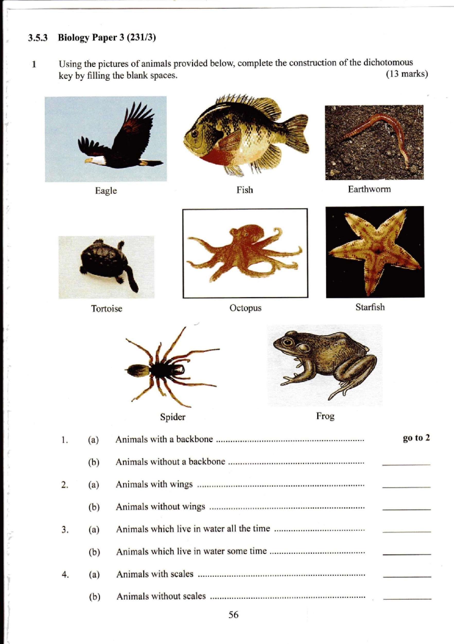
A B C
D E F
G H

- (a) Animals with a backbone ………………………………………………. Go to 2
(b) Animals without a backbone ……………………………………………. Go to 5

- (a) Animals without wings………………………………………….... Eagle
(b) Animals without wings …………………………………………………… go to 3
3. (a) Animals which live in water all the time………………………………… go to 4
(b) Animals which live in water some time………………………………….. Frog

4. (a) Animals with fins ……………………………………………………… Fish
(b) Animals without fins ………………………………………………….. Turtle

5. (a) Animals with legs ………………………………………………………. Go to 6
(b) Animals without legs …………………………………………………… go to 7

6. ( a) Animals with six legs ……………………………………………………... Butterfly
(b) Animals with eight legs ……………………………………………………. Spider

7. (a) Animals with a shell…………………………………………………………. Snail
(b) Animals without a shell…………………………………………………….. go to 8

8. (a) Animals with a jelly-like body ……………………………………………… go to 9
(b) Animals without a jelly-like body …………………………………………... Starfish

9. (a) Animals with a segmented body …………………………………………….. Earthworm
(b) Animals without a segmented body …………………………………………. Octopus

SPECIMEN | STEP FOLLOWED | IDENTIFY
A | 1a, 2a | Eagle
B | 1a,2b,3a,4a | Fish
C | 1b,5b,7b,8a, 9a | Earthworm
D | 1a, 2b, 3a,4b | Tortoise
E | 1b,5b,7b,8a,9b | Octopus
F | 1b,5b,7b,8b | Starfish
G | 1b,5a,6b | Spider
 | ½ each

- Below are photographs of specimens obtained from plants. Examine the photographs.
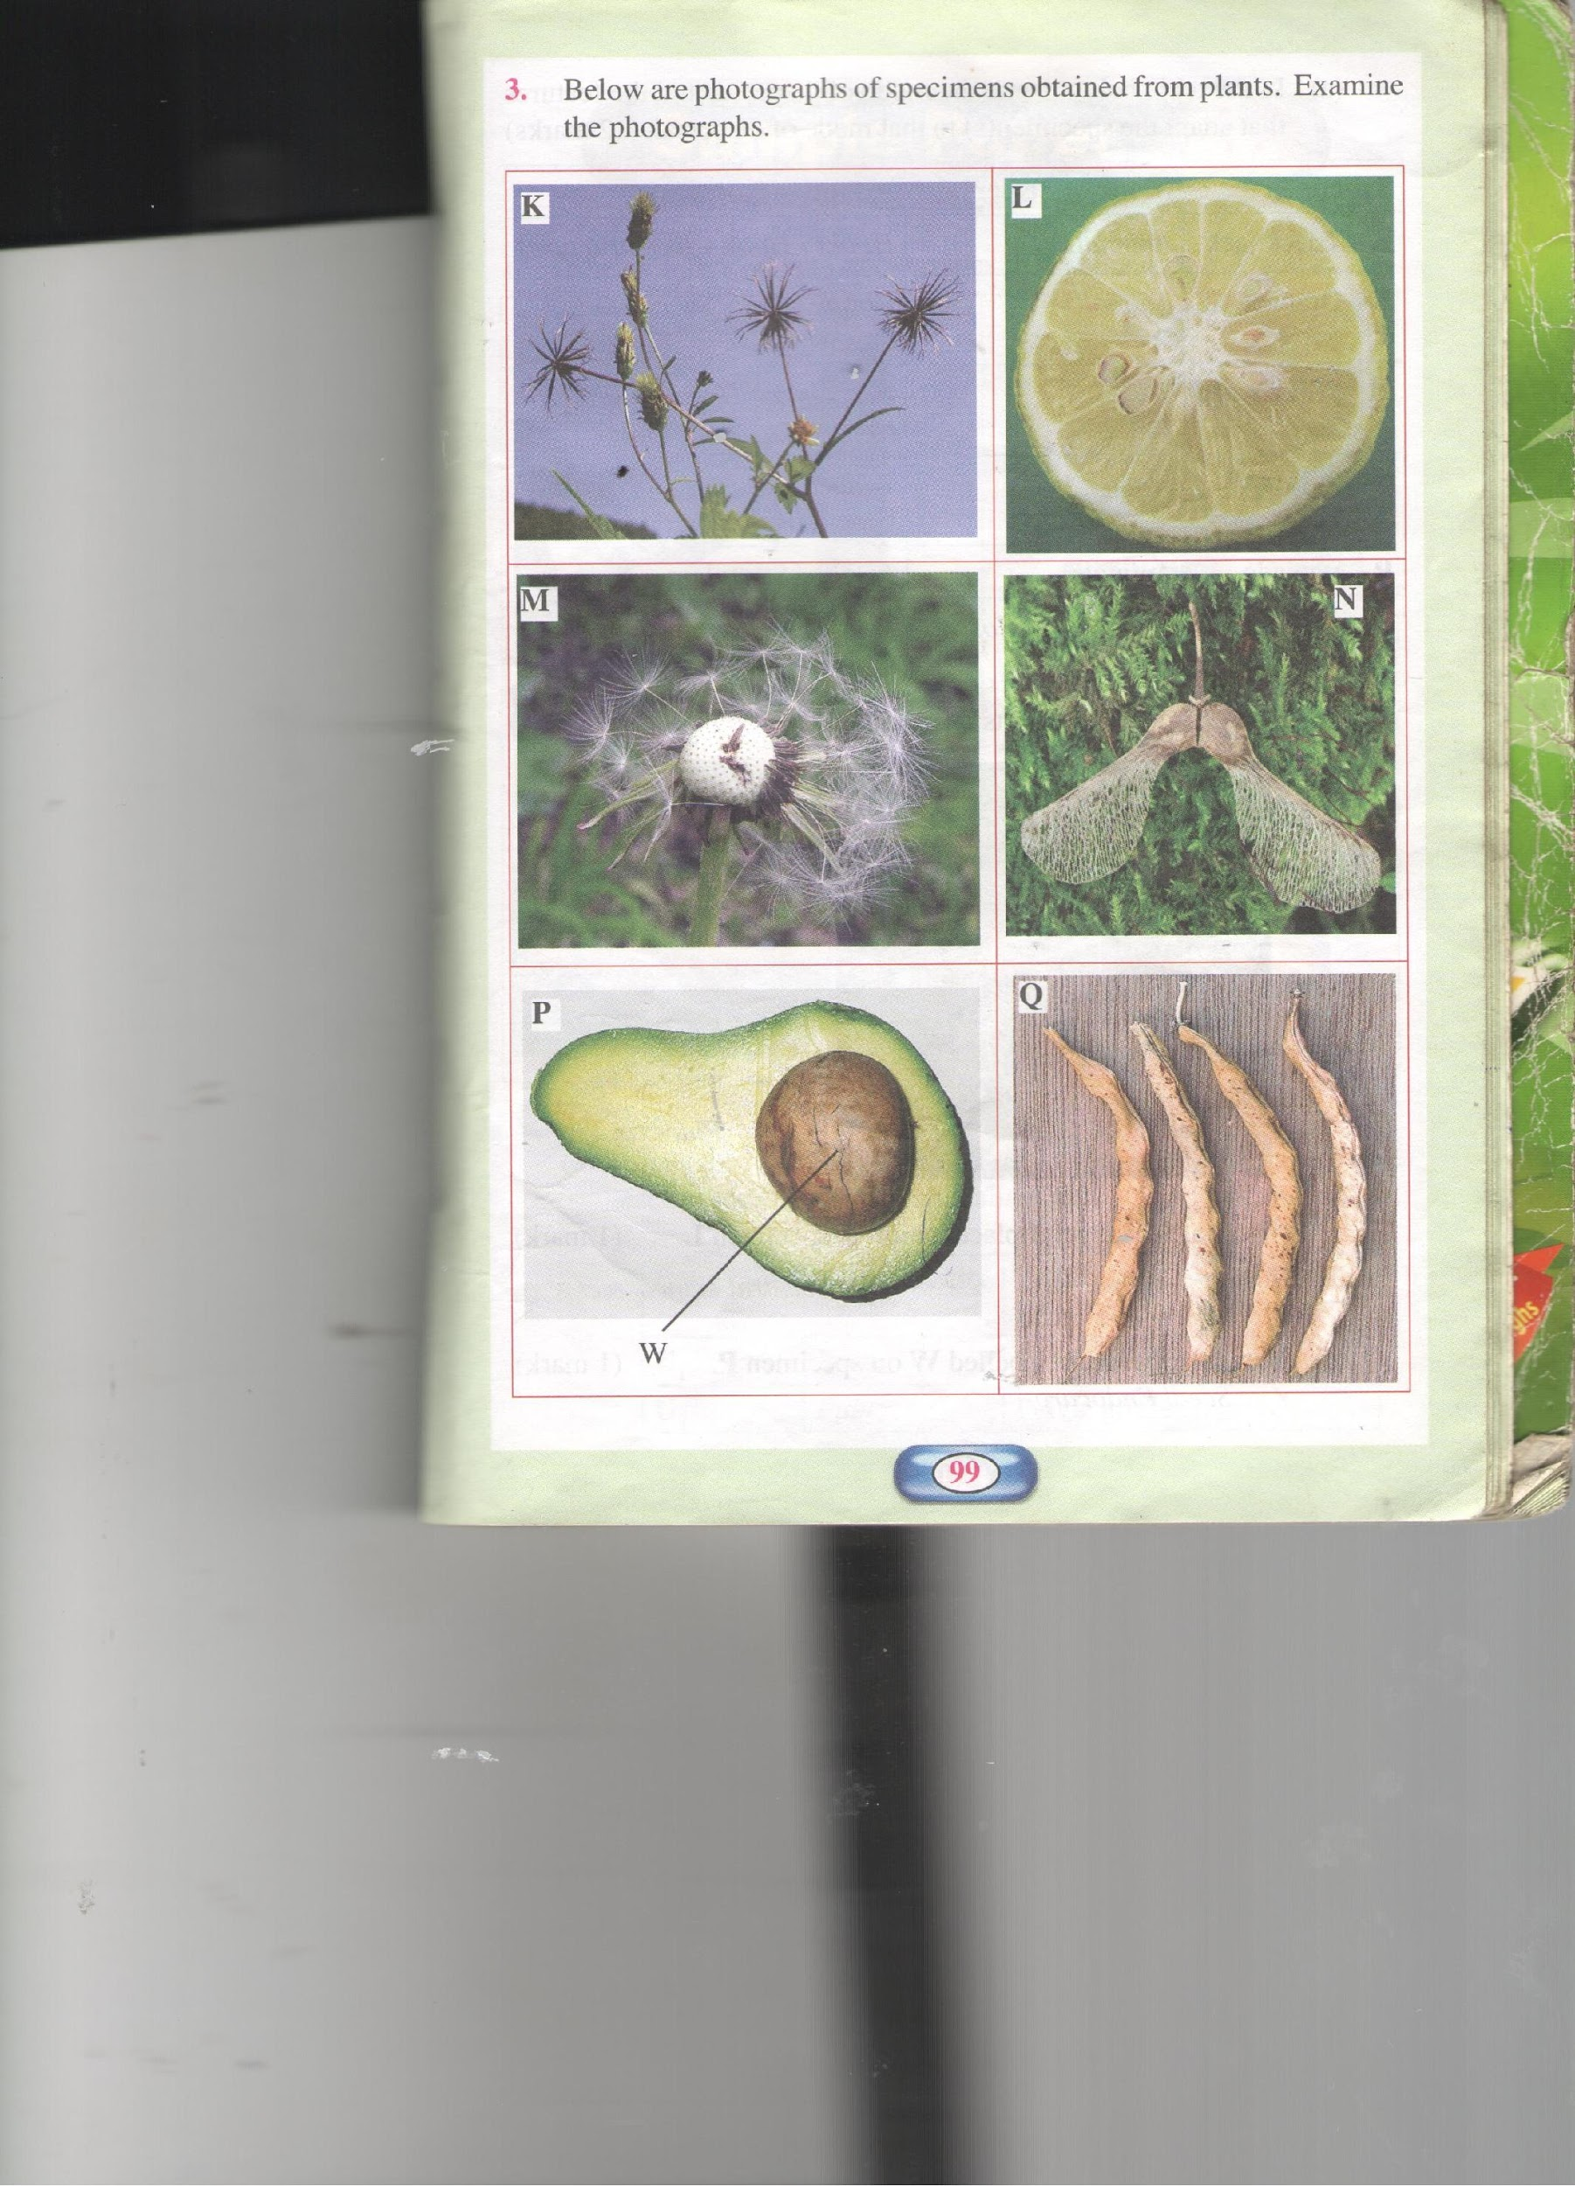
seed
mesocarp
epicarp
- In the table below name the mode of dispersal and the features that adapt the specimens(s) to that mode of dispersal.
Specimen | Mode of dispersal | Adaptive feature
K | Animal | Hooks/hook
L | Animal | Fleshly/Juicy
M | wind | Parachute /Hairs papus Hair – lice projection
N | wind | Winged pericarp wing- like projections
P | Animal | Fleshy
Q | Self/self explosive mechanism | Sutures / line of weakens
- i) Label any two parts on specimen (L ( on the diagram) (2mks)
- Epicarp
mesocarp
Endocarp
Seed
placenta
ii) State the type of placentation in specimen L. (1mk)
Axile
c. Name the structure labelled W on specimen P.
W – Seed/Endocarp

