Name:…………………………………………. Index Number:…... …….………….……

Adm. No……………….. Class: ……………….. Candidate’s Signature: ………………….

Date: ……………………………………..

231/2

**BIOLOGY**

**Theory**

Paper 2

March/April, 2020

Time: 2 Hours

**MOKASA JOINT EVALUATION EXAMS**

**MOKASA 1**

231/2

Biology

Paper 2

March/April, 2020

***Instructions To Candidates***

* *Write* ***your name*** *and* ***Index number*** *in the spaces provided above.*
* ***Sign*** *and write the* ***date*** *of the examination the spaces provided above.*
* *This paper consists of* ***two*** *sections: A and B.*
* *Answer* ***ALL*** *the questions in Section* ***A*** *in the spaces provided.*
* *In section* ***B*** *answer questions* ***6*** *(****compulsory****) and either question* ***7*** *or* ***8*** *in the spaces provided after question 8.*

**FOR EXAMINER’S USE ONLY**

|  |  |  |  |
| --- | --- | --- | --- |
| **Section** | **Question** | **Maximum score** | **Candidate’s score** |
| A | 1 |  |  |
| 2 |  |  |
| 3 |  |  |
| 4 |  |  |
| 5 |  |  |
| B | 6 |  |  |
| 7 | 20 |  |
| 8 | 20 |  |
| **TOTAL SCORE 80** | | | |

**SECTION A: (40 MARKS)**

***Answer all questions in the spaces provided.***

1. The diagrams below show samples of blood obtained from two different persons A and B.

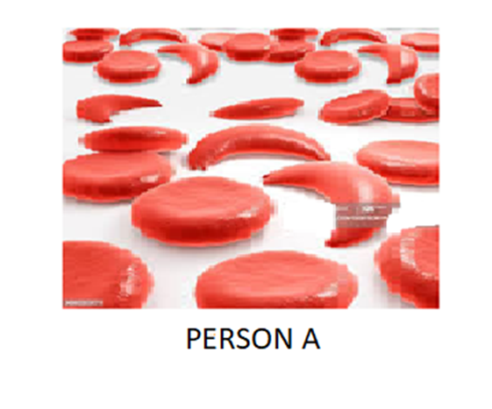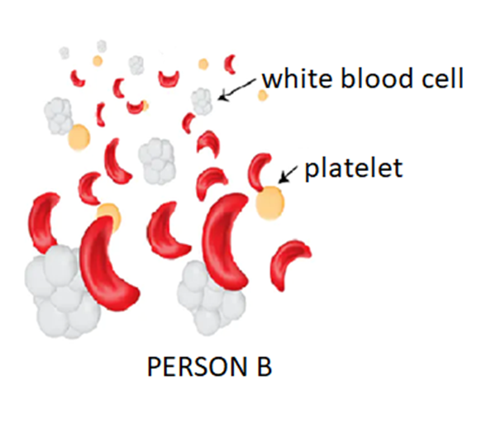

1. What genetic disorder is person B suffering from? (1 mark)

…………………………………………………………………………………………….

…………………………………………………………………………………………….

1. State **one** advantage and **one** disadvantage of the disorder exhibited in person A (2 mark)

…………………………………………………………………………………………….

…………………………………………………………………………………………….

…………………………………………………………………………………………….

…………………………………………………………………………………………….

1. Work out the genotypes and phenotypes of the resulting offsprings of a marriage between person A and person B (5 marks)

…………………………………………………………………………………………….

…………………………………………………………………………………………….

…………………………………………………………………………………………….

……………………………………………………………………………………………………………………………………………………………………………………………………………………………………………………………………………………………………………………………………………………………………………………...........

2. Study the diagram below and answer the questions that follow.

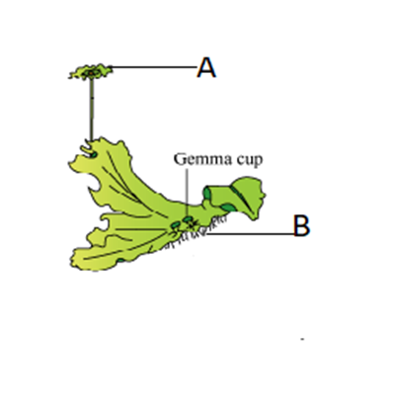

1. Name the division to which the organism belongs giving two reasons for your answer (3 marks)

Division: ………………………………………………………………………………….

…………………………………………………………………………………………….

Reasons...………………………………………………………………………………….

…………………………………………………………………………………………….

1. Name the function of the parts labelled

A ……………………………………………………………………………… (1 mark)

B ……………………………………………………………………………… (1 mark)

1. State **three** differences between the process of fertilization in the above named division and in a flowering plant. (3 marks)

…………………………………………………………………………………………….

…………………………………………………………………………………………….

…………………………………………………………………………………………….

…………………………………………………………………………………………….

…………………………………………………………………………………………….

3. A biologist carried out a study to investigate the growth of a certain species of herbivorous fish and the factors influencing plant and animal life in four lakes A, B, C and D. The lakes were located in the same geographical area.

Two of the lakes A and B were found to contain hard water due to the presence of high content of calcium salts. The mean body length of 2 year old fish, amount of plant life and invertebrates biomass in each lake were determined. The data was as shown in the table below.

|  |  |  |  |  |  |  |  |
| --- | --- | --- | --- | --- | --- | --- | --- |
| Lakes | Means of body length (cm) | Type of water | Amount of plant life | Invertebrate biomas g/cm3 | | | |
| Insects | Snails | Crabs | Worms |
| A | 31.2 | Hard | 1050 | 11 | 300 | 10 | 180 |
| B | 28.6 | Hard | 950 | 72 | 100 | 9 | 90 |
| C | 18.4 | Soft | 1.2 | 79 | 0 | 2 | 20 |
| D | 16.3 | Soft | 0.5 | 99 | 0 | 1 | 10 |

1. Describe the procedure that may have been used to determine the mean body length of the fish. (4 marks)

…………………………………………………………………………………………….

…………………………………………………………………………………………….

…………………………………………………………………………………………….

…………………………………………………………………………………………….

1. What are the likely reasons for the difference in mean body length of the fish living in lakes A and D? (2 marks)

…………………………………………………………………………………………….

…………………………………………………………………………………………….

…………………………………………………………………………………………….

…………………………………………………………………………………………….

1. Explain why primary producers have a higher biomass (2 marks)

…………………………………………………………………………………………….

…………………………………………………………………………………………….

…………………………………………………………………………………………….

…………………………………………………………………………………………….

4. The diagram below is a section from the mammalian body. Study and use it to answer the questions that follow.

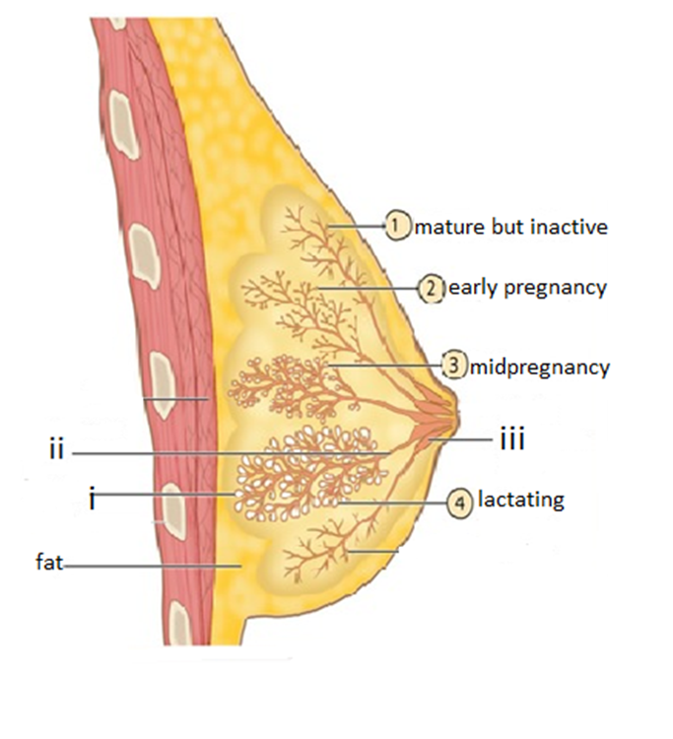

1. Name the parts labelled;

(i)………………………………………………………………………… (1 mark)

(ii)………………………………………………………………………… (1 mark)

(iii)………………………………………………………………………… (1 mark)

1. Describe the process of milk letdown (5 marks)

…………………………………………………………………………………………….

…………………………………………………………………………………………….

…………………………………………………………………………………………….

…………………………………………………………………………………………….

…………………………………………………………………………………………….

…………………………………………………………………………………………….

…………………………………………………………………………………………….

…………………………………………………………………………………………….

5. (i)In an experiment, food sample A was respired by an organism and the gaseous product was directed into a test tube containing calcium hydroxide solution through a glass capillary tube.

The same experiment was repeated using the same amount of food sample B. It was noted that it takes 15 minutes for the gaseous product of food sample A to turn calcium hydroxide solution white and 50 minutes by gaseous product of food sample B to do the same.

1. Suggest with a reason, the possible identity of food sample A and B (4 marks)

…………………………………………………………………………………………….

…………………………………………………………………………………………….

…………………………………………………………………………………………….

…………………………………………………………………………………………….

…………………………………………………………………………………………….

…………………………………………………………………………………………….

…………………………………………………………………………………………….

…………………………………………………………………………………………….

…………………………………………………………………………………………….

…………………………………………………………………………………………….

1. Suggest the possible identity of the gaseous product of food samples A and B. (1 mark)

…………………………………………………………………………………………….

…………………………………………………………………………………………….

…………………………………………………………………………………………….

…………………………………………………………………………………………….

ii) Explain how anaerobic respiration has been applied in making of beer and wines.

(3 marks)

…………………………………………………………………………………………….

…………………………………………………………………………………………….

…………………………………………………………………………………………….

…………………………………………………………………………………………….

…………………………………………………………………………………………….

…………………………………………………………………………………………….

…………………………………………………………………………………………….

…………………………………………………………………………………………….

**SECTION B: (40 MARKS)**

***Answer question 6 (COMPULSORY) in the spaces provided and either question 7 or 8***

6. The table below shows results of an experiment in which small pieces of tradescantia stems were placed in different salt concentrations. After 6 hours they were removed from the solutions, wiped to dry and weighed. The results are as shown below. Study the table and answer the questions that follow.

|  |  |
| --- | --- |
| Salt concentration (mg) | Percentage change in weight |
| 2.5 | +11 |
| 5.0 | +8 |
| 7.5 | +5 |
| 10.0 | +3 |
| 12.5 | +2 |
| 15.0 | +1 |
| 17.5 | -2 |
| 20.0 | -8 |
| 22.5 | -9.5 |
| 25.0 | -11 |

a) i) Draw a graph of the percentage change in weight against salt concentration. (6 marks)

ii) From the graph determine the salt concentration that is equal to the concentration of the tradescantia cell sap. (1 mark)

…………………………………………………………………………………………………

………………………………………………………………………………………………..

b) Account for the following changes in the weight.

(i) Percentage positive change (4marks) …………………………………………………………………………………………….

…………………………………………………………………………………………….

…………………………………………………………………………………………….

…………………………………………………………………………………………….

…………………………………………………………………………………………….

(ii) Percentage negative change (3 marks) …………………………………………………………………………………………….

…………………………………………………………………………………………….

…………………………………………………………………………………………….

…………………………………………………………………………………………….

…………………………………………………………………………………………….

c) Briefly describe how the above physiological process brings about upright posture in seedlings (3 marks)

…………………………………………………………………………………………….

…………………………………………………………………………………………….

…………………………………………………………………………………………….

…………………………………………………………………………………………….

d)i) Define the physiological process in (c) above (1 mark)

…………………………………………………………………………………………….

…………………………………………………………………………………………….

…………………………………………………………………………………………….

ii) State any **two** differences between the physiological process above and the physiological process that root hairs use to absorb mineral salts from a soil solution that is hypertonic to their cell saps (2 marks)

…………………………………………………………………………………………….

…………………………………………………………………………………………….

…………………………………………………………………………………………….

…………………………………………………………………………………………….

7. a) Explain the biological importance of abiotic factors in seed germination. (12 marks)

b) Explain the following evidences of organic evolution.

(i) Comparative anatomy (5 marks)

(ii) Geographical distribution (3 marks)

8. In terms of homeostatic balance in the body, describe the function of the following body systems in regulation of blood sugar level. (20 marks)

a) Digestive system

b) Circulatory system

c) Respiratory system

d) Nervous system

e) Hormonal system

…………………………………………………………………………………………….

…………………………………………………………………………………………….

…………………………………………………………………………………………….

…………………………………………………………………………………………….

…………………………………………………………………………………………….

…………………………………………………………………………………………….

…………………………………………………………………………………………….

…………………………………………………………………………………………….

…………………………………………………………………………………………….

…………………………………………………………………………………………….

…………………………………………………………………………………………….

…………………………………………………………………………………………….

…………………………………………………………………………………………….

…………………………………………………………………………………………….

…………………………………………………………………………………………….

…………………………………………………………………………………………….

…………………………………………………………………………………………….

…………………………………………………………………………………………….

…………………………………………………………………………………………….

…………………………………………………………………………………………….

…………………………………………………………………………………………….

…………………………………………………………………………………………….

…………………………………………………………………………………………….

…………………………………………………………………………………………….

…………………………………………………………………………………………….

…………………………………………………………………………………………….

…………………………………………………………………………………………….

…………………………………………………………………………………………….

…………………………………………………………………………………………….

…………………………………………………………………………………………….

…………………………………………………………………………………………….

…………………………………………………………………………………………….

…………………………………………………………………………………………….

…………………………………………………………………………………………….

…………………………………………………………………………………………….

…………………………………………………………………………………………….

…………………………………………………………………………………………….

…………………………………………………………………………………………….

…………………………………………………………………………………………….

…………………………………………………………………………………………….

…………………………………………………………………………………………….

…………………………………………………………………………………………….

…………………………………………………………………………………………….

…………………………………………………………………………………………….

…………………………………………………………………………………………….

…………………………………………………………………………………………….

…………………………………………………………………………………………….

…………………………………………………………………………………………….

…………………………………………………………………………………………….

…………………………………………………………………………………………….

…………………………………………………………………………………………….

…………………………………………………………………………………………….

…………………………………………………………………………………………….

…………………………………………………………………………………………….

…………………………………………………………………………………………….

…………………………………………………………………………………………….

…………………………………………………………………………………………….

…………………………………………………………………………………………….

…………………………………………………………………………………………….

…………………………………………………………………………………………….

…………………………………………………………………………………………….

…………………………………………………………………………………………….

…………………………………………………………………………………………….

…………………………………………………………………………………………….

…………………………………………………………………………………………….

…………………………………………………………………………………………….

…………………………………………………………………………………………….

…………………………………………………………………………………………….

…………………………………………………………………………………………….

…………………………………………………………………………………………….

…………………………………………………………………………………………….

…………………………………………………………………………………………….

…………………………………………………………………………………………….

…………………………………………………………………………………………….

…………………………………………………………………………………………….

…………………………………………………………………………………………….

…………………………………………………………………………………………….

…………………………………………………………………………………………….

…………………………………………………………………………………………….

…………………………………………………………………………………………….

…………………………………………………………………………………………….

…………………………………………………………………………………………….

…………………………………………………………………………………………….

…………………………………………………………………………………………….

…………………………………………………………………………………………….

…………………………………………………………………………………………….

…………………………………………………………………………………………….

…………………………………………………………………………………………….

…………………………………………………………………………………………….

…………………………………………………………………………………………….

…………………………………………………………………………………………….

…………………………………………………………………………………………….

…………………………………………………………………………………………….

…………………………………………………………………………………………….

…………………………………………………………………………………………….

…………………………………………………………………………………………….

…………………………………………………………………………………………….

…………………………………………………………………………………………….

…………………………………………………………………………………………….

…………………………………………………………………………………………….

…………………………………………………………………………………………….

…………………………………………………………………………………………….

…………………………………………………………………………………………….

…………………………………………………………………………………………….

…………………………………………………………………………………………….

…………………………………………………………………………………………….

…………………………………………………………………………………………….

…………………………………………………………………………………………….

…………………………………………………………………………………………….

…………………………………………………………………………………………….

…………………………………………………………………………………………….

…………………………………………………………………………………………….

…………………………………………………………………………………………….

…………………………………………………………………………………………….

…………………………………………………………………………………………….

…………………………………………………………………………………………….

…………………………………………………………………………………………….

…………………………………………………………………………………………….

…………………………………………………………………………………………….

…………………………………………………………………………………………….

…………………………………………………………………………………………….

…………………………………………………………………………………………….

…………………………………………………………………………………………….

…………………………………………………………………………………………….