
FORM FOUR TRIAL 2, 2019
Kenya Certificate of Secondary Education

231/1 BIOLOGY
PAPER TWO
TIME: 2HRS

INSTRUCTIONS
- Answer all questions in section A and question 6 in section B (It is compulsory)
- Answer either question 7 or 8.

SECTION A (40MKS)
Answer all the questions in these section
- Haemophilia is a sex linked characteristic caused by a recessive gene located on one of the sex chromosomes.
- Name the chromosome onto which the gene for haemophilia is linked to (1mk)
……………………………………………………………………………………………………………………………………
- A normal man for the condition marries a normal woman for the condition but sadly one of their sons develop this condition from birth.
- What are the likely genotypes of this couple? (2mks)
Man
………………………………………………………………………………………………………………………………
Woman
………………………………………………………………………………………………………………………………
- Using a punnet square, carry out a cross to show why the couple gave birth to haemophiliac son (4mks)
Use (H),to represent the gene for normal condition and (h) to represent the gene for haemophilia

- Why is this haemophiliac condition very common in males than in female (1mk)
………………………………………………………………………………………………………………………………
………………………………………………………………………………………………………………………………
- The figure below represents an organ obtained from a section of a plant. Use it to answer questions that follow.
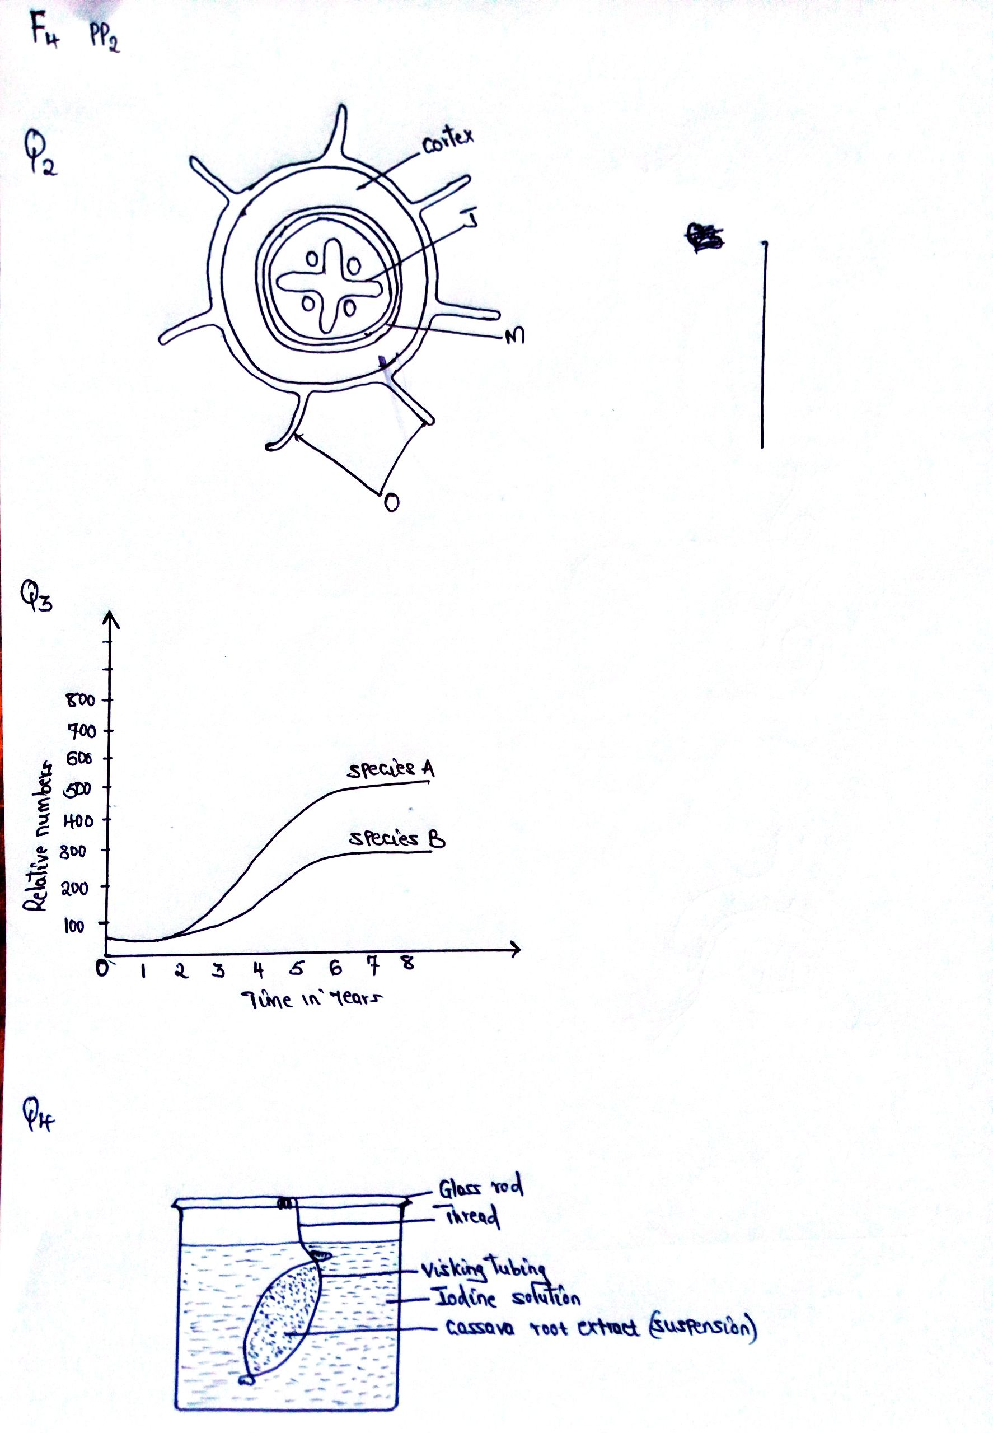

D
- i) Name the organ from which the above section was obtained. Give a reason for your answer (2mks)
………………………………………………………………………………………………………………………………………………………………………………………………………………………………………………………………………………………………………………………………………………………………………………………………………………
ii) Structure labelled J is described as a mechanical tissue. Explain (1mk)
……………………………………………………………………………………………………………………………………
……………………………………………………………………………………………………………………………………
- i) Name the process by which water passes across structure M (1mk)
…………………………………………………………………………………………………………………………………
ii)Explain two ways by which cells with structures Dare adapted to their functions
(2mks)
……………………………………………………………………………………………………………………………………
……………………………………………………………………………………………………………………………………
- Name two strengthening materials that strengthen the collenchyma tissue (2mks)
……………………………………………………………………………………………………………………………………
……………………………………………………………………………………………………………………………………
- The herbivorous mammalian species were introduced into an ecosystem at the same time and in equal numbers. The graph below represents their populations during the first seven years. Study the graph and answer the questions that follow.

- i) Which species has a better competitive ability (1mk)
……………………………………………………………………………………………………………………………………
ii) Give reason for your answer (1mk)
…………………………………………………………………………………………………………………………………………………………………………………………………………………………………………………………………………
- Account for the shape of the curve of species A between
- One year and three years (2mks)
………………………………………………………………………………………………………………………………………………………………………………………………………………………………………………………………
……………………………………………………………………………………………………………………………..
- Three years and seven years (2mks)
………………………………………………………………………………………………………………………………………………………………………………………………………………………………………………………………………………………………………………………………………………………………………………………………
- A natural predator for species A was introduced into the ecosystem. With a reason state how the population of each species would be affected (2mks)
……………………………………………………………………………………………………………………………………
……………………………………………………………………………………………………………………………………
……………………………………………………………………………………………………………………………………

- A student from Abogeta secondary set up an experiment as illustrated below.

The visking tubing was left in iodine solution for 4 hours.
- State the physiological process being investigated (1mk)
……………………………………………………………………………………………………………………………………
- i) What were the expected results in the visking tubing and in the beaker (2mks)
……………………………………………………………………………………………………………………………………
……………………………………………………………………………………………………………………………………
……………………………………………………………………………………………………………………………………
ii)Account for your expected result in visking tubing (2mks)
……………………………………………………………………………………………………………………………………
……………………………………………………………………………………………………………………………………
…………………………………………………………………………………………………………………………………………………………………………………………………………………………………………………………………………
- Mention three factors that influences the rate of active transport (3mks)
……………………………………………………………………………………………………………………………………
……………………………………………………………………………………………………………………………………
……………………………………………………………………………………………………………………………………………………………………………………………………………………………………………………………………….

- An experiment was set up to investigate a factor in autotrophism in green plants.
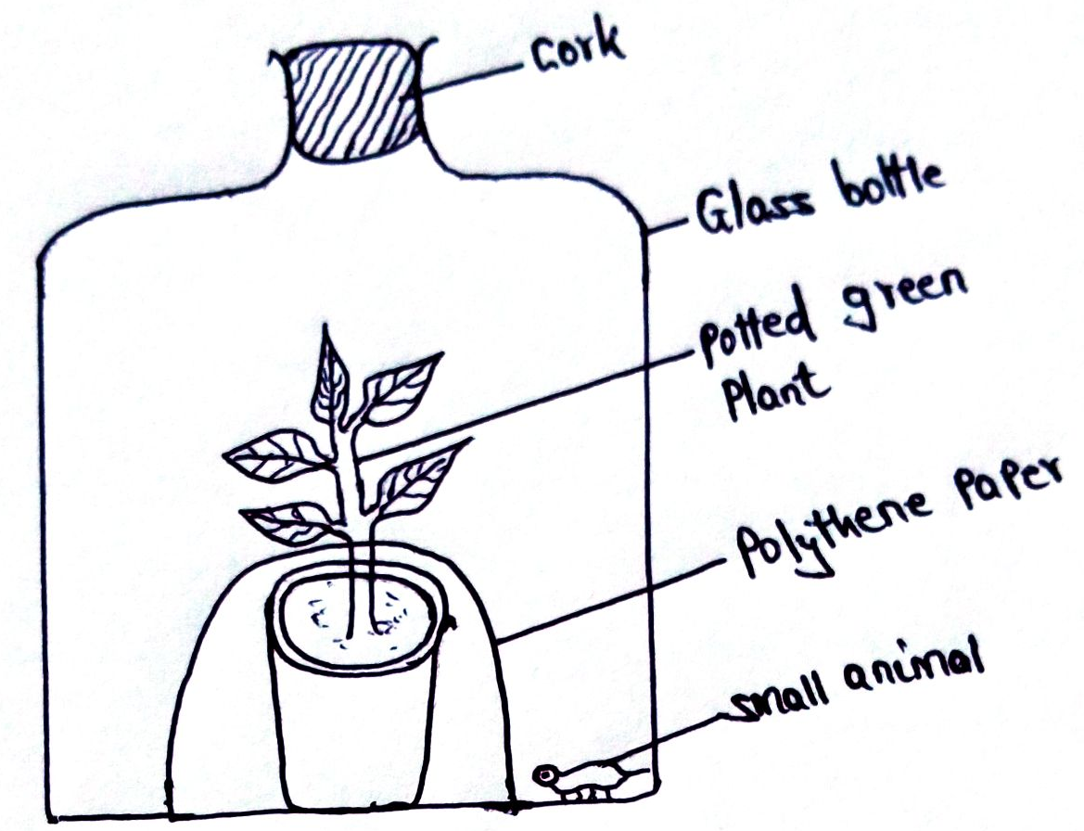

Vaseline was applied at joint between the cork and the mouth of glass bottle and set up was left under sunlight for 6 hours.
- Why was it necessary;
- To apply Vaseline (1mk)
……………………………………………………………………………………………………………………………………
- To cover the pot with polythene paper (1mk)
………………………………………………………………………………………………………………………………..
- What was the purpose of including the small animals? Give two reasons. (2mks)
……………………………………………………………………………………………………………………………………
……………………………………………………………………………………………………………………………………
- i) What would happen to the small animal if the set up was left over night in darkness
(1mk)
……………………………………………………………………………………………………………………………………
……………………………………………………………………………………………………………………………………
ii)Account for the answer in b (i) above (1mk)
……………………………………………………………………………………………………………………………………
……………………………………………………………………………………………………………………………………
- State the respiratory surface of the following organism (2mks)
- Amoeba
………………………………………………………………………………………………………………………………
- Fish
………………………………………………………………………………………………………………………………
SECTION B (40MKS)
Answer question 6 (Compulsory) and choose either question 7 or 8
- A hungry person had a meal, after which the concentration of glucose and amino acids in the blood were determined. This was measured hourly as the blood passed through the hepatic portal vein and the iliac vein in the leg. The results were as shown in the table below.
Time (Hrs) | Concentration of contents in Hepatic portal vein (Mg/100ml) |  | Concentration of contents in the iliac vein of the leg (Mg/100ml)
 | Glucose | Amino acids | Glucose | Amino acids
0  1  2  3  4  5  6  7 | 85  85  140  130  110  90  90  90 | 1.0  1.0  1.0  1.5  1.5  3.0  2.0  1.0 | 85  85  125  110  90  90  90  90 | 1.0  1.0  1.0  1.5  3.0  2.0  1.0  1.0

- Using the same axes draw graphs of concentration of glucose in the hepatic portal vein and the iliac vein in the leg against time (7mks)

- Account for the concentration of glucose in the hepatic portal vein from;
- 0-1 hour (2mks)
…………………………………………………………………………………………………………………………………………………………………………………………………………………………………………………………………………………………………………………………………………………………………………………………………………………………………………………………………………………………………………
- 1-2 hours (3mks)
……………………………………………………………………………………………………………………………………………………………………………………………………………………………………………………………………………………………………………………………………………………………………………………………………………………………………………………………………………………………………………………………………………………………………………………………………………………………………
- 2-4 hours (3mks)
……………………………………………………………………………………………………………………………………………………………………………………………………………………………………………………………………………………………………………………………………………………………………………………………………………………………………………………………………………………………………………………………………………………………………………………………………………………………………
- 5-7 hours (2mks)
………………………………………………………………………………………………………………………………………………………………………………………………………………………………………………………………………………………………………………………………………………………………………………………………………………………………………………………………………………………………………..

- Account for the difference in the concentration of glucose in hepatic portal vein and the iliac vein between 2 and 4 hours (2mks)
………………………………………………………………………………………………………………………………………………………………………………………………………………………………………………………………………………………………………………………………………………………………………………………………………………

- Using the data provided in the table explain why the concertation of amino acids in the hepatic portal vein took longer to increase (1mk)
………………………………………………………………………………………………………………………………………………………………………………………………………………………………………………………………………………………………………………………………………………………………………………………………………………

Essays
- a) Describe the opening and closing of the stomata using the photosynthetic theory
(10mks)
b) Describe blood sugar regulations in mammals (10mks)
- a) Describe the adaptation of the following plants to their habitat;
- Xerophytes (15mks)
- Hydrophytes (5mks)

