OPENER EXAMINATION TERM 2 YEAR 2021
NAME: ___________________________ ADM NO: _______ CLASS:__________
BIOLOGY PAPER 2
FORM 3
2hrs

- Below is a set up that was used to investigate a certain process in plants

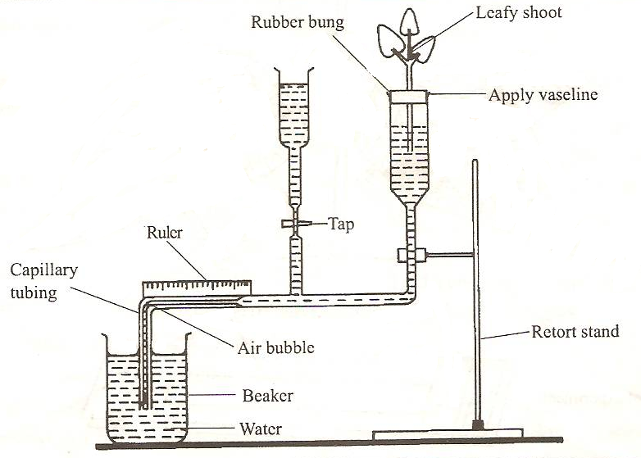

(a) State the process that was being investigated (1 mark)

(b )(i) Give two precautions that should be taken when preparing the experiment (2marks)

(ii) State a reason for each precautions stated in b (i) above (2marks)

(c) List three structural factors that affect the process under investigation (3 marks)

- a) Distinguish between pyramid of numbers and pyramid of biomass.(2marks)

b) From an ecological study, students formed the following food web
.
Hawk

Lizard Small birds

Cartepillar small insects large insects

Earthworm Green plants

Decaying leaves
From the food web, construct two food chains with lizard as tertially consumer.(2 marks)

c) i) Which organism has the least biomass in the ecosystem.(1 mark)

ii) Give reasons for your answer in c)i) above (3marks)

- The diagram below represents structure found in the walls of ileum.
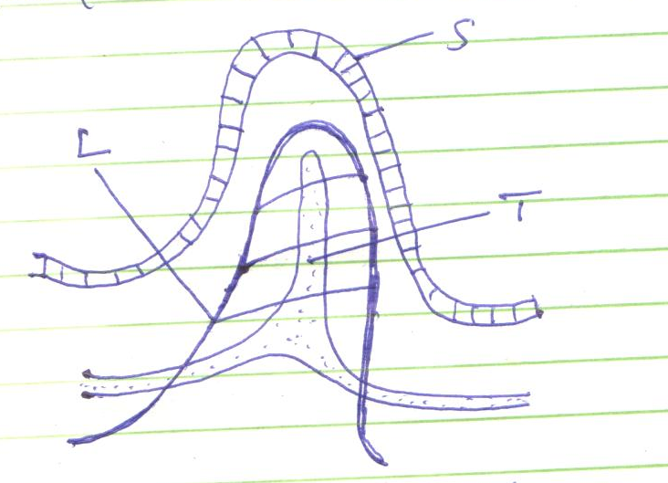
L
T
S
- Identify the structure shown in the diagram. (1 mark)

- Name parts labelled S, T and L. (3 marks)
S
T
L
- Name products of digestion which are absorbed into; (2 marks)
L
T
- State how the above structure is adapted to its function. (2 marks)

. 4. (a) Name the gaseous exchange structure in the following organisms.
(i) Amoeba (1 mark)

(ii) Grasshopper (1mark)

(b) The diagram below illustrates the structure of a gill from a bony fish.
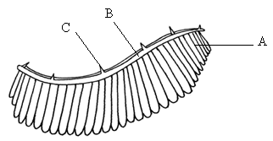

(i) Name the parts labelled A, B, C (3 marks)
A
B
C
(ii) State the function of the part labelled C (1 mark)

(iii) How is part A adapted to carry its functions (2 marks)

5.(a) The diagram below shows an experimental set – up by form two students.

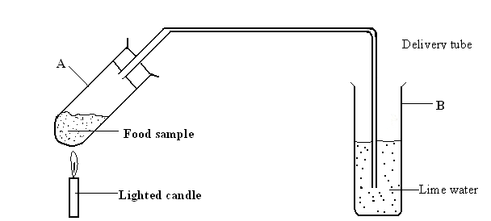

(i) State the aim of the experiment. (1mark)

(ii) State the expected results at the end of the experiment. (2 marks)

(iii) What conclusion can you make from this experiment? (1 mark)

(b) Examine the diagram which shows a set used to demonstrate a certain process.
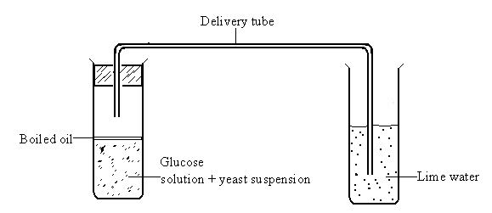
(i) State the aim of the experiment. (1 mark)

(ii) Why was it necessary to boil the glucose solution before adding the yeast suspension.
(1 mark)

(iii) Why was it necessary to cool the glucose before adding the yeast suspension?(1mark)

(iv) Why was the oil layer added? (1 mark)

SECTION B(40MARKS)
Answer questions 6 (Compulsory) and either question 7 or 8 in the spaces provided.
6. Two herbivorous mammal species were introduced into an ecosystem at the same time and in equal numbers. The graph below represents their populations during the first seven years. Study the graph and answer the questions that follow.
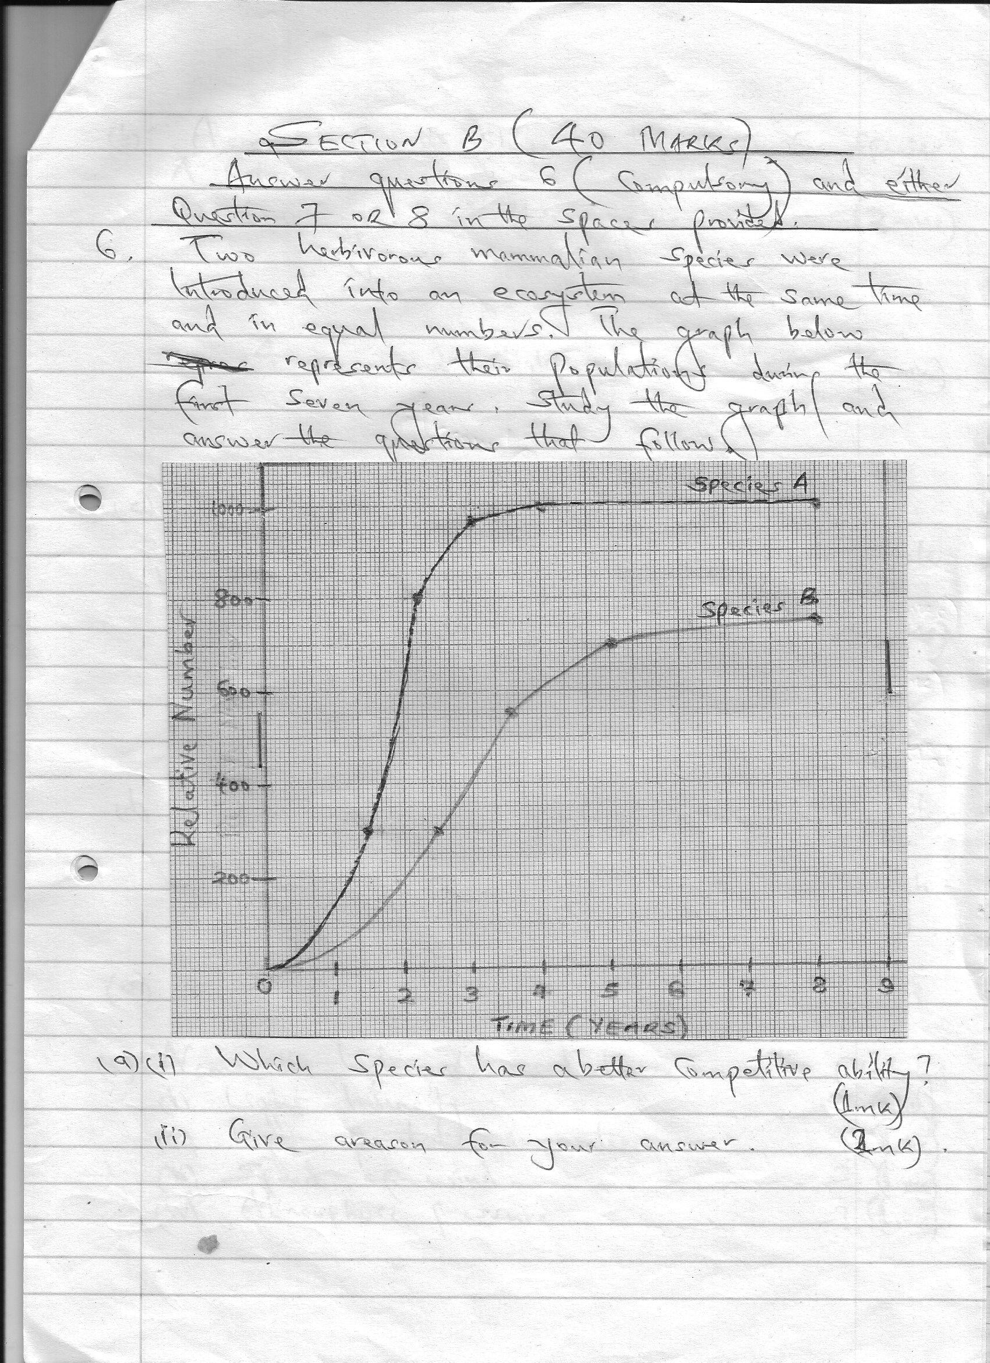

Time(Years)
Relative Numbers
x
x
x
x
x
x
x
x
x
x

(a) (i) Which species has a better competitive ability?(mark)
.
(ii) Give a reason for your answer.(1mark)

(b) Account for the shape of the curve for species A between;
(i) One year and three years. (3mark)

(ii) 4 years and eight years. (3mark)

(c) A natural predator of species A was introduced into the ecosystem. With a reason, state how the Population of each species would be affected? (4marks)

(d) State four other biotic factors of the ecosystem which affects organisms distribution in their habitat other than the one illustrated in the above graph. (4mrks)

(e) Name the instruments used to measure the following;
(i) Light intensity (1mrk)

(ii) Light penetration in water (1mrk)

(iii) Speed of wind (1mrk)

(iv) Atmospheric pressure (1mrk)

7. Describe the nitrogen cycle ( 20 mks)

8. (a)State four characteristics of gaseous exchange surfaces ( 4 mks)

(b) Describe the mechanism of gaseous exchange in a mammal (16mks)

