2020 bio. pp2(sample 1)
Marking scheme.
SECTION A (40 MARKS)
Answer all questions in this section.
1. a) W – Polar nuclei; rej with cells
X – Ovum ( egg cell) ; rej. cells
Y- Integuments ; (3mks)
b) - Dissolves the tissues of the stroma ,style and ovary ;
- Forms pathway for the male nuclei to reach the embryo sac; (2mks)
Rej. –allows for passage
_ male nucleus for nuclei/ pollen grain

c) - They disintegrate ; (1mk)
d) - Male nuclei; carry out double fertilization. ;Rej nucleus
(2mks)

2. a) Sodium hydroxide pellets; To absorbs the carbon (IV) oxides produced: rej test for carbon (IV) oxide
b) To maintain a constant temperature during the period of the experiment ; a small rise in temperature causes air to expand ; a small fall in temperature causes air to contract ; leading to erroneous results; (3mks)
c) The level of water in the capillary would rise; (1mk)
d) The insect respired taking up oxygen ; releasing carbon (IV) oxide which is absorbed by Sodium Hydroxide; up take of oxygen caused a decrease in air pressure within the flask ; rej. CO2 for Carbon (IV) Oxide (3mks)
e) A control can be set up by substituting a living insert with a dead one;

- a) K- eye piece
M-coarse adjustment knob.
b) P-concentrate the light/focuses the light.
Q- magnification of the image. Rej object/specimen for image
c) i) – N
ii) – Eyepiece magnification X objective lens magnification Rej. Length of the drawing
length of the actual
d) i) to allow light to pass through ;
ii) To make the features more clear and distinct; rej. Without distinct
iii) For cells to remain turgid/ prevent dehydration;

- Parental phenotype : Black mouse Brown mouse
Parental genotype : BB X bb ;

Gamete :

F1 generation : Bb Bb Bb Bb ;

Rej. If it does not start from phenotype
If X is not there at the genotype
If X is placed at the gamates.
If gametes are not circled
If the circle has a tail or a gap- must be as smooth as possible.
If the fusion lines do not touch the line of the circle or if it penetrates into the circle.
If fusion lines join at the gamete.
If fusion lines are not at the same level at the F1 generation.

b) i) F2 offspring’s are BB, Bb, Bb, bb:
Genotypic ratio = 1BB:2Bb:1bb;

Rej. BB:Bb:bb
1 : 2 :1
ii) Phenotypic ratio -1brown: 3black ;
iii) ¼ x 96 = 24 ;

5. a) Diffusion;
b) i) Reducing sugars/simple sugars/glucose;
ii) Diastase converts starch to reducing sugars; so present in visking tubing then due to small sized molecules of reducing sugar and semi-permeability of the visking tubing; the molecules moved across the semi-permeable to the beaker; so present both in the visking tubing and the beaker.(Rej- Second mark:-If size and semi permeability are not indicated)
c) i) Proteins; reject Amino acids
ii) The molecules of proteins are large/big so cannot pass through the pores of the semi-permeable membrane visking tubing
- Turgid; Accept turgidity

SECTION B( 40 MARKS)
Answer questions 6 ( compulsory)and either questions 7 or 8 in the spaces provided questions 8

6. (a) (i) At 45 minutes 0.6580 mg/ mp; (1 mark)
At 75 minutes 0.580 – 0.582 mg/ ml;
(ii) Check graph (6 marks)

Weaknesses
Drawing three graphs
Using broken line
Exchange of axis
Use of a ruler to join points
Not indicating the variables on the two axis
Extending the curve beyond the last point
Thick curve line
Using zig zag on the axis
No evidence on the graph on the estimated 37.5

(iii) At 37.5 minutes 0.675 0.05 mg/ ml (1 mark)
(Evidence on graph to earn mark)
(iv) To obtain reliable results; (1 mark)
(v) The rats may have been different in terms of weight, sex, age; or had
different rates of metabolism; (2 marks)
(vi) Glucose decreased; due to conversion into glycogen; utilization to
release energy;for accounting you must indicate the observation. (2 marks)
(b) It is highly soluble in the water, therefore easily transported to the sites of
respiration; it requires relatively low oxygen to oxidise a unit mass of glucose
than the other substrates; (3 marks)
- Oxidized to give energy, carbon (IV) oxide and water; converted to glycogen and stored in the liver; converted to fats and stored under the skin, around the kidneys etc; Rej. Without converted (3 marks)
Glocose is not used but oxidized.

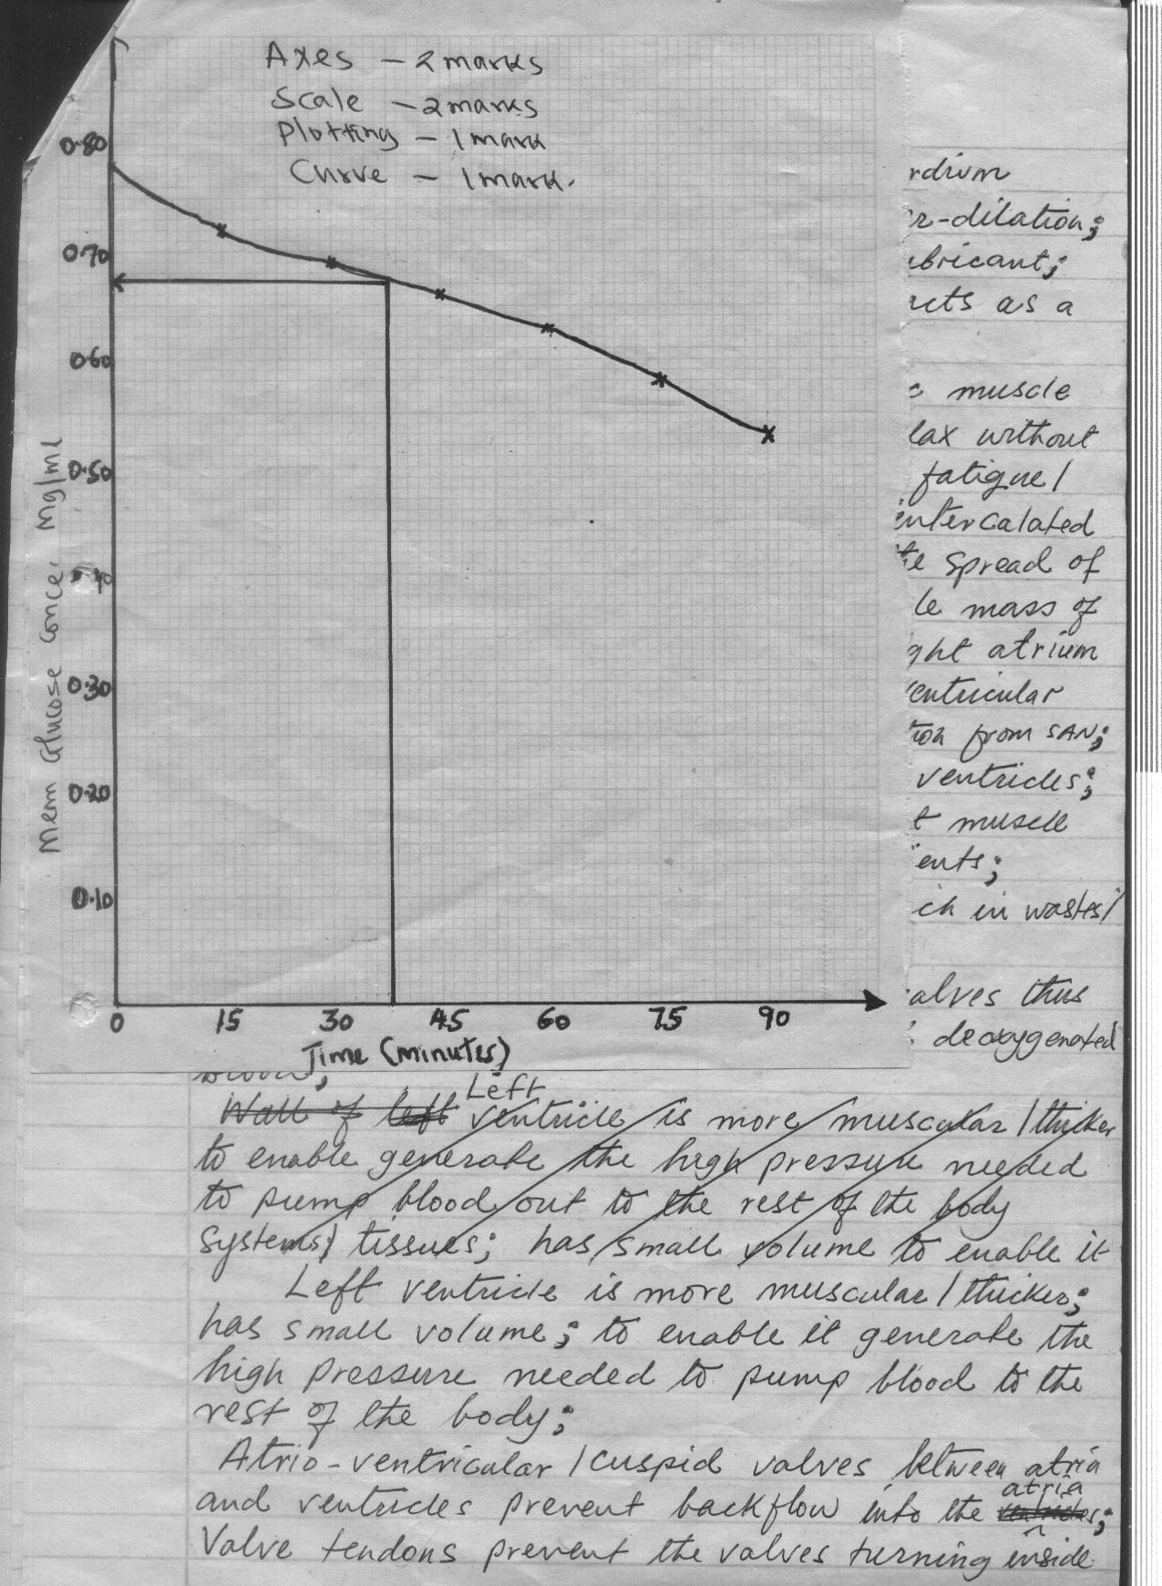

7. a)
Answers
- The animals when released mix freely and evenly with others;
- Marked animals will have enough time to mix freely and evenly with
others;
- No immigration / emigration / migration of animals during the study
period;
- No animal dies / born during the study period / the man does not change the balance of the animals or the others. (5mks)
- mark does not fade out
- mark on the animal does not expose it to the predator
- mark does not scare other animals
b)
Answers:
- Using a fish net ; catch as many fish as possible ; place the caught fish in a basin / pail with water ; count; mark the fish with a light coloured water proof paint / nail vanish; record the number caught and marked / first marked (FM);
- Release the fish back to the pond;
- After 24 hrs to 3 days ; use the same net to catch as many fish as possible ;
- Second catch (sc); and those caught with marks ie marked recapture (MR) return all the fish back to the pond;
If p is total population ;

Then

Hence P = ;
Rej.
Use a bucket basket to catch the fish
Catch a few/some fish
Give the fish sometime
Counting without recording or recording without counting
Use fish trap
Not placing the fish in a basin when counting
First trip instead of capture
Set aside a section of the school fish pond
Using fish net get to the fish pond and fish out the fish.
Take the number of the captured fish
Through head count find the population
Make sure the fish pond is save to carry out capture recapture method.

7. (a) Process by which nature selects those individuals which are sufficiently well
adapted to the environment and allow them to survive; but rejects those that are
poorly adapted.(2mks)
(b) Individuals of same species show certain variations; which are caused by genes; and the variations can be passed from parents to their offsprings; through genetic inheritance; some of the variations or characters become more suited to the prevailing environment condition; due to selection pressure or competition; most organisms tend to produce more offsprings that the environment can support; this leads to struggle for existence; among the individual species e.g food, water, shelter, mates; due to stiff competition; individuals that posses characteristics that enable them to have competitive advantage stand a better chance of survival in the struggle; the result is that well adapted individuals survive; and their reproductive age; from where they pass on their desirable genes/ trails to their offsprings; those that are poorly adapted; fail to reach their reproductive age; and hence does not pass over the poor traits to their offsprings; and thus perish to allow the fittest survive. (max 18mks)

