MAGS 2 CYCLE 7 MARCH 2020 MARKING SCHEME

BIOLOGY PAPER 2
(THEORY)
MARCH 2020
TIME: 2 HOURS

NAME:.....................................................................CLASS:..............ADM NO:.....................

SIGNATURE....................................................................DATE...............................................

INSTRUCTIONS TO CANDIDATES:-
- Write your name and admission number in the spaces provided above.
- This paper consists of two sections; A and B.
- Answer all the questions in section A in the spaces provided.
- In section B, answer question 6 (compulsory) and either question 7 or 8 in the spaces provided after question 8.

For Examiner’s Use Only:

Section | Question | Maximum score | Candidates score
A | 1  2  3  4  5 | 8  8  8  8  8
B | 6  7 or  8 | 20  20  20
TOTAL SCORE |  | 80

This paper consists of 8 printed pages. Candidates should check to ascertain that all the pages are printed as indicated and that no questions are missing.
- An investigation was carried out to study the effects of the concentration of sucrose solutions on pieces of tulip stem 44mm in length. The pieces were placed in different concentrations of sucrose solutions and measured after two hours of immersion. The results are shown in the table below.
Sucrose concentration (moles per litre) | 0.2 | 0.3 | 0.4 | 0.5 | 0.6 | 0.7 | 0.8
Length after 2 hours (mm) | 50 | 48 | 46 | 44 | 42 | 42 | 42

  - Explain the effect of the 0.2 moles per litre sucrose solution on the length of the pieces of the tulip stem. (3mks).
0.2 moles/l is hypotonic to cell sap of the tulip stem cells; the cells therefore gained water by osmosis; and increased in length;
  - Use information from the table to predict the concentration of a sucrose solution isotonic to the cells in the tulip stem. (1mk).
0.5 moles/l
  - (i) Give the term which would be used to describe the cells in the tulip stem after immersion in a solution with a sucrose concentration of 0.7 moles per litre. (1mk)
Plasmolysed;
ii. Draw the appearance of a cell from the tulip stem after immersion in a solution with a sucrose concentration of 0.7 moles per litre. 2mks).
Cell wall
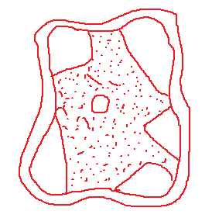
Tonoplast membrane
Cell membrane
Nucleus
d) State one role of the process being investigated in plants. (1mk)
Feeding in insectivorous plants;
Absorption of water;
Opening and closing of the stomata;

- The diagram below illustrates circulation in certain organs of the mammalian body.
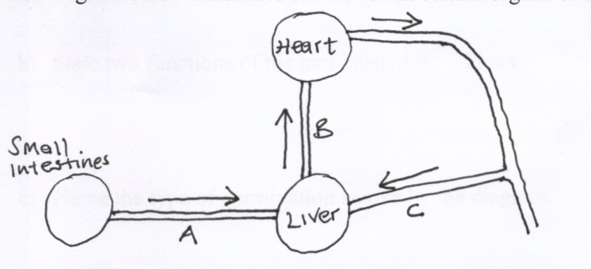

Heart

B
Small Intestines

C
Liver
A

a) Identify the blood vessels represented by A, B and C. (3mks)
(a) A – Hepartic portal vein; B – Hepartic vein; C – Hepartic artery;
b) Explain why blood from the small intestines goes to the liver before it goes to any
other organ of the body.
(b) – So that any toxic substances absorbed together with food nutrients from the ileum be detoxified;
- So that food substances e.g. glucose, can be regulated. Only the required quantity of glucose is left in circulation as excess is either stored as glycogen, fat and excess may be respired.
-Excess amino acids are deaminated;
c) Compare the blood in vessels B and C. (1mk)
(c) B – Deoxygenated C - Oxygenated
d) Outline how a glucose molecule in vessel A finally reaches the heart. (2mks)

d) From the small intestines, it is transported to the liver through Hepartic portal vein; (It is then transported to the heart through the hepartic vein, then the venacava to the heart.
3. Polydactyl is a genetic disorder in which people inherit an extra digit. Polydactyl is caused by a dominant allele (B). The table below describes the different genotypes for polydactyl.

- Complete the table below by giving the correct genotype, alleles of each genotype and the expected number of fingers per hand. (4mks)
Genotype | Alleles | Expected number of digits per hand.
Homozygous dominant | BB | Six
Homozygous recessive | bb | five
Heterozygous. | Bb | six

- The table below shows results of marriages between various parents. Complete the table by writing the probability of each marriage producing a child with polydactyl. One has been done for you. (2mks)
Parental genotypes. | Probability of child with polydactyl
Bb X BB | 1
Bb X bb | 0.5
Bb X Bb | 0.75

4. Kenyan pond weed (Elodea kenyiensis) is a common water plant that produces tiny air bubbles of oxygen during photosynthesis. The number of bubbles produced per minute indicates the rate of photosynthesis. The graph shows how the rate of photosynthesis in the pond weed relates to light intensity.
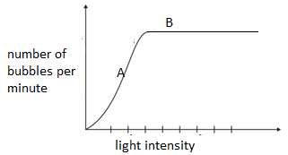
a). write the equation to account for the air bubbles. (1mk)
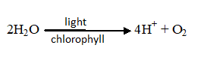
Light/Chlorophyll

Water Hydrogen atoms + Oxygen
b). Name the factor that affects photosynthesis at point A. Explain. (2mks)
-amount of light intensity;
-increase in light intensity increases the rate of photosynthesis;
c). explain why the rate of photosynthesis does not increase any further at high light intensity.(point B) (2mks)
-Due to other limiting factors; example carbon (IV) oxide concentration; temperature;
d). Explain the role of the following in photosynthesis;
i) Chlorophyll. (1mk)
-Trap light (for photolysis ;)
ii) Water. (1mk)
-Provision of Hydrogen ions which combine with carbon (IV) oxide to form simple sugars;
e). Name one product of the light stage of photosynthesis used in the dark stage of photosynthesis. (1mk)
-hydrogen ions/ atoms
-Adenosine triphosphate molecules; (rej ATP
5. Study the diagram below and answer the questions that follow.

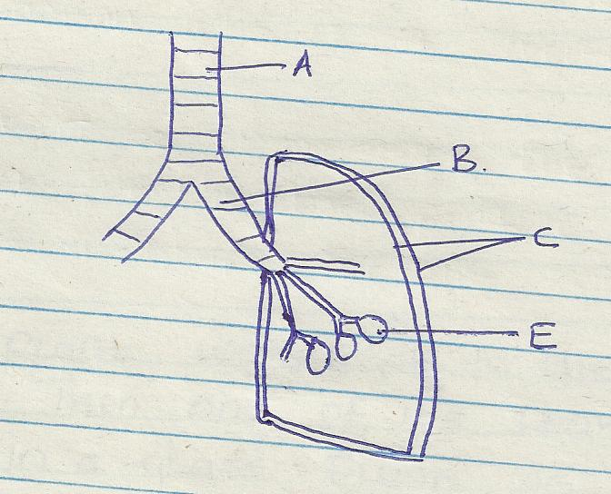

a) Name the part labeled A and B (2marks)
A-trachea
B-bronchus
b) State the function of the part labeled C (2marks)
secrete pleural fluid which reduce friction
enclose lungs
c) How is he part labeled E adapted to its function (2marks)
Thin epithelium do reduce distance for diffusion;
Moist surfaces to dissolve gases before they diffuse;
Well vascularized to transport diffusing gases;
d) Identify the structure that perform the same function as one illustrated above in (2marks)
i) Amoeba
Cell membrane
ii) Fish
gill filament (rej Plural
SECTION B (40 Marks)
Answer question 6 (compulsory) and either questions 7 or 8 in the spaces provided after questions 8
- The pressure in the flow of blood in a mammal was determined at two different vessels; A and B. The data was taken within a period of 1 minute and was presented as follows.
Time in seconds | Blood pressure in
Time in seconds | Vessel A | Vessel B
0 | 160 | 320
10 | 165 | 360
20 | 170 | 320
30 | 180 | 400
40 | 170 | 360
50 | 160 | 320
60 | 160 | 360
- Plot the graph of blood pressure in both vessels against time on the same axis. (7 marks)


a) Graph
Blood pressure – Y axis
Time (Seconds) – x Axis
Curves - in Vessel B – zigzag
- in vessel A – not zigzag
Marking
Axes – 1 Mk
Plotting 2Mks
Smooth curve 1Mk
Identity 1Mk
Scales 1Mk
Curves 1 Mk Total 7mks
- . Describe the trend of each curve. (2 marks)
Vessels A – Pressure is low and remains fairly constant
Vessels B – Pressure is high, rises and drops within a certain range
- (I) From the graph, suggest the possible identity for:
- Blood vessel A. (1 mark)
A - vein
- Blood vessel B. (1 mark)
B – Artery
- Give reasons for your answer in (c) i) and ii) above. (2 marks)
iii) A – vein, because veins have low and constant pressure without pulses while;
B – Is artery because it has high pressure and has pulses which fluctuates
- Explain a factor that would result to an increase in blood pressure in both the blood vessels above. (2 marks)
Exercise causes heart to beat faster, hence increase pressure in arteries, then exercises makes skeletal muscles to contract and presses the veins causing the blood to flow towards the heart.

- State two structural differences between the two vessels mentioned in (c) above. (2 marks)
Vessel A | Vessel B
Wider lumen | Narrow lumen
Thinner muscular walls | Thicker muscular walls
Valves present | Has no valves except pulmonary artery

- i) Name two diseases of circulatory system in humans. (2 marks)
Arteriosclerosis
Thrombosis
Hypertension ( High blood pressure)
Varicose veins
ii) Other than transport of substances give one other function of blood. (1 mark)
ii) Fight body infection / protection
Prevent excessive bleeding / blood clotting
Thermoregulation
Osmoregulation

7. State and explain various areas where knowledge about genetics is applied. (20mks)
- Plant and animal breeding;

Breeding is done by artificial selection; (that is selectively choosing plants and animals with desirable qualities for breeding) done either by inbreeding or cross breeding;
Cross breeding is preferred to inbreeding for purposes of increasing heterozygosity;
Offsprings resulting from a cross breed often possess hybrid vigour; which has been put to good use in plant and animal breeding;

Example
A cross between Dura and Pisifera varieties of wheat results to Tenera variety which has good qualities of both varieties, i. e. thick mesocarp yielding high quantity of oil, relatively thin endocarp for ease of oil extraction, large kernel for large quantity of oil;
(any other example)

- Blood transfusion;

Blood typing is done before transfusion to ensure compatibility of donor and recipients blood groups;
Tests for ABO and Rhesus antigens are done to consider the effect that the recipient’s antibodies will have on donor’s antigens;
Knowledge of human blood typing and matching has also been used in solving disputed parentage;

- Genetic counseling;

This is provision of information by specialists and advise on genetically inherited disorders, the risks and outcomes; to enable the person to arrive at an informed decision;

- Genetic engineering;
This is the identification of a desirable gene, altering, isolation and transferring the gne from one living organism to another;
A rapidly reproducing living organism is used in the production of useful life saving substances; e.g hormone like insulin; antibiotics
Genetic engineering has also made it possible to produce genetically modified organisms (transgenics) which have resulted in increased production in crops and domestic animals;
Genetic engineering is applied in the following areas,
- Environment,
- Farming;
- Medicine in the production of –hormones e.g insulin, medicinal protein, production of vaccines,
- Gene therapy,
- Crime detection;
Through a series of genetic techniques the patterns of DNA base sequence is prepared and produced in a film;
The DNA is unique to each individual
At the scene of crime ,a specimen from suspect is obtained and DNA extracted from the developed
specimen; then compared to the DNA pattern at the scene of crime to isolate the culplit from
several suspect;
DNA fingerprinting can also be conclusively used in solving disputed parentage;
DNA extracted from the child, the mother and the father is matched to determine the biological parents;

- Cloning;
Where a group of cells arise from single individual cells without fertilization;
Cloning of plants results to tissue culture techniques through which new variety of crops have been produced;
- Human genome;
Genome is total genetic content of any cell in an organism;
All genes on all the chromosomes
It aims at gene mapping to identify specific positions occupied by specicific genes on a chromosome.
-sequencing of genes.

8.a) Describe the process of fertilization in flowering plant. (15mks)
-Pollen grains stick to the stigma surface; surface of the stigma produces a chemical substances ; which stimulates the pollen grain to produce a pollen tube // germinate;
-The pollen tube grows down ( into the tissues of the style ( from which it derives nutrients;
-The generative nucleus divides to give rise to two male nuclei; and embryo sac has eight nuclei; 2 synergids ; egg cell ; two polar nuclei ; three antipodal cells;
-When the pollen tube reaches the micropyle the tube nucleus in the pollen tube degenerates// disintegrates ; one male nucleus fuses with eggs cell ovum ; and forms a zygote; which develops into embryo;
-The other male nucleus fuses with two polar nuclei ; to form triploid nuclei; which develops into endosperm; the process involves double fertilizations;

b) State the changes that take place in a flower after fertilization. (5mks)

- Interguments of ovule to seed coat / testa
- Zygote to embryo ;
- Triploid nucleus to endosperm ;
- Ovary wall to pericarp;
- Ovary to fruit;
- Ovule to seed
- Any other part // style / petal / calyx / stamen // corolla // stigma – dry // falls off;

