**NAME………………………………………………….INDEX NO…………………………**

**CANDIDATES’ SIGN………………………………..DATE……………………………….**

**SCHOOL……………………………………………………………………………………….**

**231/3**

**BIOLOGY**

**PAPER 3**

**PRACTICALS**

**TIME: 1 ¾ HOURS**

**INSTRUCTIONS TO CANDIDATES.**

a) Write your name and index number in the spaces provided above.

b) Sign and write the date of examination in the spaces provided above.

c) Answer **ALL** questions in the spaces provided above.

d) All workings **MUST** be clearly shown where necessary.

***FOR EXAMINERS’ USE ONLY.***

|  |  |  |
| --- | --- | --- |
| Question | Maximum Score | Candidates’ Score |
| 1  2  3 | 11  15  14 |  |
| TOTAL | 40 |  |

***This paper consists of 4 printed pages.***

***Candidates should check the question paper to ascertain that all pages are printed as indicated and no questions are missing.***

1. You are provided with photograph of specimen P.

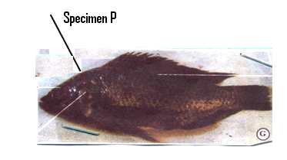

a) i) Name the class to which the specimen P belongs. (1mk)

…………………………………………………………………………………………..

ii) Give two reasons for your answer in a(i) above. (2mks)

………………………………………………………………………………………………………………………………………………………………………………………………………………………………………………………………………………

b) Name observable features that adapt the specimen to.

i) Forward movement (1mk)

…………………………………………………………………………………………..

ii) Balancing (1mk)

…………………………………………………………………………………………..

iii) Staying upright (1mk)

…………………………………………………………………………………………..

iv) Fast movement (1mk)

…………………………………………………………………………………………..

c) The part below was cut and removed from specimen P.

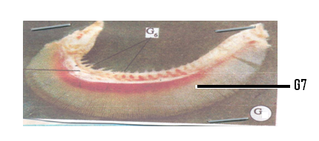

i) Identify the specimen extract (1mk)

………………………………………………………………………………………….

ii) Name parts labeled G6 and G7 (2mks)

……………………………………………………………………………………………………………………………………………………………………………………

iii) State the function of the specimen extract (1mk)

…………………………………………………………………………………………...........................................................................................................................................

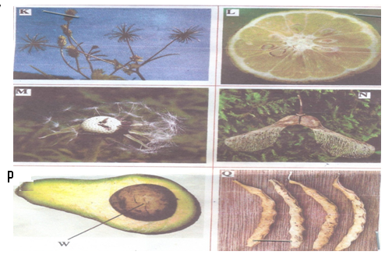2 Below are photographs of specimens obtained from plants. Examine the photographs.

a) In the table below name the mode of dispersal and the features that adapt each

specimen to that mode of dispersal. (12mks)

|  |  |  |
| --- | --- | --- |
| Specimen | Mode of Dispersal | Adaptive Feature |
| K |  |  |
| L |  |  |
| M |  |  |
| N |  |  |
| P |  |  |
| Q |  |  |

b) State the type of placentation in specimen L. (1mk)

…………………………………………………………………………………………

c) Name the structure labeled W on specimen P. (1mk)

…………………………………………………………………………………………

d) State the type of fruit represented by specimen L (1mk)

…………………………………………………………………………………………

3 You are provided with specimen Y which is part of a plant.

a) With reason identify the part of the plant represented by specimen Y. (2mks)

……………………………………………………………………………………………………………………………………………………………………………………

b) Draw a plain diagram of the transverse section of one of the cut surfaces. (1mk)

c) With reason state the class of the plant from which specimen Y was obtained. (2mks)

…………………………………………………………………………………………………………………………………………………………………………………….

d) Peel the specimen using a knife. Put the small pieces of the peeled parts in a mortar. Use the pestle to crush the pieces. Squeeze out juice from the crushed pieces into a small beaker. Use the reagent provided to determine the food substance present in specimen Y.Record the food substance tested.Procedure,observations and conclusions in the table below. (9mks)

Note: . Solution P is Iodine Solution,

. Solution Q is Benedict Solution

. Solution R is 1% CuSO4,

. Solution S is 5% NaOH,

|  |  |  |  |
| --- | --- | --- | --- |
| Food Tested | Procedure | Observation | Conclusion |
|  |  |  |  |
|  |  |  |  |
|  |  |  | **END** |