**Name**…………………………………… …………………………..………… Index No:………………………….

231/3 Candidate’s Signature …………..……………

**BIOLOGY** Date: …………………………

Paper 3

(Practical)

**1 ¾ Hours**

**INSTRUCTIONS TO CANDIDATES**

* Answer ***all*** the questions in the spaces provided.
* You are required to spend 15 minutes of the 1 ¾ hours allowed for this paper reading the whole paper carefully before commencing your work.
* Answer must be written in the spaces provided.
* Additional pages must not be inserted.

**For Examiners Use Only**

|  |  |  |
| --- | --- | --- |
| **Question** | **Maximum score** | **Candidate’s score** |
| 1 | 14 |  |
| 2 | 16 |  |
| 3 | 10 |  |
| TOTAL |  |  |

*This paper consists of 8 printed pages. Candidates should check to ascertain that all pages are printed as indicated and that no questions are missing.*

1 (a) Study the photographs below for specimen Rand S

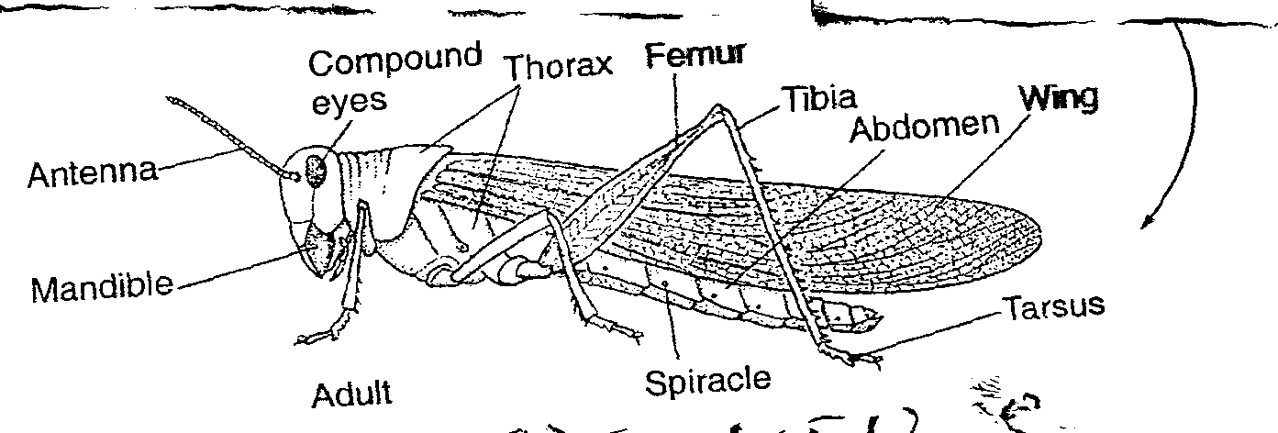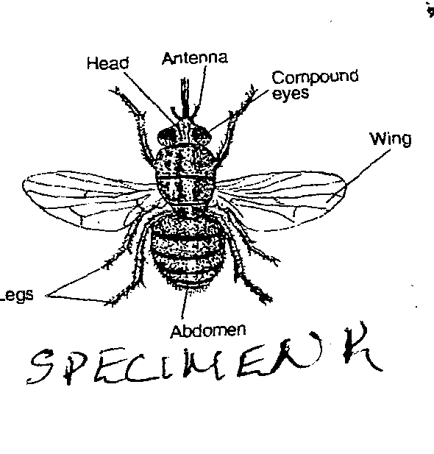

**Specimen R Specimen S**

i) State **two** observable differences between the specimen R and S (2mks)

|  |  |
| --- | --- |
| **Specimen R** | **Specimen S** |
|  |  |

ii) Suggest the advantage of the adaptations on the limbs of specimen S (2mks)

……………………………………………………………………………………………………………….

……………………………………………………………………………………………………………….

b) i) Name the phylum and the class to which the specimens belong

Phylum ……………………………………………………………

Class……………….………………………………………………

ii) State **two** distinguishing features found in the members of

Phylum ……………………………………………………………

Class……………….………………………………………………

|  |  |
| --- | --- |
| **Complete** | **Incomplete** |
|  |  |

State the specimen that exhibit;

i) Complete metamorphosis (1 mk)

……………………………………………………………………………………………………………….

……………………………………………………………………………………………………………….

ii) Incomplete metamorphosis (1 mk)

……………………………………………………………………………………………………………….

……………………………………………………………………………………………………………….

2. You are provided with a solution T and sodium chloride in two different concentrations 0.1% and 1.4%. Place 3m1

of starch solution in a test-tube labeled 1,2 and 3. Add 3 drops of 0.1% sodium chloride to test tube labeled 2 and 1.4% sodium chloride solution to test tube labeled 3. Add 3m1 of solution L to each test tube labeled 2 and 3

a) Place a drop of the contents from each test tube 1,2 and 3 on a white tile. To each drop add iodine solution. Record

your result in the table below (3mks)

|  |  |  |  |
| --- | --- | --- | --- |
| **Test-tube** | **Treatment** | **Observation at start of experiment** | **Observation at end of experiment** |
| 1 | Starch |  |  |
| 2 | Starch to 1.0% NaC l + L |  |  |
| 3 | Starch+ l.4%NaCI+ L |  |  |

b) Place the test tubes in water bath maintained at 3 7°c. Allow to stand for 30 minutes. Place a drop of the contents

from each test tube on a white tile. To each drop add iodine solution. Record your observations in the table above

c) Add equal amounts of Benedict’s solution in test tubes labeled 2 and 3 and bu1l. Record your observation below

Test —tube 2 (lmk)

……………………………………………………………………………………………………………….

……………………………………………………………………………………………………………….

Test —tube 3 (lmk)

……………………………………………………………………………………………………………….

……………………………………………………………………………………………………………….

d) Why was the test tube labeled 1 included in the experiment (lmk)

……………………………………………………………………………………………………………….

……………………………………………………………………………………………………………….

e) Account for the results in test tube 1,2 and 3 at the end of the experiment (4mks)

……………………………………………………………………………………………………………….

……………………………………………………………………………………………………………….

……………………………………………………………………………………………………………….

……………………………………………………………………………………………………………….

f) Suggest the identity of solution L (lmk)

……………………………………………………………………………………………………………….

……………………………………………………………………………………………………………….

g) Why were the test-tubes placed in a water bath maintained at 37°c (lmk)

……………………………………………………………………………………………………………….

……………………………………………………………………………………………………………….

3 (a (i) On diagram P and Q label the parts **A,B,C,D,E** and **F** (3mks)

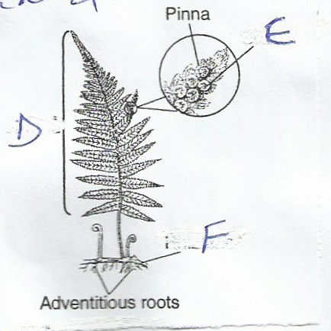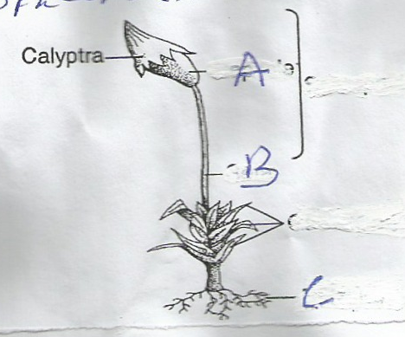

**F**

**E**

C

B

A

**D**

**Specimen P Specimen Q**

ii) Name the divisions of **P** and **Q** (2mks)

**P**………………………………………

**Q**………………………………………

b) From the diagram name the organ of reproduction (2mks)

**P**………………………………………

**Q**………………………………………

c) On diagram P show the part representing gametophyte and sporophyte (2mks)

d) Name the gametophyte of specimen Q (lmk)

Q ……………………………………….. (1mk)