NAME: ………………………………………….………………………… INDEX NO: .........................................
SCHOOL………………………………………………………………….. DATE………………………………… CANDIDATE’S SIGN………………………………………….…………

231/3
BIOLOGY
PAPER 3
TIME: 1 ¾ HOURS

Kenya Certificate of Secondary Education (K.C.S.E)
INSTRUCTIONS TO CANDIDATES

- Write your name and index number in the spaces provided above.
- Sign and write the date of examination in the spaces provided above.
- You are required to spend the first 15 minutes of the 1 ¾ hours allowed for this paper reading the whole paper carefully before commencing your work.
- Answers must be written in the spaces provided in the question paper.

For Examiner’s Use only:-

Question | Maximum Score | Candidate’s Score
1 | 14
2 | 14
3 | 12
TOTAL | 40

This paper consists of 4 printed pages. Candidates should check to ascertain that all pages are printed as indicated and that no questions are missing.

1. You are provided with 10% glucose solution and substance labeled Y. Also provided is a solution labeled X. You are to investigate the reaction between the glucose solution and substance Y. Measure 20.00cm³ of the glucose solution and transfer it to the boiling tube provided. Transfer all the substance Y provided into the solution in the boiling tube. Tightly fit the rubber bung carrying a delivery tube to the boiling tube. Place the boiling tube in a water bath kept between 35 – 38⁰ c. Measure 1.0. Cm3 of solution X and transfer to a test tube. Connect the delivery tube so that the open end enters the solution X. Allow the set – up to stand for about 30 minutes and during this time observe the changes occurring in the boiling tube and in the test tube having solution X.

a) Fill the table below (2 marks)
Tube | Observations
Boiling Tube
Test Tube

b) What conclusions can your draw from your observations in the test tube?
(2 marks)

………………………………………………………………………………………………………………………………………………………………………………………………………………………………………………………………………………………………………………………………………………………………………………………………
c) Name the process that took place in the test tube (1 mark)

………………………………………………………………………………………………………………………………………………………………………………………………
d) Shake the contents of the boiling tube and using a dropper remove a little of the
contents. Transfer a drop to a glass slide; add two drops of methylene blue stain. Cover with a cover slip and observe using a microscope of x10 or x15 eye piece lens.

(i) Draw and label the substance Y which is in the slide (2 marks)

(ii) What is the possible identity of substance Y (1 mark)

………………………………………………………………………………………………
e) Why was the temperature of the water bath kept between 35 – 38⁰c (1 mark)

………………………………………………………………………………………………
f) If the experiment was done under the following conditions, suggest, giving reasons the expected results.
(i)Water bath was kept at 100⁰c

Observations: (1 mark)

………………………………………………………………………………………
Reasons: (1 mark)

………………………………………………………………………………………………

g) From the microscope
(i) Name the part labeled Q. (1 mark)

………………………………………………………………………………………

(ii) Give the function of part labeled P. (1 mark)

………………………………………………………………………………………
h) Name the form in which substance Y stores its excess glucose (1 mark)

………………………………………………………………………………………………

Q2. (a) Examine photograph A, B1 and B2 carefully and answer the questions that follow. B2
was extracted from B1

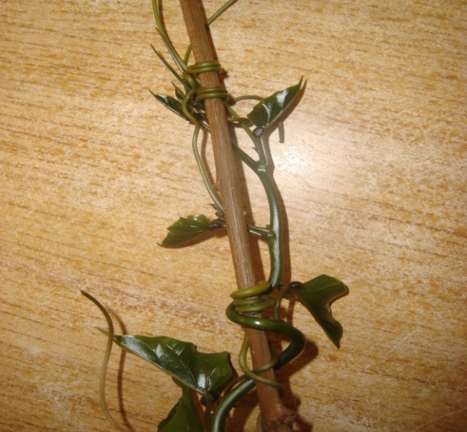
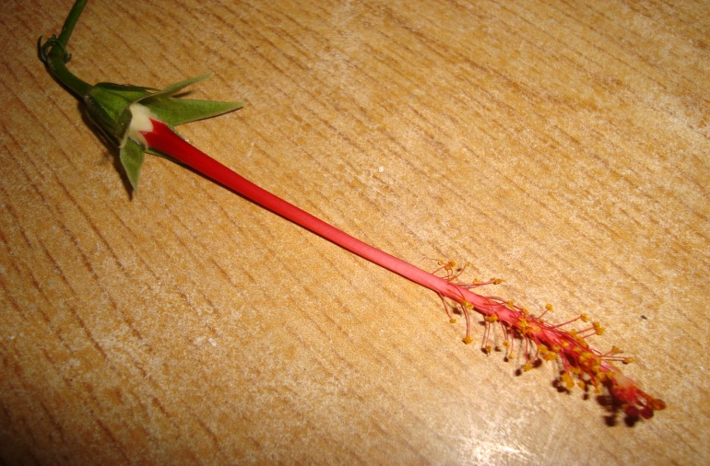
A
B2

T

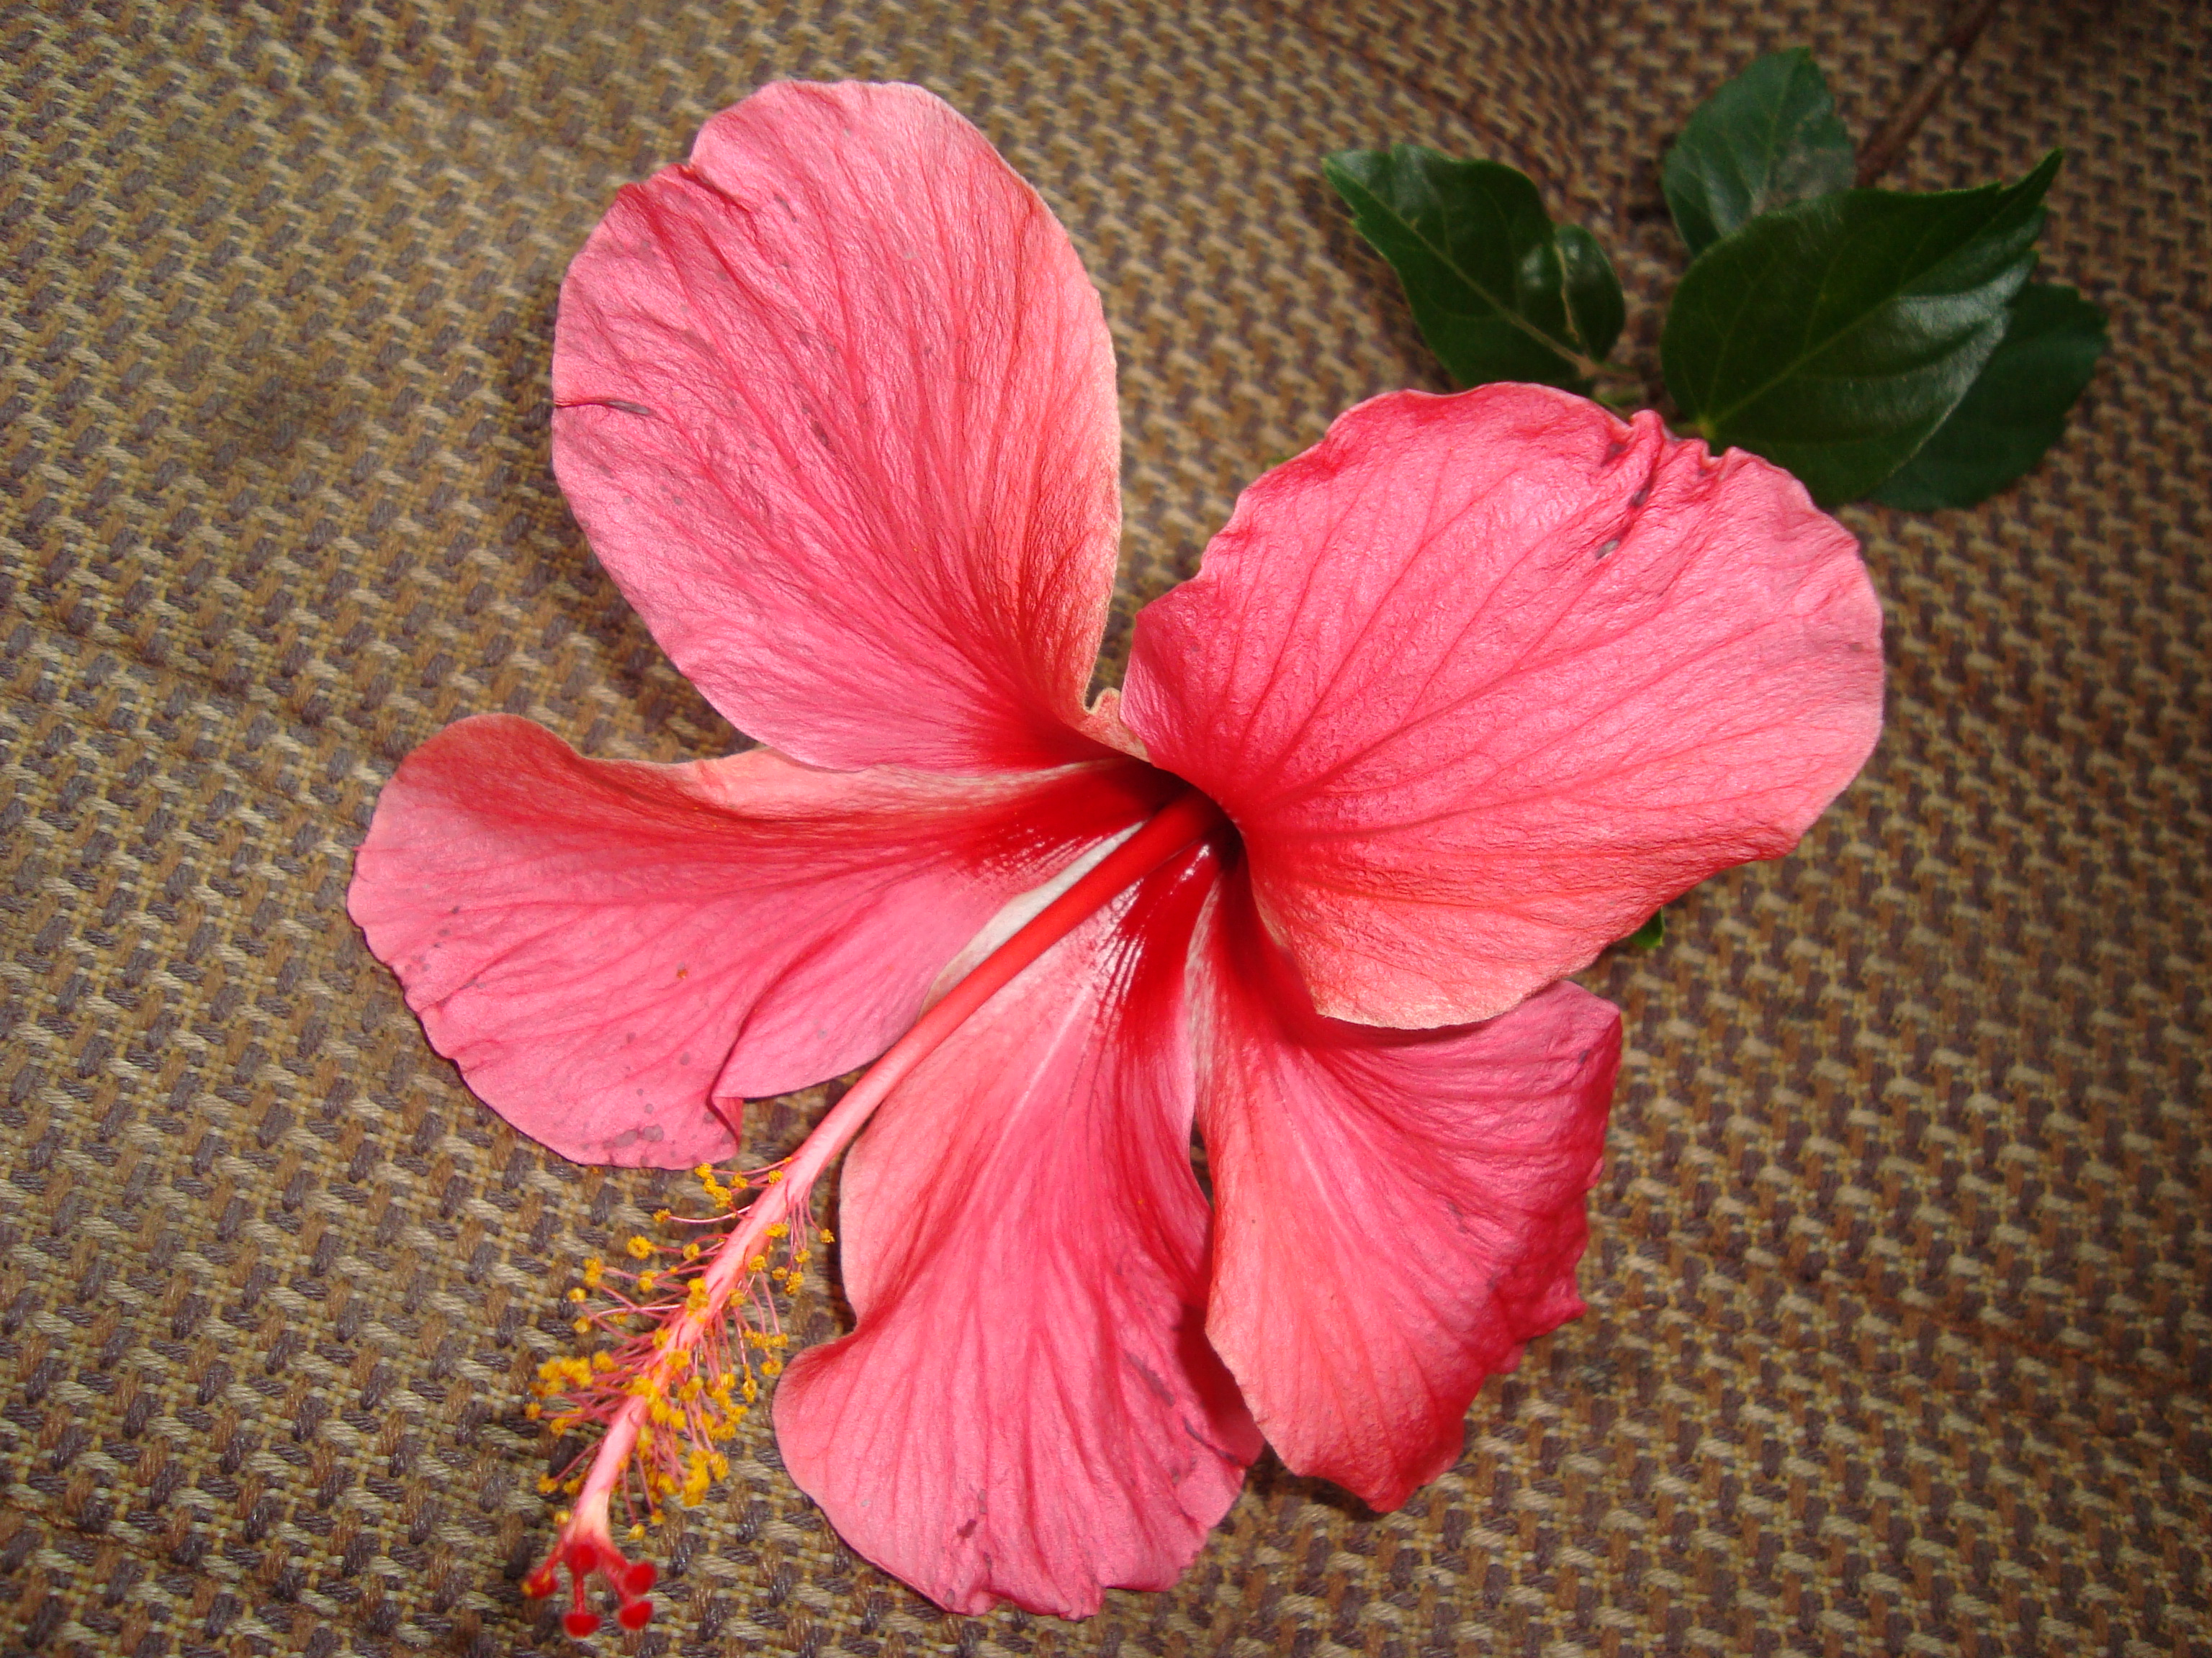

B1

(i) What name is given to the coiled part labeled T found on specimen A (1 mark)

………………………………………………………………………………………………

(ii) Name the type of response exhibited by the coiled part on specimen A (1mark)

………………………………………………………………………………………

(iii) Name the stimulus responsible for the response named in (ii) above. (1mark)

………………………………………………………………………………………………

(iv) Explain how the response exhibited by the coiled part on specimen A occurred
(3 marks)

………………………………………………………………………………………………
………………………………………………………………………………………………
………………………………………………………………………………………………
………………………………………………………………………………………………
(v) State the biological significance of the response described in (iv) above to the
survival of the specimen. (1mark)

………………………………………………………………………………………………
b) Use photographed specimens labeled B1 and B2 above to answer the questions below.
(i) State the agent of pollination for the specimen above. (1mark)

………………………………………………………………………………………………

(ii) Give a reason for your answer. (1mark)

………………………………………………………………………………………………

(iii) Describe the external features of leaves of the specimen B2. (3marks)

………………………………………………………………………………………………
………………………………………………………………………………………………
………………………………………………………………………………………………
………………………………………………………………………………………………

(iv) Based on the floral parts, state the class to which specimen B belongs. (1mark)

………………………………………………………………………………………………

(v) Give a reason for your answer in (iv) above. (1mark)

………………………………………………………………………………………………
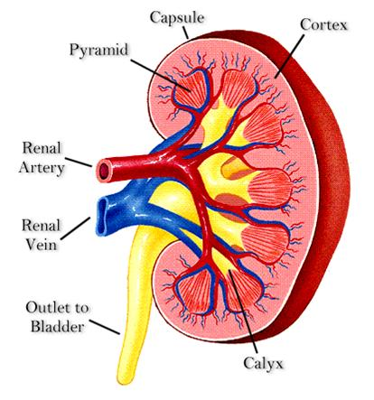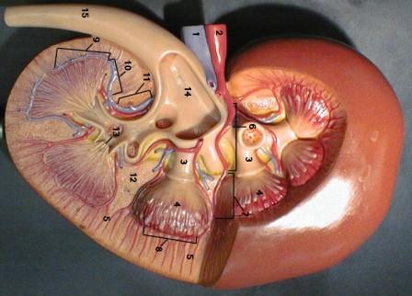 Q3 Below is a section through a mammalian organ.
A
B
C

i) Identify the section (1mark)

………………………………………………………………………………………………

ii) Name the parts labeled A, B and C (3marks)

A ………………………………………………………………………………….

B …………………………………………………………………………………...

C …………………………………………………………………………………...
iii) State two functions of the photographed specimen. (2marks)

………………………………………………………………………………………………

……………………………………………………………………………………………....

iv) Label on the photograph using G and L the region where the Glomerulus, and
Loop of Henle are located respectively. (2marks)

………………………………………………………………………………………………
…….....................................................................................................................................
(v) Name a process that occurs in the glomerulus and Loop of Henle (2marks)

a) Glomerulus …………………………………………………………………………….

b) Loop of Henle ………………………………………………………………………….

(vi) Name two renal diseases (2marks)

……………………………………………………………………………………………… ………………………………………………………………………………………………

