Name………………………………………………………… Admission No:………………………..

School: …….……………………………………………….. Candidate’s Sign: …………………...

Date: …………………………………..................................

231/3
BIOLOGY
Paper 3
Time: 2 Hours

Kenya Certificate of Secondary Education (K.C.S.E)

BIOLOGY
Paper 3

INSTRUCTIONS TO CANDIDATES:
- Write your name and Index Number in the spaces provided at the top of this page.
- Sign and write the date of examination.
- Answer all the questions
- You are required to spend the first 15 minutes of 1½ hrs allowed for this paper reading the whole paper carefully before commencing your work.
- All answers must be written in the spaces provided in this question paper.
- Additional pages must not be inserted

EXAMINER’S USE ONLY
Question | Maximum score | Candidate’s Score
1  2  3  TOTAL | 13  15  12  40

This paper consists of 4 printed pages. Candidates should check to ascertain that all papers are printed as indicated and that no questions are missing.

1. Below are photographs of organisms belonging to a certain phylum. Examine them and answer the questions that follow.
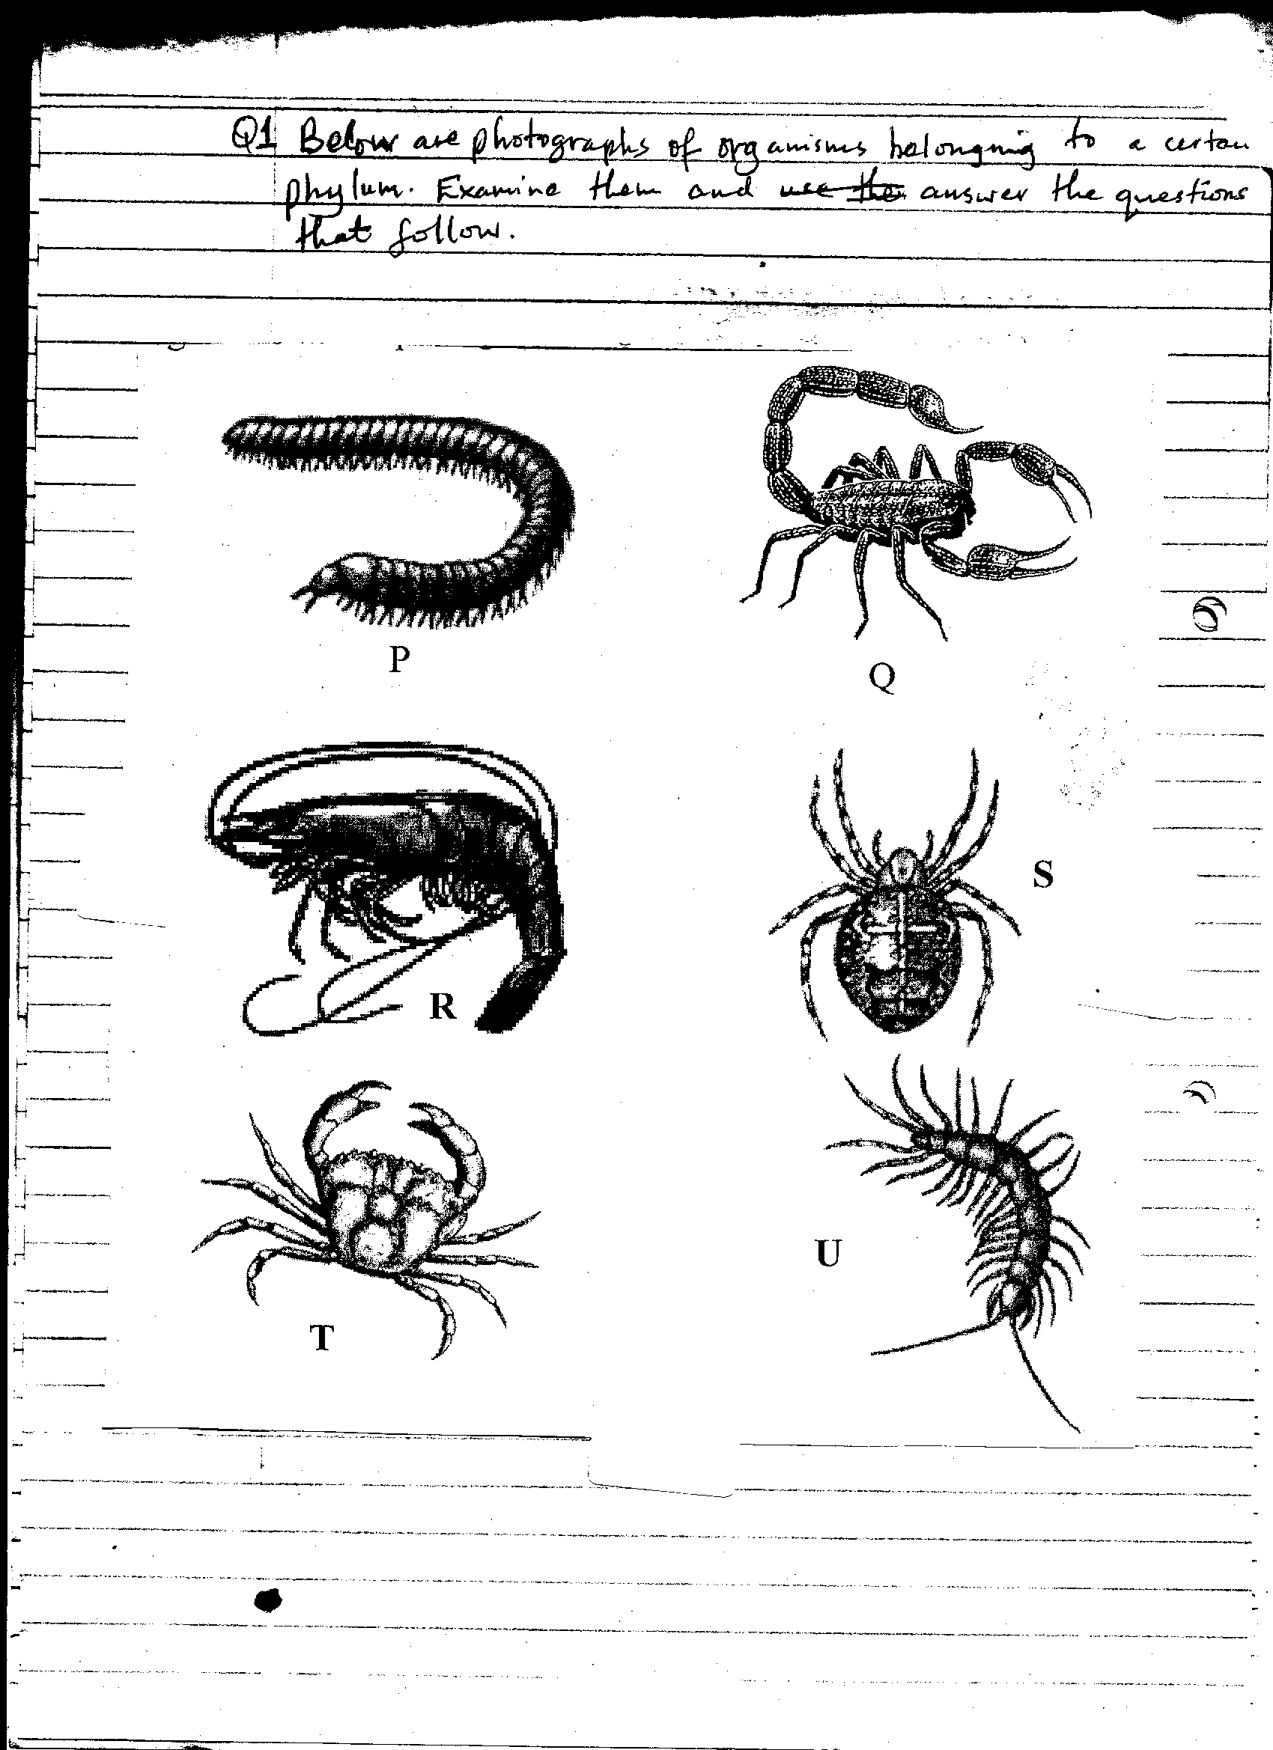

- By stating two observable features from the photographs, identify the phylum of the above animals. (3mrks)

Phylum: ......................................................................................................................................

Features: .....................................................................................................................................

(i) ................................................................................................................................................

(ii) ..............................................................................................................................................

(b) Below is a dichotomous key which can be used to identify the organisms whose photographs
are provided above.

a Body divided into two segmented body parts ............................................. go to 2
1
b Body divided into more than two segments ................................................ go to 3
2
a Posses eight legs .......................................................................................... go to 4
b Posses more than eight legs .......................................... .............................. go to 5
a Long cylindrical body with two pair of legs per segment ................... Diplopoda
3
b Long flattened body with one pair of legs per segment ............................ Chilopoda
4
a Posses segmented abdomen ...................................... .............................. Scorpionidae
b Abdomen not segmented ......................................................................... Crustacea
5
a Flat leaf –like feet .................................................... ............................. Branchiopoda
b Feet not flat and leaf-like ..................................... .................................. Decapoda

Identify organisms labelled P,Q.T and U by filling the table provided below: (8mrks)

Organism | Steps followed | Identity
P
Q
T
U

(c) Name a structure found in organism labeled U which is missing in organism labeled P and
state it’s importance. (2mrks)
Name of structure……………………………………………………………………………….
Importance………………………………………………………………………...…………….
2. The photograph below represents a cell.
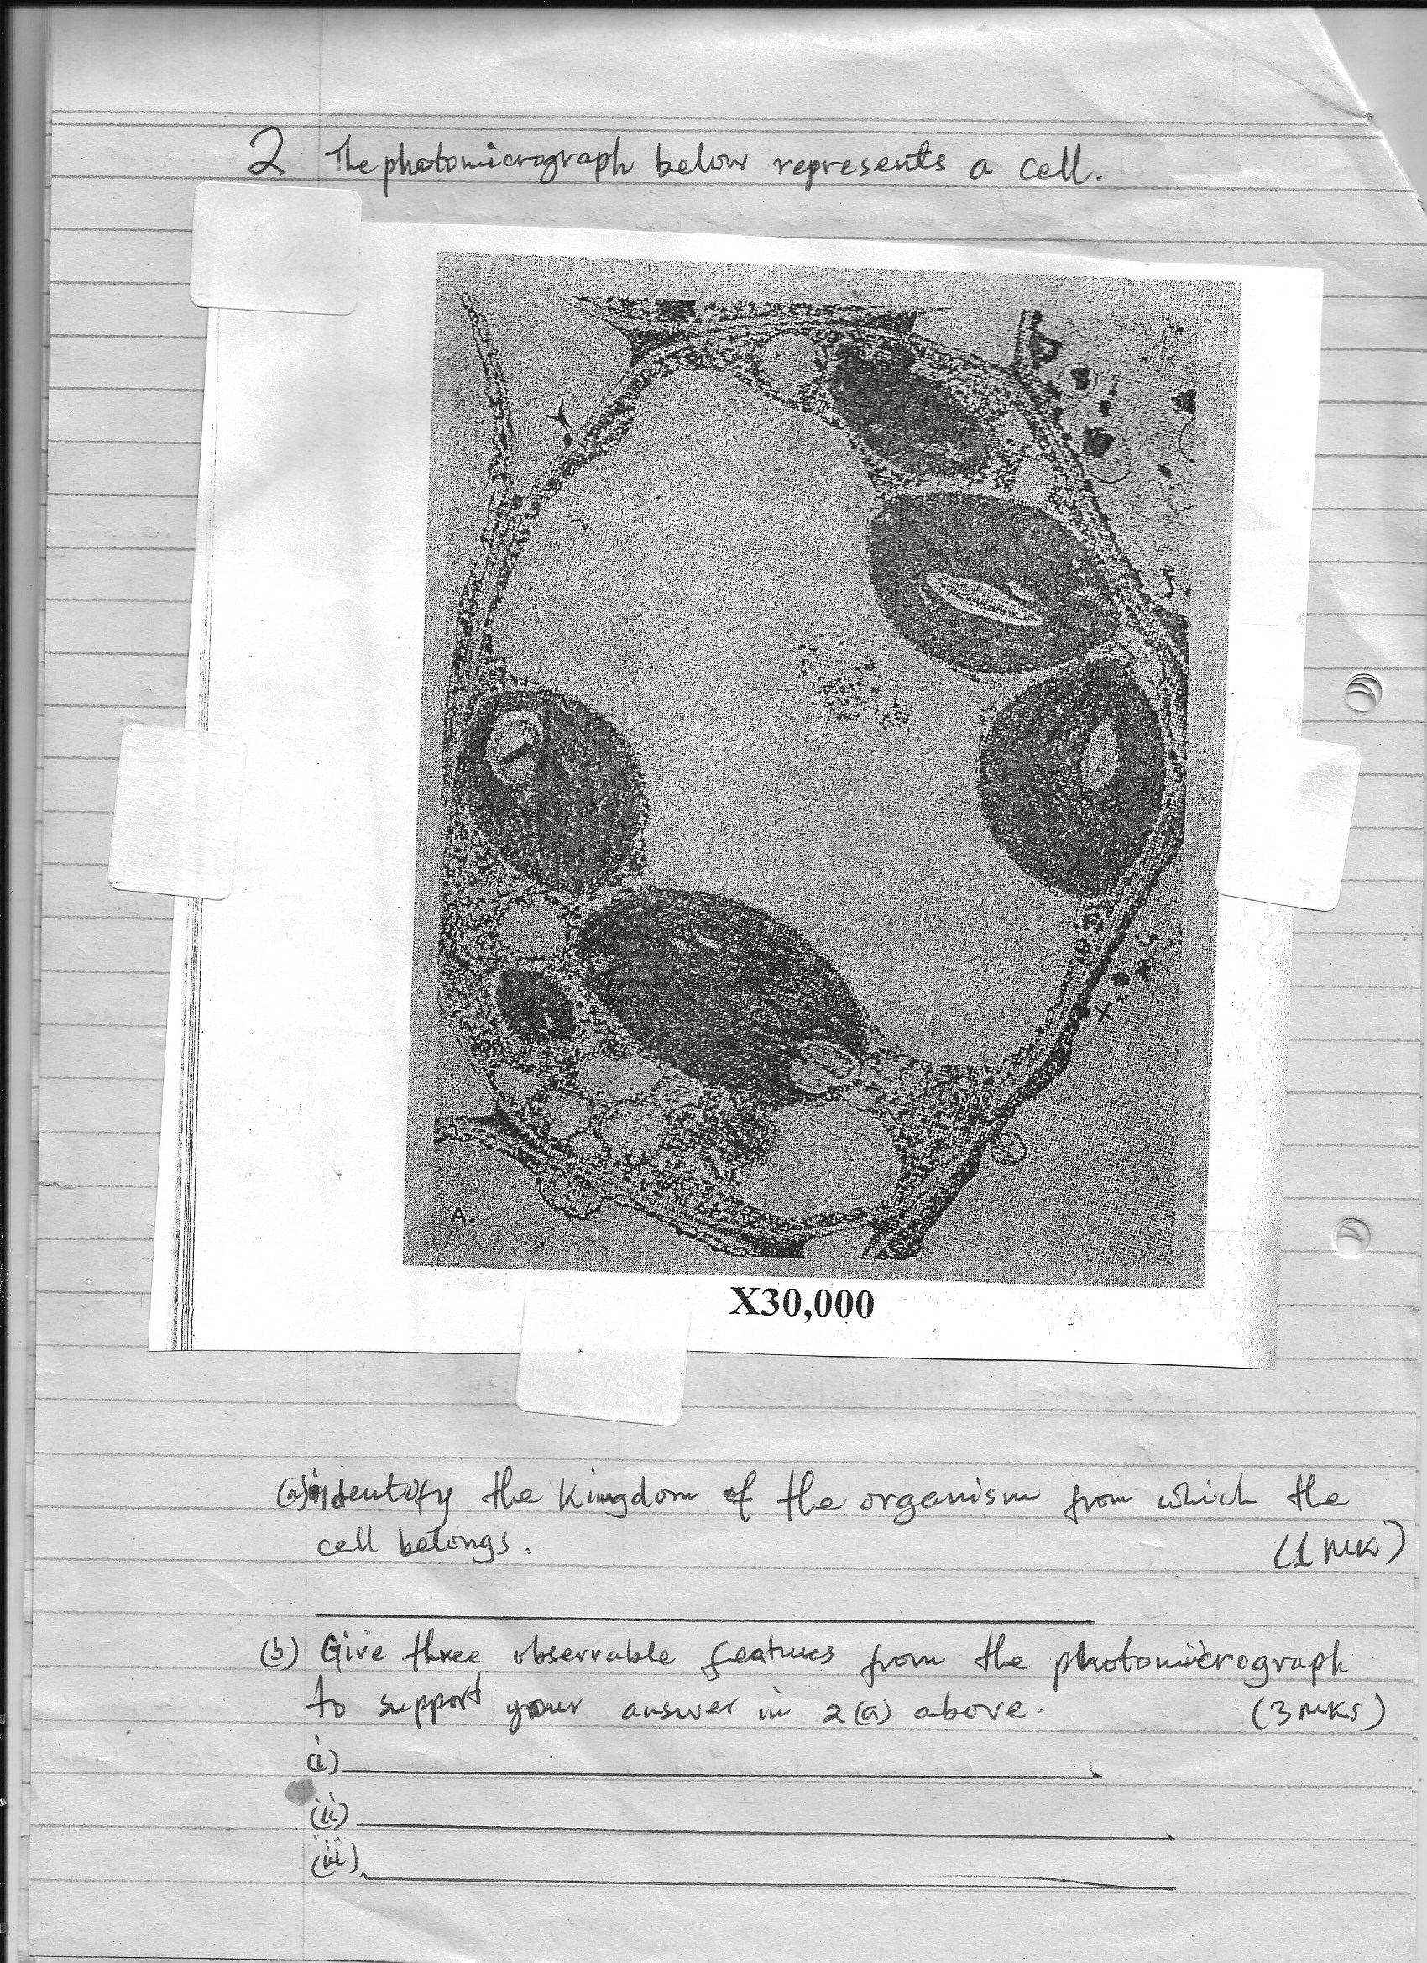

(a) Identify the Kingdom of the organism from which the cell belongs. (1mrk)
.....................................................................................................................................................
(b) Give three observable features from the photomicrograph to support your answer in 2 (a) above. (3mrks)
(i) .................................................................................................................................................
(ii) ................................................................................................................................................
(iii) ..............................................................................................................................................,
(c) Work out the length between points X and Y of the actual cell in micrometres. (3mrks)

(d) Below are photographs A,B and C showing different types of root systems in plants. Examine them and answer the questions which follow.
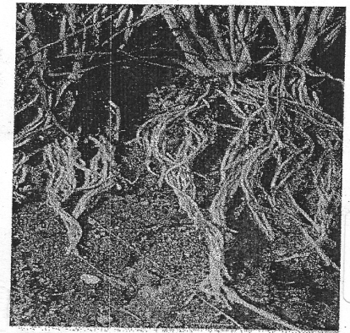
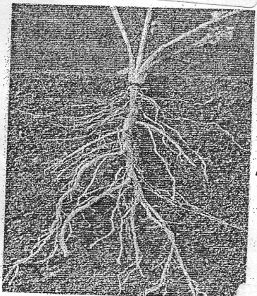
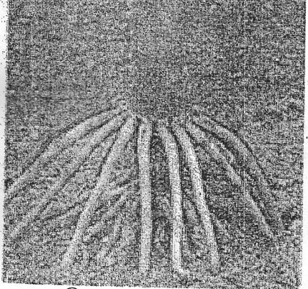

A
B
C

Identify the types of root system labelled A,B, and C. (3mrks)
A ......................................................................................................................................
B ......................................................................................................................................
C ......................................................................................................................................
(e) Name the class of the plants to which root system labelled B belongs. (1mrk)
......................................................................................................................................................
(f) Give an example of a common plant with root system labelled C. (1mrk)
......................................................................................................................................................
(g) State three characteristic features of plants with root system labelled A. (3mrks)
(i) ................................................................................................................................................
(ii) ..............................................................................................................................................
(iii) ..............................................................................................................................................
3. You are provide with liquid labeled T and a range of reagents and materials . Select the appropriate
requirements and carry out iodine, Benedict’s, Biuret’s and DCPIP test and fill in the table below. (12mks)
Test | Procedure | Observation | Conclusion
Iodine test

Benedict’s test

Biuret’s test

DCPIP test

