**NAME………………………………………………INDEX NO…………………. Date……………**

**SCHOOL………………………………………………………………… signature …………………**

231/3

BIOLOGY

PAPER 3 (Theory)

INSTRUCTIONS TO CANDIDATES.

* *Answer ALL the questions.*
* *You are required to spend the first 15 minutes of the 2¼ hour allowed for this paper reading the whole paper carefully before commencing your work.*
* *Answers must be written in the spaces provided in the question paper.*
* *Candidates may be penalized for recording irrelevant information.*

**FOR EXAMINERS USE ONLY**

|  |  |  |
| --- | --- | --- |
| QUESTION | MAX SCORE | CANDIDATES SCORE |
| 1 | 16 |  |
| 2 | 14 |  |
| 3 | 10 |  |

1. You are provided with a suspension labeled M and the reagents. Using the reagents and suspension, carry out the relevant food tests. Record your results in the table below. (16mks)

|  |  |  |  |
| --- | --- | --- | --- |
| Food substance | Procedure | Observation | Conclusion |
|  |  |  |  |
|  |  |  |  |
|  |  |  |  |
|  |  |  |  |

1. The photograph below shows a transverse section of a young cowpea root

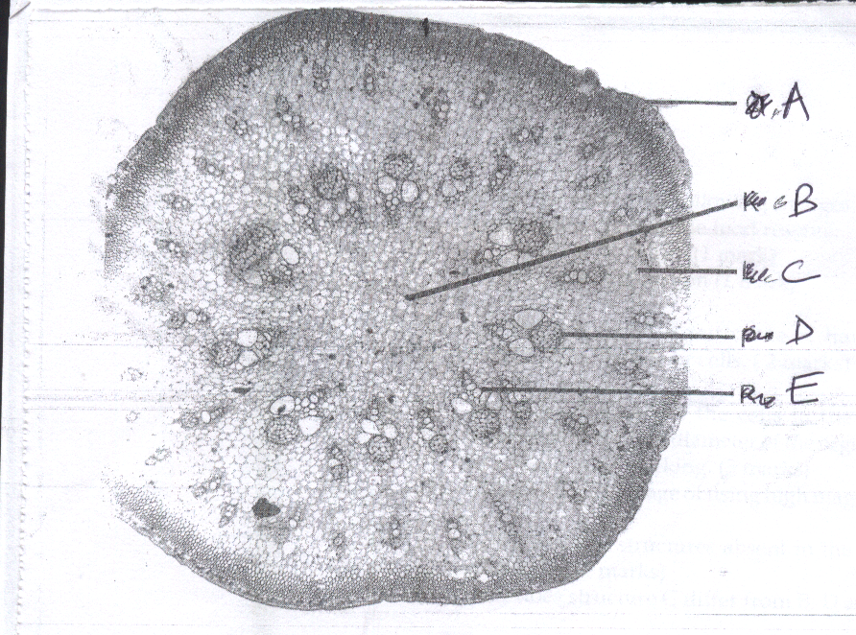

**A**

**B**

**C**

**D**

**E**

(a) State **two** observable evidences that suggest that the root was quite young (2mks)

…………………………………………………………….…………………………………………………………………….…………………………………………………………….……………………………………………………………………………………………………………………………………………………………………………………………….

(b) **Name** the structures labeled A, B and C (3mks)

A……………..……………………………..………………………

B……………………………………………………………………

C……………………………………………………………………

(c ) Suggest the functions of the parts labeled A and C (2mks)

A…………………………………………………….………………………………………………………………………

C….………………………………………………..……………………………………………………………………….

(d) **Identify** and **state** the functions of structures labeled D and E. (4mks)

|  |  |  |
| --- | --- | --- |
| Structure | Identity | Functions |
| D |  |  |
| E |  |  |

(e) **State** the biological importance of the following structures in a root

(i) Root cap (1mk)

………………………………………….……………………………………………..……………………………………………………………………………………………………

(ii) Cambium. (1mk)

.…………………………………………………….…………………………………………………………………………………………………………………………………………

(iii) Numerous root hairs. (1mk)

……………………………………………………….………………………………………………………………………………………………………………………………………..

1. The figure below represents a response exhibited by a plant tendril.

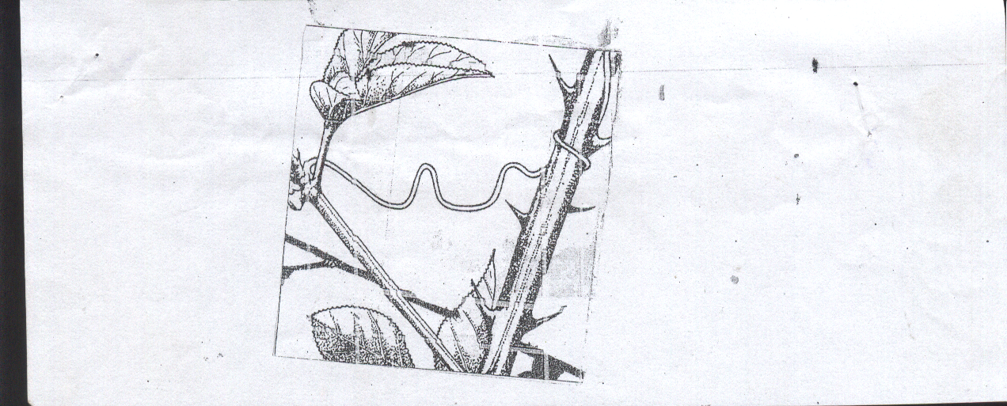

(a) **Name** the response ………………………………………………………… (1mk)

(b) **Explain** how the response occurs (3mks)

………………………..……………………………….…………………………………………………………………….………………………..……………………………….…………………………………………………………………….………………………..……………………………….…………………………………………………………………….………………………..……………………………….…………………………………………………………………….

(c) Name **two** parts of a plant where auxins are produced. (2mks) ………………………..……………………………….………………………………………             ………………….…………………………..……………………………….……………………            ……………………………………………………………………………………………………            …………………………………..

(e) State **four** applications of auxins in agriculture (4mks)

…………………………..……………………………….…………………………………………………………………….………………………..……………………………….…………………………………………………………………….………………………..……………………………….…………………………………………………………………….………………………..……………………………….……………………………………………………………………………………………………………………………………………………………………………………………………………………………………………………………………………………………………………………………………………………………………………………………………………………………………………………………………………………………………………………………………………………………………………………………………………………………………………………………………