**Name………………………………………………………. Index No…………………/…….**

**School………………………………………………………Date ………………………….…**

**Candidate’s Signature………………………**

**231/3**

**BILOGY**

**PAPER 3**

**(PRACTICAL)**

**Time: 1 ¾ Hours**

***Kenya Certificate of Secondary Education (K.C.S.E)***

**INSTRUCTIONS TO CANDIDATES**

1. Write your name and Index Number in the spaces provided above.

2. Sign and write the date of the examination in the spaces provided above.

3. Answer all the questions in the spaces provided.

4 You are required to spend the first 15 minutes of the 1 ¾ hours allowed for this paper reading the whole paper carefully before commencing your work.

5. Additional pages must not be inserted.

**FOR EXAMINER’S USE**

|  |  |  |
| --- | --- | --- |
| **Questions** | **Maximum score** | **Candidates score** |
| **1** | **11** |  |
| **2** | **16** |  |
| **3** | **13** |  |
| **Total score** | **40** |  |

1. You are provided with solution labeled Q,Benedict’s solution, DCPIP reagent, dilute sodium

hydroxide and 1% copper (II) sulphate; using

(a) 2ml in a test-tube in each case, test for the food substances in solution Q. (10mks)

|  |  |  |  |
| --- | --- | --- | --- |
| Test | Procedure | Observation | Conclusion |
| Burette test | (1mk) | (1mk) | (1mk) |
| DCPIP test | (1mk) | (1mk) | (1mk) |
| Benedict’s test | (2mk) | (1mk) | (1mk) |

(b) Name the deficiency disease in humans that would result from lack of nutrients contained

in solution Q (1mk)

………………………………………………………………………………………………………

………………………………………………………………………………………………………

2. Below are two photographs of specimen D and specimen E.

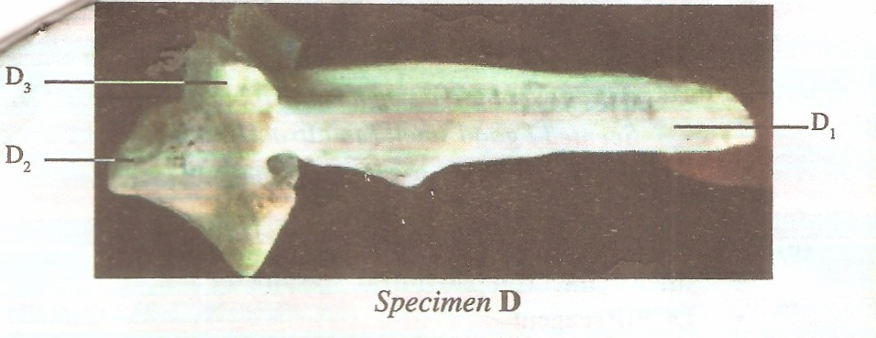

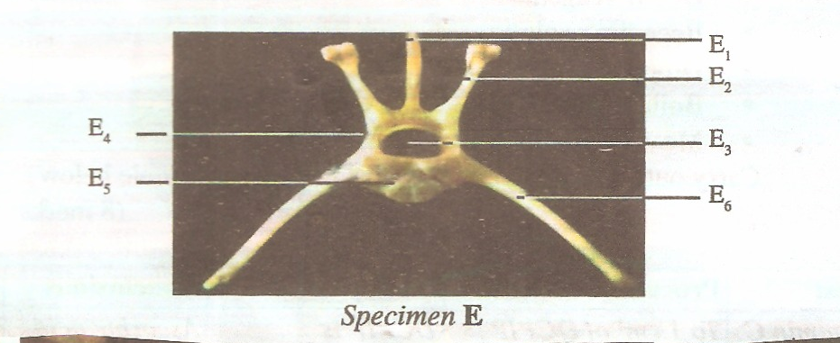

Study the photographs of specimen then answer the questions that follow.

Specimen D

………………………………………………………………………………………………………

Specimen E

………………………………………………………………………………………………………

(a) Identify the specimen D and E (2mks)

………………………………………………………………………………………………………

………………………………………………………………………………………………………

(b) State the distinguishing features of specimen D. (3mks)

………………………………………………………………………………………………………

………………………………………………………………………………………………………

………………………………………………………………………………………………………

………………………………………………………………………………………………………

………………………………………………………………………………………………………

………………………………………………………………………………………………………

(c) State the distinguish features of specimen E. (3mks)

………………………………………………………………………………………………………

………………………………………………………………………………………………………

………………………………………………………………………………………………………

………………………………………………………………………………………………………

………………………………………………………………………………………………………

………………………………………………………………………………………………………

(d) Identify each of the labeled parts and state a function of each part. (8mks)

|  |  |  |
| --- | --- | --- |
| Part | Identity | Function |
| E1 |  |  |
| E2 |  |  |
| E3 |  |  |
| E4 |  |  |

3. Below are photographs labeled B and C of organs obtained from different animals.

The organs perform similar functions Example them and answer the questions that follow

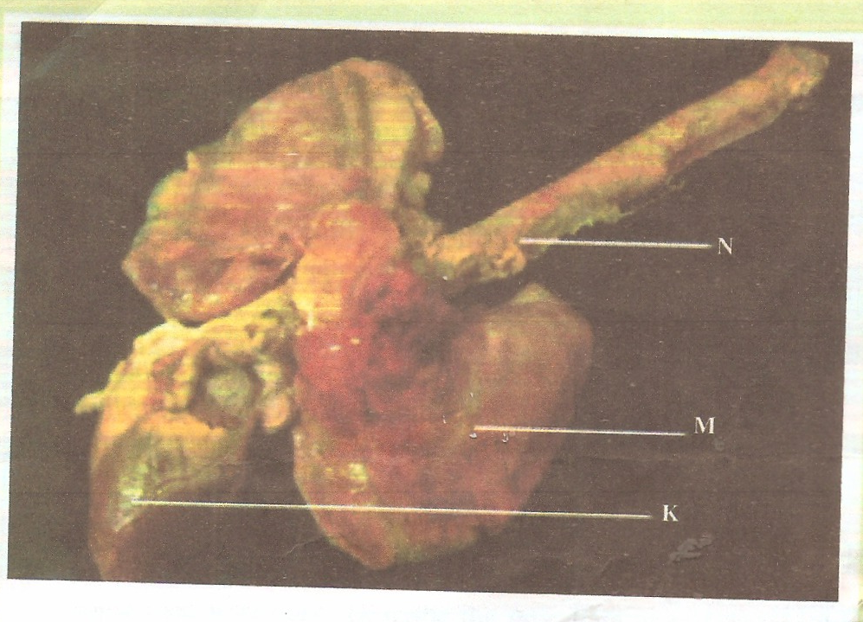

(a) Name the organs (2mks)

………………………………………………………………………………………………………

………………………………………………………………………………………………………

(b) State the common functions performed by the organs stated above (1mk)

………………………………………………………………………………………………………

………………………………………………………………………………………………………

(c) Name the parts labeled B1,B2 and B3 in photo graph B. (3mks)

………………………………………………………………………………………………………

………………………………………………………………………………………………………

………………………………………………………………………………………………………

………………………………………………………………………………………………………

(d) (i) Identify the parts labeled K1, K2 and K3 in photograph C. (3mks)

………………………………………………………………………………………………………

………………………………………………………………………………………………………

………………………………………………………………………………………………………

………………………………………………………………………………………………………

(ii) Using observable features, state how the parts labeled K1 and K3 you identify in

(d)(i) above are adapted to their functions. (4mks)

………………………………………………………………………………………………………

………………………………………………………………………………………………………

………………………………………………………………………………………………………

………………………………………………………………………………………………………

………………………………………………………………………………………………………

………………………………………………………………………………………………………

END

END