**NAME**……………………………………………………………………………**INDEX NO**……………………………………..…..

**SCHOOL** …………………………………………………………. **SIGNATURE**………………..…..…**DATE**…………………

231/3

BIOLOGY

PAPER 3

*Write your name and index in the spaces provided above.*

* *Sign and write the date of examination in the spaces provided above.*
* *Answer all questions in the spaces provided above.*
* *You are required to spend the first* ***15*** *minutes of the 13/4 hours allowed for this paper reading the whole paper carefully before commencing your exam.*
* *Answers must be written in the spaces provided in the question paper.*
* *Additional papers must not be inserted*
* *The candidate should check the question paper to ascertain that all the pages are printed as indicated and no questions are missing.*

**For examiners only**

|  |  |  |
| --- | --- | --- |
| **Question** | **Maximum score** | **Candidate scores** |
| 1 | 14 |  |
| 2 | 14 |  |
| 3 | 12 |  |
| **Total score** | **40** |  |

1. You are provided with the following; specimen K, specimen X, scalpel blade, pair of forceps, Iodine solution and Benedict’s solution.
2. What type of fruit is K? (1mrk)

........................................................................................................................................................................................

1. With a reason, identify the agent of dispersal for specimen. (2mrks)

Agent ........................................................................................................................................................................................

Reason

........................................................................................................................................................................................

........................................................................................................................................................................................

1. On specimen X, carry out food tests using the re agents provided. Record your procedures, observations and conclusions in the table below. (4mrks)

|  |  |  |  |
| --- | --- | --- | --- |
| **Food substance** | **Procedure** | **Observation** | **Conclusion** |
|  |  |  |  |
|  |  |  |  |

1. Cut the specimen 1.0cm from the tip as well as shown in the diagram into two parts:

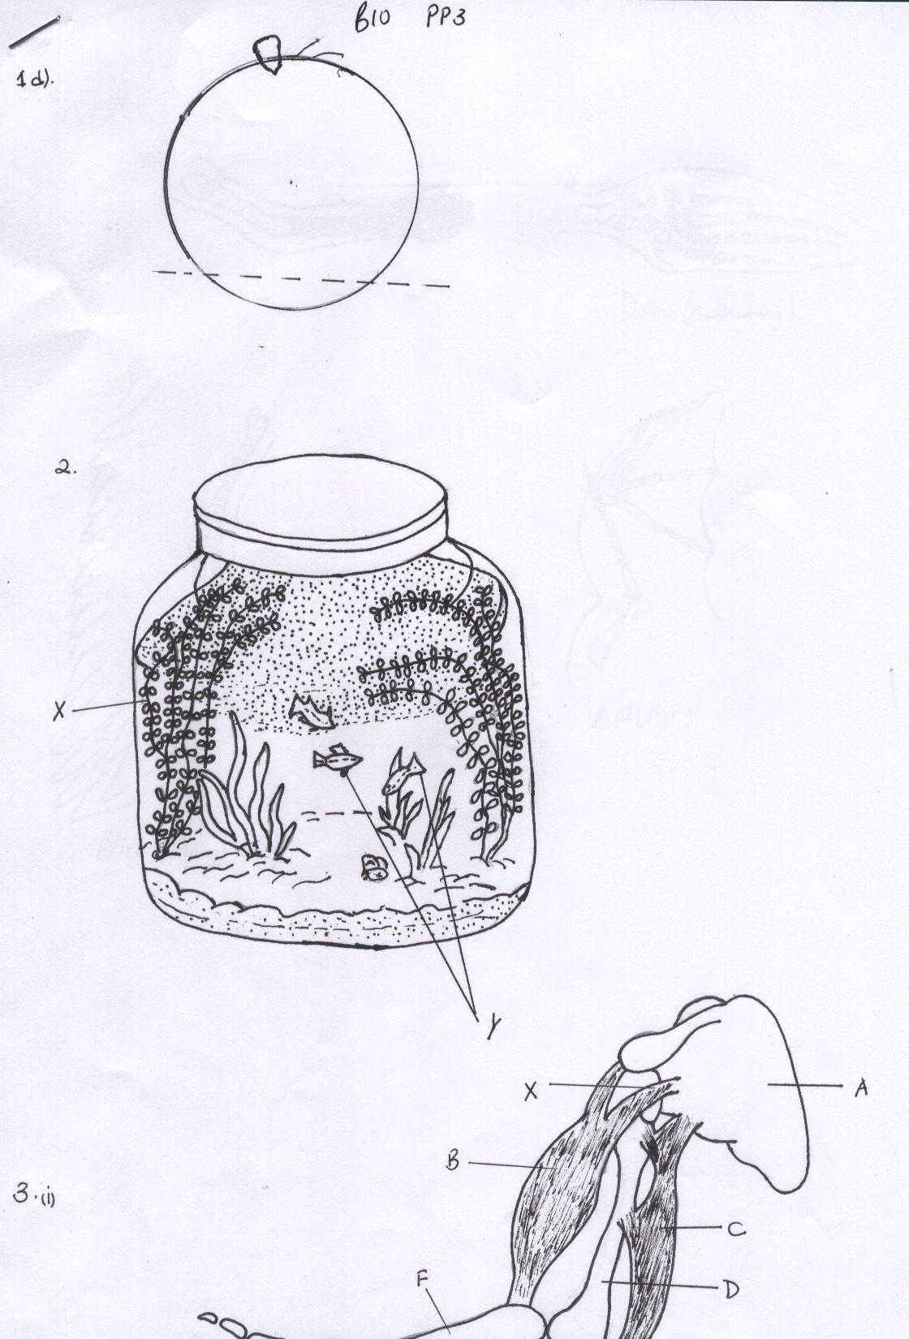

Place both pieces on the petridish with the 6cm3 of specimen X so that the cut surface is in contact with the substance. Allow the pieces to remain there for 30 minutes. After 30 minutes, carefully remove the pieces. Put the solution into two test tubes. Use the reagents provided to carry out food tests. Record your observations. (2mrks)

........................................................................................................................................................................................

........................................................................................................................................................................................

........................................................................................................................................................................................

........................................................................................................................................................................................

1. Account for the observation in (c) and (d) above. (4mrks)

...............................................................................................................................................................................................

................................................................................................................................................................................................

...............................................................................................................................................................................................................................................................................................................................................................................................

................................................................................................................................................................................................

1. What is the significance of the process being investigated. (2mrks)

........................................................................................................................................................................................

........................................................................................................................................................................................

........................................................................................................................................................................................

........................................................................................................................................................................................

1. In an ecological study carried out by form 3 students, they designed an experiment as shown below.

The jar in which the materials are assembled was airtight; containing seawater, algae, small crustaceans, saprophytic bacteria, X and Y. the set up was kept in the open sun and studied for 5months. Study this illustration carefully and answer the questions that follow.

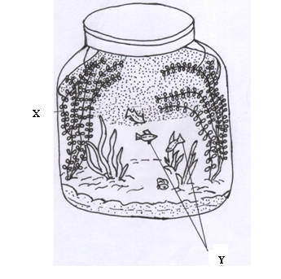

1. What was the aim of the study? (1mrk)

........................................................................................................................................................................................

........................................................................................................................................................................................

1. What was the possible observation the students made after 5 months. (1mrk)

........................................................................................................................................................................................

........................................................................................................................................................................................

1. Account for your answer in (b) above. (6mrks)

........................................................................................................................................................................................

........................................................................................................................................................................................

........................................................................................................................................................................................

........................................................................................................................................................................................

........................................................................................................................................................................................

........................................................................................................................................................................................

........................................................................................................................................................................................

........................................................................................................................................................................................

1. Identify X and Y in the jar. (2mrks)

X......................................................................................................................................................................................

Y......................................................................................................................................................................................

e) What would happen if?

i) X was removed from the jar. (2mrks)

........................................................................................................................................................................................

........................................................................................................................................................................................

........................................................................................................................................................................................

ii) The set up was put in the dark. (2mrks)

........................................................................................................................................................................................

........................................................................................................................................................................................

........................................................................................................................................................................................

........................................................................................................................................................................................

1. i) The diagram below shows the bones and two of the muscles in the human arm

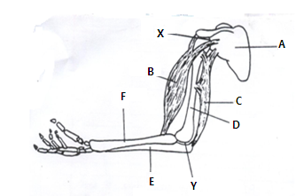

1. Name the parts A, C, E and F (2mrks)

A.................................................................................................................................................................................

C.................................................................................................................................................................................

E..................................................................................................................................................................................

F..................................................................................................................................................................................

1. Name the type of joint present in part Y. (1mrk)

....................................................................................................................................................................................

.................................................................................................................................................................................... What type of movement is possible at point X. (1mrk)

....................................................................................................................................................................................

...................................................................................................................................................................................

1. What happens when the muscle labeled C contracts (1mrk)

....................................................................................................................................................................................

....................................................................................................................................................................................

....................................................................................................................................................................................

....................................................................................................................................................................................

ii) In the study of evolution researchers have observed that vertebrate’s animals have the type of structures shown below.

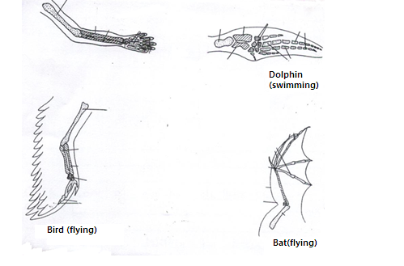

1. Which theory of evolution do this structures support? (1mrk)

....................................................................................................................................................................................

....................................................................................................................................................................................

1. On the diagrams identify the basic similarities observed. (2mrks)
2. Explain clearly why this structures justify evolution in animals. (3mrks)

....................................................................................................................................................................................

....................................................................................................................................................................................

....................................................................................................................................................................................

....................................................................................................................................................................................

....................................................................................................................................................................................

....................................................................................................................................................................................

....................................................................................................................................................................................

....................................................................................................................................................................................

....................................................................................................................................................................................

....................................................................................................................................................................................