**Name_________________________________________________________ Index No. ______________**

**Candidate’s signature ______**

**Date __________________**

**Kenya Certificate of Secondary Education**

**BIOLOGY**

**PAPER 3**

**1 ¼ HOURS**

**INSTRUCTIONS TO CANDIDATES**

1. Write your name and index number on the spaces provided

2. Answer ALL questions in the spaces provided

**For examiner’s use only**

|  |  |  |
| --- | --- | --- |
| **Question** | **Maximum score** | **Candidate’s score** |
| 1  2  3 | 13  13  14 |  |
| **Total score** | **40** |  |

***This paper consists of 6 printed pages***

***Turn Over***

1. You are provided with photographs of parts of a skull of an animal. Photograph 1 is from the lower jaw while photograph 2 is from the upper jaw. Use it to answer the questions that follow.

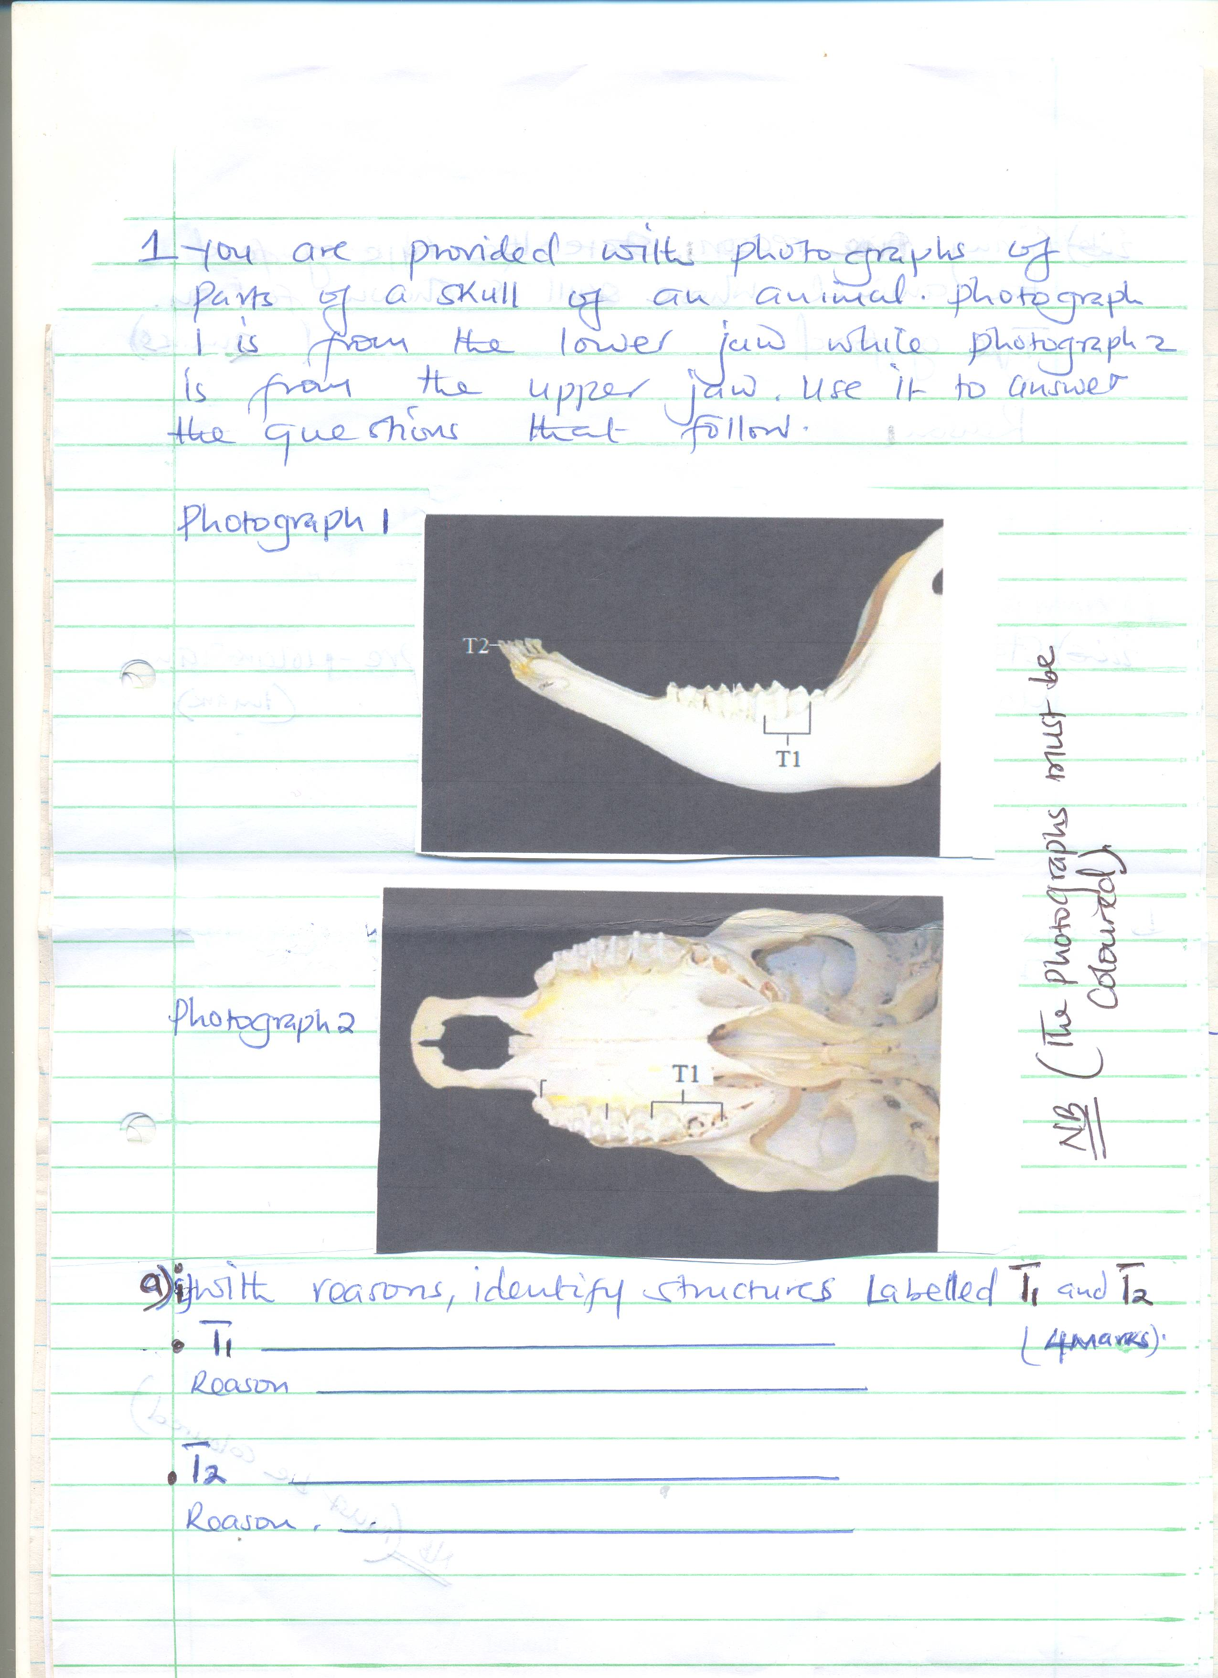

**Photograph 2**

**Photograph 1**

(a) (i) With reasons, identify structures labeled T1 and T2 (4mks)

T1

_________________________________________________________________________________

_________________________________________________________________________________

Reason

_________________________________________________________________________________

_________________________________________________________________________________

_________________________________________________________________________________

T2

_________________________________________________________________________________

_________________________________________________________________________________

Reason

_________________________________________________________________________________

_________________________________________________________________________________

_________________________________________________________________________________

(ii) Giving one reason state the type of food the animal whose skull is shown feed on

Type of food (2mks)

_________________________________________________________________________________

_________________________________________________________________________________

_________________________________________________________________________________

Reason

_________________________________________________________________________________

_________________________________________________________________________________

_________________________________________________________________________________

(iii) State the total number of pre-molars and molars on the skull (1mk)

_________________________________________________________________________________

_________________________________________________________________________________

_________________________________________________________________________________

(b) Photograph P below is from a mammalian skeleton

**Photograph P**

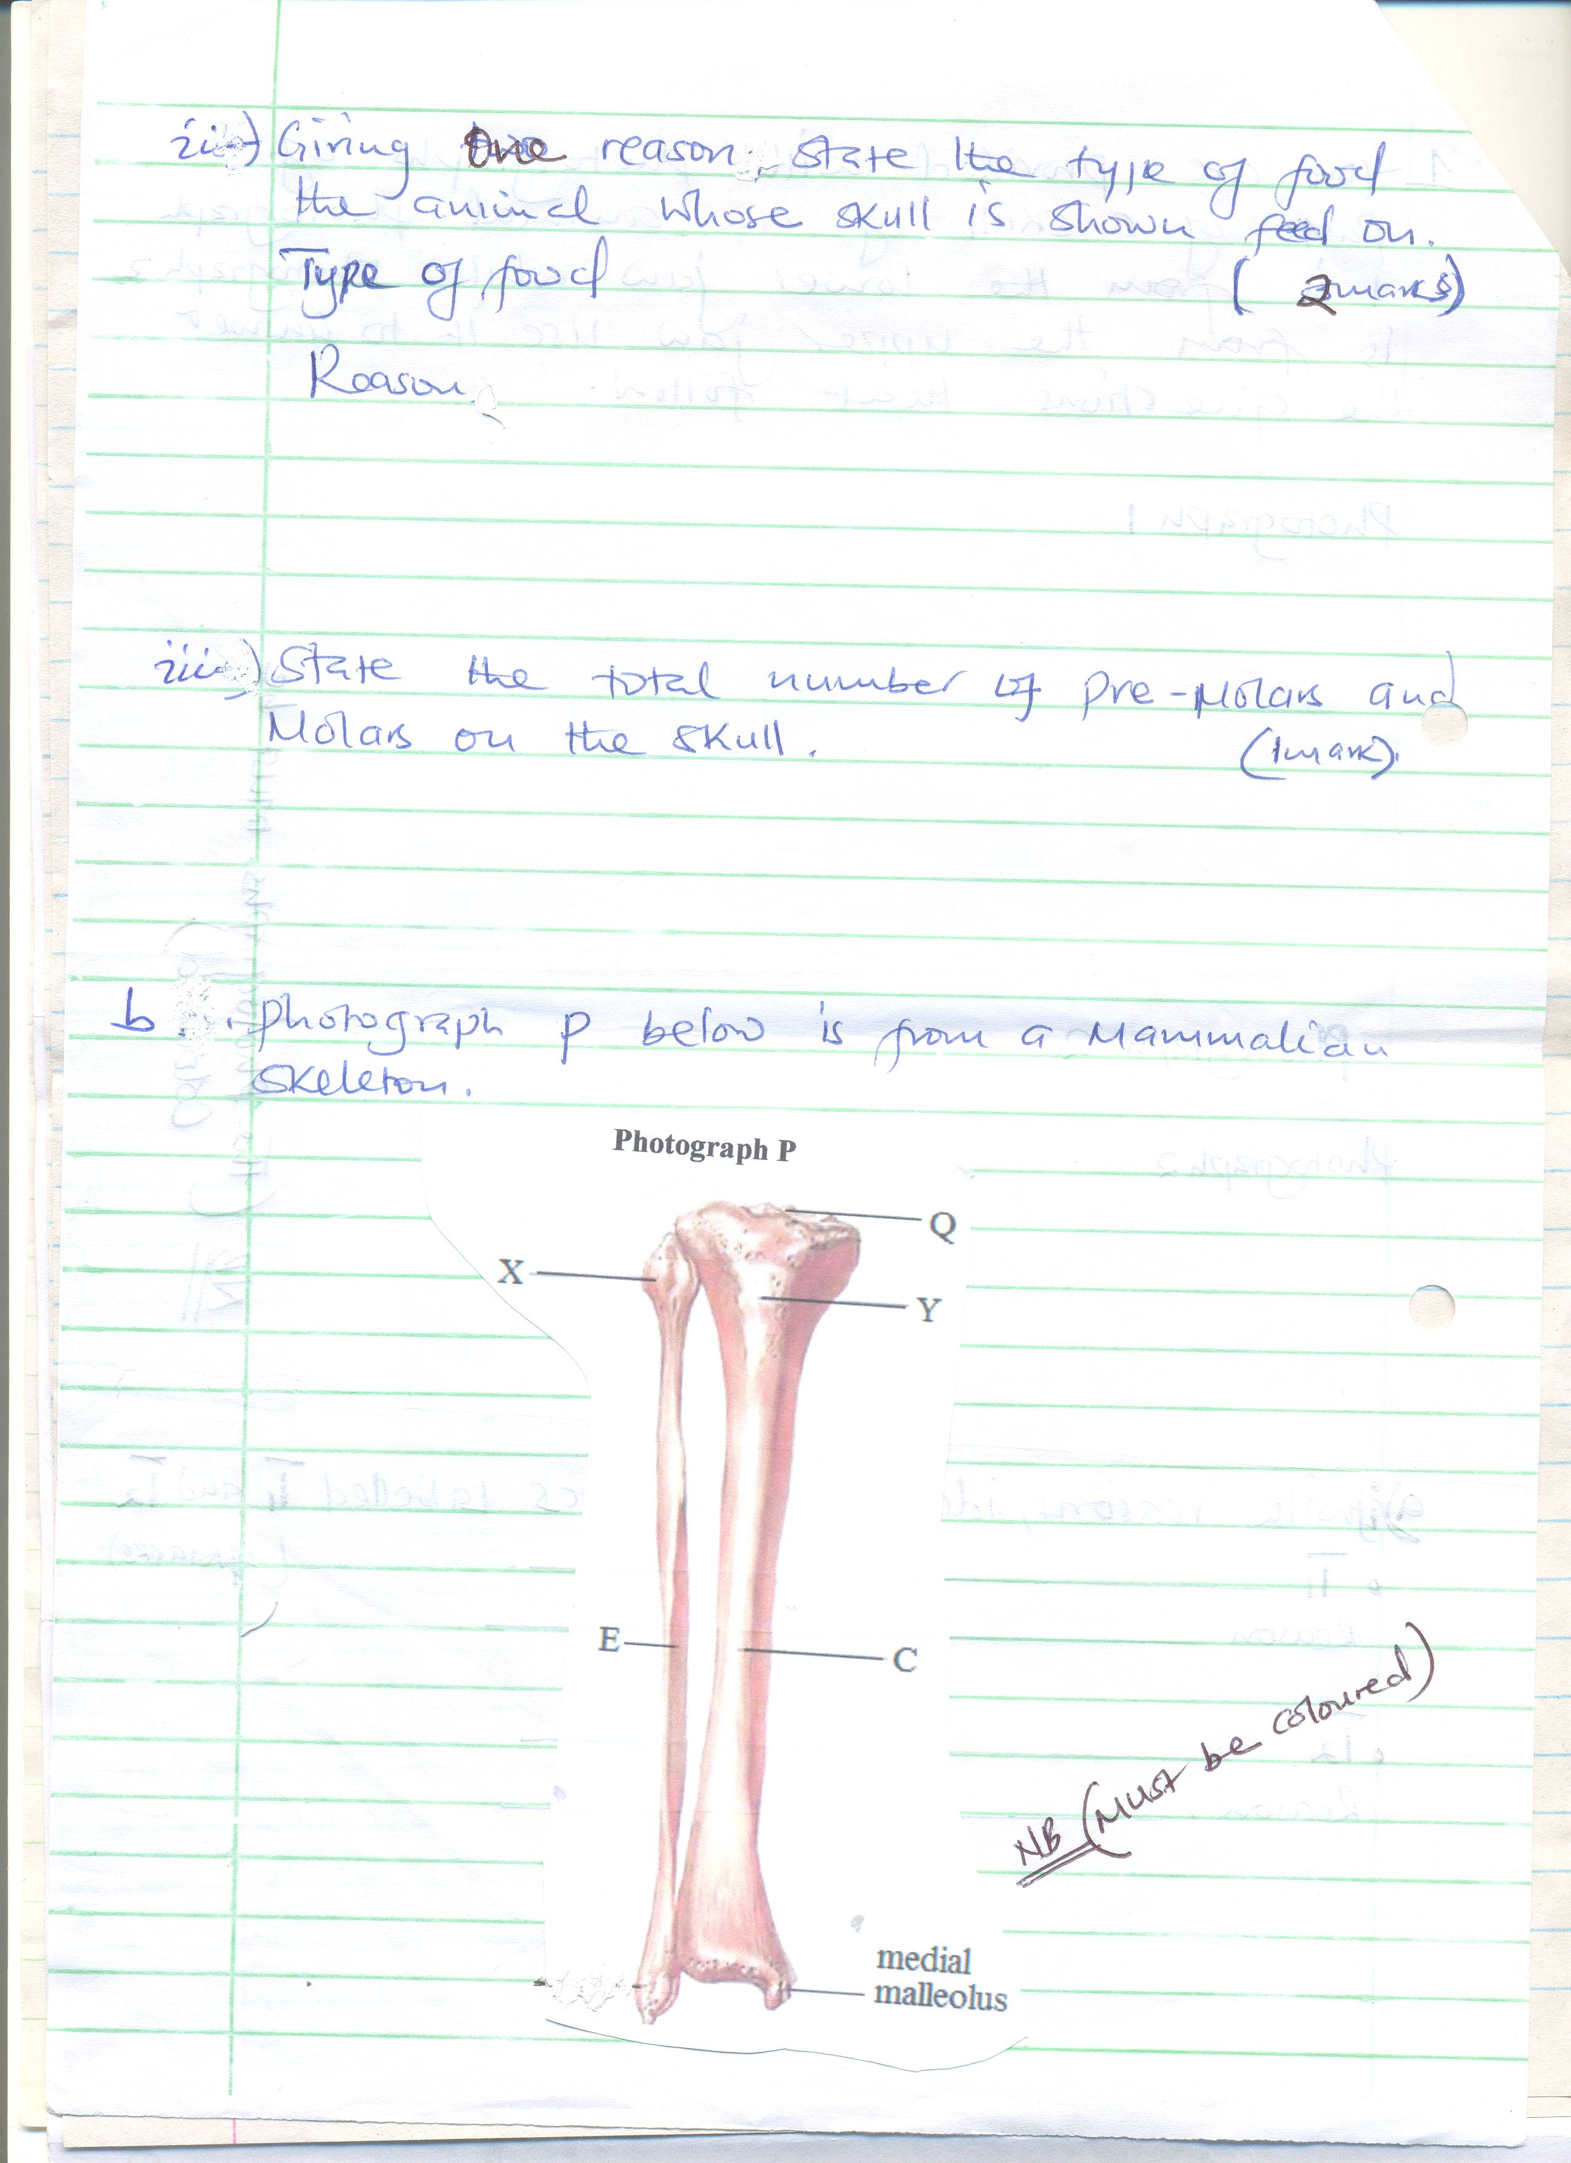

(i) Identify bone C and E (2mks)

C ______________________________________

E ______________________________________

(ii) Name the bone that articulates at point Q and the type of joint formed. (2mks)

Bone _______________________________________

Joint _______________________________________

2. You are provided with a specimen labeled K and hydrogen peroxide

(a) (i) What part of plant is specimen K? (1mk)

_________________________________________________________________________________

_________________________________________________________________________________

_________________________________________________________________________________

(ii) Give a reason for your answer in a (i) above (1mk)

_________________________________________________________________________________

_________________________________________________________________________________

_________________________________________________________________________________

(b) Cut three equal cubes whose sides are about 1cm from specimen K. place one of the cubes in a boiling tube labeled A; boil the second cube for about 15 minutes and then place it into a boiling tube labeled B; Cut the third cube into small pieces and place the pieces in a boiling tube labeled C

To each boiling tube add 5ms of hydrogen peroxide

(i) Record your observations in the table below (3mks)

|  |  |
| --- | --- |
| Tube | Observations |
| A |  |
| B |  |
| C |  |

(ii) Account for your observations in tubes B and C (4mks)

B

_________________________________________________________________________________

_________________________________________________________________________________

_________________________________________________________________________________

_________________________________________________________________________________

C

_________________________________________________________________________________

_________________________________________________________________________________

_________________________________________________________________________________

_________________________________________________________________________________

(c) (i) Write a word equation for the reaction that occurs in test tube A (2mks)

_________________________________________________________________________________

_________________________________________________________________________________

_________________________________________________________________________________

(ii) What is he significance of the reaction to living organisms (1mk)

_________________________________________________________________________________

_________________________________________________________________________________

_________________________________________________________________________________

(iii) Name the organ in mammals where the above reaction occurs at the highest rate (1mk)

_________________________________________________________________________________

_________________________________________________________________________________

_________________________________________________________________________________

3. Study the following photographs and answer the questions that follow.

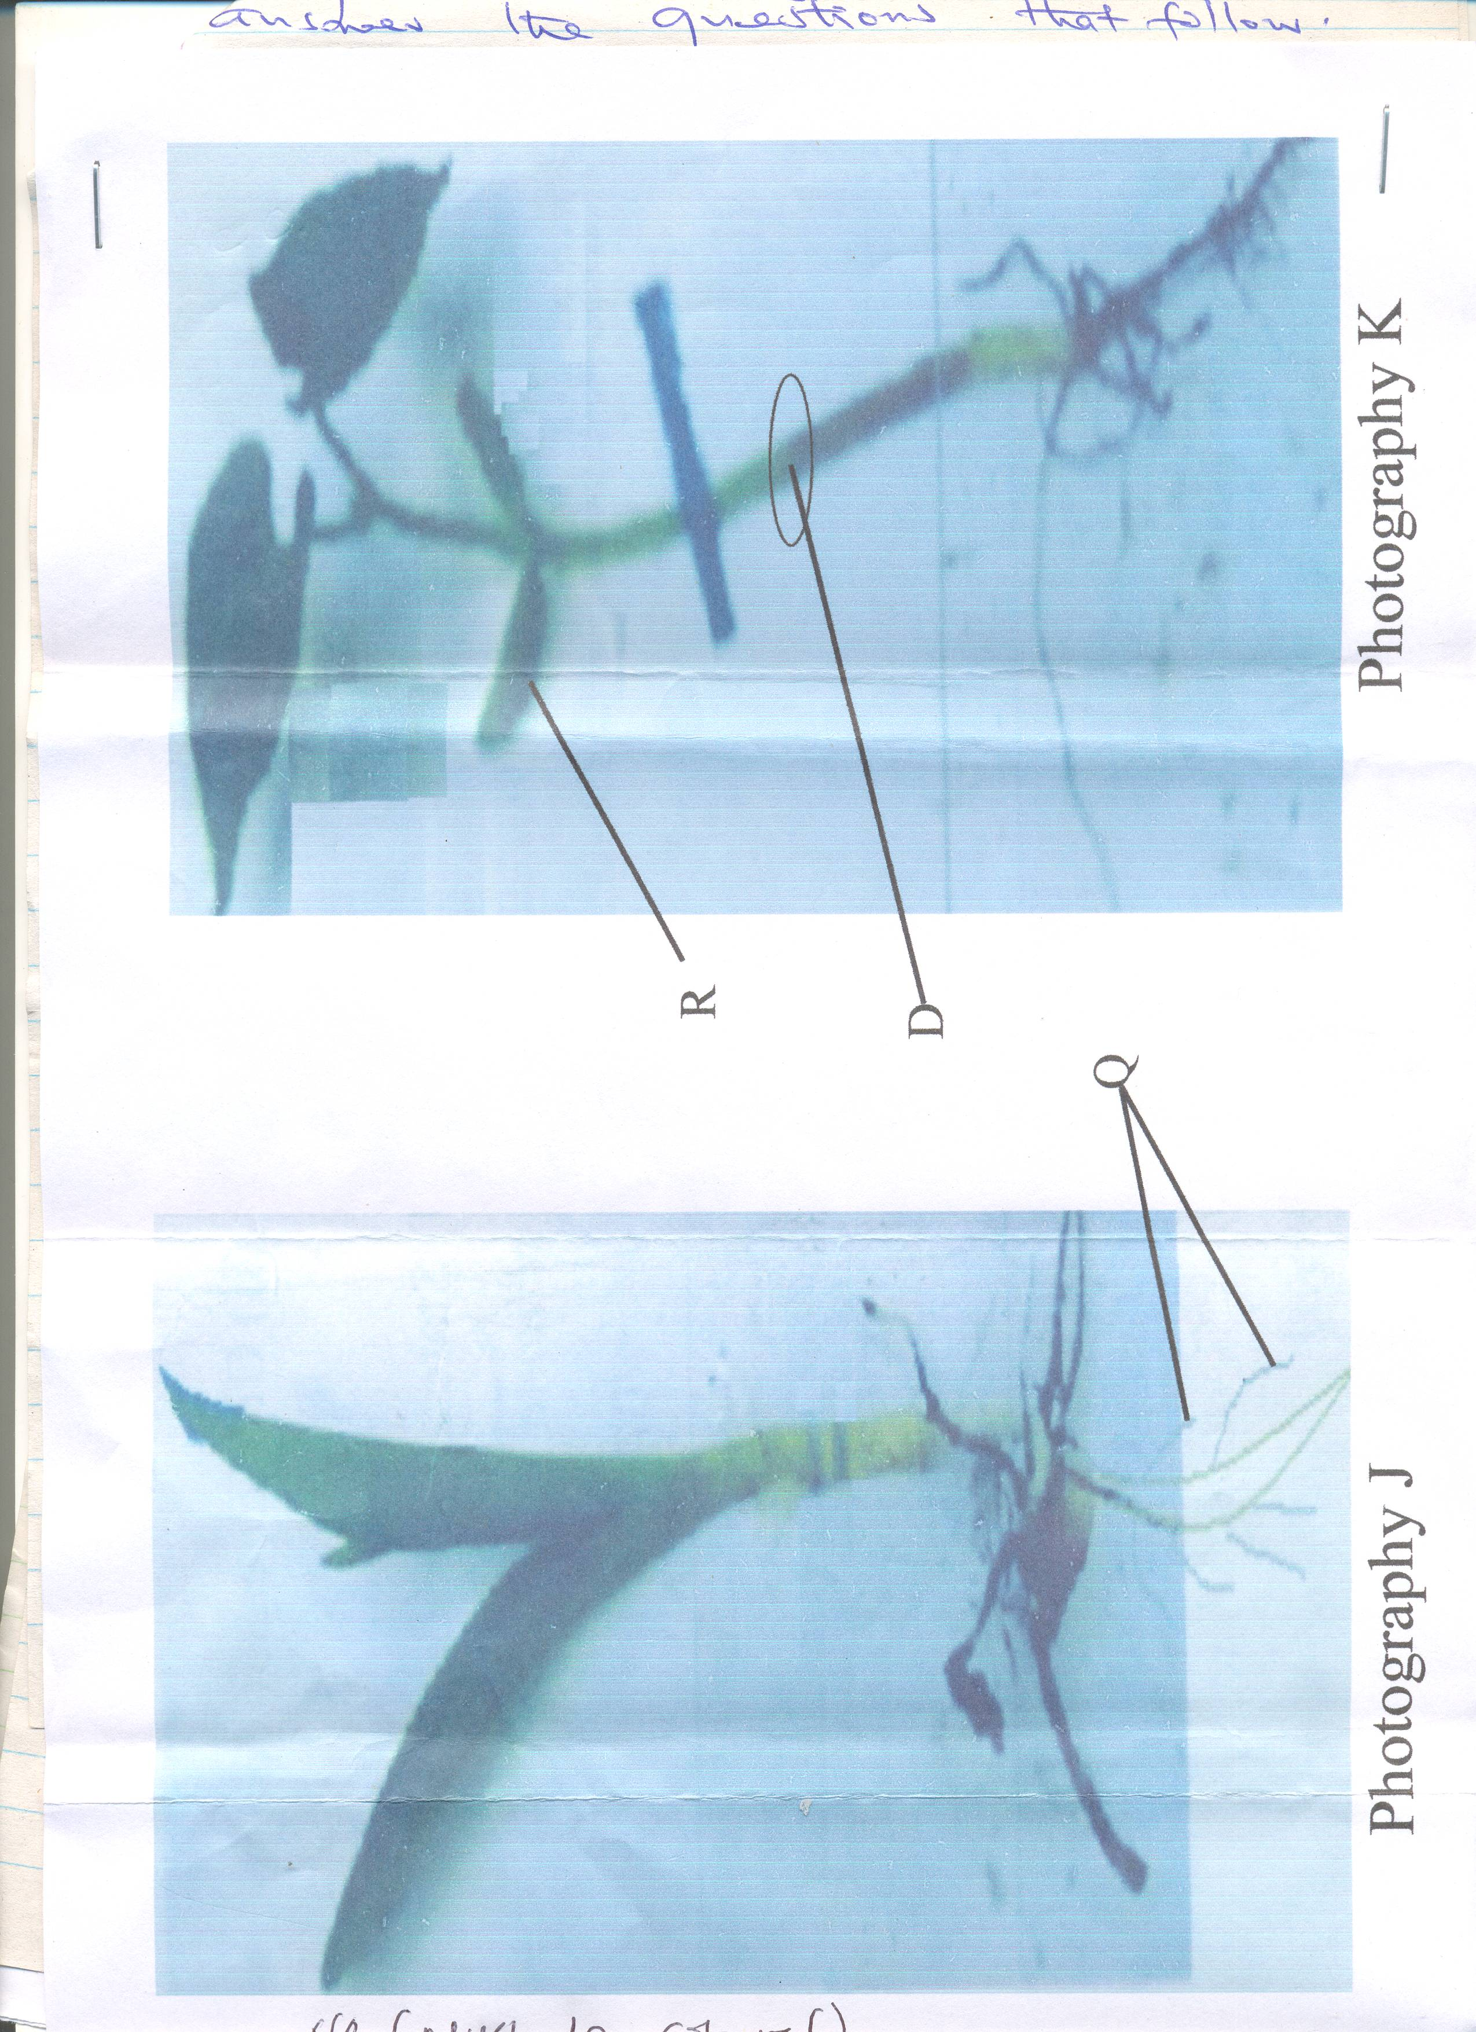

(a) (i) State the class to which specimen J and K belongs

J___________________________________________________ (1mk)

K __________________________________________________ (1mk)

(ii) Using observable features only give reasons for your answer in a (i) above

J (2mks)

_________________________________________________________________________________

_________________________________________________________________________________

_________________________________________________________________________________

K (2mks)

_________________________________________________________________________________

_________________________________________________________________________________

_________________________________________________________________________________

(b) Identify the type of germination shown by specimen J and K

J (1mk)

_________________________________________________________________________________

_________________________________________________________________________________

K (1mk)

_________________________________________________________________________________

_________________________________________________________________________________

(c) Name the parts labeled

R ____________________________________ (1mk)

Q ____________________________________ (1mk)

(d) Using photograph K, indicate using letter x to show two regions where mitosis would take

place at highest rate (2mks)

(e) Sketch a cross section of what would be revealed if a thin section of part D of specimen

K was observed under a light microscope (2mks)