**NAME……………………………………………………….. INDEX NO……………………........................**

**231/3 CANDIDATE’S SIGN………….….….….…...**

**BIOLOGY**

**PAPER 3 DATE……….…………………………………**

**(PRACTICAL)**

**TIME: 1¾ HOURS**

**INSTRUCTIONS TO CANDIDATES:**

(a) Write your **name** and **index number** in the spaces provided above.

(b) **Sign** and write the **date** of examination in the spaces provided above.

(c) Answer all the questions in the spaces provided.

(d) You are required to spend the first 15 minutes of the 1¾ hours allowed for this paper

reading the whole paper carefully before commencing your work.

(e) Additional papers must not be inserted.

(f) This paper has **three** questions and pages.

(g) Students should check the question paper to ascertain that all the paper are printed

as indicated and that no questions are missing.

(h) Candidates should answer all the questions in English.

**FOR EXAMINER’S USE ONLY:**

|  |  |  |
| --- | --- | --- |
| **Question** | **Maximum**  **Score** | **Candidate’s**  **Score** |
| **1** | **15** |  |
| **2** | **13** |  |
| **3** | **12** |  |
| **Total Score** | **40** |  |

*Biology Paper 3 Turnover*

1. Photograph **D** and **E** shows parts of a mammal and a dissected mammal respectively.

Examine them carefully then answer the questions that follow.

**PHOTOGRAPH D PHOTOGRAPH E**

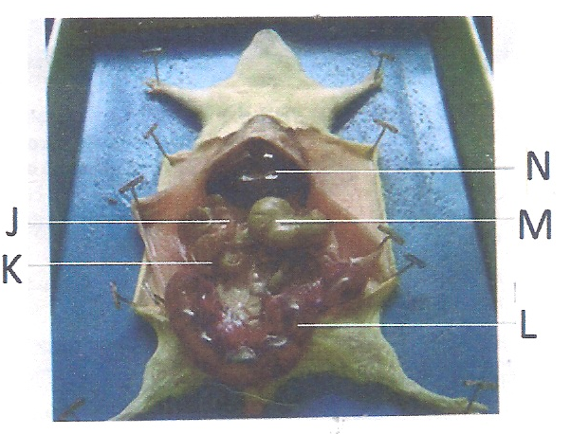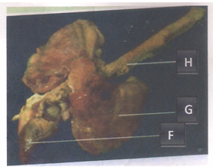

1. Name the parts marked **F** and **H** on photograph **D** and **J**, **K** and **M** on photograph **E**.

(5mks)

**F** ____________________________________________________________________

**H** ____________________________________________________________________

**J** _____________________________________________________________________

**K** ____________________________________________________________________

**M** ___________________________________________________________________

(b) State **one** function of each of the parts **L** and **N** on photograph **E**. (2mks)

Part **L**:

______________________________________________________________________

______________________________________________________________________

______________________________________________________________________

Part **N**:

______________________________________________________________________

______________________________________________________________________

______________________________________________________________________

*Biology Paper 3 2*

(c) (i) State the sex of the dissected mammal. (1mk)

_________________________________________________________________

(ii) Give a reason for your answer in c (i) above. (1mk)

_________________________________________________________________

_________________________________________________________________

_________________________________________________________________

(d) Name the body region of the mammal from where parts **G** and **H** of photograph **D** were

obtained.

**G** __________________________________________________________ (1mk)

**H** __________________________________________________________ (1mk)

(e) State the adaptations of parts **G** and **H** to their functions.

Part **G**. (2mks)

______________________________________________________________________

______________________________________________________________________

______________________________________________________________________

______________________________________________________________________

Part **H**. (2mks)

______________________________________________________________________

______________________________________________________________________

______________________________________________________________________

______________________________________________________________________

*Biology Paper 3 3*

2. (a) The following are photographs of various animals. Examine them and answer the

following questions.

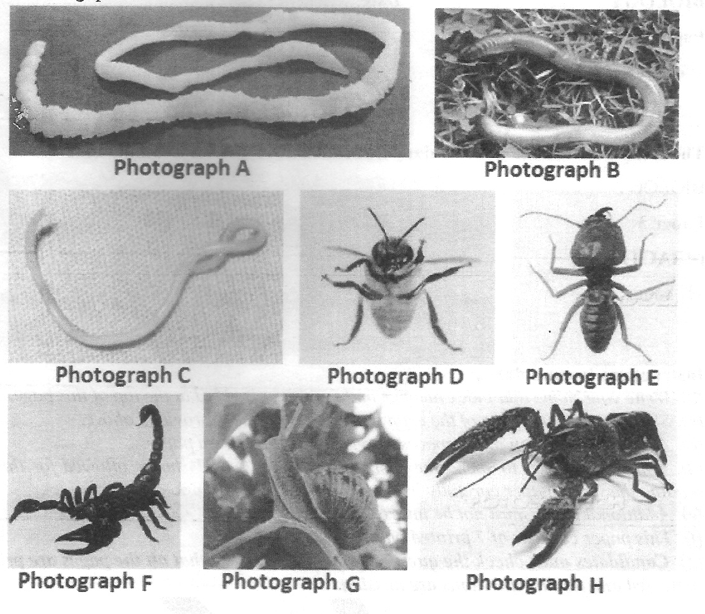

The dichotomous key shown below can be used to place each specimen into its taxonomic group.

Dichotomous key

1(a) Organisms having a flat body ------------------- go to 9

(b) Organism without flat body ------------------- go to 2

2(a) Organism having a body in a shell ------------------ Mollusca

(b) Organisms without a shell -------------------------- go to 3

3(a) Organisms having segmented body ----------------- go to 4

(b) Organisms with a body not segmented ------------- Nematoda

4(a) Organisms having jointed appendages -------------- go to 6

(b) Organisms without jointed appendages ------------- go to 5

5(a) Organisms having a long cylindrical body ---------- Annelida

(b) Organisms having a short stout body.---------------- Trematoda

6(a) Organism with antennae ------------------------------- go to 7

(b) Organism lacking antennae ---------------------------- go to 8

7(a) Organism with a pair of antennae --------------------- Insecta

(b) Organism with more than one pair of antennae ----- Crustacea

8(a) Organism with pincer like mouth parts --------------- Arachnida

(b) Organism with sucking mouth parts ------------------- Acarina

9(a) Organism having a ribbon like body ------------------ Cestoda

(b) Organism with circular body --------------------------- Crinoidea

*Biology Paper 3 4*

Using the dichotomous key, identify the taxonomic group of each of the specimens. (8mks)

|  |  |  |
| --- | --- | --- |
| Photograph | Steps followed | Identity |
| A |  |  |
| B |  |  |
| C |  |  |
| D |  |  |
| E |  |  |
| F |  |  |
| G |  |  |
| H |  |  |

1. The diagram below represent part of mammalian skeleton. Examine the diagram

and answer the questions that follow.

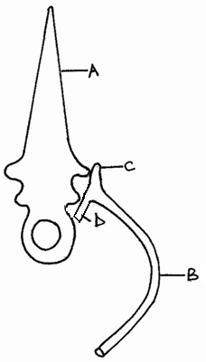

* 1. With a reason, give the identity the bone labelled **A**.

Identity. _______________________________________________ (1mk)

Reason. (1mk)

_________________________________________________________________

_________________________________________________________________

_________________________________________________________________

_________________________________________________________________

*Biology Paper 3 5*

(ii) Identify parts labelled **C** and **D**. (2mks)

**C** _______________________________________________________________

**D** _______________________________________________________________

(iii) Name the bone which articulates with bone **B** to the ventral side of the body.

(1mk)

_________________________________________________________________

3. You are provided with a substance labelled X in a small beaker. Using the reagents provided, test for the food substances in X. Record the food tested, procedures, observations and conclusions in the table below. (12mks)

|  |  |  |  |
| --- | --- | --- | --- |
| Food substance | Procedure | Observations | Conclusions |
|  |  |  |  |
|  |  |  |  |
|  |  |  |  |

*Biology Paper 3 6*