Name……………………………………………………Index number……………………

Candidate’s signature………………………. Date…………………………………

565/1
BUSINESS STUDIES
Paper 1
2 Hours

SMARTPASS EXAMINATION
Kenya Certificate of Secondary Education (KCSE)
MODEL ONE 2019

BUSINESS STUDIES
Paper 1

INSTRUCTIONS TO CANDIDATES
- Write your name and index number in the spaces provided above.
- Sign and write the date of examination.
- Answer all the questions in the spaces provided.

For examiners use only
QUESTION | 1 | 2 | 3 | 4 | 5 | 6 | 7 | 8 | 9 | 10 | 11 | 12 | 13 | 14 | 15 | 16 | 17
MARKS

QUESTION | 18 | 19 | 20 | 21 | 22 | 23 | 24 | 25
MARKS

TOTAL MARKS

This paper consists of 11 printed pages. Candidates should check the question paper to ensure that all the pages are printed as indicated and no questions are missing.

Answer ALL questions in the spaces provided.
1. Identify four difficulties that may make an individual not to satisfy most of his needs.
(4 marks)
a)…………………………………………………………………………………………...............
……………………………………………………………………………………………….........
b)…………………………………………………………………………………………...............
……………………………………………………………………………………………….........
c)………………………………………………………………………………………….............
………………………………………………………………………………………………
2. Highlight four characteristics of free resources. (4 marks)
a).........................................................................................................................................................
b)........................................................................................................................................................
c).........................................................................................................................................................
d)........................................................................................................................................................

3. Outline four measures that can be taken to improve the efficiency of parastatals in Kenya.
(4 marks)
a)……………………………………………………………………………………………...........
………………………………………………………………………………………………..........
b)…………………………………………………………………………………………..............
………………………………………………………………………………………………..........
c)…………………………………………………………………………………………...............
……………………………………………………………………………………………..............
d)…………………………………………………………………………………………………...
………………………………………………………………………………………......................

4. State four factors that would influence the amount of money held by an individual for
transaction purposes. (4 marks)
a)…………………………………………………………………………………………................
……………………………………………………………………………………………..............
b)……………………………………………………………………………………………...........
………………………………………………………………………………………………..........
c)…………………………………………………………………………………………...............
………………………………………………………………………………………………..........
d)…………………………………………………………………………………………...............
………………………………………………………………………………………...................

5. State four measures that the government may employ to regulate and control business
activities. (4 marks)
a)……………………………………………………………………………………………............
………………………………………………………………………………………………...........
b)……………………………………………………………………………………………...........
………………………………………………………………………………………………..........
c)……………………………………………………………………………………………...........
………………………………………………………………………………………………..........
d)……………………………………………………………………………………………...........
……………………………………………………………………..................................................
6. Given below are books of original entry, state the source document used to prepare each of the books. (4 marks)
Books | Source document
- Cash book  - Sales journal  - Purchase journal  - Sales return journal | ..........................................................................  ................................................................................  ...............................................................................  .............................................................................

7. Post the following transactions to the relevant ledger accounts.
a) Started business by depositing in the bank a cheque of shs. 100,000.
b) Withdrew Kshs. 20,000 cash from the bank for business use.
c) Tumanka a debtor paid shs. 40,000 cash.
d) Took shs.10, 000. from cash till for personal use. (4mks)

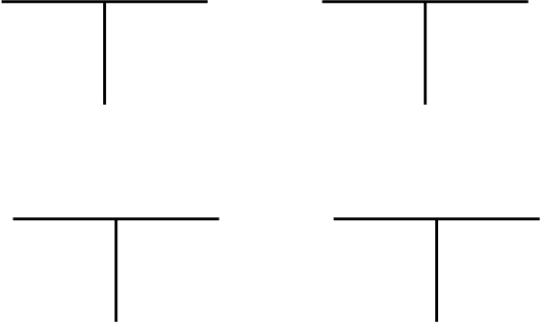

8. Identify four ways through which manufacturers protect the consumers against exploitation. (4 marks)
a)……………………………………………………………………………………………............
………………………………………………………………………………………………...........
b)……………………………………………………………………………………………............
………………………………………………………………………………………………............
c)……………………………………………………………………………………………............
………………………………………………………………………………………………..........
d)…………………………………………………………………………………………….........
……………………………………………………………………………………………….........

9. List four sources of monopoly power for a firm in a market. (4 marks)
(i)………………………………………………………………………………………….............
(ii)……………………………………………………………………………………….................
(iii)…………………………………………………………………………………………...........
(iv)………………………………………………………………………………………….........
10. Outline any four benefits of “pooling of risks” to insurance company. (4 marks)
a)……………………………………………………………………………………………...........
……………………………………………………………………………………………….........
b)……………………………………………………………………………………………..........
………………………………………………………………………………………………........
c)……………………………………………………………………………………………........
………………………………………………………………………………………………........
d)…………………………………………………………………………………………….........
………………………………………………………………………………………………........
11. The diagram below shows a supply curve S_{o}S_{o} and S_{I}S_{I}.
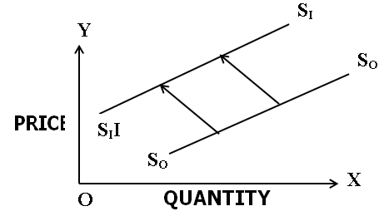
Highlight four factors that account for the above phenomena. (4 marks)
a)……………………………………………………………………………………………
………………………………………………………………………………………………
b)……………………………………………………………………………………………
………………………………………………………………………………………………
c)……………………………………………………………………………………………
………………………………………………………………………………………………
d)……………………………………………………………………………………………
………………………………………………………………………………………………
12. Highlight four roles played by inter-mediaries in the chain of distribution. (4 marks)
a)…………………………………………………………………………………………................
………………………………………………………………………………………………..........
b)…………………………………………………………………………………………...............
………………………………………………………………………………………………............
c)…………………………………………………………………………………………................
………………………………………………………………………………………………............
d)……………………………………………………………………………………………............
………………………………………………………………………………………………..........
……………………………………………………………………………………………….........
13. Outline four uses of national income statistics (4 marks)
i).............................................................................................................................................
ii)...........................................................................................................................................
iii)..........................................................................................................................................
iv)..........................................................................................................................................
14. Highlight four methods that can be used by a country to solve the problem of deficit
balance of payment. (4 marks)
i).....................................................................................................................................................
ii).....................................................................................................................................................
iii)...................................................................................................................................................
iv)..................................................................................................................................................
15. Outline four positive implications of high population growth rate in a country. (4 marks)
a)……………………………………………………………………………………………..........
……………………………………………………………………………………………….........
b)……………………………………………………………………………………………........
………………………………………………………………………………………………........
c)……………………………………………………………………………………………........
……………………………………………………………………………………………….......
d)……………………………………………………………………………………………......
………………………………………………………………………………………………
16. Highlight four reasons why hypermarkets are increasingly becoming popular in Kenya. (4 marks)
i)…………………………………………………………………………………………………..
ii)………………………………………………………………………………………………….
iii)…………………………………………………………………………………………………
iv)…………………………………………………………………………………………………

17. For each of the following transactions, indicate with a tick (√) whether it will increase,
decrease or have no effect on the balance sheet totals. (4 marks)

Transaction | Effect on the balance total
Transaction | Increase | Decrease | No effect
(i) Borrowing sh 20,000 from bank for paying creditors
(ii) Used sh 10,000 cash pay for loan arrears
(iii) Sale of part of business premises
(iv) Sale of goods worth sh 5,000 for sh 4,500

18. Outline four circumstances under which personal selling is appropriate. (4 marks)
i)……………………………………………………………………………………………………
ii)…………………………………………………………………………………………………… iii)…………………………………………………………………………………………………..
iv)…………………………………………………………………………………………………..

19. State four disadvantages of localization to a developing country (4 marks)
a) …………………………………………………………………………………………………
b) …………………………………………………………………………………………………
c) …………………………………………………………………………………………………
d) …………………………………………………………………………………………………

20. The following information relates to NtutuTraders
Purchases sh 2,700,000
Return outwards sh 600,000
Closing stock sh 500,000
Opening stock sh 1,200,000
Margin ²/₉
Calculate (i) Cost of sales (2 marks)

…………………………………………………………………………………………………
…………………………………………………………………………………………………
…………………………………………………………………………………………………
…………………………………………………………………………………………………
(ii) Gross profit (2 marks)
…………………………………………………………………………………………………
…………………………………………………………………………………………………
…………………………………………………………………………………………………
…………………………………………………………………………………………………
21. State the meaning and significance of the following terms used in international trade.
(i) Depreciation of the currency of country.......................................................................................................................................
(ii) Determination of the terms of trade of a country........................................................................................................................................
(iii) Traderestrictions..........................................................................................................................

(iv) Common market.................................................................................................................

22. Outline four advantages of a business using E-mail in communication. (4 marks)
a) …………………………………………………………………………………………………
b) …………………………………………………………………………………………………
c) …………………………………………………………………………………………………
d) …………………………………………………………………………………………………

23. Outline four economic conditions that would prevail in a country undergoing inflation.
(4 marks)
a) …………………………………………………………………………………………………
b) …………………………………………………………………………………………………
c) …………………………………………………………………………………………………
d) …………………………………………………………………………………………………

24. Indicate in the spaces provided whether the following taxes are either direct taxes or
indirect taxes. (4 marks)
Tax Types of tax
Corporation tax _________________________________
Capital gain tax _________________________________
Value added tax _________________________________
Income tax ________________________________

25. Indicate in the spaces provided, the account to be debited and account to be credited. (4 marks)

Transaction | Account Debited | Account Credited
(a) Started business by depositing sh 80,000 in the bank account of the business.
(b) Bought stock of goods worth sh 20,000 from XYZ retailers on credit.
(c) Returned goods worth sh 4,000 to XYZ retailers
(d) Paid XYZ retailers’ sh 15,000 cheque

